
Chapel End Primary School Calculation Policy – March 2026 – to be reviewed in Spring 2027-2028

This calculation policy has been written in line with the programmes of study taken from the revised National Curriculum for Mathematics (2014) and developed from Whiterose Maths Hub. It provides guidance on appropriate calculation methods and progression. The content is set out in blocks (guidance only) under the following headings: addition, subtraction, multiplication and division. This policy was agreed by all staff in October 2024.

Intent

- To ensure consistency and progression in our approach to calculation

- To ensure that children develop an efficient, reliable, formal written method of calculation for all operations

- To ensure that children can use these methods accurately with confidence and understanding

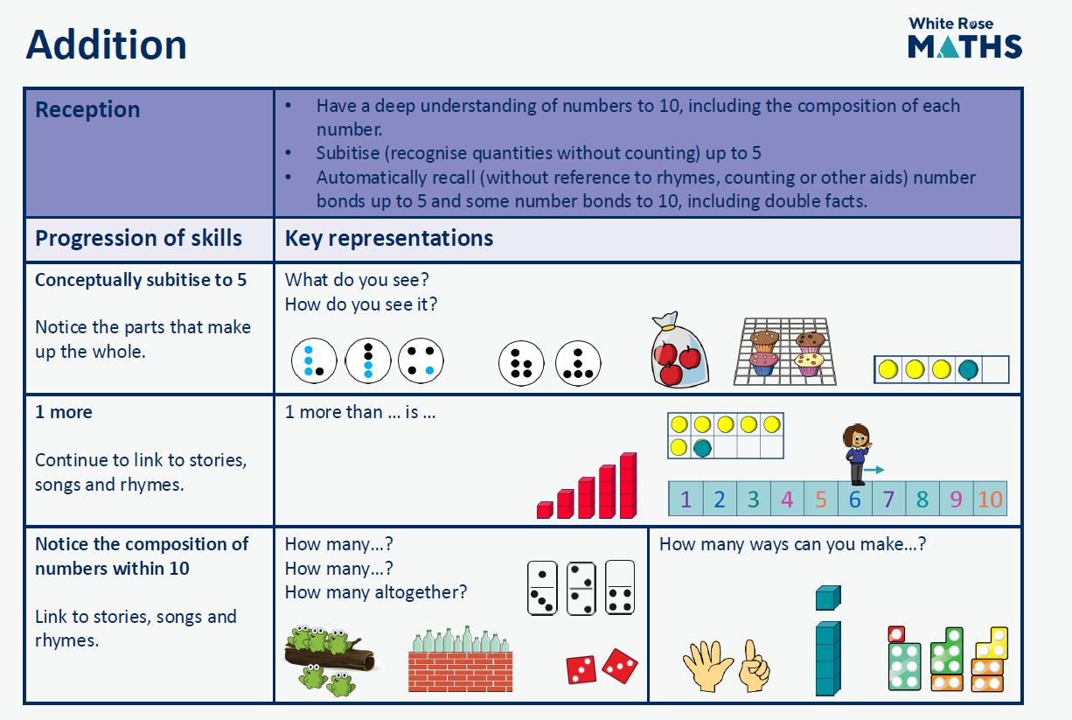
Curriculum Guidance - Addition
Implementation Guidance - Addition
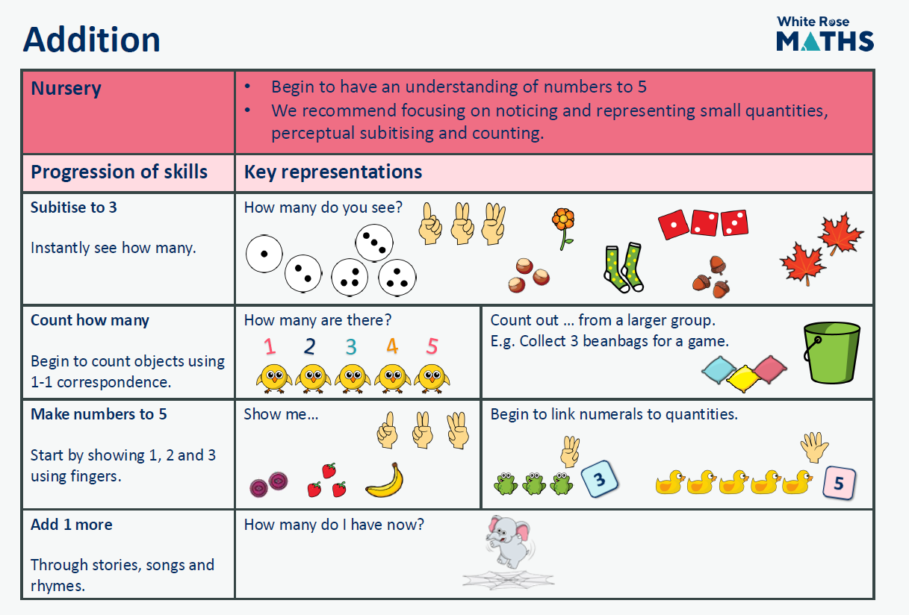
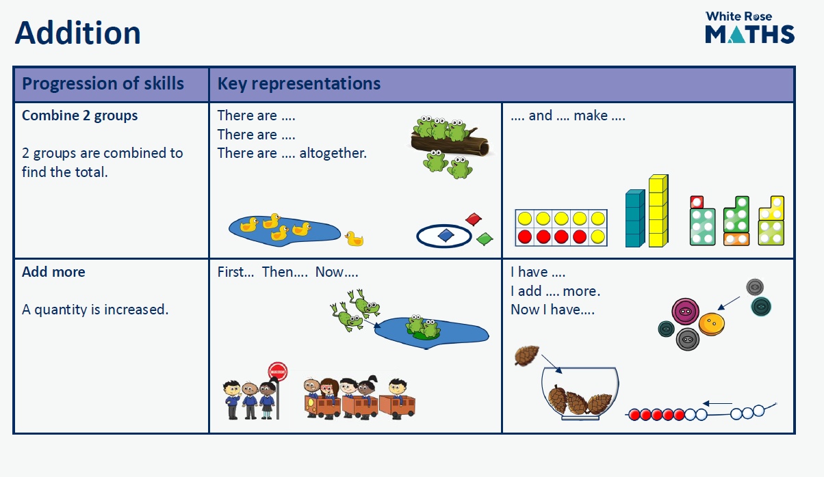
Curriculum Guidance - Addition

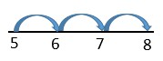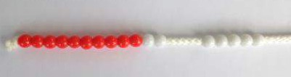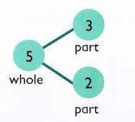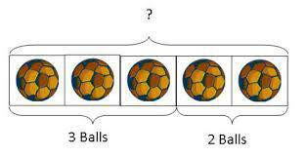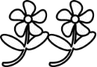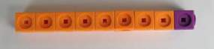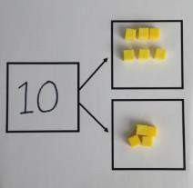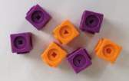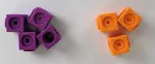
Curriculum Guidance - Addition

 | Objective | Concrete | Pictorial | Abstract
Year 1 | Number bonds of 5, 6, 7, 8, 9 and 10 | Use cubes to add two numbers together as a group or in a bar. | Use pictures to add two numbers  together as a group or in a bar.  3 2 | 2 + 3 = 5  3 + 2 = 5  2  5 = 3 + 2  5 = 2 + 3  3  Use the part-part-whole diagram as shown above to move into the abstract.
Year 1 | Counting | 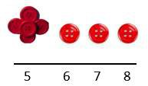Start with the larger number on the bead string and then count on to the smaller number 1 by 1 to find the answer. | Use a number line to count on in ones. | 5 + 3 = 8

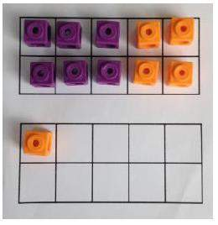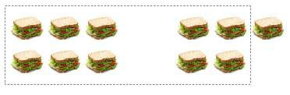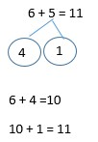
Curriculum Guidance - Addition
+

+

 | Objective | Concrete | Pictorial | Abstract
Year 1 | Regrouping to make 10 | 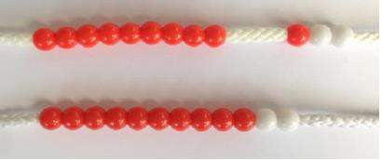  6 + 5 = 11  Start with the bigger number and use the smaller number to make 10. |  | 6 + 5 = 11
Year 2 | Adding 3 single digit numbers | 4 + 7 + 6= 17  Put 4 and 6 together to make 10. Add on  7.  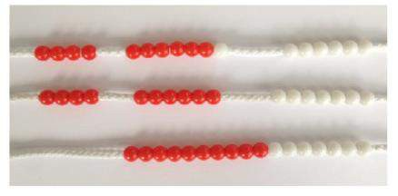  Following on from making 10, make 10 with 2 of the digits (if possible) then add on the third digit. | + +  +  Add together three groups of objects. Draw a picture to recombine the groups to make 10. | 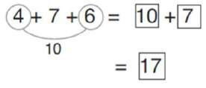  Combine the two numbers that make 10 and then add on the remainder.

Curriculum Guidance - Addition

 | Objective | Concrete | Pictorial | Abstract
Year 2 | Column method without regrouping | Add together the ones first, then add the  tens. Use the Base 10 blocks first before moving onto place value counters.  24 + 15 = 44 + 15 = |  | 24 + 15 = 39
Year 2 | Column method without regrouping |  | draw the counters to help them to solve | 24
Year 2 | Column method without regrouping |  | additions. | + 15
Year 2 | Column method without regrouping |  | 10s 1s | 39
Year 2 | Column method with regrouping | Make both numbers on a place value | Using place value counters, children can | 40 + 9
Year 2 | Column method with regrouping | grid. | draw the counters to help them to solve | 20 + 3
Year 2 | Column method with regrouping |  | additions. | 60 + 12 = 72
Year 2 | Column method with regrouping |  | 10s 1s
Year 2 | Column method with regrouping | Add up the units and exchange 10 ones for 1 ten. | 10s 1s

and place value counters, children can

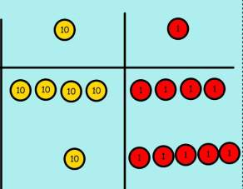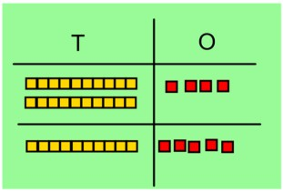

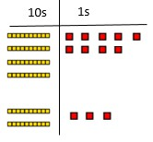

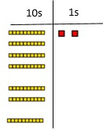
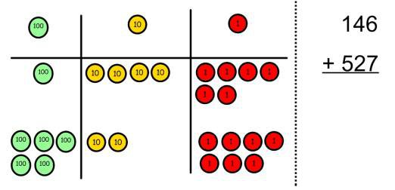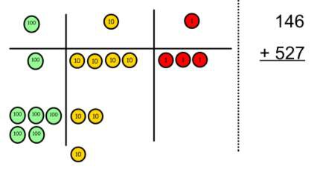
Curriculum Guidance - Addition

 | Objective | Concrete | Pictorial | Abstract
Year 3/4 | Column method with regrouping | Make both numbers on a place value | 100s 10s 1s | 100 + 40 + 6
Year 3/4 | Column method with regrouping | grid. |  | 500 + 20 + 7
Year 3/4 | Column method with regrouping |  |  | 600 + 70 + 3 = 673
Year 3/4 | Column method with regrouping |  |  | As the children progress, they will move from the expanded to the compacted method.
Year 3/4 | Column method with regrouping |  | 100s 10s 1s | 146
Year 3/4 | Column method with regrouping | Add up the units and exchange 10 ones |  | + 527
Year 3/4 | Column method with regrouping | for 1 ten. |  | 673
Year 3/4 | Column method with regrouping |  |  | 1
Year 3/4 | Column method with regrouping | As children move on to decimals, money and decimal place value counters can be used to support learning. | Children can draw a pictoral representation of the columns and place value counters to further support their learning and understanding. | As the children move on, introduce decimals with the same number of decimal places and different. Money can be used here.
Year 3/4 | Column method with regrouping | NB By Year 4 children will progress on to adding four digit numbers. | NB Addition of money needs to have £  and p added separately.
Year 5/6 | Column method with regrouping | understanding using numbers with more than 4 digits and extend by adding numbers with up to 3 decimal places.

Curriculum Guidance - Subtraction
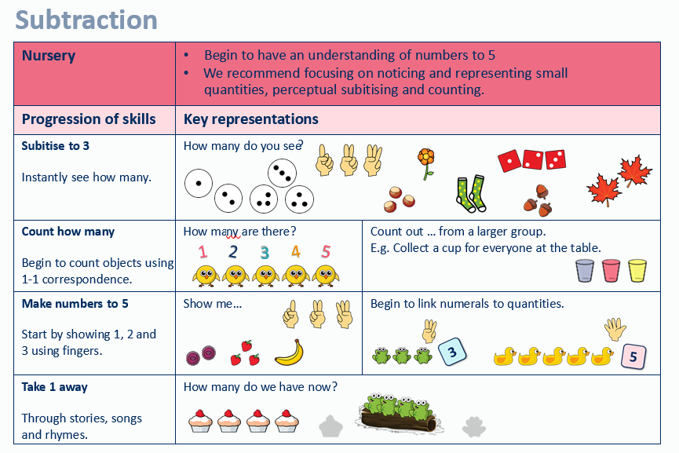

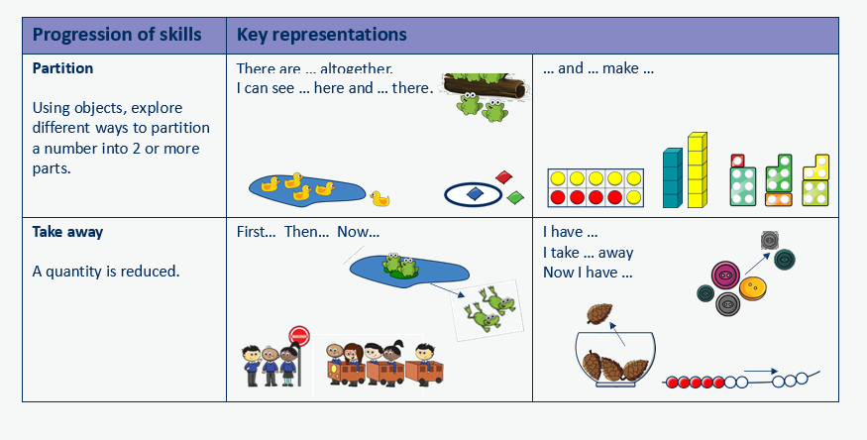
Curriculum Guidance - Subtraction
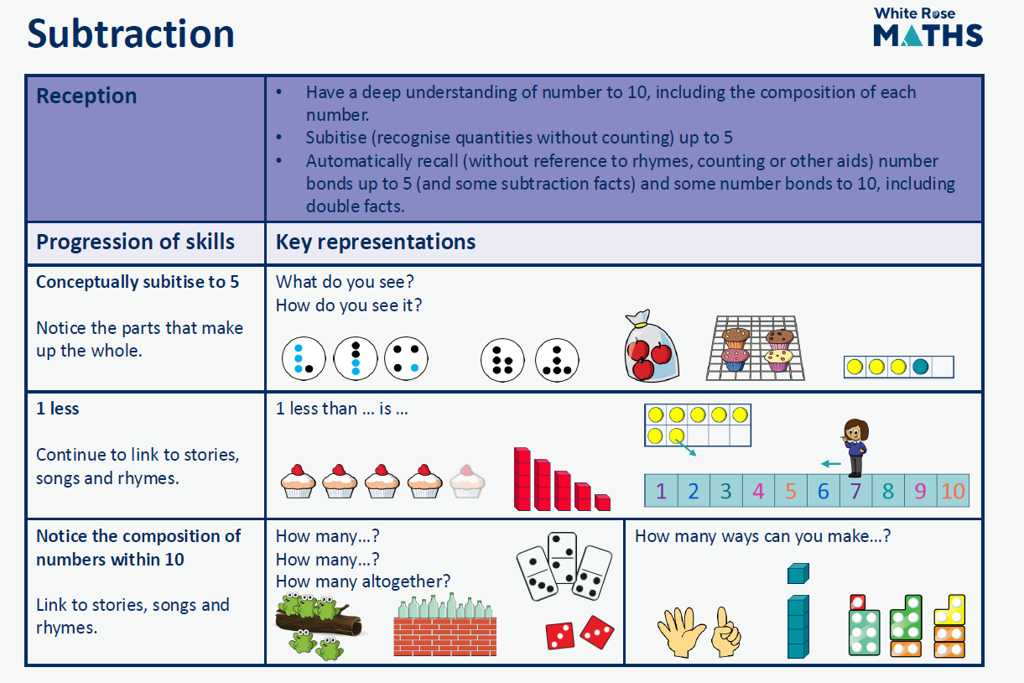
Curriculum Guidance - Subtraction

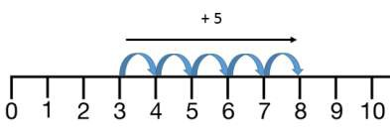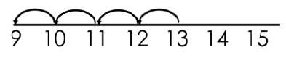
Curriculum Guidance - Subtraction

 | Objective | Concrete | Pictorial | Abstract
Year 1 | Taking away ones | Use physical objects, counters, cubes etc.  to show how objects can be taken away.  4 – 2 = 2 | Cross out drawn objects to show what  has been taken away.  4 – 2 = 2 | 4 – 2 = 2
Year 1 | Counting back | Make the larger number in your  subtraction. Move the beads along your bead string as you count backwards in ones.  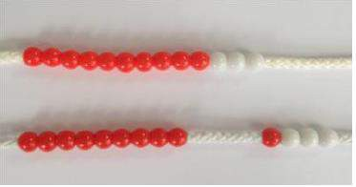  13 – 4 = 9 | Count back on a number line or number  track  Start at the bigger number and count back the smaller number, showing the jumps on the number line. | Put 13 in your head, count back 4. What  number are you at?  Use your fingers to help.
Year 1 | Find the difference | Compare amounts and objects to find  the difference.  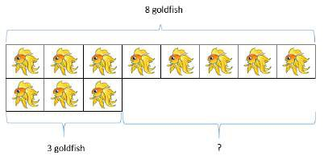  Use cubes to build towers or make bars to find the difference. Use basic bar models with items to find the difference. | Count on to find the difference.  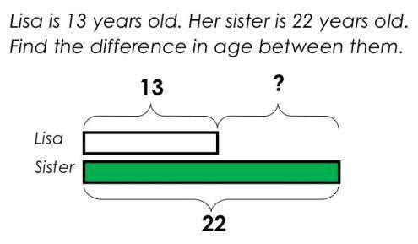  Draw bars to find the difference between  2 numbers. | Hannah has 8 goldfish.  Helen has 3 goldfish.  Find the difference between the number of goldfish the girls have.

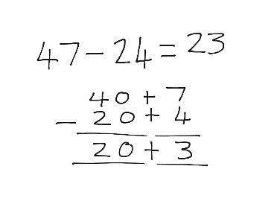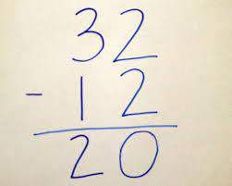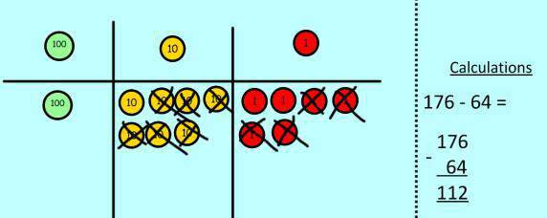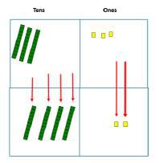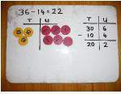
Curriculum Guidance- Subtraction

 | Objective | Concrete | Pictorial | Abstract
Year 2 | Column method without regrouping | 75 – 42 = 33  Use Base 10 to make the bigger number then take the  smaller number away.  Show how you partition numbers to subtract.  Again make the larger number first. | 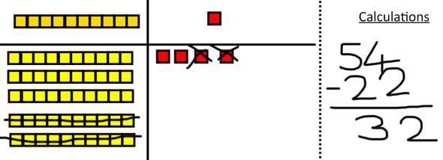  Draw the Base 10 or place value counters alongside the written calculation to help to show working. | This will lead to a clear written column subtraction.
Year 2 | Column Method with regrouping |  | Draw the counters onto a place value grid and show what you have taken away by crossing the counters out as well as clearly showing the exchanges you make.  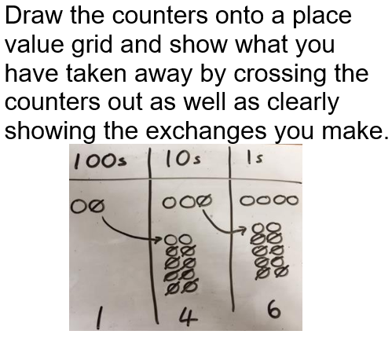 | 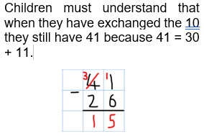  Children must understand that when they have exchanged the 10, they still have 41 because 41 = 30 + 11

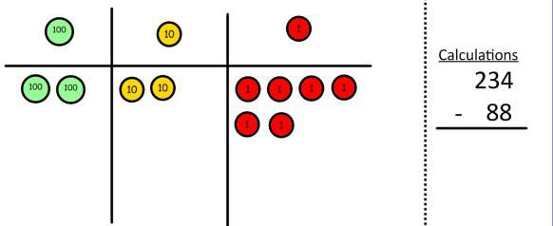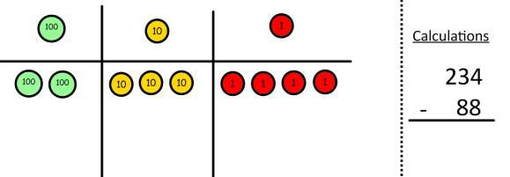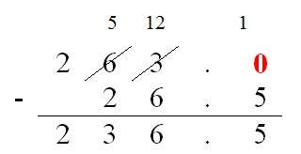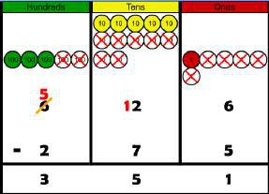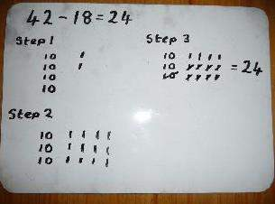
Curriculum Guidance - Subtraction

 | Objective | Concrete | Pictorial | Abstract
Year 3 onwards | Column method with regrouping | Use Base 10 to start with before moving  on to place value counters. Start with one exchange before moving onto subtractions with 2 exchanges.  Make the larger number with the place value counters  Start with the ones, can I take away 8 from 4 easily? I need to exchange 1 of my tens for 10 ones.  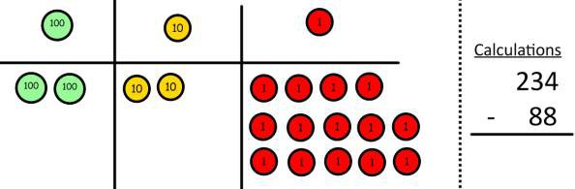  Now I can subtract my ones. | Draw the counters onto a place value  grid and show what you have taken away by crossing the counters out as well as clearly showing the exchanges you make.  When confident, children can find their own way to record the exchange/regrouping.  Just writing the numbers as shown here shows that the child understands the method and knows when to exchange/regroup. | 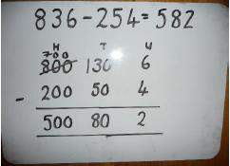  Children can start their formal written method by partitioning the number into clear place value columns.  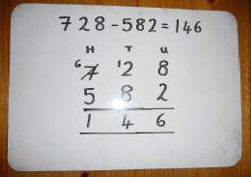  Moving forward the children use a more compact method.  This will lead to an understanding of subtracting any number including decimals.

Curriculum Guidance - Subtraction

 | Objective | Concrete | Pictorial | Abstract
Year 3 up | Column method with regrouping (continued) | Now look at the tens, can I take away 8  tens easily? I need to exchange 1 hundred for 10 tens.  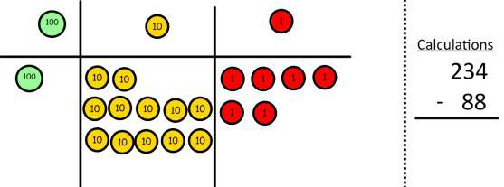  Now I can take away 8 tens and complete my subtraction.  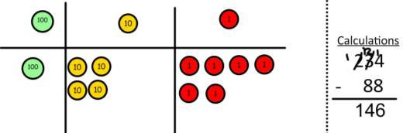  Show children how the concrete method links to the written method alongside your working. Cross out the numbers when exchanging and show where we write our new amount.

Curriculum Guidance - Multiplication
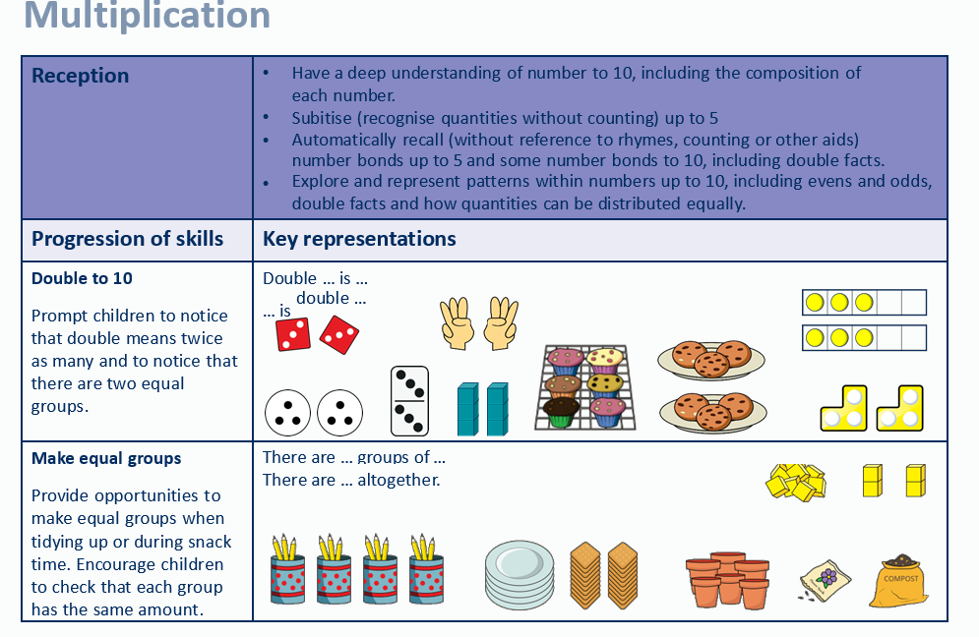

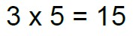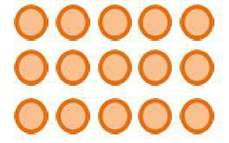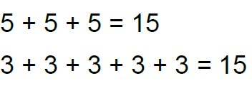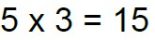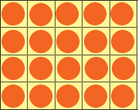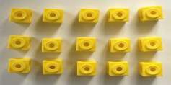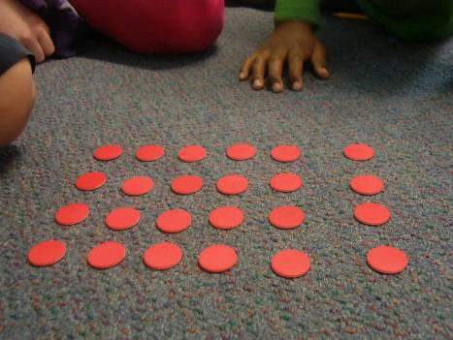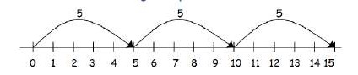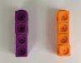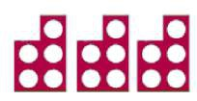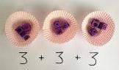
Curriculum Guidance - Multiplication

 | Objective | Concrete | Pictorial | Abstract
Year ½ | Repeated addition | Use different objects to add equal groups. | There are 3 plates. Each plate has 2 star  biscuits on. How many biscuits are there?  2 + 2 + 2 = 6  5 + 5 + 5 = 15 | Write addition sentences to describe  objects and pictures.  2 + 2 + 2 = 6
Year ½ | Arrays- showing commutative multiplication | Create arrays using counters/cubes to  show multiplication sentences. | Draw arrays in different rotations to find  commutative multiplication sentences.  4 × 2 = 8  2 × 4 = 8  2 × 4 = 8  4 × 2 = 8  Link arrays to area of rectangles. | Use an array to write multiplication  sentences and reinforce repeated addition.

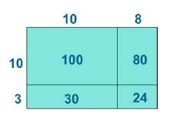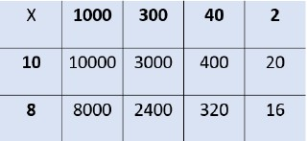
Curriculum Guidance - Multiplication

 | Objective | Concrete | Pictorial | Abstract
Year 3/4 | Grid method |  |  | Start with multiplying by one digit  numbers and showing the clear addition alongside the grid.  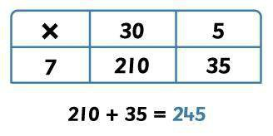  Moving forward, multiply by a 2 digit number showing the different rows within the grid method.

Curriculum Guidance - Multiplication

 | Objective | Concrete | Pictorial | Abstract
 | Expanded method |  |  | Start with long multiplication, reminding  the children about lining up their numbers clearly in columns.  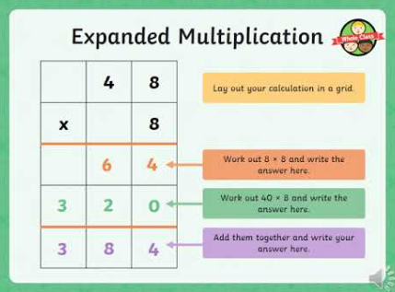
Year 5/6 | Compact method | Children can continue to be supported by  place value counters at the stage of multiplication.  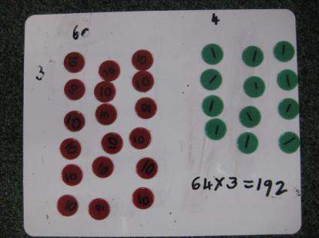  It is important at this stage that they always multiply the ones first and note down their answer followed by the tens which they note below. | Bar modelling and number lines can support  learners when solving problems with multiplication alongside the formal written methods. | Start with long multiplication, reminding the  children about lining up their numbers clearly in columns.  If it helps, children can write out what they are solving next to their answer.  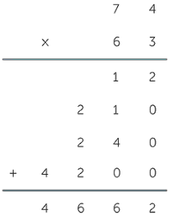  This moves to the more compact method. Remembering to do the ones first  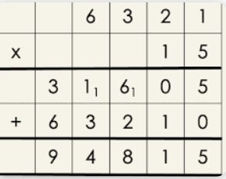

Curriculum Guidance - Division
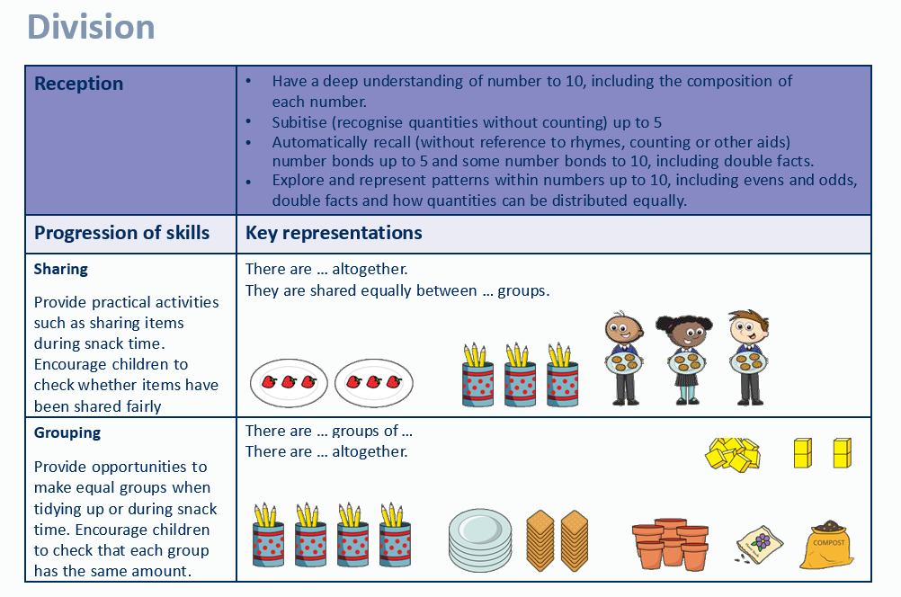
Curriculum Guidance - Division

 | Objective | Concrete | Pictorial | Abstract
Year 1/2 | Sharing | I have 8 cubes, can you share them  equally between two people? | Children use pictures or shapes to share  quantities. | Share 8 buns between two people.  8 ÷ 2 = 4
Year 1/2 | Sharing |  |   8 ÷ 2 = 4 | Share 8 buns between two people.  8 ÷ 2 = 4
Year 1/2 | Grouping | Divide quantities into equal groups.  Use cubes, counters, objects or place value counters to aid understanding.  10 ÷ 5 = 2  10  x x x x x x x x x x | Use number line to show jumps in groups. | 10 ÷ 5 = 2
Year 1/2 | Grouping |  | The number of jumps equals the number of groups.  10 ÷ 5 = 2 | Divide 10 into 5 groups. How many are in each group?
Year 1/2 | Grouping |  | 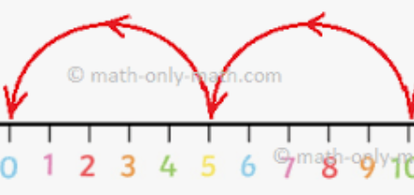

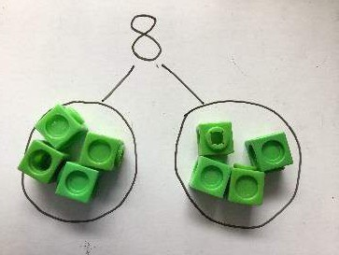

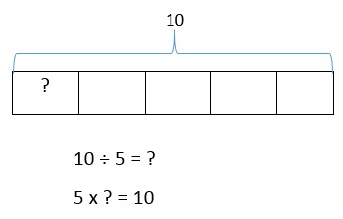

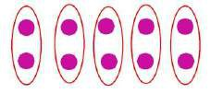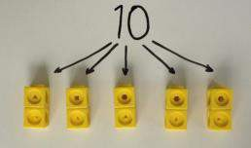

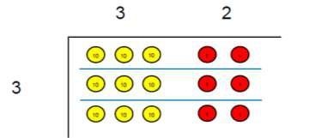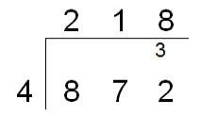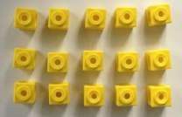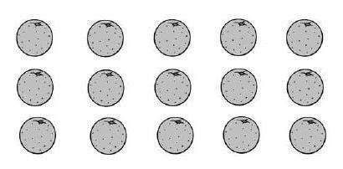
Curriculum Guidance - Division

 | Objective | Concrete | Pictorial | Abstract
Year 3/4 | Division with arrays | Link division to  multiplication by creating an array and thinking about the  number sentences that can be created. Eg 15 ÷ 3 = 5 5 x 3 = 15  15 ÷ 5 = 3 3 x 5 = 15 | Draw an array and use lines to split the array into groups to make multiplication and division sentences. | Find the inverse of multiplication and  division sentences by creating four linking number sentences.  5 x 3 = 15  3 x 5 = 15  15 ÷ 5 = 3  15 ÷ 3 = 5
Year 3/4 | Short division | Use place value counters to divide using  the short division method alongside.  96 ÷ 3 | 96 divided by 3  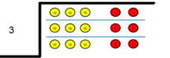 | Begin with divisions that divide equally  with no remainder.

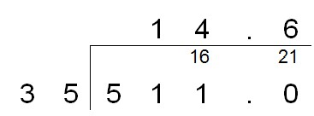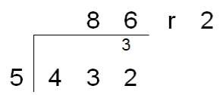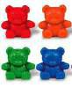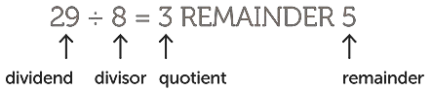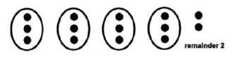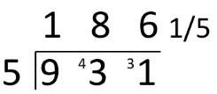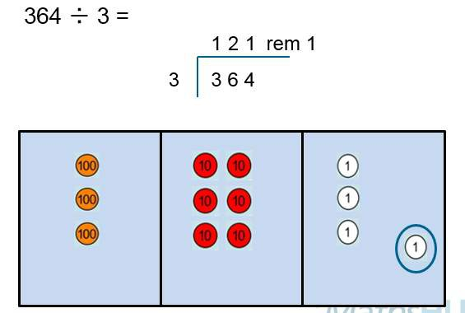
Curriculum Guidance - Division

 | Objective | Concrete | Pictorial | Abstract
Yr 4/5/6 | Division with remainders | 14 ÷ 3 =  Divide objects between groups and see how much is left over | Jump forward in equal jumps on a  number line then see how many more you need to jump to find a remainder.  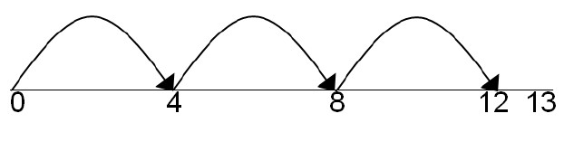  Draw dots and group them to divide an amount and clearly show a remainder. | Complete written divisions and show the  remainder using r.
Yr 4/5/6 | Short division with remainders |  |  | Move onto divisions with a remainder.  Once children understand remainders, begin to express as a fraction or decimal  according to the context.

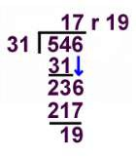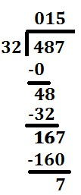
Curriculum Guidance - Division

 | Objective | Concrete | Pictorial | Abstract
Yr 5/ 6 | Long division |  |  | Children will use long division to divide  numbers with up to 4 digits by 2 digit numbers.  (1 x 32 = 32)  (2 x 32 = 64)  (3 x 32 = 96)  (4 x 32 = 128)  (5 x 32 = 160)  Partial Tables  (1 x 31 = 31)  (2 x 31 = 62)  (3 x 31 = 91)  (4 x 31 = 124)  (5 x 31 = 155)  (6 x 31 = 186)  (7 x 31 = 217)

Impact

By consistently following and building upon these methods of calculation, the Maths curriculum at Chapel End Primary School
will have developed children into the best mathematicians they can be. These children will have worked towards leaving the school with:

- The fundamental methods of how to multiply, divide, add and subtract numbers efficiently.

- Confidence when using and talking about mathematical processes in later life.

- Independence and resilience to solve problems involving mathematical operations.

- A stimulated curiosity to understand the four operations in mathematics.

- Cultivated their personal aspirations in mathematical thinking.

