Letter from Kooth Digital Health outlining support over Christmas and New Year.

Dear Parent/Carer,

Kooth.com is an NHS-commissioned service in your area, offering free mental health support and counselling via text-based interactions. Children and young people aged 10 - 25 in St Helens can sign-up to the platform anonymously on an internet enabled device at Kooth.com.

The platform offers self-help tools such as wellbeing activities, goal setting and a journaling space, resources such as articles, pre-moderated forums and podcasts, and support from qualified professionals via messaging and live-chat message support.

The platform can be accessed 24/7, and an asynchronous message (someone doesn’t respond live in the moment) can be sent anytime day or night, with a response coming within 48 hours.

Our live-chat support will remain available over the Christmas and New Year period. I have included the times for live-chat support via an image below:

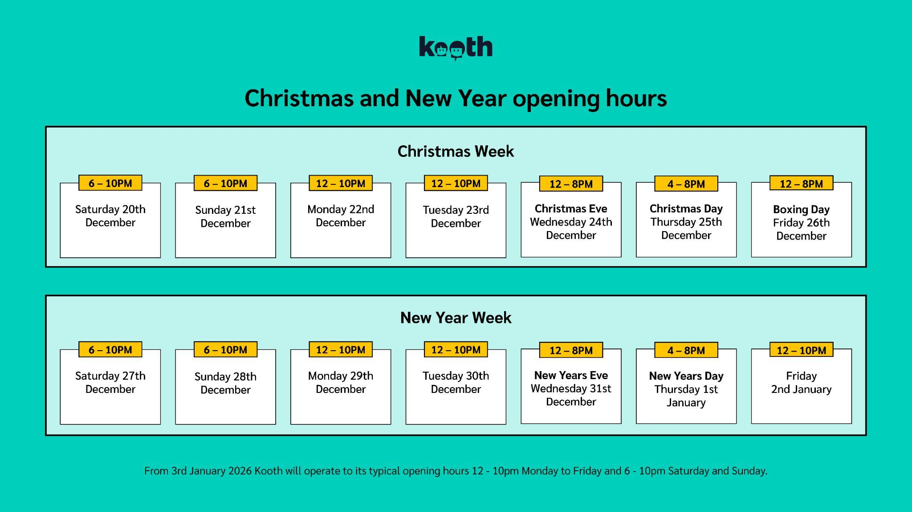

Kooth is accredited by the BACP, meaning all support provided and information shared is within their guidelines.

There are no thresholds to meet to access the service. Some young people chat to us seeking advice, some people are having a bad day, and others may speak to us weekly due to some greater challenges: the majority of young people don’t even speak to us, they explore the site independently.

If you want to learn more about our services, you can do so via: https://connect.kooth.com/for-families

If you would like to support your young person or child to access Kooth, I’ve included a sign-up graphic below:

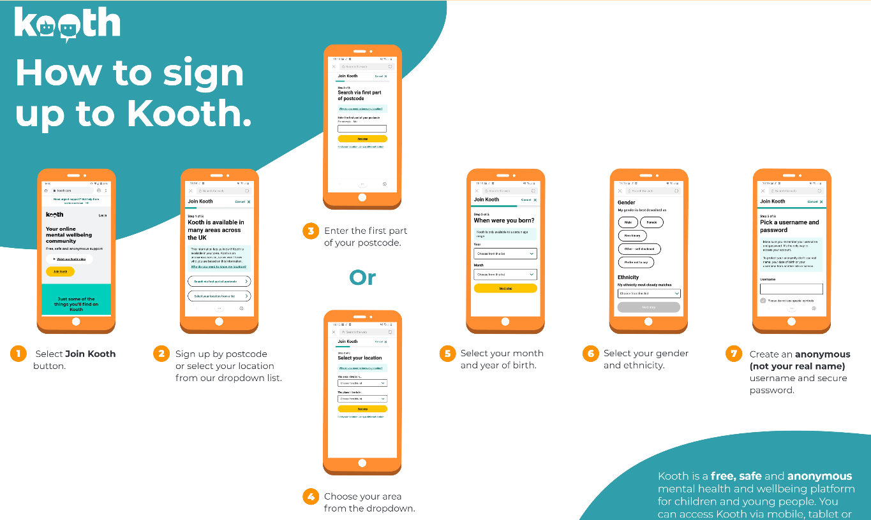

If you have any questions, you can contact us via parents@kooth.com.

Support for adults via Qwell.io
Qwell.io is our adult platform which is an NHS-commissioned in St Helens for anyone over the age of 18.

Similarly to Kooth, we provide an online service which you can sign up to completely anonymously, for free, on any internet enabled device.

Similarly to Kooth, you can access resources, content and support from a qualified practitioner. There are no thresholds to meet to qualify for support.

Our “Collections” page offers a wealth of content on different topics including: parenting, neurodivergence, workplace mental health, cost of living and more.

Qwell can be accessed 24/7, however, we have live chat times where you can “chat” via typed conversations with a practitioner. I’ve included the live chat times over Christmas and New Year below:

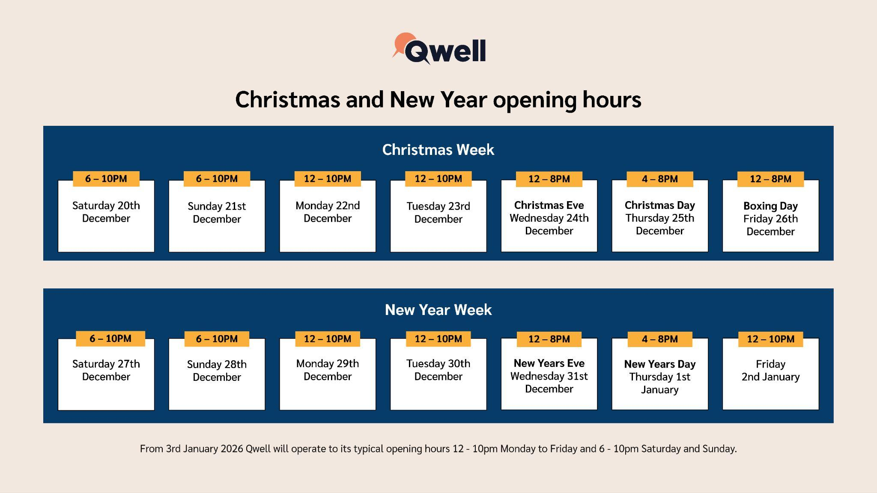

Wishing you all a Merry Christmas and a Happy New Year when it comes.

Kind regards,
Ryan Whittaker

