
English Termly Plan Year Group: Year 3
Term  Text / Topic | Writing Evidence | Success Criteria
Autumn 1  Charlie and the Chocolate factory  Roald Dahl.  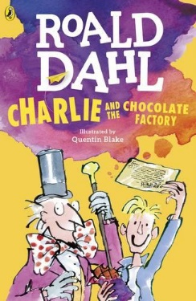 | Narrative  Setting Description – The Chocolate Room | My writing shows that capital letters, numbers and ascenders are tall and that my descenders go under the line with all of the letters facing the right way.  My writing shows that I leave clear spaces between words.
 | Narrative  Setting Description – The Chocolate Room | I can organise my work to fit the type of writing that I am doing
 | Narrative  Setting Description – The Chocolate Room | I can write a narrative with a clear structure and setting description
 | Narrative  Setting Description – The Chocolate Room | I can use the coordinating conjunctions and/ but/ so/ or
 | Narrative  Setting Description – The Chocolate Room | Most of my sentences start with a capital letter and finish with a full stop.
 | Non fiction  Diary entry – The day Charlie went to the factory | My writing shows that capital letters, numbers and ascenders are tall and that my descenders go under the line with all of the letters facing the right way.  My writing shows that I leave clear spaces between words.
 |  | I can organise my work to fit the type of writing that I am doing
 |  | I can write about real events recording these simply and clearly
I can use time adverbials (First, next, after that)
I can use:
• Adverbs (quickly, excitedly)
• prepositions (under, above, next to, opposite, besides)
 |  | I can use full stops, capital letters, commas in a list or to separate clauses (If it stops raining, we will go out to play.)
 | Narrative  New chapter for Charlie and the Chocolate Factory | My writing shows that capital letters, numbers and ascenders are tall and that my descenders go under the line with all of the letters facing the right way.  My writing shows that I leave clear spaces between words.
 | Narrative  New chapter for Charlie and the Chocolate Factory | Most of my work is set out in paragraphs or headed sections
 | Narrative  New chapter for Charlie and the Chocolate Factory | I can write a narrative with a clear structure, setting, characters and plot  My writing flows and generally makes sense
 | Narrative  New chapter for Charlie and the Chocolate Factory | I can use expanded noun phrases eg. The enormous monster with fierce eyes was chasing me!  I can use the coordinating conjunctions and/ but/ so/ or  I can use:  • Adverbs (quickly, excitedly)  • prepositions (under, above, next to, opposite, besides)
 | Narrative  New chapter for Charlie and the Chocolate Factory | I can use full stops, capital letters, commas in a list or to separate clauses (If it stops raining, we will go out to play.)

Term  Text / Topic | Writing Evidence | Success Criteria
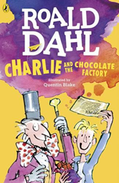  Autumn 2  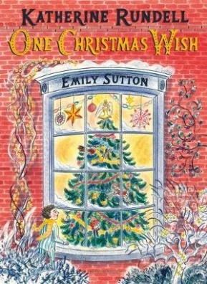  One Christmas Wish  One Big Night – Sainsburys Advert 2018 | Non fiction  Writing an explanation text  ‘From Bean to Bar, how chocolate is made’ | My writing shows that capital letters, numbers and ascenders are tall and that my descenders go under the line with all of the letters facing the right way.  My writing shows that I leave clear spaces between words.
 |  | Most of my work is set out in paragraphs or headed sections
Non-narrative using organisational devices such as headings and sub headings
I can include enough detail to engage the audience (facts, questions, description)
I can use the correct tense
My writing flows and generally makes sense

 |  | I can use a range of sentence types (statements, questions, exclamations, commands)
 |  | I can use full stops, capital letters, commas in a list or to separate clauses (If it stops raining, we will go out to play.) question marks and exclamation marks
 | Narrative  Write a story opener based on the story One Christmas Wish | I can use joined handwriting.
 |  | Most of my work is set out in paragraphs or headed sections
I can include enough detail to engage the audience (facts, questions, description)
I can plan my ideas then edit my work to make improvements to punctuation and grammar
I can use the correct tense
My writing flows and generally makes sense

I can use expanded noun phrases eg. The enormous monster with fierce eyes was chasing me!
I can use the coordinating conjunctions and/ but/ so/ or--- I can replace these with words such as: also/however/therefore
I can use prepositions (under, above, next to, opposite, besides)
I can use simple, compound sentences within a piece of work

 |  | I can use full stops, capital letters, commas in a list or to separate clauses (If it stops raining, we will go out to play.) question marks and exclamation marks
 | Non-Fiction  To write a newspaper report | I can use joined handwriting.
 | Non-Fiction  To write a newspaper report | Most of my work is set out in paragraphs or headed sections
 | Non-Fiction  To write a newspaper report | I can include enough detail to engage the audience (facts, questions, description)  I can plan my ideas then edit my work to make improvements to punctuation and grammar  I can use the correct tense  My writing flows and generally makes sense
 | Non-Fiction  To write a newspaper report | I can use a range of sentence types (statements, questions, exclamations, commands)
 | Non-Fiction  To write a newspaper report | I can use full stops, capital letters, commas in a list or to separate clauses (If it stops raining, we will go out to play.) question marks and exclamation marks


Term  Text / Topic | Writing Evidence | Success Criteria
Spring 1  The Hodgeheg  Dick King-Smith  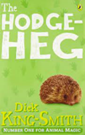 | Narrative  Planning and writing a descriptive dialogue | Most of my work is set out in paragraphs
 | Narrative  Planning and writing a descriptive dialogue | I can write narrative with a clear structure, setting, characters and plot  I can include enough detail to engage the audience (facts, questions, description)  I can plan my ideas then edit my work to make improvements to punctuation and grammar  I can use the correct tense  My writing flows and generally makes sense
 | Narrative  Planning and writing a descriptive dialogue | I can use expanded noun phrases eg. The enormous monster with fierce eyes was chasing me!  I can use the coordinating conjunctions and/ but/ so/ or  I can use adverbs (quickly, excitedly)
 | Narrative  Planning and writing a descriptive dialogue | I can use full stops, capital letters, commas in a list or to separate clauses (If it stops raining, we will go out to play.) question marks and exclamation marks  I am beginning to use inverted commas appropriately
 | Non Fiction  Planning and writing a newspaper article | I can use joined handwriting
 | Non Fiction  Planning and writing a newspaper article | Most of my work is set out in paragraphs
 | Non Fiction  Planning and writing a newspaper article | Non-narrative using organisational devices such as headings  I can plan my ideas then edit my work to make improvements to punctuation and grammar
 | Non Fiction  Planning and writing a newspaper article | I can use time adverbials (First, next, after that)  I can use expanded noun phrases eg. The enormous monster with fierce eyes was chasing me!
 | Non Fiction  Planning and writing a newspaper article | I can use full stops, capital letters, commas in a list or to separate clauses (If it stops raining, we will go out to play.) question marks and exclamation marks  I am beginning to use inverted commas appropriately

Term  Text / Topic | Writing Evidence | Success Criteria
Spring 2  The Hodgeheg  Dick King-Smith  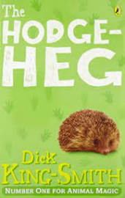  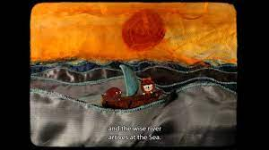  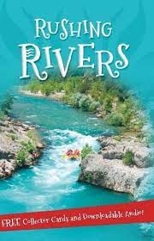  https://www.literacyshed.com/the-poetry-shed.html | Narrative  Planning and writing a diary entry | I can use joined handwriting
 | Narrative  Planning and writing a diary entry | Most of my work is set out in paragraphs
 | Narrative  Planning and writing a diary entry | I can include enough detail to engage the audience (facts, questions, description)  I can plan my ideas then edit my work to make improvements to punctuation and grammar  I can use the correct tense  My writing flows and generally makes sense
 | Narrative  Planning and writing a diary entry | I can use time adverbials (First, next, after that)  I can use expanded noun phrases eg. The enormous monster with fierce eyes was chasing me!  I can use adverbs (quickly, excitedly)  I can use prepositions (under, above, next to, opposite, besides)
 | Narrative  Planning and writing a diary entry | I can use full stops, capital letters, commas in a list or to separate clauses (If it stops raining, we will go out to play.) question marks and exclamation marks
 | Narrative  Poetry writing using personification | I can use joined handwriting
 | Narrative  Poetry writing using personification | I can include enough detail to engage the audience (facts, questions, description)
 | Narrative  Poetry writing using personification | I can use expanded noun phrases eg. The enormous monster with fierce eyes was chasing me!  I can use adventurous vocabulary for stage 3 (high level adjectives or topic words)
 | Narrative  Poetry writing using personification | I can use full stops, capital letters, commas in a list or to separate clauses (If it stops raining, we will go out to play.) question marks and exclamation marks
 | Non fiction  Writing a fact sheet about the River Mersey | I can use joined handwriting
 | Non fiction  Writing a fact sheet about the River Mersey | Most of my work is set out in paragraphs or headed sections
 | Non fiction  Writing a fact sheet about the River Mersey | I can include enough detail to engage the audience (facts, questions, description)  I can plan my ideas then edit my work to make improvements to punctuation and grammar  I can use the correct tense  My writing flows and generally makes sense
 | Non fiction  Writing a fact sheet about the River Mersey | I can use time adverbials (First, next, after that)  I can use adventurous vocabulary for stage 3 (high level adjectives or topic words)
 | Non fiction  Writing a fact sheet about the River Mersey | I can use full stops, capital letters, commas in a list or to separate clauses (If it stops raining, we will go out to play.) question marks and exclamation marks

Term  Text / Topic | Writing Evidence | Success Criteria
Summer 1  The Boy Who Grew Dragons  Andy Shepard  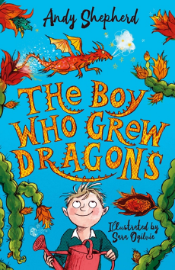 | Narrative  Planning and writing an adventure story | I can use joined handwriting
 | Narrative  Planning and writing an adventure story | Most of my work is set out in paragraphs or headed sections
 | Narrative  Planning and writing an adventure story | I can write a narrative with a clear structure, setting, characters and plot  I can include enough detail to engage the audience (facts, questions, description)  I can plan my ideas then edit my work to make improvements to punctuation and grammar  I can use the correct tense  My writing flows and generally makes sense
 | Narrative  Planning and writing an adventure story | I can use time adverbials (First, next, after that)  I can use expanded noun phrases eg. The enormous monster with fierce eyes was chasing me!  I can use adventurous vocabulary for stage 3 (high level adjectives or topic words)  I can use coordinating conjunctions and/ but/ so/ or--- I can replace these with words such as: also/however/therefore  I can use subordinating conjunctions because if when that whilst  I can use Adverbs (quickly, excitedly) and prepositions (under, above, next to, opposite, besides)  I can use simple, compound and complex sentences within a piece of work
 | Narrative  Planning and writing an adventure story | I can use full stops, capital letters, commas in a list or to separate clauses (If it stops raining, we will go out to play.) question marks and exclamation marks
 | Non fiction  Writing a non chronological report about Dragon Fruit | I can use joined handwriting.
 |  | Most of my work is set out in paragraphs or headed sections
I can write a non-narrative using organisational devices such as headings and sub headings
I can include enough detail to engage the audience (facts, questions, description)
I can plan my ideas then edit my work to make improvements to punctuation and grammar
I can use the correct tense
 |  | I can use adventurous vocabulary for stage 3 (high level adjectives or topic words)
 |  | I can use full stops, capital letters, commas in a list or to separate clauses (If it stops raining, we will go out to play.) question marks and exclamation marks.

Term  Text / Topic | Writing Evidence | Success Criteria
Summer 2 | Narrative | I can use joined handwriting.
 | Narrative | Most of my work is set out in paragraphs
 | Narrative | I can include enough detail to engage the audience (facts, questions, description)  I can use the correct tense
 | Narrative | I can use time adverbials (First, next, after that)  I can use expanded noun phrases eg. The enormous monster with fierce eyes was chasing me!  I can use adventurous vocabulary for stage 3 (high level adjectives or topic words)
 | Narrative | I can use full stops, capital letters, commas in a list or to separate clauses (If it stops raining, we will go out to play.) question marks and exclamation marks  I am beginning to use inverted commas appropriately
 | Poem
 | Teacher choice

