Subtraction
Year 1 | Year 2 | Year 3
Mental Strategies  Children should experience regular counting on and back from different numbers in 1s and in multiples of 2, 5 and 10.  Children should memorise and reason with number bonds for numbers to 20, experiencing the = sign in different positions.  They should see addition and subtraction as related operations. E.g. 7 + 3 = 10 is related to 10 – 3 = 7, understanding of which could be supported by an image like this.  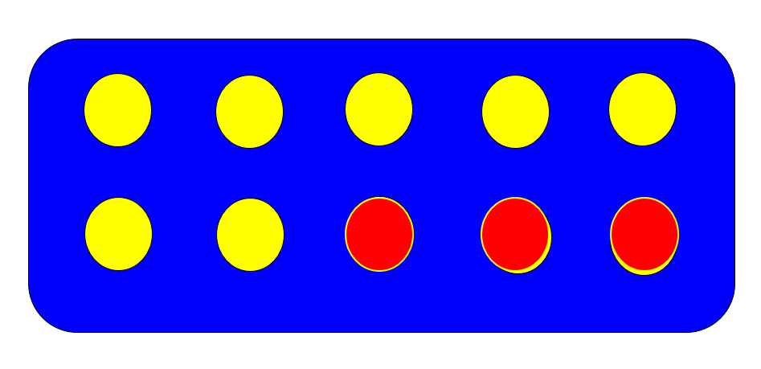  Use bundles of straws and Dienes to model partitioning teen numbers into tens and ones.  Children should begin to understand subtraction as both taking away and finding the difference between, and should find small differences by counting on.  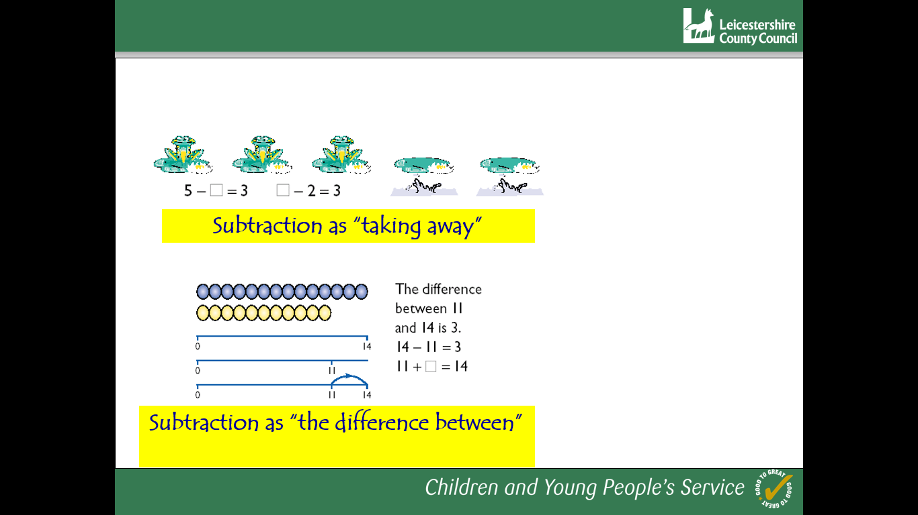  Vocabulary  Subtraction, subtract, take away, distance between, difference between, more than, minus, less than, equals = same as, most, least, pattern, odd, even, digit,  Generalisations  - True or false? Subtraction makes numbers smaller  - When introduced to the equals sign, children should see it as signifying equality. They should become used to seeing it in different positions.  Children could see the image below and consider, “What can you see here?” e.g.  3 yellow, 1 red, 1 blue. 3 + 1 + 1 = 5  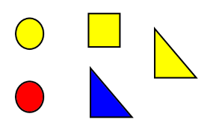  2 circles, 2 triangles, 1 square. 2 + 2 + 1 = 5  I see 2 shapes with curved lines and 3 with straight lines. 5 = 2 + 3  5 = 3 + 1 + 1 = 2 + 2 + 1 = 2 + 3  Some Key Questions  How many more to make…? How many more is… than…? How much more is…? How many are left/left over? How many have gone? One less, two less, ten less… How many fewer is… than…? How much less is…?  What can you see here?  Is this true or false? | Mental Strategies  Children should count regularly, on and back, in steps of 2, 3, 5 and 10. Counting back in tens from any number should lead to subtracting multiples of 10.  Number lines should continue to be an important image to support thinking, for example to model how to subtract 9 by adjusting.  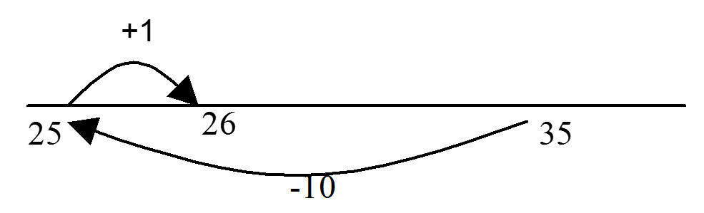  Children should practise subtraction to 20 to become increasingly fluent. They should use the facts they know to derive others, e.g using 10 - 7 = 3 and 7 = 10 - 3 to calculate 100 - 70 = 30 and 70 = 100 - 30.  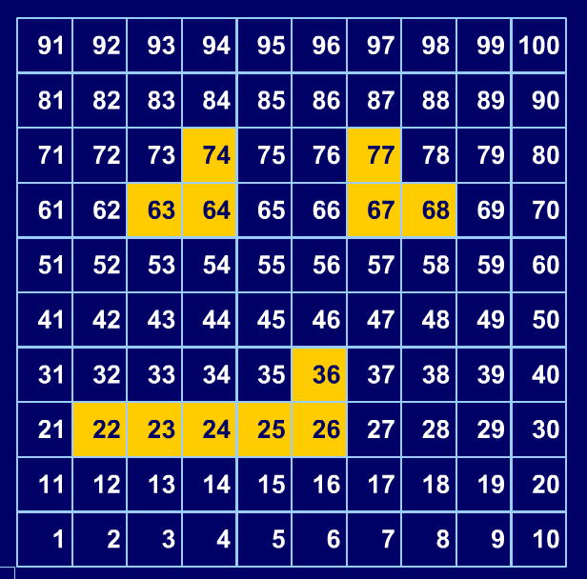  As well as number lines, 100 squares could be used to model calculations such as 74 – 11, 77 – 9 or 36 – 14, where partitioning or adjusting are used. On the example above, 1 is in the bottom left corner so that ‘up’ equates to ‘add’.  Children should learn to check their calculations, including by adding to check.  They should continue to see subtraction as both take away and finding the difference, and should find a small difference by counting up.  They should use Dienes to model partitioning into tens and ones and learn to partition numbers in different ways e.g. 23 = 20 + 3 = 10 + 13.  Vocabulary  Subtraction, subtract, take away, difference, difference between, minus  Tens, ones, partition  Near multiple of 10, tens boundary  Less than, one less, two less… ten less… one hundred less  More, one more, two more... ten more... one hundred more Generalisation  - Noticing what happens when you count in tens (the digits in the ones column stay the same)  - Odd – odd = even; odd – even = odd; etc  - show that addition of two numbers can be done in any order (commutative) and subtraction of one number from another cannot  - Recognise and use the inverse relationship between addition and subtraction and use this to check calculations and missing number problems. This understanding could be supported by images such as this.  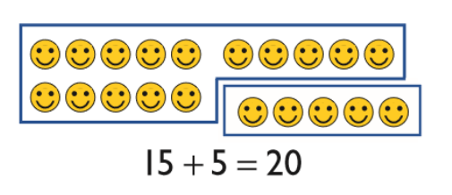  Some Key Questions  How many more to make…? How many more is… than…? How much more is…? How many are left/left over? How many fewer is… than…? How much less is…?  Is this true or false?  If I know that 7 + 2 = 9, what else do I know? (e.g. 2 + 7 = 9; 9 – 7 = 2; 9 – 2 = 7; 90 – 20 = 70 etc).  What do you notice? What patterns can you see? | Mental Strategies  Children should continue to count regularly, on and back, now including multiples of 4, 8, 50, and 100, and steps of 1/10.  The number line should continue to be used as an important image to support thinking, and the use of informal jottings should be encouraged.  Children should continue to partition numbers in difference ways.  They should be encouraged to choose the mental strategies which are most efficient for the numbers involved, e.g. counting up (difference, or complementary addition) for 201 – 198; counting back (taking away / partition into tens and ones) for 201 – 12.  Calculators can usefully be introduced to encourage fluency by using them for games such as ‘Zap’ [e.g. Enter the number 567. Can you ‘zap’ the 6 digit and make the display say 507 by subtracting 1 number?]  The strategy of adjusting can be taken further, e.g. subtract 100 and add one back on to subtract 99. Subtract other near multiples of 10 using this strategy.  Vocabulary  Hundreds, tens, ones, estimate, partition, recombine, difference, decrease, near multiple of 10 and 100, inverse, rounding, column subtraction, exchange  See also Y1 and Y2  Generalisations  Noticing what happens to the digits when you count in tens and hundreds.  Odd – odd = even etc (see Year 2)  Inverses and related facts – develop fluency in finding related addition and subtraction facts.  Develop the knowledge that the inverse relationship can be used as a checking method.  Key Questions  What do you notice? What patterns can you see?  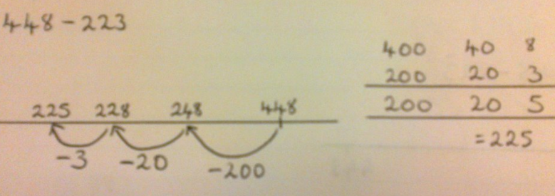  When comparing two methods alongside each other: What’s the same? What’s different? Look at this number in the formal method; can you see where it is in the expanded method / on the number line

