Addition
Year 1 | Year 2 | Year 3
Mental Strategies (addition and subtraction)  Children should experience regular counting on and back from different numbers in 1s and in multiples of 2, 5 and 10.  Children should memorise and reason with number bonds for numbers to 20, experiencing the = sign in different positions.  They should see addition and subtraction as related operations. E.g. 7 + 3 = 10 is related to 10 – 3 = 7, understanding of which could be supported by an image like this.  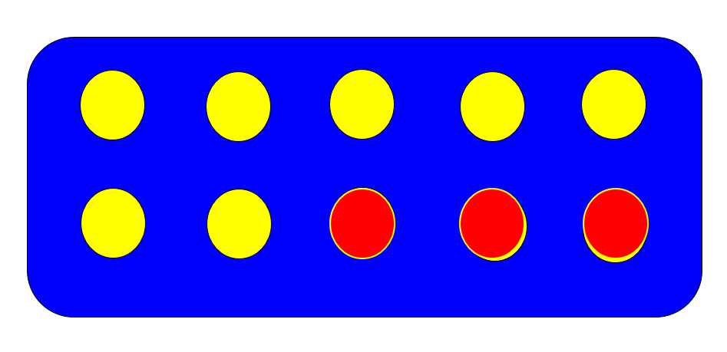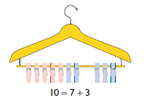  Use bundles of straws and Dienes to model partitioning teen numbers into tens and ones and develop understanding of place value.  Children have opportunities to explore partitioning numbers in different ways.  e.g. 7 = 6 + 1, 7 = 5 + 2, 7 = 4 + 3 =  Children should begin to understand addition as combining groups and counting on.  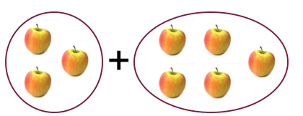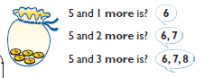  Vocabulary  Addition, add, forwards, put together, more than, total, altogether, distance between, difference between, equals = same as, most, pattern, odd, even, digit, counting on.  Generalisations  - True or false? Addition makes numbers bigger.  - True or false? You can add numbers in any order and still get the same answer.  (Links between addition and subtraction)  When introduced to the equals sign, children should see it as signifying equality. They should become used to seeing it in different positions.  Another example here…  Some Key Questions  How many altogether? How many more to make…? I add …more. What is the total? How many more is… than…? How much more is…? One more, two more, ten more…  What can you see here?  Is this true or false?  What is the same? What is different? | Mental Strategies  Children should count regularly, on and back, in steps of 2, 3, 5 and 10. Counting forwards in tens from any number should lead to adding multiples of 10.  Number lines should continue to be an important image to support mathematical thinking, for example to model how to add 9 by adding 10 and adjusting.  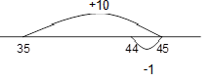  Children should practise addition to 20 to become increasingly fluent. They should use the facts they know to derive others, e.g using 7 + 3 = 10 to find 17 + 3= 20, 70 + 30 = 100  They should use concrete objects such as bead strings and number lines to explore missing numbers – 45 + __ = 50.  As well as number lines, 100 squares could be used to explore patterns in calculations such as 74 +11, 77 + 9 encouraging children to think about ‘What do you notice?’ where partitioning or adjusting is used.  Children should learn to check their calculations, by using the inverse.  They should continue to see addition as both combining groups and counting on.  They should use Dienes to model partitioning into tens and ones and learn to partition numbers in different ways e.g. 23 = 20 + 3 = 10 + 13.  Vocabulary  +, add, addition, more, plus, make, sum, total, altogether, how many more to make…? how many more is… than…? how much more is…? =, equals, sign, is the same as, Tens, ones, partition  Near multiple of 10, tens boundary, More than, one more, two more… ten more… one hundred more  Generalisation  - Noticing what happens when you count in tens (the digits in the ones column stay the same)  - Odd + odd = even; odd + even = odd; etc  - show that addition of two numbers can be done in any order (commutative) and subtraction of one number from another cannot  - Recognise and use the inverse relationship between addition and subtraction and use this to check calculations and missing number problems. This understanding could be supported by images such as this.  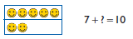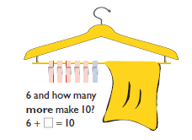  Some Key Questions  How many altogether? How many more to make…? How many more is… than…? How much more is…?  Is this true or false?  If I know that 17 + 2 = 19, what else do I know? (e.g. 2 + 17 = 19; 19 – 17 = 2; 19 – 2 = 17; 190 – 20 = 170 etc).  What do you notice? What patterns can you see? | Mental Strategies  Children should continue to count regularly, on and back, now including multiples of 4, 8, 50, and 100, and steps of 1/10.  The number line should continue to be used as an important image to support thinking, and the use of informal jottings should be encouraged. This will help to develop children’s understanding of working mentally.  Children should continue to partition numbers in different ways.  They should be encouraged to choose the mental strategies which are most efficient for the numbers involved, e.g.  Add the nearest multiple of 10, then adjust such as 63 + 29 is the same as 63 + 30 – 1;  counting on by partitioning the second number only such as 72 + 31 = 72 + 30 + 1 = 102 + 1 = 103  Manipulatives can be used to support mental imagery and conceptual understanding. Children need to be shown how these images are related eg.  What’s the same? What’s different?  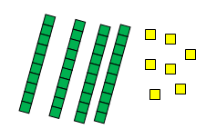  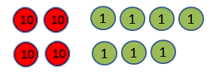  Vocabulary  Hundreds, tens, ones, estimate, partition, recombine, difference, decrease, near multiple of 10 and 100, inverse, rounding, column subtraction, exchange  See also Y1 and Y2  Generalisations  Noticing what happens to the digits when you count in tens and hundreds.  Odd + odd = even etc (see Year 2)  Inverses and related facts – develop fluency in finding related addition and subtraction facts.  Develop the knowledge that the inverse relationship can be used as a checking method.  Key Questions  What do you notice? What patterns can you see?  When comparing two methods alongside each other: What’s the same? What’s different? Look at this number in the formal method; can you see where it is in the expanded method / on the number line?  