When? (Time line)
1800 | The first electric battery was invented by Alessandro Volta.
1821 | The first electric motor was invented by Michael Faraday
1876 | Alexander Graham Bell invented the telephone.
1878 | Joseph Swan, a British scientist, demonstrated the first electric light with a carbon filament lamp. A few months later, Thomas Edison made the same discovery in America.
1890 | Turbine driven generators were introduced to produce electricity
1891 | The first electric kettle was made.
1901 | The vacuum cleaner was invented in 1901 by Hubert Booth
1918 | Electric washing machines and refrigerators first became available
1922 | Electric kettle with integrated heating element was Manufactured by the Swan company
1930s | Mains powered radios, vacuum cleaners, irons and fridges were becoming part of every household.
1935 | ‘The National Grid’ provided electricity across the UK for houses and businesses
1936 | Scottish inventor, John Logie Baird, pioneered the television
1947 | To preserve energy supplies during WWII, electricity was rationed. Domestic consumers' usage was limited to the hours of 9:00am to 12:00pm, and 2:00pm to 4:00pm.
1950s | Diesel and electric trains are introduced to replace steam trains
1955 | The automatic electric kettle was invented by William Russel and Peter Hobbs
1956 | The world's first large-scale nuclear power station opened at Calder Hall in Cumbria
1958 | Mister Softee Ice Cream Vans appear on UK street
1971 | Fiddler’s Ferry Power Station was built in Widnes.
1973 | First call on a hand held mobile phone by Motorola
1974 | The first Personal computers (PC’s) became available led by Amstrad, Apple, Tandy and Commodore
1982 | The first electricity generated by wind power came from the wind turbines in North Wales
2000 | Electricity generated by wave power began in Scotland
2001 | X-Box invented by Microsoft
How has the invention of electricity changed our lives?
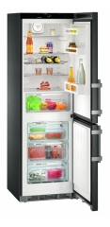

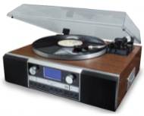
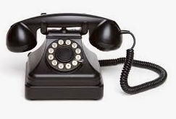

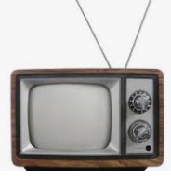
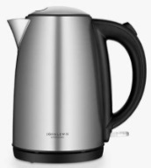

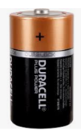

All these electrical items have changed the way we live our lives in the last 100 years.
Our leisure time has changed over the decades
Who? Famous People
Michael Faraday |  | Invented the electric motor and known as the ‘Father of Electricity.’
Joseph Swan |  | The inventor of the Lightbulb. He also set up an electronic business with Thomas Edison.
Spelling |  | Definition
invention |  | A new device, machine or idea that changes our lives.
artefact |  | An object from the past
technology |  | Application of scientific or mechanical ideas
century |  | 100 years
decade |  | 10 years
refrigeration |  | To preserve food by cooling or freezing
electrification |  | The use of electricity to power objects

