LUNT’S HEATH PRIMARY SCHOOL

POSITIVE BEHAVIOUR POLICY

Author | David Paton
Approval Date | 1st September 2022
Reviewed | Annually
First Version | 1st September
Version | 1

Positive Behaviour Policy

Philosophy

At Lunt’s Heath, we believe in positive behaviour management based on the good relationships fostered within the school community. We have high expectations and utilise a wide range of strategies to encourage and reward all children in taking responsibility for their own actions.

Aims

- To encourage a calm, purposeful and happy atmosphere within the school.
- Provide a consistent approach to behaviour management
- Define what we consider to be unacceptable behaviour, including bullying and discrimination
- Outline how pupils are expected to behave
- Summarise the roles and responsibilities of different people in the school community with regards to behaviour management
- To foster positive, caring attitudes towards everyone, where achievements at all levels are acknowledged and valued.
- To encourage increasing independence and self-discipline, so that each child learns to accept responsibility for his/her own behaviour.
- To have a consistent approach to behaviour throughout the school with parental co-operation and involvement giving a common purpose.
- To enable children to make positive choices to correct their behavior. Outline our system of rewards and sanctions

Legislation and statutory requirements

This policy is based on advice from the Department for Education (DfE) on:
  - Behaviour and discipline in schools
  - Searching, screening and confiscation at school
  - The Equality Act 2010
  - Keeping Children Safe in Education
  - Use of reasonable force in schools
  - Supporting pupils with medical conditions at school
  - Special educational needs and disability (SEND) code of practice
  - Section 175 of the Education Act 2002, which outlines a school’s duty to safeguard and promote the welfare of its pupils
  - Sections 88-94 of the Education and Inspections Act 2006, which require schools to regulate pupils’ behaviour and publish a behaviour policy and written statement of behaviour principles, and give schools the authority to confiscate pupils’ property.
  - DfE guidance explaining that maintained schools must publish their behaviour policy online

Definitions

Misbehaviour is defined as:
  - Disruption in lessons, at break and lunchtimes
  - Non-completion of classwork
  - Poor attitude to learning
  - Refusing to follow adult instructions

Serious misbehaviour is defined as:
  - Repeated breaches of the school rules

  - Any form of bullying
  - Sexual violence
  - Sexual harassment, meaning unwanted conduct of a sexual nature, such as:
Sexual comments, sexual jokes or taunting. Physical behaviour like interfering with clothes.
Online sexual harassment such as unwanted sexual comments and messages (including on social media), sharing of nude or semi-nude images and/or videos, or sharing of unwanted explicit content
  - Vandalism or theft
  - Fighting
  - Smoking
  - Racist, sexist, homophobic or discriminatory behavior
  - Possession of any prohibited items.

Bullying
Bullying is defined as the repetitive, intentional harming of one person or group by another person or group, where the relationship involves an imbalance of power.
Bullying is, therefore: Deliberately hurtful
Repeated, often over a period of time Difficult to defend against
Bullying can include:

TYPE OF BULLYING | DEFINITION
Emotional | Being unfriendly, excluding, tormenting
Physical | Hitting, kicking, pushing, taking another’s belongings, any use of violence
Prejudice-based and discriminatory, including:  Racial  Faith-based Gendered (sexist) Homophobic/biphobic Transphobic Disability-based | Taunts, gestures, graffiti or physical abuse focused on a particular characteristic (e.g. gender, race, sexuality)
Sexual | Explicit sexual remarks, display of sexual material, sexual gestures, unwanted physical attention, sexual comments or inappropriate touching
Direct or indirect verbal | Name-calling, sarcasm, spreading rumours, teasing

TYPE OF BULLYING | DEFINITION
Cyber-bullying | Bullying that takes place online, such as through social networking sites, messaging apps or gaming sites

Roles and responsibilities The Governing Body
The schools Governing Body is responsible for reviewing and approving the written statement of behaviour principles (appendix 1).
The Governing Body will also review this Behaviour Policy in conjunction with the Headteacher and monitor the policy’s effectiveness, holding the Headteacher to account for its implementation.

The Headteacher

The Headteacher is responsible for reviewing this behaviour policy in conjunction with the Governors giving due consideration to the school’s statement of behaviour principles (appendix 1). The Headteacher will also approve this policy.

The Headteacher will ensure that the school environment encourages positive behaviour and that staff deal effectively with poor behaviour, and will monitor how staff implement this policy to ensure rewards and sanctions are applied consistently

School Staff
Staff are responsible for:

- Implementing the behaviour policy consistently
- Modelling positive behaviour
- Providing a personalised approach to the specific behavioural needs of particular pupils
- Recording serious behaviour incidents on our electronic system.
- We may use the Reflection Room in response to serious or persistent breaches of this policy. Pupils may be sent to the Reflection Room is during lessons if they are disruptive or their behaviour is dysregulated, and a calm space is required. Children in the Reflection Room will be expected to complete the same work as they would in class.

The Senior Leadership Team will support staff in responding to behaviour incidents.

Parents
Parents are expected to:

- Support their child in adhering to our School Rules
- Inform the school of any changes in circumstances that may affect their child’s behaviour
- Discuss any behavioural concerns with the class teacher promptly

School Rules

The children follow a simple Code of Conduct during their time at school. This involves the following:

- Come to School on time and ready to learn
- Show respect for others and the environment
- Listen carefully and follow instructions
- Always try your best
- Be honest
- Be kind, caring and helpful to everyone in school
- Always be polite and well-mannered
- Always keep yourself safe and think about the safety of others
- Always walk around the school building
- Make sensible choices at all times.

All staff will make every effort to ensure all children are engaged in meaningful tasks, which offer the appropriate level of challenge, with support where necessary. Children are encouraged to concentrate, stay on-task and become increasingly independent learners. Every child is valued and benefits from both public and private praise. The importance of self-esteem is never underestimated.

Pupil Reward System

Good behaviour is expected at our school and all members of school staff endeavour to promote and model the behaviour we expect to see. In addition, we think it is very important that children who are; polite, respectful, well-mannered and try hard with their learning are rewarded and made to feel proud of their choices.

At Lunt’s Heath, we believe that positive reinforcement of good behaviour is the most effective way of encouraging children to follow our school rules. Our Pupil Reward ClassDojo System encourages children to behave appropriately, whilst ensuring that every child is treated fairly and respectfully. Children are awarded ClassDojos linked to the core school values. Children will have the opportunity to earn ClassDojos during the school day. See Behaviour Steps

Behaviour points earned can be used by the children to purchase items from our ClassDojo Reward Shop. Children’s individual ClassDojo will also be added to their allocated Houses’ weekly points score. Totals for each house are unveiled by the House Captains in the school’s weekly celebration assembly and are an accumulative total when unveiled on Interhouse Day

General Strategies used for Positive Behaviour Management
Teaching and support staff are responsible for setting the tone and context for positive behaviour within the classroom. They will create and maintain a stimulating environment that encourages pupils to be engaged. They will do this by:

  - Clearly displaying their own classroom rules
  - Developing a positive relationship with pupils, which may include:
  - Greeting pupils in the morning/at the start of lessons
  - Establishing clear routines,
  - Communicating expectations of behaviour in ways other than verbally
  - Identifying and acknowledging children who model required behaviours
  - Concluding the day positively and starting the next day afresh
  - Having a plan for dealing with low-level disruption
  - Using positive reinforcement

Characteristics of Learning

The characteristics of learning are the school values that we ensure all of the children are showing at all times:

Ambition
Enterprising
Inner Resilience
Colloboration
Understanding

Behaviour Steps System

In school, when dealing with unacceptable classroom behaviour, school staff follow our Behaviour Steps system. The aim of the steps is to re-focus and re-engage the child with as little disruption to learning as possible.

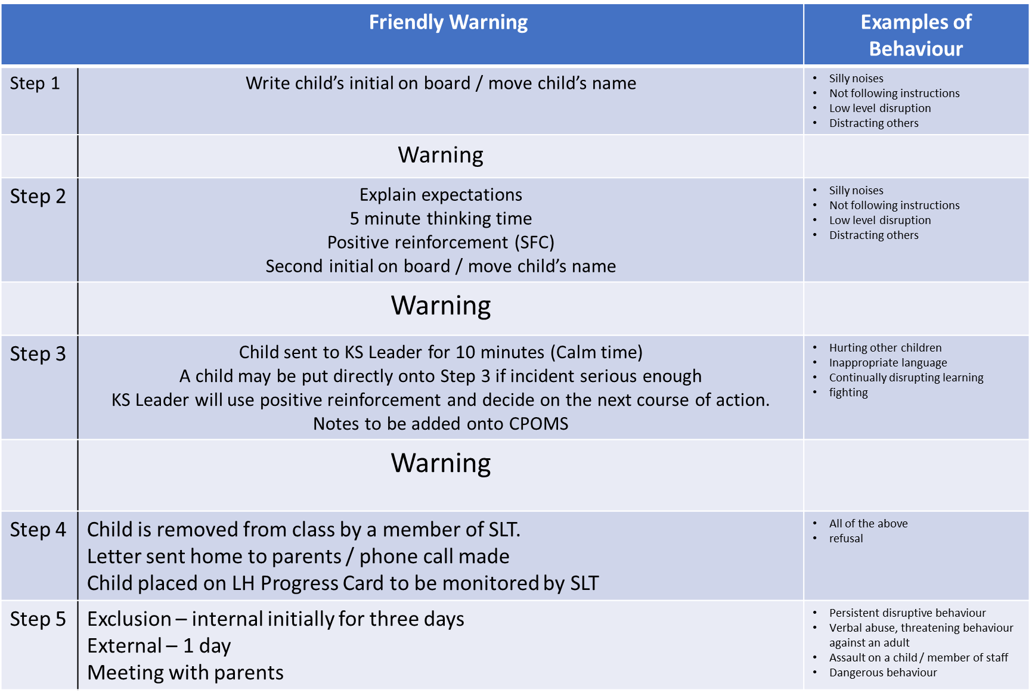

Persistent misbehaviour will involve parents being called to speak with their child’s class teacher, Key Stage Leader or a member of the Senior Leadership Team.
Children, who access learning away from their class setting, will then be supported in school in accordance with our Behaviour Pathway Flow Chart. (Appendix 2)
In cases of extremely serious misbehaviour, fixed term or even permanent exclusion will be considered. Children who are unable to access learning in our school may be referred to external specialist provision.

Playground Rules and Sanctions
All Children should enjoy playing outside in safety. Adults in the playground will be positive role models. Our playground rules are:
- Children should respect each other and treat each other kindly
- Children should be encouraged to play in a positive way and learn to resolve problems or conflicts in a non-physical way
- Children show respect towards all adults in the playground
- Children will be able to play freely unless it is judged that they are a danger to themselves or others
- Children will look after equipment and play sensibly with it, tidying up at the end of playtimes

Positive role models
- Adults will play and talk with children modelling positive attitudes such as tolerance, resilience and fairness.

- Adults will use positive language when talking to children about problems or conflicts, asking open questions such as ‘Why do you think xx is feeling unhappy?, ‘What do you think you could have done?’
- Adults will give all parties the chance to speak before deciding if any sanctions are necessary
- Playground monitors will model good behaviour and assist children in finding friends to play with, tidying up and supporting adults on duty
- At the end of playtime adults remind children to stand still on the playground at the first bell and walk to their lines at the second bell.

Playground Behaviour Sanctions
Children will be given a verbal reminder when inappropriate behaviour is spotted and a chance to improve their behaviour. If unacceptable behaviour continues they will be taken to a quiet area in the playground by the adult on duty to discuss and reflect on their behaviour. If this still does not address the issue then the child will be taken inside by an adult to a member of the SLT and will miss the remainder of their break time.
A child will be removed from the playground immediately if:
- They act in a way that is a danger to themselves or others
- They demonstrate aggressive or violent behaviour, verbal or physical
- Bullying behaviour - persistent incidences will be dealt with according to our bullying policy and procedures
- Deliberate breaking of equipment

Zero-tolerance approach to sexual harassment and sexual violence
The school will ensure that all incidents of sexual harassment and/or violence are met with a suitable response, and never ignored.
Pupils are encouraged to report anything that makes them uncomfortable, no matter how ‘small’ they feel it might be.
The school’s response will be: Proportionate Considered Supportive
Decided on a case-by-case basis
The school will be clear whether action taken is disciplinary, supportive or both. The school will make such decisions on a case-by-case basis, with the Designated Safeguarding taking a leading role. The Police and Children’s Social Care will be consulted where necessary.
The school has procedures in place to respond to any allegations or concerns regarding a child’s safety or wellbeing. These include clear processes for:
- Responding to a report
- Carrying out risk assessments, where appropriate, to help determine whether to: Manage the incident internally
Refer to Early Help
Refer to Children’s Social Care Report to the police

Off-site behaviour
Sanctions may be applied where a pupil has misbehaved off-site when representing the school. This means misbehaviour when the pupil is:
Taking part in any school-organised or school-related activity (e.g. school trips) Travelling to or from school
Wearing school uniform
In any other way identifiable as a pupil of our school
Sanctions may also be applied where a pupil has misbehaved off-site at any time, whether or not the conditions above apply, if the misbehaviour:
Could have repercussions for the orderly running of the school Poses a threat to another pupil or member of the public
Could adversely affect the reputation of the school

Malicious allegations
Where a pupil makes an allegation against a member of staff and that allegation is shown to have been deliberately invented or malicious, the school will discipline the pupil in accordance with this policy.
Where a pupil makes an allegation of sexual violence or sexual harassment against another pupil and that allegation is shown to have been deliberately invented or malicious, the school will discipline the pupil in accordance with this policy.
In all cases where an allegation is determined to be unsubstantiated, unfounded, false or malicious, the school (in collaboration with the local authority designated officer, where relevant) will consider whether the pupil who made the allegation is in need of help, or the allegation may have been a cry for help. If so, a referral to children’s social care may be appropriate.
The school will also consider the pastoral needs of staff and pupils accused of misconduct.

Pupil support
The school recognises its legal duty under the Equality Act 2010 to prevent pupils with a protected characteristic from being at a disadvantage. Consequently, our approach to challenging behaviour may be differentiated to cater to the needs of the pupil.
The school’s special educational needs co-ordinator will evaluate a pupil who exhibits challenging behaviour to determine whether they have any underlying needs that are not currently being met.
Where necessary, support and advice will also be sought from specialist teachers, an educational psychologist, medical practitioners and/or others, to identify or support specific needs.
When acute needs are identified in a pupil, we will liaise with external agencies and plan support programmes for that child. We will work with parents to create the plan and review it on a regular basis.

Safeguarding
The school recognises that changes in behaviour may be an indicator that a pupil is in need of help or protection. We will consider whether a pupil’s misbehaviour may be linked to them suffering, or being likely to suffer, significant harm. Where this may be the case, we will follow our child protection and safeguarding policy. Pupil transition
To ensure a smooth transition to the next year, pupils have transition sessions with their new teacher(s). In addition, staff members hold transition meetings.
To ensure behaviour is continually monitored and the right support is in place, information related to pupil behaviour issues may be transferred to relevant staff at the start of the term or year.

Training
Our staff are provided with training on managing behaviour, including proper use of restraint, as part of their induction process. Behaviour management will also form part of continuing professional development.

Monitoring Arrangements
This behaviour policy will be reviewed by the Headteacher and the Governors. At each review the policy will be approved by the Headteacher.
The written statement of behaviour principles (appendix 1) will be reviewed and approved by Governors.

Links with other policies
This behaviour policy is linked to the following policies:
Safeguarding and Child Protection Policy Anti-Bullying Policy
We value the support and co-operation of Parents. Parents are requested to work in partnership with the school and support the implementation of the Positive Behaviour Policy.

Appendix 1: Written Statement of Behaviour Principles
All children, staff and visitors have the right to feel safe, valued and respected at all times at school. Every pupil understands have the right to learn free from the disruption of others
Lunt’s Heath Primary School is an inclusive school. Bullying or harassment of any description is unacceptable. All members of the school community should be free from any form of discrimination. Measures to protect children should be set out in the Positive Behaviour and Equality policies, reflecting the duties of the Equality Act 2010.
Staff and volunteers set an excellent example to pupils at all times The Positive Behaviour Policy is understood by pupils and staff.
High standards of behaviour are expected. The school rules should be clearly set out in the Positive Behaviour Policy and displayed around school. Rewards, sanctions and reasonable force are used consistently by staff, in line with the behaviour policy
Sanctions should be applied fairly, consistently, proportionally and reasonably, taking into account special educational needs and disability and the needs of vulnerable children. Support and assessment from external agencies should be available support as necessary for pupils who display continued disruptive behaviour.
The exclusions policy explains that exclusions will only be used as a last resort, and outlines the processes involved in permanent and fixed-term exclusions
Pupils are helped to take responsibility for their actions
Families are involved in behaviour incidents to foster good relationships between the school and pupils’ home life
The Governors wish to emphasise that violence, threatening behaviour or abuse by pupils or parents towards the school’s staff will not be tolerated. If a parent does not conduct himself/herself properly, the school may ban them from the school premises and, if the parent continues to cause disturbance, he or she may be liable to prosecution.
This written statement of behaviour principles is reviewed and approved annually by the Full Governing Body.

APPENDIX 2
Behaviour Pathway Flow Chart

Classroom behaviour strategies including positive praise and individual and class Dojos

Time away from class
Parents notified of time away with either Key Stage Leader, Deputy Head or Headteacher
Children’s Learning is supported by senior staff
For pupils who work beyond their class three times,
Individual Behaviour Plan (1BP) This IBP will be shared with parents
Step Behaviour Management System Implemented

No Improvement
Headteacher’s Report.
Individual Support Plans will be discussed with Parents and Carers
No Improvement
4 Weeks of intensive behaviour support from ELSA staff or Key Stage Leaders
Review IBP
Face to face meeting with child/teacher/parent.
Further support required
Targets met
Success shared with child and parent/carer
IBP monitored by the teacher and the school’s Senior Leadership for 6 weeks
IBP’s must contain SMART targets with a child chosen daily reward.
Progress Card issued to child and shared with staff.
Signed (Head Teacher): 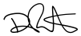 Date: 01.09.22

Signed (Chair of Governors): Date: 01.09.22

