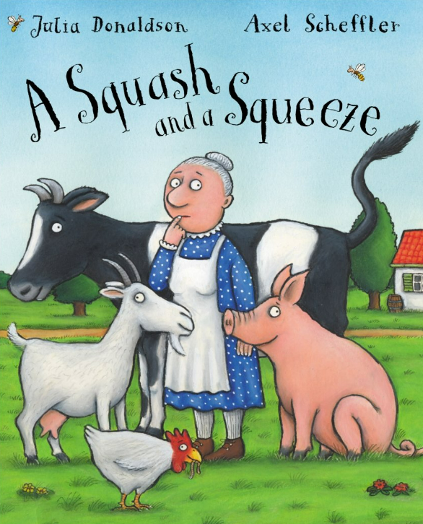
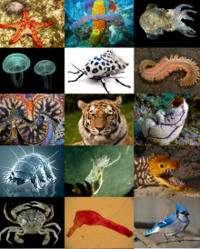
Year 1 Newsletter
Classes 1L and 1H
This term the children will be exploring the following topics:
In Science, we will be learning about ‘animals including humans’, we will identify and name a variety of common animals such as mammals, fish, reptiles, amphibians and birds. In addition, we will learn about the basic parts of the human body and take part in many interesting activities that allow us to use our senses.
How can parents help? Can you help your child channel their inner David Attenborough to name different animals, discuss the animal group that they belong to and how they know that?
Can you challenge them identify the parts of the body associated with each sense?

In English we will be exploring stories with repetitive patterns or structures. The book we will be reading will be ‘A Squash and a Squeeze’ by Julia Donaldson. Following this, children will learn how to write a fact file and will base this on their previous learning in History all about toys. Towards the end of term, children will have the opportunity to recite traditional rhymes.

In Maths, we will be recognising, reading and writing numbers up to 20 in words and numerals. The children will use the terms 'greater than' or 'less than' to compare numbers. The children will then learn how to add to numbers by first making 10 and then adding on the remainder. As well as learning how to subtract by counting back from the largest number. The chapter that will follow this will be all about shapes and patterns.

In History we will be comparing the lives and achievements of Queen Elizabeth II and Queen Victoria.
In Geography we will identify the four capitals and countries of the United Kingdom and identify their human and physical features.
In Art, we will study the artist William Morris and investigate different ways of creating our own prints using a variety of resources.
In RE, we will consider how beliefs about creation may affect how people treat the world and we will learn about Islam and their beliefs.
In Music, children will learn how to sing the song ‘In The Groove’. In The Groove is a song that was specially written for classroom use to teach children about different styles of music.

During our indoor PE sessions, we will be developing our gymnastics skills as we learn about balancing and spinning on points and patches. Our outdoor PE unit is called ‘object manipulation’, we will develop our throwing and catching skills.
In Computing, children will use technology to sort and classify minibeasts. They will learn about gathering and presenting information, searching the web, taking photographs and using a paint application.
In PSHE, our focus will be dreams and goals. Children will learn how to set goals and make plans for how to achieve them. Children will get the opportunity to go on a trip to ‘Imagine That’ for inspiration for future careers.

Messages and Reminders
Please check that children’s uniforms are labelled with names to prevent jumpers and cardigans getting lost. You will soon be receiving the evolve to complete for our trip to ‘Imagine That’ on the 15th January and look forward to having some parent volunteers join us! Spellings will be set weekly on Edshed for the children to practice. Thank you so much for your continued support. Miss Bruen & Mr Oakes

