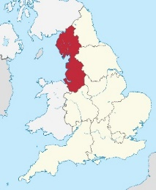
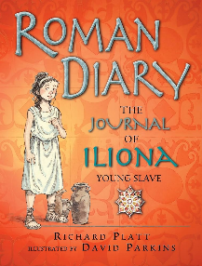
Year 4 Autumn 2 Newsletter
4L and 4H
This term the children will be exploring the following topics:
In Science, we will be exploring Animals including Humans. The children will be understanding the process of eating food. They will be looking at the food processing through the body, from the teeth all the way to digestion in the stomach. We will investigate this in both humans and animals using food webs.

In English: For our Non-Fiction text type we will be looking at are: Newspapers where we will be exploring the features of a Newspaper and then finally writing our own!
For our Fiction text, we will be reading ‘Roman Diary, The Journal of Illiona’ by Richard Platt. The children will be exploring character perspectives, writing balanced arguments and writing our own version.
In Maths, some of the things we will be learning about are:
- Multiplication and Division
- Time
In our multiplication and division topic, we will be learning how to multiply and divide by 6, 7, 8, 9, 11 and 12 as well as solving word problems.
In Time, the children will be learning how to read from both a 24 and 12-hour clock. They will be converting between units of time (Seconds, minutes and hours). Finally, children will be able to solve problems involving time.

For our Geography topic we will be continuing to investigate the question: Why should we settle here?
For our History topic we will be continuing to investigate the question: Who were the Romans and why were they so powerful?
How can you help?
If you think you might have anything linking to our humanities topics please send this in with your child on the first week of term.
In D.T. we will be looking at Cooking and Nutrition by adapting and following a baking recipe, from start to finish!
In R.E. we will be looking at how and why might Christians use a Bible.

In PE we will be doing (indoors) Yoga and Cricket(outdoors).
Yoga for this term will be looking at Position and alignment.
For Hockey the children will learn to effectively use the push pass and jab tackle
P.E. Days: Indoor Tuesday Outdoor, Thursday

Messages and Reminders:
Mirodo tasks will be set every Monday and will include either one English and one Maths. Your child has until the following Monday to complete these tasks. Your child will receive spellings on a Monday in paper form and will be put onto Edshed incase this sheet goes missing. Spelling tests take place on Monday mornings. Please ensure you are listening to your child read at least 3 times a week and log this in their reading diary on the day sections. Finally, multiplications should be practiced daily, this can be oral rehearsal with your child, logging onto Ed shed and completing the MTC task or joining in with any YouTube songs to help memorise them!

