Reception and Year 1and 2 children
Enter school through the infant gate.
Reception – through Reception gates and as per Tapestry Instructions
Year 1 through the door next to the pergola and exit that way – 3:05pm
Year 2 in through the door next to the hall. Mrs Walters’ class will exit through this door, Mr Hawkins class through the single door by the Buddy bench. They will need to be collected from the same doors at 3:10pm
Year 3 – All entry through these gates – leave the children to walk to their classrooms
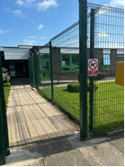
Year 3 enter school this way. 3L (Miss Cameron) will exit this way too.

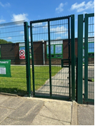
3H (Mrs Povey / Miss Barrie) will exit this way.

Year 4
Enter through the gates below and into their classroom doors. They will then leave by these doors are parents can wait for them in the area indicated below. They will leave at 3:10pm
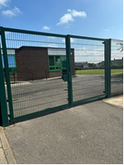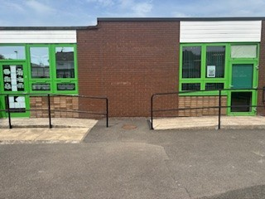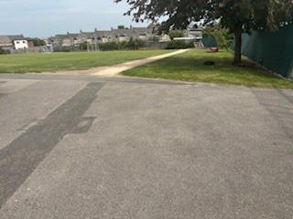
Year 5
They enter through the gates below and around to the side doors where they will be met. They will need to be collected on the junior yard at 3:15pm.
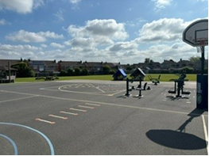
Year 6
They will come in through the front door and go to the year 6 classes. They will leave by this route at 3:05pm
As a reminder, these are the classes from September 2025
New class and teacher, Sept 2025
1L – Mr Oakes
1H – Miss Bruen
2L – Mr Hawkins
2H – Miss Walters
3L – Mrs Povey / Miss Barrie
3H – Miss Cameron
4L – Mrs McIlhagga
4H – Mrs Worthington
5H – Mrs Davies
5L – Mr Moore
6H – Mr Crook
6L - Miss Huddlestone

