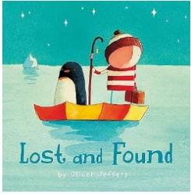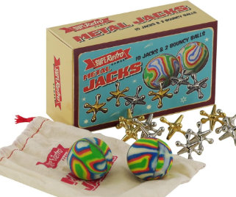

**Year 1 Curriculum Newsletter**

Classes 1L and 1H

This term the children will be exploring the following topics:

|  |  |  |
| --- | --- | --- |
| In **Maths**, we will be exploring numbers to 10. We will be learning all about place value, and we will be creating addition and subtraction equations with our number bonds to 10. As children build their knowledge and skills, we will then move onto solving some word problems. | In **English**, we will be reading the books ‘Lost and Found’ and ‘How to Catch a Star’ by Oliver Jeffers. The children will learn how to make inferences, how to innovate the story, and then to finish this off, the children will write their own version of the story! The children will have their RWInc sound mats and Y1 common exception word mats to support them with their writing in class. | In **Science**, we will be learning about different materials. The children will identify the material that an object is made from, describe their properties and how they can be grouped.  **How can parents help?** Can you explore items in your house or outside and discuss the materials they are made from? Can you spot the similarities and differences? |
| In **PE** we will be focusing on dance (indoor) and fundamental skills (outdoor).  Our PE days this term:  - Outdoor PE: Monday  - Indoor PE: Wednesday | In **History** we will be exploring a variety of toys and comparing them from now to the past. The children will identify the materials they are made from, their function and their use of technology. Year 1 will answer the enquiry question: How were our grandparents’ toys different to ours? | In **Geography** we will learn about animals that live in hot and cold places, identify where they live on a world map and discuss how they have adapted to their environment. The children will have an opportunity to meet the animals relating to the enquiry question ‘Why can’t a meerkat live in the north pole?’ |
| In **Art** the children will create a colour wheel, learn about primary and secondary colours and colour mixing. Following this, the children will create their own painting using warm or cool colours. | In **RE** we will be exploring the enquiry question of ‘Why do Christians say that God is a Father? | **Continuous Provision**  In Y1, children will still have the opportunity for continuous provision (choose time) for short bursts throughout the day. The children will be able to choose from a range of fun activities that are linked to the national curriculum. |

Messages

We are so excited to welcome all the children and their families to our Year 1 team! Please follow us on X (twitter) for updates throughout the day @Y1LuntsHeath . Please ensure that all reading records and books are kept in the children’s book bags ready for reading times with an adult in school. Please ensure all uniform is labelled with your child’s name to prevent belongings getting lost. We can’t wait for such a fun year!

Miss Bruen & Mr Oakes