Menopause Policy and Guidance
September 2025

Menopause Policy

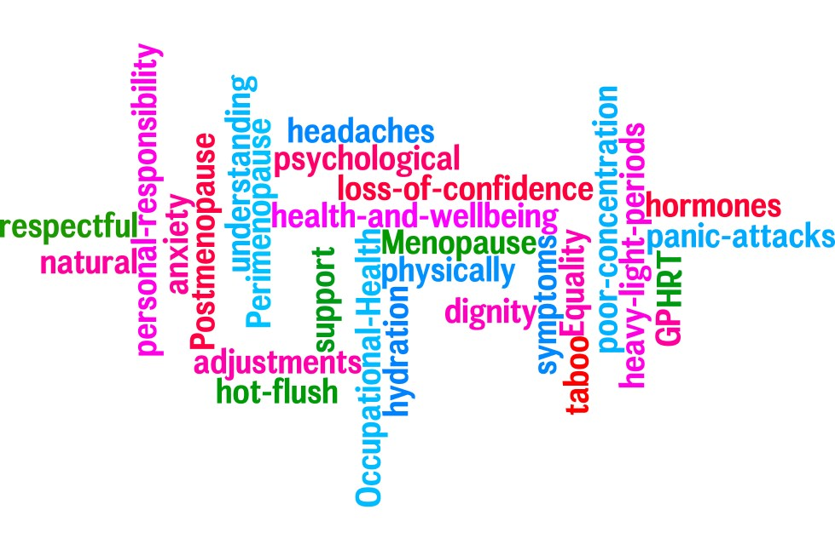

Contents | Page
Introduction | 4
Aims | 4
Scope | 5
Definitions | 5
Symptoms of Menopause | 5
Drivers | 5
Roles and responsibilities | 6
Links to other policies | 7
Appendices | 8
External links | 8
Appendices
Appendix 1: Managers’ Guidance | 9
Appendix 1a: Confidential Discussion Template | 12
Appendix 2: Menopause Advice Sheet | 13

1. Introduction

1.1. The School is committed to providing an inclusive and supportive working environment for everyone who works here.

1.2. Menopause is a natural part of every woman’s life, and it isn’t always an easy transition. With the right support, it can be much better. Whilst every woman does not suffer with symptoms, supporting those who do will improve their experience at work.

1.3. Menopause should not be taboo or ‘hidden’. We want everyone to understand what menopause is, and to be able to talk about it openly, without embarrassment. This is not just an issue for women, men should be aware too.

1.4. The changing age of the UK’s workforce means that between 75% and 80% of menopausal women are in work. Research shows that the majority of women are unwilling to discuss menopause-related health problems with their line manager, nor ask for the support or adjustments that they may need.

1.5. This policy sets out the guidelines for members of staff and managers on providing the right support to manage menopausal symptoms at work. It is not contractual and does not form part of the terms and conditions of employment.

2. Aims

2.1. The aims of this policy are to:

2.1.1. Foster an environment in which colleagues can openly and comfortably instigate conversations or engage in discussions about menopause.

2.1.2. Ensure everyone understands what menopause is, can confidently have good conversations, and are clear on the school’s policy and practices, supported by Human Resources and Occupational Health.

2.1.3. Educate and inform managers about the potential symptoms of menopause, and how they can support women at work.

2.1.4. Ensure that women suffering with menopause symptoms feel confident to discuss it and ask for support and any reasonable adjustments so they can continue to be successful in their roles or studies.

2.1.5. Reduce absenteeism due to menopausal symptoms.

2.1.6. Assure women that we are a responsible employer, committed to supporting their needs during menopause.

- Scope

3.1. This policy applies to all staff and managers.

4. Definitions

4.1 Menopause is defined as a biological stage in a woman's life that occurs when she stops menstruating and reaches the end of her natural reproductive life. Usually, it is defined as having occurred when a woman has not had a period for twelve consecutive months (for women reaching menopause naturally). The average age for a woman to reach menopause is 51, however, it can be earlier or later than this due to surgery, illness or other reasons.

4.2. Perimenopause is the time leading up to menopause when a woman may experience changes, such as irregular periods or other menopausal symptoms. This can be years before menopause.

4.3. Postmenopause is the time after menopause has occurred, starting when a woman has not had a period for twelve consecutive months.

5. Symptoms of Menopause

5.1. It is important to note that not every woman will notice every symptom, or even need help or support. However, 75% of women do experience some symptoms, and 25% could be classed as severe.

5.2. Symptoms can manifest both physically and psychologically including, but not exclusively, hot flushes, poor concentration, headaches, panic attacks, heavy/light periods, anxiety, and loss of confidence. Some women also experience difficulty sleeping.

7. Roles and Responsibilities

7.1. Members of staff:

7.1.1. All staff are responsible for:
- Taking a personal responsibility to look after their health;
- Being open and honest in conversations with managers/HR and Occupational Health;
- Staff can speak to their supervisee or another member of staff
- Contributing to a respectful and productive working environment;
- Being willing to help and support their colleagues;
- Understanding any necessary adjustments their colleagues are receiving as a result of their menopausal symptoms.

7.2. Line Managers / Senior Leaders (see Appendix 1 for Managers’ Guidance)

7.2.1. All senior Leaders should:
- Familiarise themselves with the Menopause Policy and Guidance;
- Be ready and willing to have open discussions about menopause, appreciating the personal nature of the conversation, and treating the discussion sensitively and professionally;
- Use the guidance in Appendices 1 and 2, signposting and reviewing together, before agreeing with the individual how best they can be supported, and any adjustments required;
- Record adjustments agreed, and actions to be implemented;
- Ensure ongoing dialogue and review dates;
- Ensure that all agreed adjustments are adhered to.

Where adjustments are unsuccessful, or if symptoms are proving more problematic, the Senior Leader may:
      - Discuss a referral to Occupational Health for further advice;
      - Refer the employee to Occupational Health;
      - Review Occupational Health advice, and implement any recommendations, where reasonably practical;
      - Update the action plan and continue to review.

7.3. Occupational Health

7.3.1. The role of Occupational Health is to:
- Carry out an holistic assessment of individuals as to whether or not menopause may be contributing to symptoms/wellbeing, providing advice and guidance in line with up-to-date research;
- Signpost to appropriate sources of help and advice (refer to Appendix 2 for more information);
- Provide support and advice to HR and Line Managers in identifying reasonable adjustments, if required;

7.4. Human Resources (HR)

7.4.1. HR will:
- Offer guidance to managers on the interpretation of this Policy and Guidance;
- Attend training sessions, and develop briefing sessions, for staff;
- Monitor and evaluate the effectiveness of this policy in respect of related absence levels and performance.

8. Links to other policies

This policy is linked to:
- Flexible working guidance;
- Health and Safety Policy;

9. Appendices

Appendix 1 – Leader’s Guidance for Colleague Discussions;
Appendix 1a – Confidential Colleague Discussion Template;
Appendix 2 – Menopause Advice Sheet.

10. External links

National Institute for Health and Care Excellence (NICE) guidelines. These explain how your GP will determine what types of treatments and interventions they can offer you. You can find out more information by using the following link https://www.nice.org.uk/guidance/ng23/ifp/chapter/About-this-information.

The National Health Service provides an overview of menopause. You can find more at http://www.nhs.uk/Conditions/Menopause/Pages/Introduction.aspx.

Menopause information. The Royal College of Obstetricians and Gynaecologists offer further information in a dedicated area of their website at: https://www.rcog.org.uk/en/patients/menopause/.

Premature Ovarian Insufficiency (POI) information and support on very early menopause. You can find out more at https://www.daisynetwork.org.uk.

Information on hysterectomy. This provides an insight into surgically induced menopause as a result of having a hysterectomy. Further details can be found at https://www.hysterectomy-association.org.uk.

Henpicked. This site provides information on managing menopause, and an insight into women's stories (see https://henpicked.net/menopause/).

Appendix 1 Leaders’ Guidance for colleague discussions

We recognise that every woman is different, and it is, therefore, not feasible to set out a structured set of specific guidelines.

If an employee wishes to speak about their symptoms, or just to talk about how they are feeling (they may not recognise themselves that they are symptomatic), or if a male employee wishes to speak about a family member, please ensure that you:

- Allow adequate time to have the conversation;
- Find an appropriate room to preserve confidentiality;
- Encourage them to speak openly and honestly;
- Suggest ways in which they can be supported (see symptoms below) – hand out the Menopause Advice Sheet (Appendix 2);
- Agree actions, and how to implement them (you should use the template at Appendix 1a to record the meeting, so that all parties agree what has been discussed, and the next steps, before the meeting ends). Ensure that this record is treated as confidential and is stored securely.
- Agree if other members of the team should be informed, and by whom;
- Ensure that designated time is allowed for a follow up meeting. Do not rely on quick queries during chance encounters in the corridor or break room.

Symptoms Support
Symptoms can manifest both physically and psychologically, including, but not exhaustively or exclusively; support for women should be considered as detailed below:

Hot Flushes
- Request temperature control for their work area, such as a fan on their desk (where possible a USB connected desk fan to ensure environmentally friendly) or moving near a window, or away from a heat source;
- Easy access to drinking water;
- Be allowed to adapt prescribed uniform, such as by removing a jacket;
- Have access to a rest room for breaks if their work involves long periods of standing or sitting, or a quiet area if they need to manage a severe hot flush.

Heavy/light Periods
- Have permanent access to washroom facilities;
- Request wearing lighter clothes
- Ensure sanitary products are available
- Ensure storage space is available for a change of clothing.

Headaches
- Have ease of access to fresh drinking water;
- Offer a quiet space to work;
- Have time out to take medication if needed.

Difficulty Sleeping
- Ask to be considered for flexible working, particularly suffering from a lack of sleep.

Low Mood
- Agree time out from others, when required, without needing to ask for permission;
- Identify a ‘buddy’ for the colleague to talk to – outside of the work area;
- Identify a ‘time out space’ to be able to go to ‘clear their head’;

Loss of Confidence
- Ensure there are regular personal discussions or supervision;
- Have regular protected time with their manager to discuss any issues;
- Have agreed protected time to catch up with work.

Poor Concentration
- Discuss if there are times of the day when concentration is better or worse, and adjust working pattern/practice accordingly;
- Review task allocation and workload;
- Provide books for lists, action boards, or other memory-assisting equipment;
- Offer quiet space to work;
- Reduce interruptions;
- Have agreements in place in an open office that an individual is having ‘protected time’, so that they are not disturbed;
- Have agreed protected time to catch up with work.

Anxiety

- Identify a ‘buddy’ for the colleague to talk to – outside of work their area;
- Be able to have time away from their work to undertake relaxation techniques;
- Undertake mindfulness activities such as breathing exercises or going for a walk.

Panic Attacks
- Agree time out from others, when required, without needing to ask for permission;
- Identify a ‘buddy’ outside of work area;
- Be able to have time away from their work to undertake relaxation techniques;
- Undertake mindfulness activities such as breathing exercises or going for a walk.

Discuss whether the member of staff has visited their GP. Depending on the discussion, this may be the next step suggested, particularly if the areas of difficulty are sleeping, panic attacks or anxiety.

If they have visited their GP, and are being supported by them, it may be helpful at this point to make an Occupational Health referral to give specific advice regarding the workplace.

Appendix 1a Discussion – Template

Member of staff’ details:
Name |  | Job Title
 |  | Location

Present at meeting (line manager name and position)
Date of discussion

Summary of Discussion:

Agreed Actions/Adjustments:

Date of next review meeting ..................................................................................................

Signed (Member of staff) ..................................................................................................

Signed (Manager) ..................................................................................................

Appendix 2 Menopause Advice Sheet – How to talk to your GP about menopause

If you are suffering from menopausal symptoms to the point they’re getting in the way of you enjoying life, it’s time to talk to your doctor. But, sometimes, that’s easier said than done.

We all know how difficult it can often be just to get an appointment, and then it’s often only ten minutes. And talking about symptoms can be hard, let alone if you feel rushed or unprepared. So, what can you do? We’ve put together some helpful, straightforward tips to help you get the best from your appointment.

Don’t wait. It is all too common for women to feel they must simply ‘put up’ with menopausal symptoms as a part of life, but if they are affecting you, there are things you can do, and support available. There is no need to wait until symptoms feel unbearable.

Read the NICE guidelines. This stands for National Institute for Health and Care Excellence and these guidelines are what your doctor will use to determine the type of conversations to have with you and treatments to offer. There are guidelines for patients, which are really useful to read before you see your GP, so you know what to expect.

Prepare for your appointment. It’s easier for your doctor to understand what’s going on if you provide them with all the information. That may sound obvious, but blood tests to say where you are on the menopause transition aren’t always available or accurate – your hormones can fluctuate daily during this time. So, your doctor will be thinking about what to recommend for you, based on your symptoms.

Keep a list of your symptoms, your menstrual cycle, hot flushes, how you’re feeling, and any changes you’ve noticed. Write them down, and take them to your appointment. Your doctor will thank you for it, and it’s more likely that together, you’ll find the right solution faster. And, if you have any preferences about how you manage your symptoms, tell them that too – for example, if you’d like to try hormone replacement therapy (HRT), or not.

Ask the receptionist which doctor is best to talk to about menopause. They are often the font of all knowledge at a surgery, and can help you find the best person to speak to – it might not be your usual GP, it could be someone who has had special training in the subject.

Ask for a longer appointment. If you don’t think your standard appointment will be long enough, try to book a double appointment, as some surgeries do offer this.

Don’t be afraid to ask for a second opinion. If you don’t feel you’ve received the help you need, ask to speak to someone else. Don’t be put off, you know how you’re feeling, and how it’s affecting you.

Ask if there is a menopause clinic in your area. Occasionally, there are regional clinics, specifically devoted to menopause. If there is one in your area, and you think this would be helpful, ask for a referral.

Take your partner or a friend with you. The chances are, you spend your life supporting others and, during menopause, it’s your turn to ask them for support. Your partner, or a friend, will know how the symptoms are affecting you. They could support you at the appointment, and also find out how they can continue supporting you.

What to expect from your doctor
There are certain things a GP should – and should not – do during your appointment.

They should:
- Talk to you about your lifestyle, and how to manage both your symptoms, and your longer-term health;
- Offer advice on hormone replacement therapy and other non-medical options;
- Talk to you about the safety and effectiveness of any treatment.

They should not:
- Tell you that it’s just that time of your life. Yes, menopause is a natural stage, but please don’t feel that means you should have to put up with every symptom without help;
- Tell you they don’t prescribe HRT. It’s up to you what you want to try, and for them to say whether it could be right for you, depending on your medical history;
- Impose unnecessary time restrictions, such as they will only prescribe this once, or for a year or two. This is an ongoing conversation, and if your symptoms persist, you will still need help to manage them.

