Lunt’s Heath Primary School Pupils’ Privacy Notice (Child Friendly version)
What personal information we hold about our pupils
- Your name
- Your address
- Your unique pupil number
- Your nationality
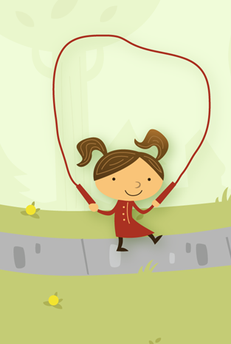
- Your attendance at school and reasons
- Your behavior at school and reasons
- Your medical needs
- Your free school meals
- Your special educational needs
- Your assessments and progress
Why we hold personal information about our pupils
- To support your learning
- To monitor your progress at school
- To provide help with lessons
- To comply with the Law about personal data
- To support your medical needs
- To support free school meals/pupil premium
- To support your special educational needs
Where is the personal information we hold about our pupils
- Our school database/Server /Cloud
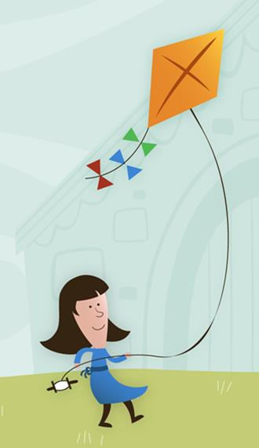
- Your name address and unique pupil number
- Your nationality
- Your attendance at school
- Your medical needs
- Your free school meals
- Your special educational needs
Who we share personal information with about our pupils
- The Local Authority where you live
- The Local Authority where the school is
- Multi Academy Trust/Federation/Academy Chain
- The Department for Education
- The School Nurse/Doctor
- The Courts if we are requested
- Your next school

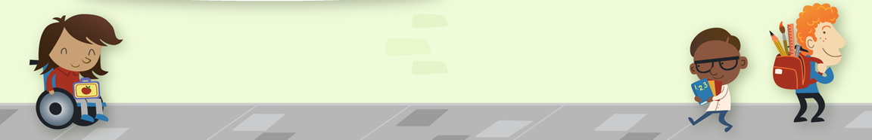
Why we share personal information about our pupils
Our Laws in England and our School Policies allow for sharing of some information.

- (Department for Education (DfE)Section 3 of the Education Information about Individual Pupils Regulations of 2013)
- Your unique pupil number and nationality
- Your attendance at school
- Your free school meals
- Your special educational needs
- Your next school to enable transition
- Our Local Authority
How long will we store this data?
We hold personal data for 7 years after your child leaves our school.
Requesting access to your personal Data
Parents and pupils have the right to request access to information about them held by the school.
Person to contact: Mr David Paton Head.LuntsHeath@halton.gov.uk .
Rights and Responsibilities
- You can object to the processing of personal data that is likely to cause or is causing damage or distress.
- You can prevent processing for the purpose of direct marketing.
- You can object to decisions being taken by automated means.
- You can in certain circumstances have inaccurate personal data rectified, blocked, erased or destroyed.
- You can in certain circumstances claim compensation for damages caused by a breach of GDPR Regulations.
The National Pupil Database
- This is owned and managed by the DFE and contains information about pupils in schools in England and is held in electronic format.
- Information is gathered by means of School Census and statutory Data Collections as identified by the Information about Education(Information about Individual Pupils) Regulations of 2013.
Strict Terms Conditions and Regulations are in place concerning:
- Requests
- Purpose / Requirement
- Level and Sensitivity of data requested
- Handling and Storage Arrangements.
