Useful Information
Author | John Burningham
Illustrator | John Burningham
Year published | 2001
Other titles by this author | Mr Gumpy’s Motorcar, Mouse House, Would you rather?

Tales Toolkit

 | Character- A person or an animal in a story. |  | Setting- Where the story takes place.
 | Mr Gumpy and his friends |  | In his boat along the river
 | Problem- There is another character or a situation that is a problem for the main character. |  | How the characters manage to sort out the problem and have a happy ending.
 |  |  | The successful last delivery being dispatched – a perfect puppy for the character of the story
 | A letter to the zoo asking for a pet - all of the deliveries containing highly unsuitable pets!

Phrases and repeated refrains from story text
Children will become very familiar with these phrases and use them in the oral retelling of the story
I wrote to the Zoo to send me a pet … | He was too fierce/grumpy/big …
They sent me a … | They thought very hard
I sent him back … | He was perfect, I kept him
So, they sent me a … | Animal sounds e.g ssss-snake, woof woof – dog etc

Vocabulary – definitions and synonyms
synonyms are words with the same meaning (or almost the same meaning)
heavy | Weighing a lot and needing effort to move or lift (chunky, clumsy)
fragile | Something that is easily broken or damaged (frail, breakable, delicate)
fierce | When an animal / a person is very aggressive or angry (strong,  wild, dangerous)
grumpy | Unhappy and dissatisfied, often for no obvious reason (bad-tempered, annoyed, cross)
pet | an animal that you keep in your home to give you company and pleasure and you look after it (animal)
zoo | a park where live animals are kept so that people can look at them  (safari park, nature reserve, national parl)

Book Knowledge and Concepts about Print
Can your child show you the
Front Cover  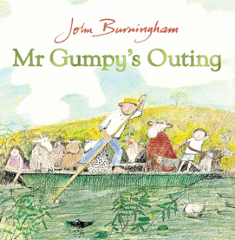 | Back Cover  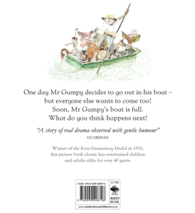
Spine   | Title  

