Useful Information
Author | Jill Murphy
Illustrator | Jill Murphy
Year published | 2007
Other titles by this author | Peace at last, On the way home, Five Minutes Peace, All in One Piece

Tales Toolkit

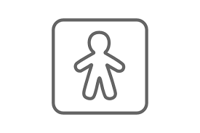 | Character- A person or an animal in a story. | 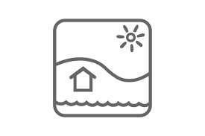 | Setting- Where the story takes place.
 | Baby Bear |  | Earth – home  Space - moon
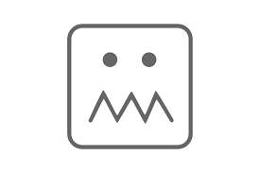 | Problem- There is another character or a situation that is a problem for the main character. |  | How the characters manage to sort out the problem and have a happy ending.
 |  |  | Baby bear is safe back home, ready for his bath …Of course, mummy doesn't believe where he has been. Whatever Next?
 | It rained … the rain dripped through his helmet – home went down the chimney with a BUMP!

Phrases and repeated refrains from story text
Children will become very familiar with these phrases and use them in the oral retelling of the story
Can I go to the moon? | Took off up the chimney…whoosh out into the night!
You’d have to find a rocket first | Where are you off to? The moon, said baby bear
He found a space-helmet on the draining board | On and on they flew, up and up, above the clouds
He found a pair of space-boots on the mat | ‘You and your stories’, she said. Whatever Next?

Vocabulary – definitions and synonyms
synonyms are words with the same meaning (or almost the same meaning)
take off | when an aircraft, bird, insect leaves the ground and begins to fly (blast off, depart, push off)
land | Arrive on the ground or other surface after moving down through the earth (come down, arrive)
drain | removing the liquid from something, usually by pouring it away or allowing it to flow away (clear out, empty)
journey | travelling from one place to another (trip, tour, outing)
drip | if a liquid drips, it falls in drops (dribble, leak, drizzle)
passenger | a passenger who is travelling in a vehicle but isn’t driving it, flying it or working on it (traveller, rider)

Book Knowledge and Concepts about Print
Can your child show you the
Front Cover  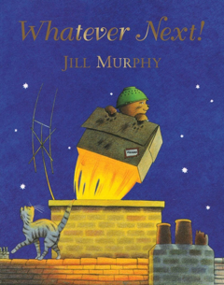 | Back Cover  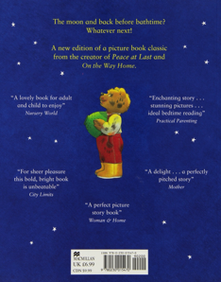
Spine  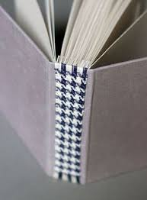 | Title  
