Little Red

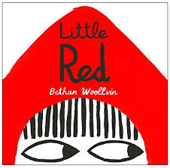

Unit D

Traditional Tale

