Juniper Jupiter

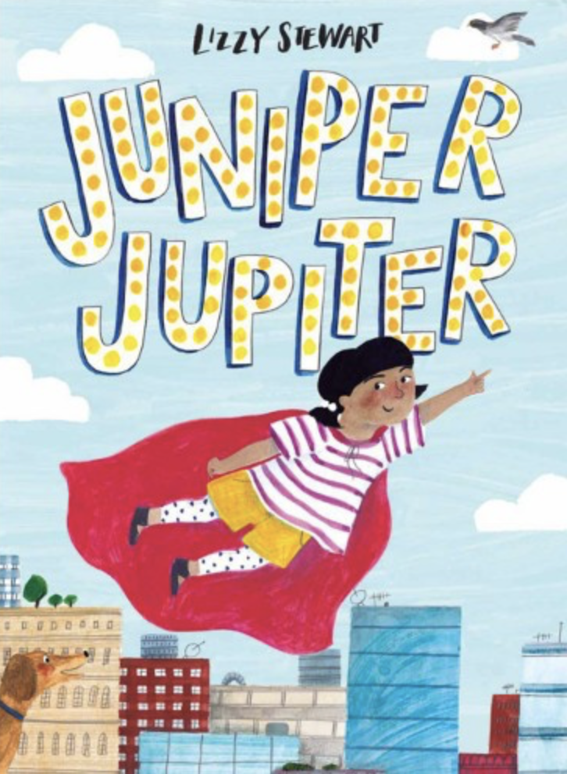
A Superhero Story
Unit C

