Counting on and counting back
Addition  +  Subtraction | 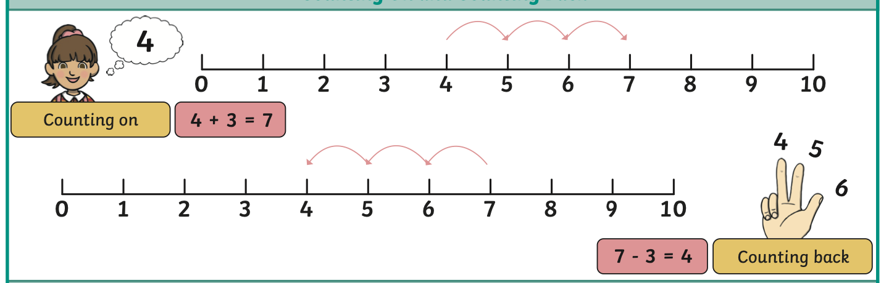
Number bonds
Counters  Numicon  Part-part whole model  Pictorial | 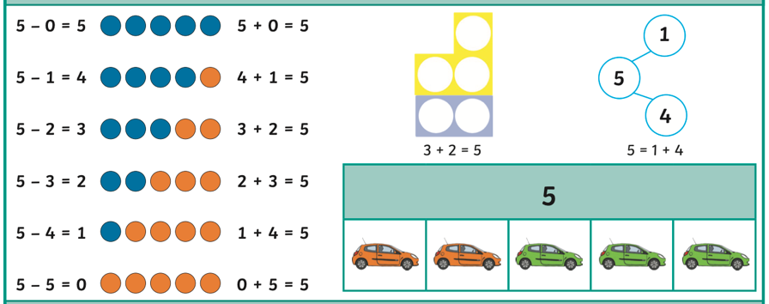

Year 1 – Addition and Subtraction (to 10)

Key Vocabulary
Add | Combine two or more numbers using a plus (+) sign.
Subtract | To take one number away from another using minus (–) sign.
Equal | = equals or is the same as.
Altogether | The amount in total.
Take away | To remove something, such as objects or numbers.
How many left over | The amount after something has been taken away.
Part | A part is one of two numbers that equal the whole.
Whole number | The total or sum of the parts.

Fact families
Find all 8 facts using addition and subtraction. | 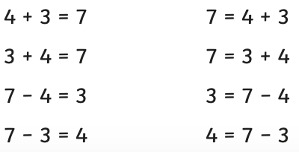  
Number bonds to 10
