Star in the Jar

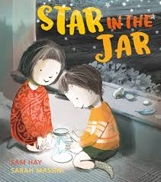
Unit B

Finding Story
Poster

