Chocolate Investigation

Can you help Maya find the temperature that melts chocolate the fastest? Plan your investigation then carry it out!
Equipment: Circle the things you will need.
thermometer |  | tape measure | 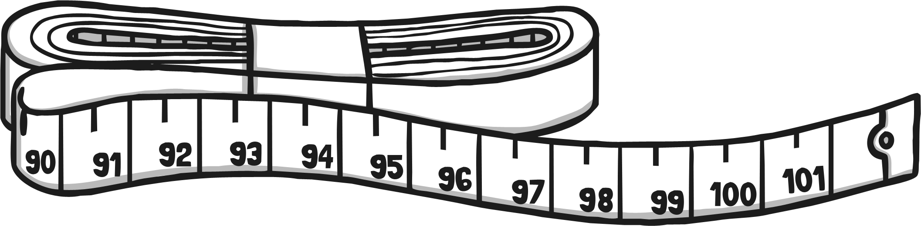 | magnifying glass | 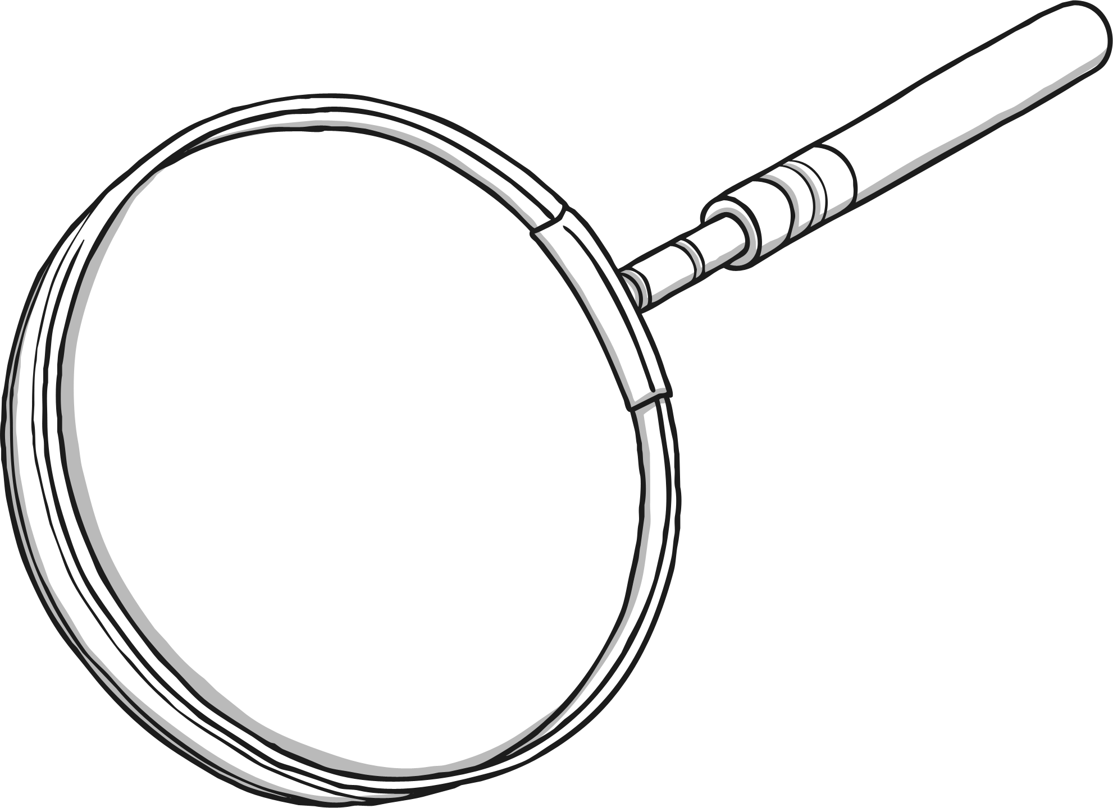
foil tins | 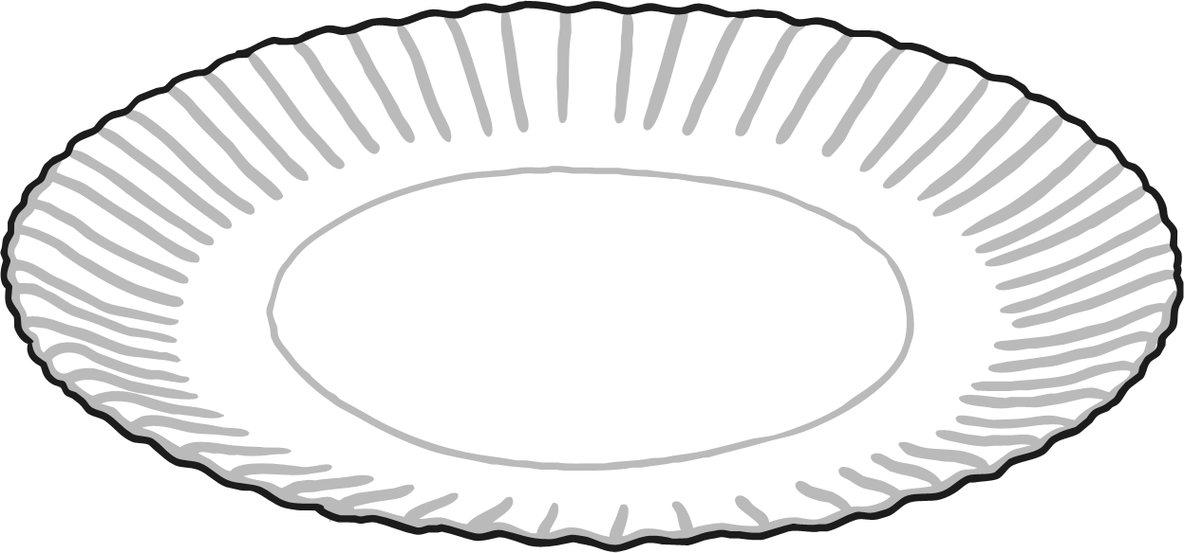 | sand | 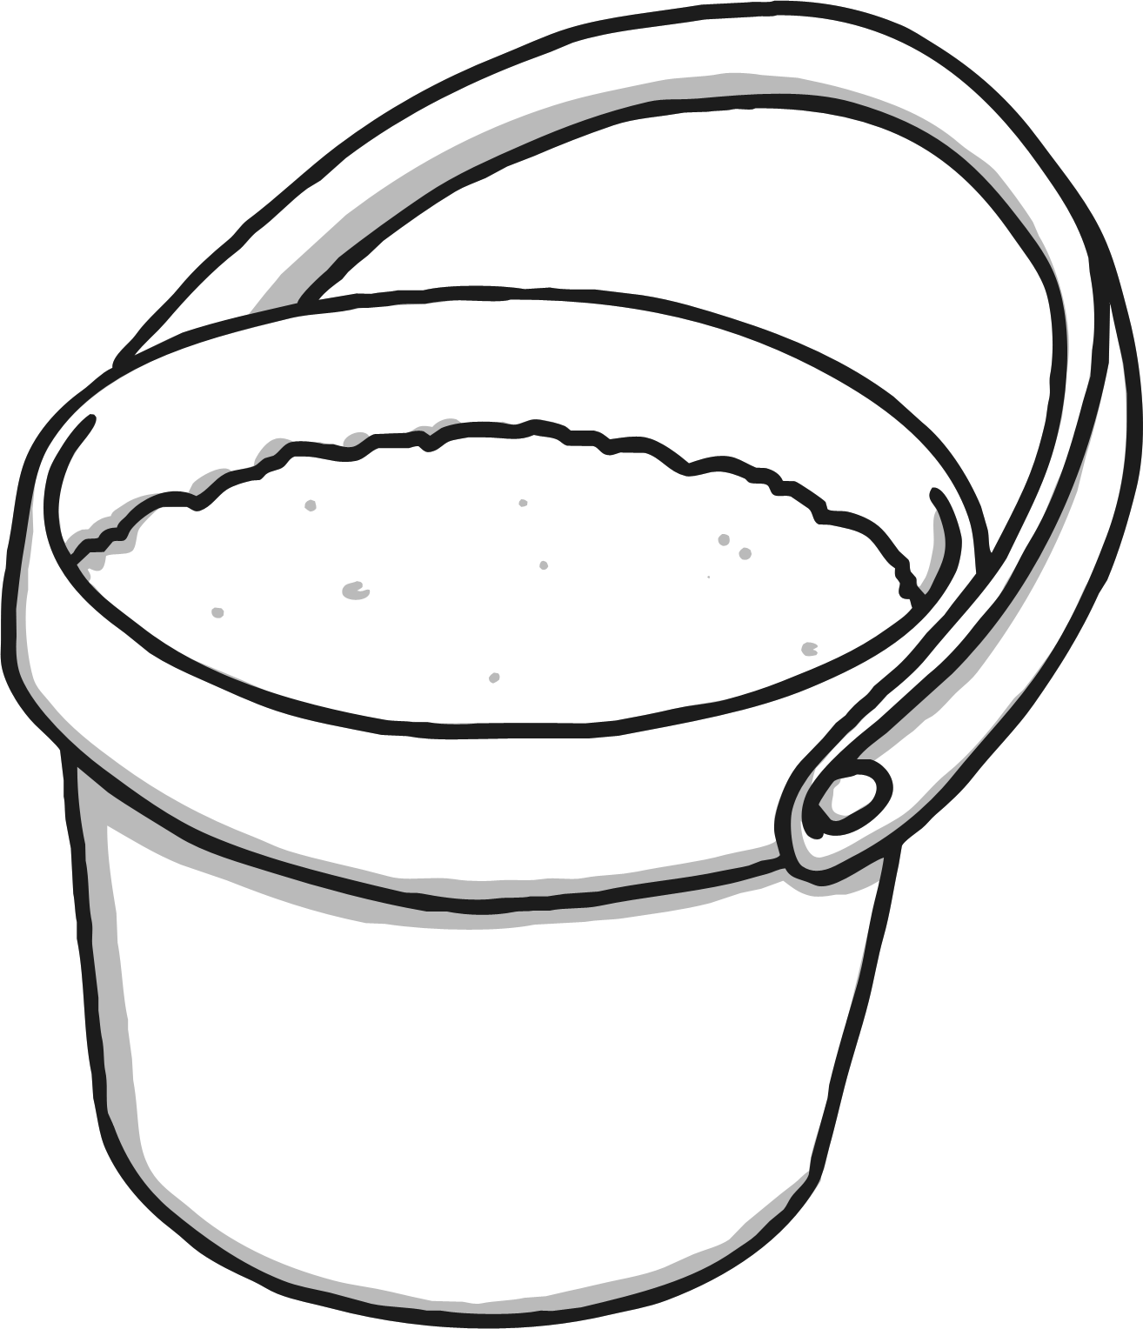 | stopwatch | 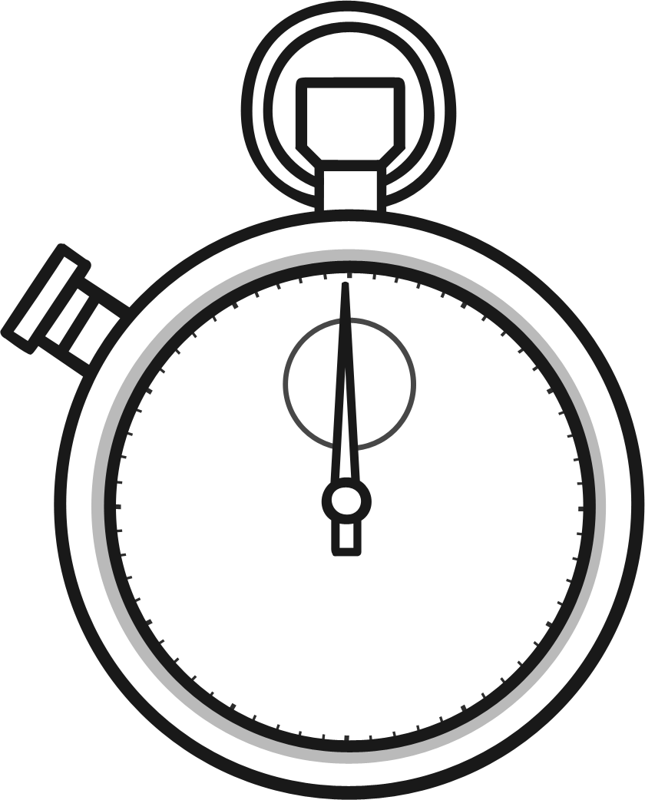
torch | 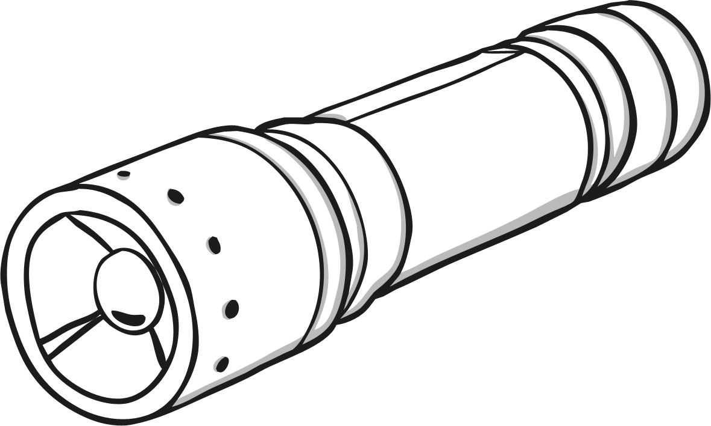 | chocolate | 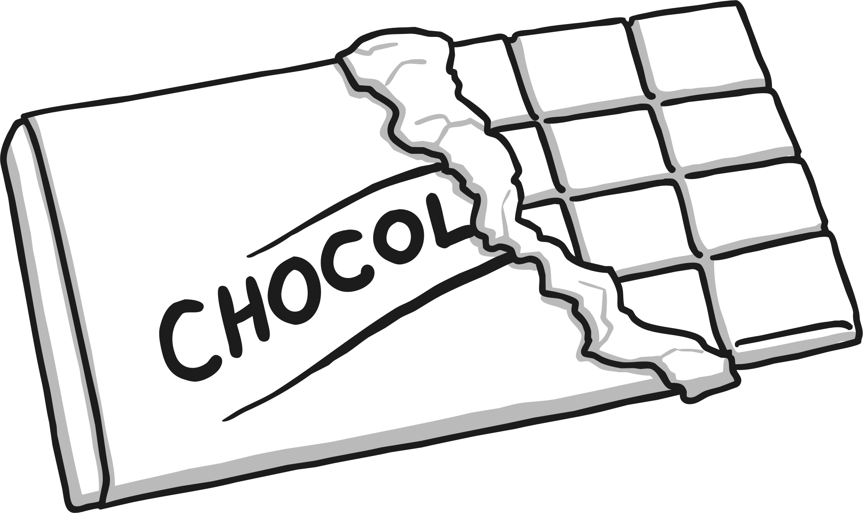 | water | 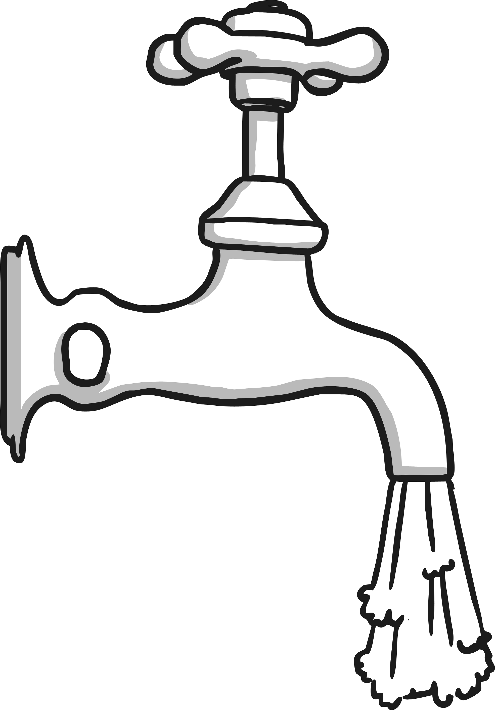
ruler | 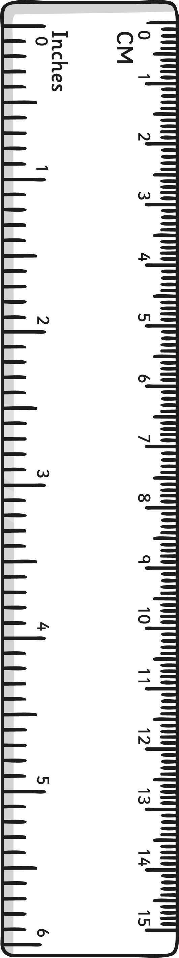 | pipette |  | trays | 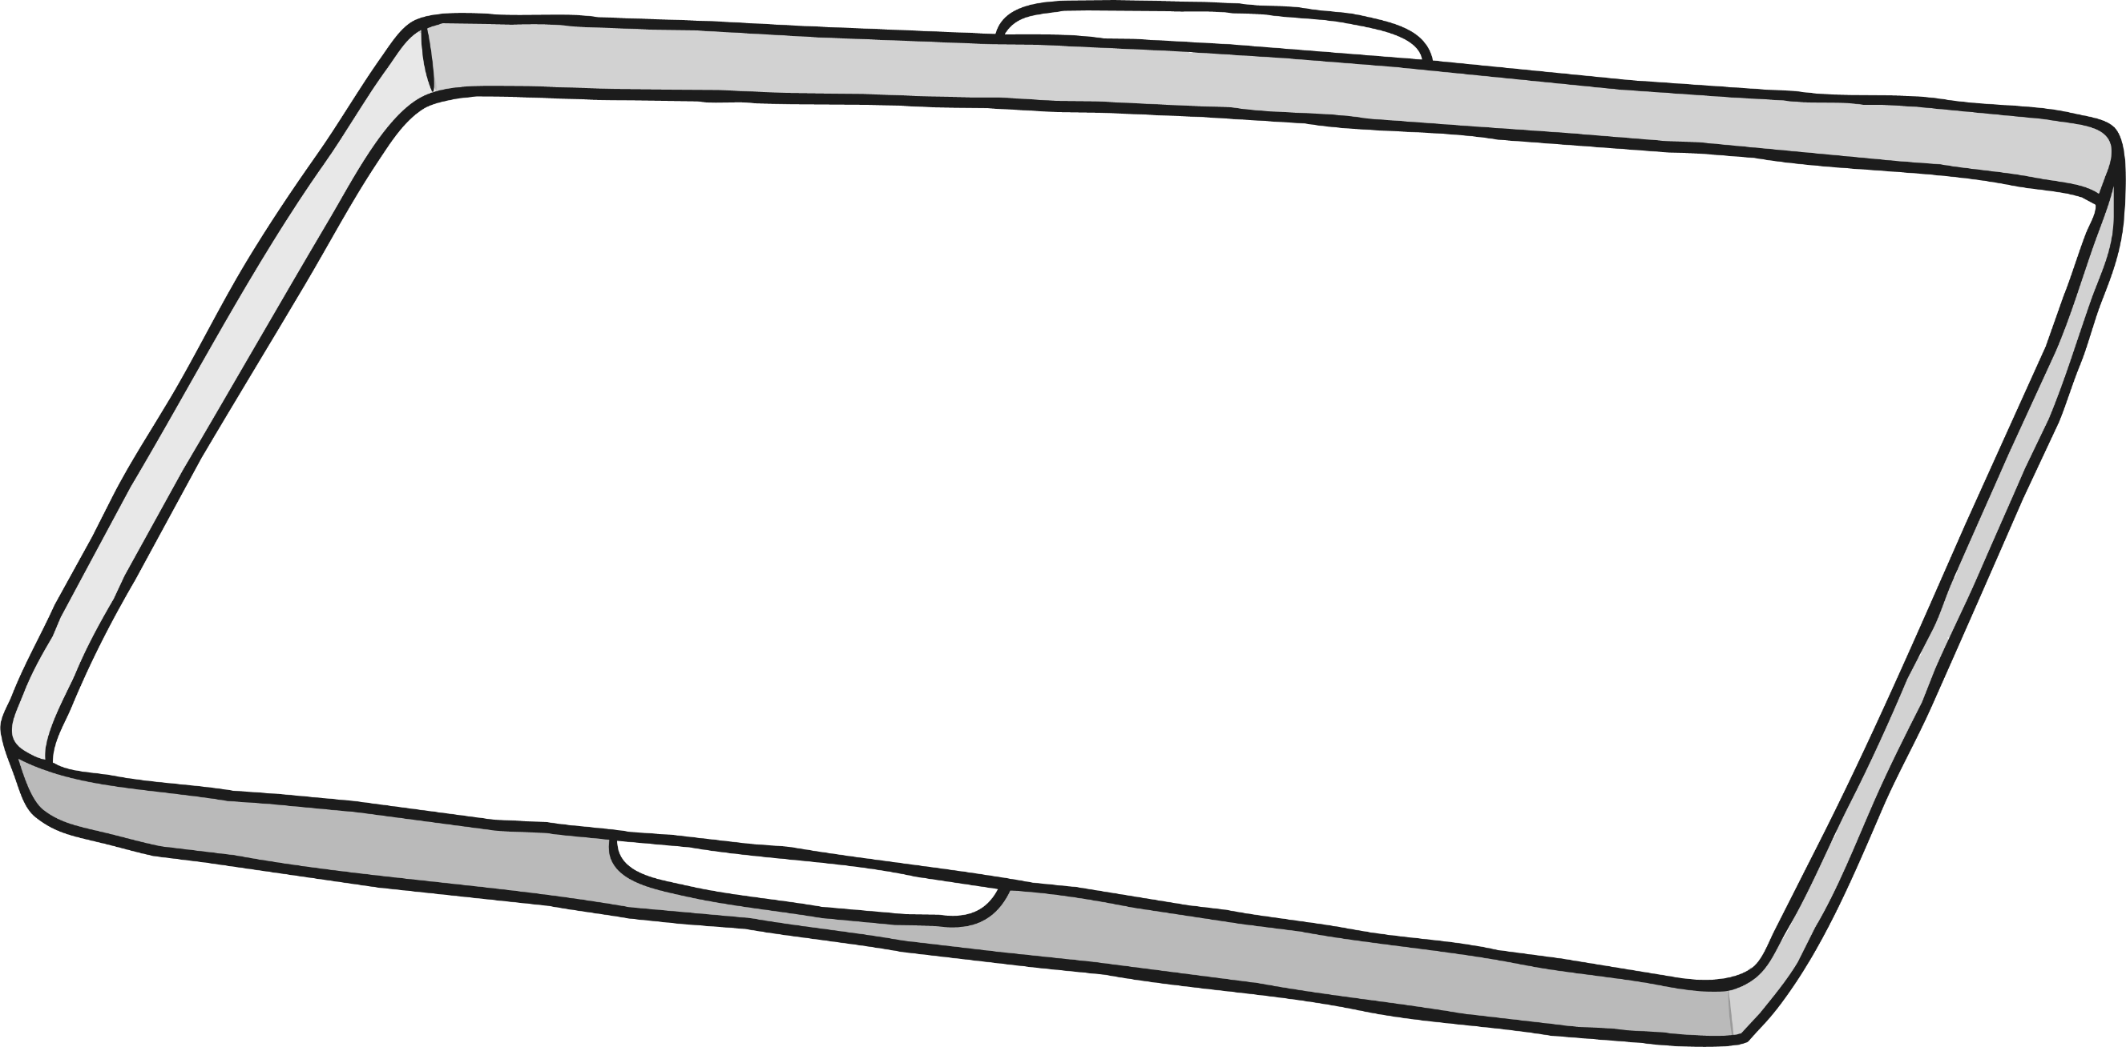

You will float the pieces of chocolate in foil tins on trays filled with different temperatures of water. Underline the correct words or phrases below to show how you will make sure your investigation is reliable.
I will make sure each piece of chocolate is the same/a different size. I will use the same/different amounts of water in each tray. The temperatures of the water in each tray should be the same/different.
What will you measure and observe in this investigation? Use the pictures to help you.
I will measure the...
I will measure the...
I will observe the...
What do you predict will happen? Which temperature of water will melt the chocolate fastest?

Chocolate Investigation

Complete this table with your results:
 | Tray 1 | Tray 2 | Tray 3
Temperature of water
Time taken for chocolate to melt

Draw a bar chart using your results:
Time Taken for Chocolate to Melt
 | 5⁰C | 30⁰C | 40⁰C
Temperature of Water
What is your conclusion? Can you tell Maya which temperature melts chocolate the fastest?

Use these words to help you.
chocolate | water | hot | cold | faster | slower | shorter | longer

Chocolate Investigation

Can you help Maya find the temperature that melts chocolate the fastest? Plan your investigation then carry it out!
Equipment: Draw or write the things you will need.
You will float the pieces of chocolate in foil tins on trays filled with different temperatures of water. How will you make sure your results are reliable? Think about what you will keep the same and what you will change.

What will you measure and observe in this investigation? Use the pictures to help you.
I will measure...

I will observe...

What do you predict will happen? Which temperature of water will melt the chocolate fastest? Why do you think this will happen? Refer to the behaviour of the particles in the pieces of chocolate in your answer.

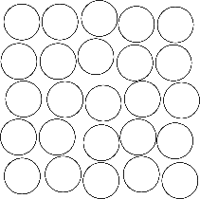
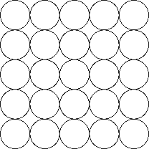
liquid
solid
Chocolate Investigation

Complete this table with your results:
 | Tray 1 | Tray 2 | Tray 3
Temperature of water
Time taken for chocolate to melt
Draw a bar chart using your results. Don’t forget to label the axes.

What is your conclusion? Can you tell Maya which temperature melts chocolate the fastest? Can you explain why this happened?

Chocolate Investigation

Can you help Maya find the temperature that melts chocolate the fastest? Plan your investigation then carry it out!
Equipment: Draw or write the things you will need.
You will float the pieces of chocolate in foil tins on trays filled with different temperatures of water. How will you make sure your results are reliable? Think about what you will keep the same and what you will change.

What will you measure and observe in this investigation? Use the pictures to help you.
I will measure...

I will observe...

What do you predict will happen? Which temperature of water will melt the chocolate fastest? Why do you think this will happen? Refer to the behaviour of the particles in the pieces of chocolate in your answer.

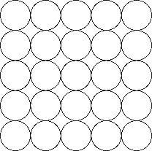
solid
liquid
Chocolate Investigation

Complete this table with your results:
 | Tray 1 | Tray 2 | Tray 3
Temperature of water
Time taken for chocolate to melt
Draw a bar chart using your results. Don’t forget to label the axes. Choose suitable intervals for the ‘Time taken for the chocolate to melt’ axis.

What is your conclusion? Can you tell Maya which temperature melts chocolate the fastest? Can you explain why this happened by referring to the particles in the chocolate?

