
Cycle A Autumn Term Year 5/6 History Knowledge Organiser
Key Vocabulary
Settlement | Where people live and sometimes work.
migration | The movement of people from one place to another.
trade | The buying and selling of goods and services.
The Windrush Generation | A term used to describe people who moved from the Caribbean to Britain between 1948 to 1971.
immigration | the process of moving to a new country, with plans to live there permanently
emigration | The act of leaving one’s own country to settle permanently in another; moving abroad.
discrimination | treating some people differently from others
culture | The traditions and beliefs that groups of people practice in their daily lives

(Sticky) Knowledge & Skills that I need to remember
- I can explain who the earliest people to migrate to Britain were | - I understand that different civilizations were developing at the same time and where they first appeared.
- I can explain why the Romans, Anglo Saxons and The Vikings invaded Britain | - I can identify the major achievements of the Ancient Civilizations
- I can explain how trade affected migration to the UK. | - I can use images of artefacts
- I can explain the impact WWII had on migration to Britain | - I can say how pyramids could have been built using evidence.
- I can explain the wind rush. | - I can explain the greatest achievements of the Ancient Egyptians.
- I can explain recent migration to the UK. | - I can learn about ancient beliefs in different civilizations

Main Learning

How did migration change over time?

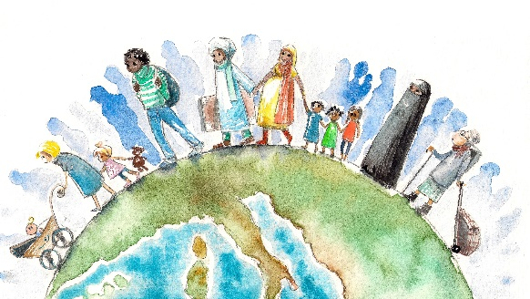
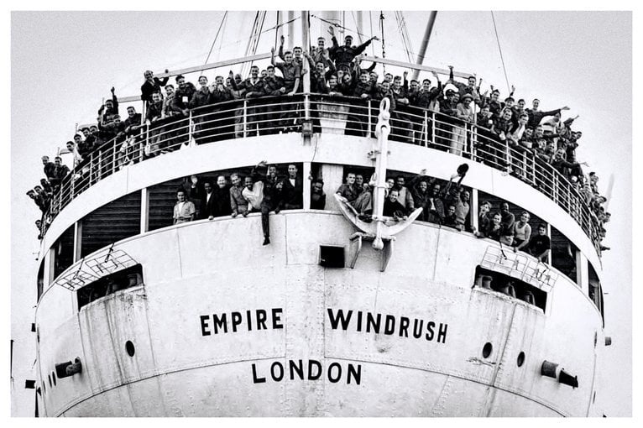


History Quiz 1
Name ………………………….
 | Question | A | B | C
1 | What does migration mean? | The traditions and beliefs that groups of people practice in their daily lives | The movement of people from one place to another. | Where people live and sometimes work.
2 | Who invaded Britain? | Vikings | The Mayan | Victorians
3 | Why did the Anglo Saxons come to Britain? | They were invited | They accidently came across Britain | For better ships
4 | During WWII, why did people come to Britain? | Jobs | Family | Sanctuary
5 | How did trade effect migration to the UK? | More jobs available | Better water access | More land
6 | Where did people from the Windrush Generation come from? | Asia | Caribbean | England
7 | When did WW2 begin? | 1939 | 1914 | 1066
8 | Vikings were known for… | Horses | Farming | longships
Total
Prior knowledge % | 1st Attempt % | 2nd attempt % | 3rd Attempt %


What else have you Learned
(optional)

