
Cycle A Autumn Term Year 1/2 History Knowledge Organiser
Main Learning
How did aeroplanes change the world?

Key Vocabulary
Aircraft | A vehicle that is able to fly by gaining support from the air.
Engine | a machine that produces motion or power for doing work
aviation | the flying or operating of aircraft
invention | Something new that has been created by someone.
Hot air balloon | a large balloon that is filled with heated air and that floats in the sky
legacy | Something that is left behind from the past
pilot | a person who is qualified to fly an aircraft or spacecraft.
gliders | aeroplanes with no engine
propeller | a device with blades that move around to push against air or water
Chronology | Past events that are in the order that they happened from oldest to newest. A timeline shows their chronology.

hot
(Sticky) Knowledge & Skills that I need to remember
- I know what life was like before aeroplanes were invented.

- I can find out different ways people tried to fly before the invention of aeroplanes

- I can find out about who the Wright brothers were and know why they are significant

- I can recall when the first flight was

- I can explain how aeroplanes have contributed to the world today

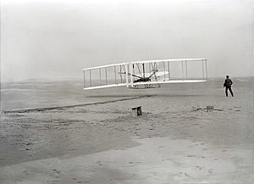
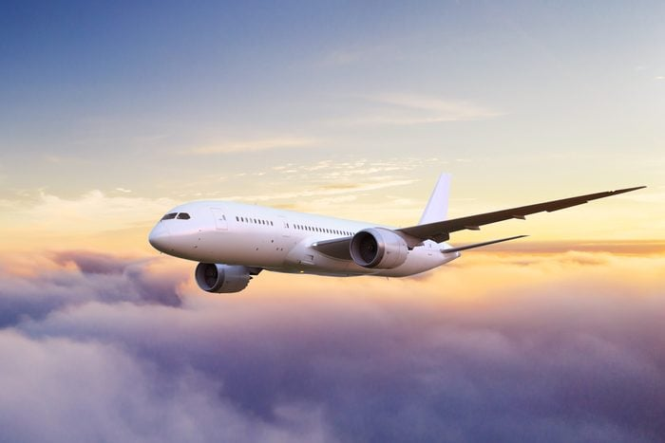

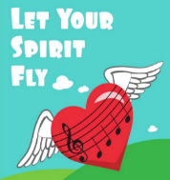
History Quiz 1
Name ………………………….

 | Question | A | B | C
1 | What was the first invention that was able to take people in the air? | Aeroplane | Hot air balloon | Helicopter
2 | When did the first flight take place? | 1903 | 1930 | 1805
3 | How did people travel before aeroplanes and cars were invented? | tractors | Horse-drawn carriages | Donkeys
4 | How did people try to fly before the invention of aeroplanes? | jumping | trampolines | ornithopters
5 | Who completed the world's first successful powered flight? | The Wright Brothers | the Montgolfier brothers | Neil Armstrong
6 | What is a glider? | A helicopter | A bird | An aeroplane with no engine

Total
Prior knowledge % | 1st Attempt % | 2nd attempt % | 3rd Attempt %

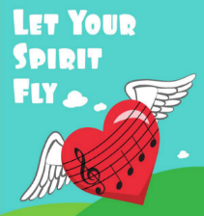
What else have you Learned
(optional)

