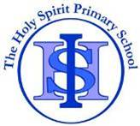
Cycle A Autumn Term Year 1/2 History Knowledge Organiser
Main Learning
How has our school changed within living memory?

Key Vocabulary
after | Later in time than, or behind in order
before | At an earlier time, in the past.
old | Having existed for many years; not new.
new | Having recently arrived, been produced or come into being.
past | Having happened or gone by at an earlier time
present | Existing at this time
century | One hundred years
chronology | The order of events in time
Similarity | likeness
Difference | The condition of being different from or not like something or someone else.

(Sticky) Knowledge & Skills that I need to remember
- I can learn about The History of the Holy Spirit School and the community of Halton Brook.

- I can recall when it was it first built.

- I can find out about when the School Fire was and when was rebuilt.

- I can find out what different games my grandparents used to play.

- I can compare how our school has changed today from the time of my parents and grandparents.

- I can understand a simple timeline to show when events happened in our local area.

- I can place pictures of significant places, people, events, in chronological order.

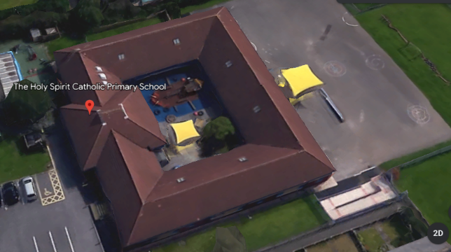
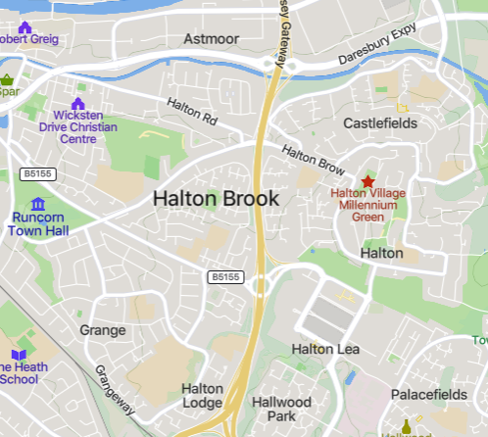

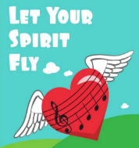
History Quiz 1
Name ………………………….

 | Question | A | B | C
1 | When was The Holy Spirit first built? | 1760 | 2000
2 | When did the fire happen at The Holy Spirit? | 2018 | A | 1560
3 | Following the fire, when did the school get rebuilt? | 1996 | 2015 | 1650
4 | Which games might your grandparents have played? | Hopscotch | Timetable Rock stars | Minecraft
5 | Why was Halton Brook estate built? | 1967 | 1980 | 1870
6 | How has the school changed today from the time of my parents and grandparents? | The hall | ICT suite | Headteacher’s office

Total
Prior knowledge % | 1st Attempt % | 2nd attempt % | 3rd Attempt %

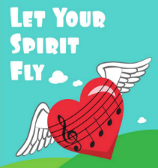
What else have you Learned
(optional)

