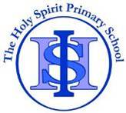
Cycle A Autumn Term Year 5/6 History Knowledge Organiser
Key Vocabulary
Transportation | A general word for all the methods people use to move themselves and their goods from one place to  another.
The Industrial Revolution | A time when the manufacturing of goods moved from small shops and homes to large factories.
efficiency | Operating or working in a way that  gets results, with little wasted effort.
developments | A process that creates growth, progress, positive change or the addition of physical, economic, environmental, social and  demographic components.
community | A group of people living in the same place or having particular  characteristic in common.
invention | The process of creating  something that has never been made before
manufacture | the process of turning raw materials  or parts into finished goods

Main Learning
Why is the history of transport so important in our local area?

(Sticky) Knowledge & Skills that I need to remember
- I can explain the different kinds of transport there have been in Runcorn. | - I understand that different civilizations were developing at the same time and where they first appeared.
- I can explain the challenges people in the past have had when using transport. | - I can identify the major achievements of the Ancient Civilizations
- I can understand how early transport held back developments in Runcorn. | - I can use images of artefacts
- I can understand how local people reacted to the Runcorn Bridge. | - I can say how pyramids could have been built using evidence.
- I can explain the difference these improvements in transport made to Runcorn. | - I can explain the greatest achievements of the Ancient Egyptians.
- I can explain why changes occur in the order they did. | - I can learn about ancient beliefs in different civilizations
- I can explain how far this transport continues to benefit the local community.

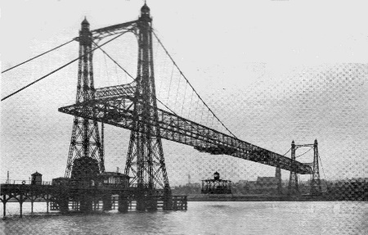

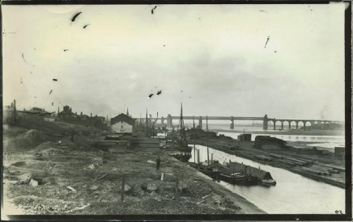
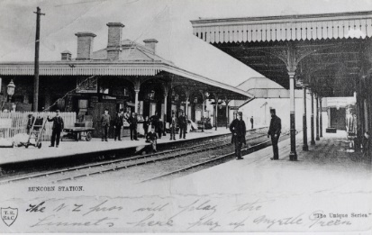

History Quiz 1
Name ………………………….
 | Question | A | B | C
1 | When did humans learn to domesticate animals and, use them for transport? | 4000BC | 1000 AD | 2000BC
2 | Which modes of transport were developed to aid The Industrial Revolution? | Aeroplane and tanks | Canals and Railway | Cars and Roads
3 | Which canals run through Runcorn? | Bridgewater and The Manchester Ship Canal | Leeds and Liverpool Canal | Trent and Mersey Canal
4 | What was the first modes of transport? | Bicycle | Walking and Horses | Steam engine trains and ships
5 | How does transport developments benefit the local community? | More jobs available | Pollution | Landscape
6 | What are the disadvantages of transport advancements? | Access to remote rural areas | Air Pollution | It’s quick
7 | The largest cities are connected by… | Country roads | Streets | motorways
8 | During their time in Britain, who built a network of roads connecting the main cities? | Anglo Saxons and Celts | Vikings | Romans

Total
Prior knowledge % | 1st Attempt % | 2nd attempt % | 3rd Attempt %


What else have you Learned
(optional)

