
Cycle A Autumn Term Year 3/4 History Knowledge Organiser
(Sticky) Knowledge & Skills that I need to remember
- I understand that different civilizations were developing at the same time and where they first appeared.

- I can identify the major achievements of the Ancient Civilizations

- I can use images of artefacts

- I can say how pyramids could have been built using evidence.

- I can explain the greatest achievements of the Ancient Egyptians.

- I can learn about ancient beliefs in different civilizations

Key Vocabulary
civilisation | a group of people with their own languages and way of life
dynasty | rulers who belong to the same royal family for generations. The term is also used to describe the era which that family ruled.
River valley | the natural channel/s which has/have been formed by a river.
irrigation | Irrigation is what farmers do when they add water to their fields.
achievements | Something achieved through hard work, courage or skill.
artefacts | a simple object (such as a tool or weapon) that was made by people in  the past.
settlement | Settlements are places where people live and sometimes work.
pyramids | A pyramid is a structure with four triangular sides. The pyramids were  built as tombs for the pharaohs.
beliefs | Is an idea that we hold as being correct

Main Learning
What do the 4 Ancient Civilisations have in common? How was Ancient Egypt similar or different to the other earliest cities?

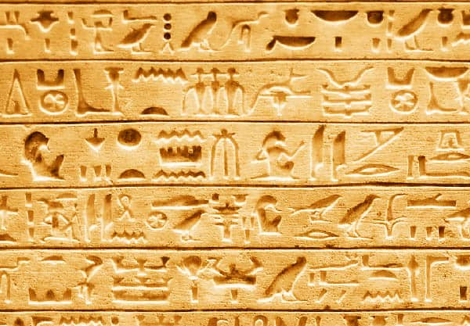
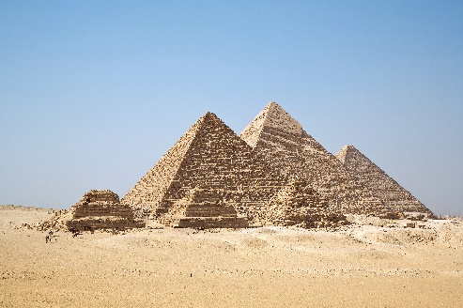


History Quiz 1
Name ………………………….
 | Question | A | B | C
1 | Approximately, when did the first civilisations appear? | 500 AD | 1000 BC | 3000 BC
2 | Where did the first ancient civilisation first appear? | Egypt | Mesopotamia | Mexico
3 | What is one major achievement of Ancient Sumer? | A ball | A computer | The Wheel
4 | What is one major achievement of Ancient Egypt? | hieroglyphic writing | cars | books
5 | What is one major achievement of Indus Valley? | sandstone | cities | buses
6 | What is one major achievement of Shang Dynasty? | Organised government | Pyramids | hieroglyphics
7 | Which is the tallest pyramid in Egypt? | Great Sphinx of Giza | The Great Pyramid of Giza | Red Pyramid
8 | Which rivers did the Sumerians rely on? | The Tigris and Euphrates | The River Nile | The River Mersey and the River Tame
Total
Prior knowledge % | 1st Attempt % | 2nd attempt % | 3rd Attempt %


What else have you Learned
(optional)

