Feasts and Seasons –
Through the year at Holy Spirit
Advent – the Church’s year begins
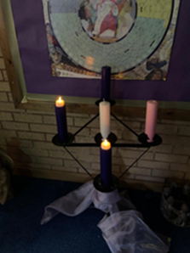
- Travelling Crib
- Advent Calendar
- Colour purple
- Advent Wreath

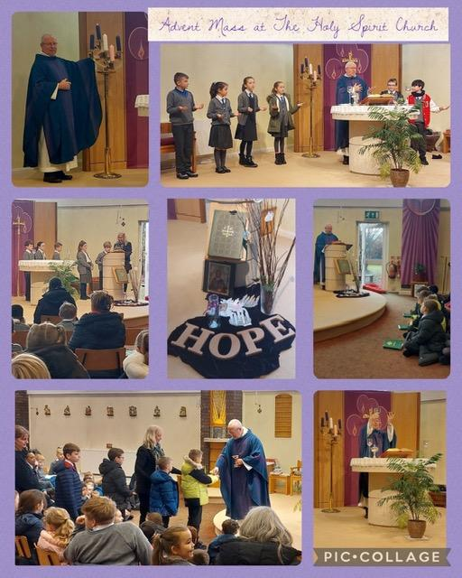
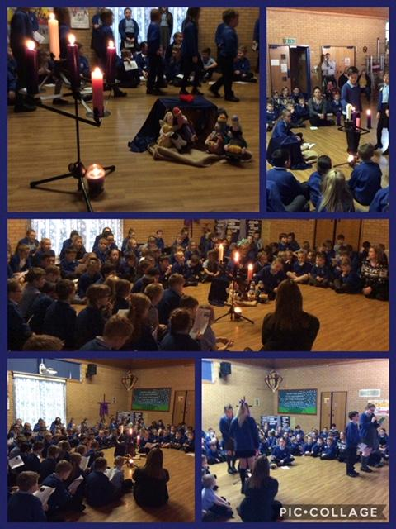

Christmas
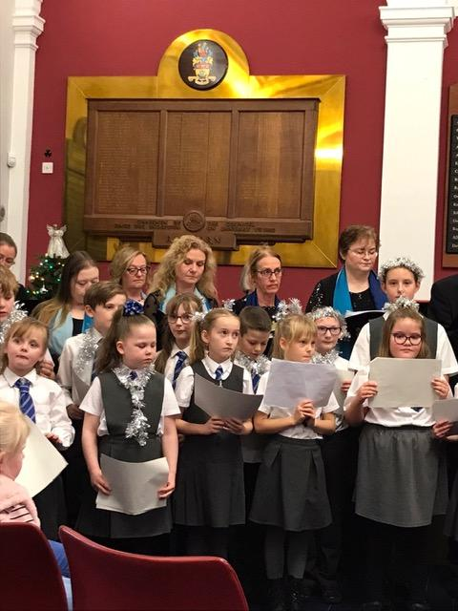

Spreading the Good News to the Mayor and people of Halton. Singing at the Town Hall.

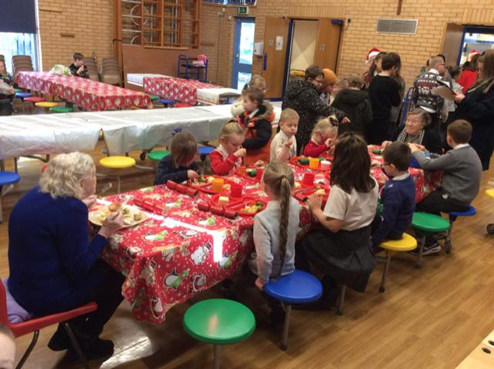
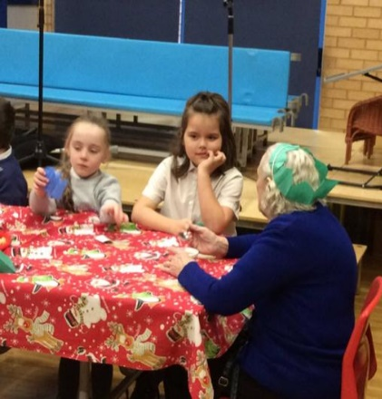

Sharing Christmas dinner with two parishioners

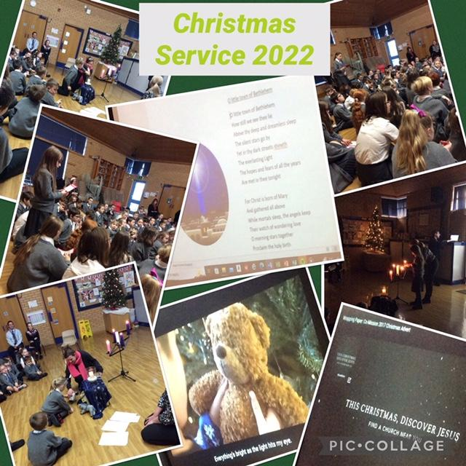

Epiphany – Christmastide – season of LIGHT

Lent
- Lenten bags to take home  - Lenten calendar  - Ashes on Ash Wednesday  - Saying sorry – Children following the sacramental programme receive the sacrament of forgiveness during Lent. | 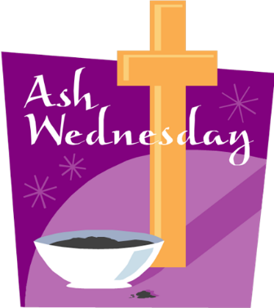
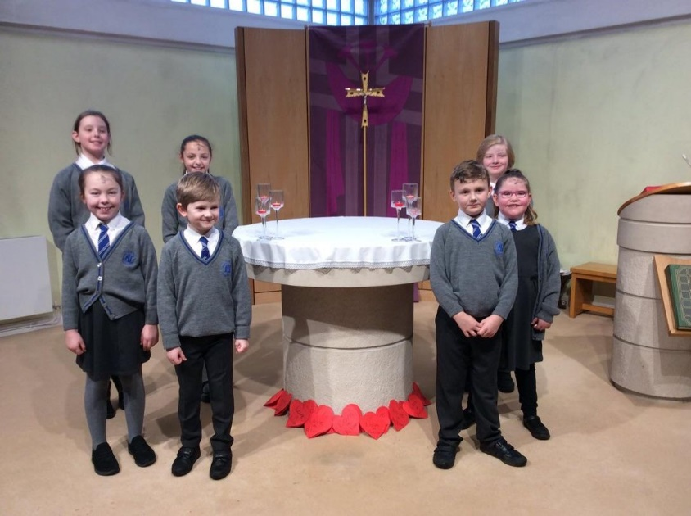  Mass on Ash Wednesday | Making clay footprints – we are following in the footsteps of Jesus.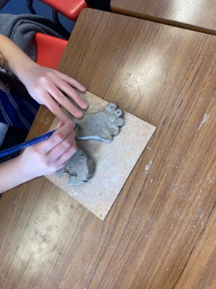
Holy Week – parents are invited to join us as we journey through Holy Week
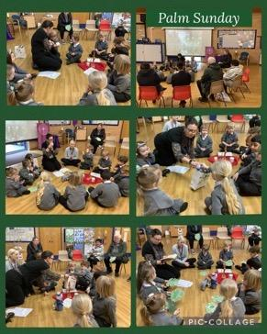

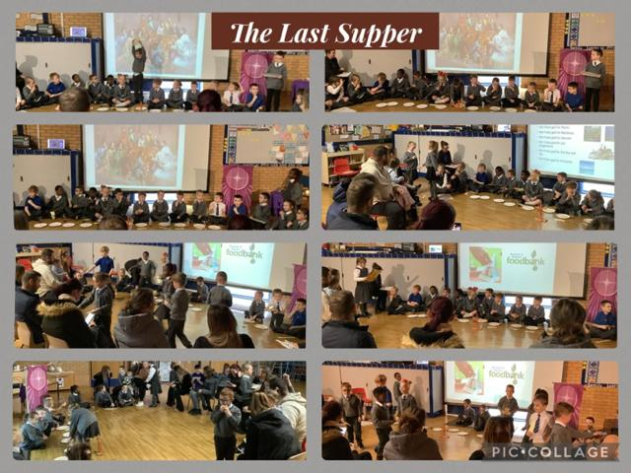
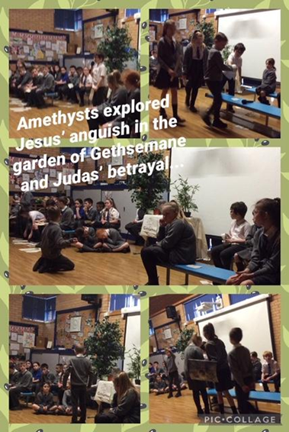 | 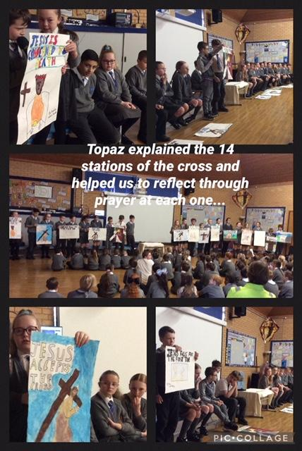
Easter
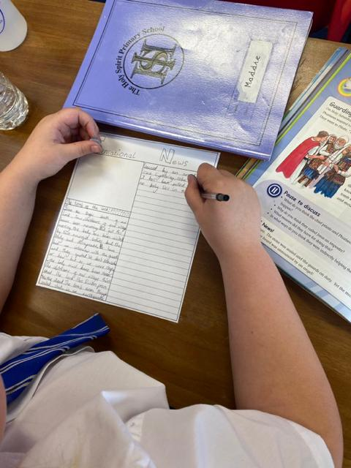
Telling the Good News – through Easter cards and recounting
the events of the resurrection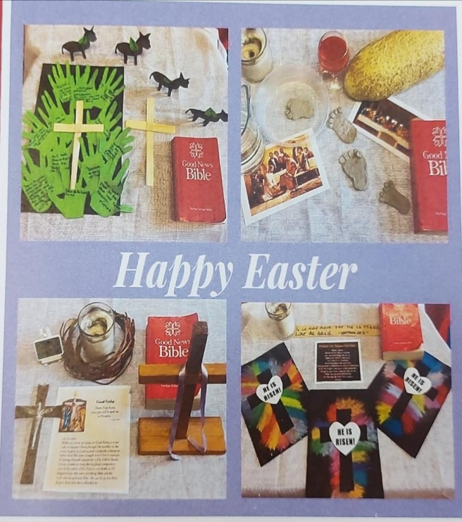

May – the month of Mary

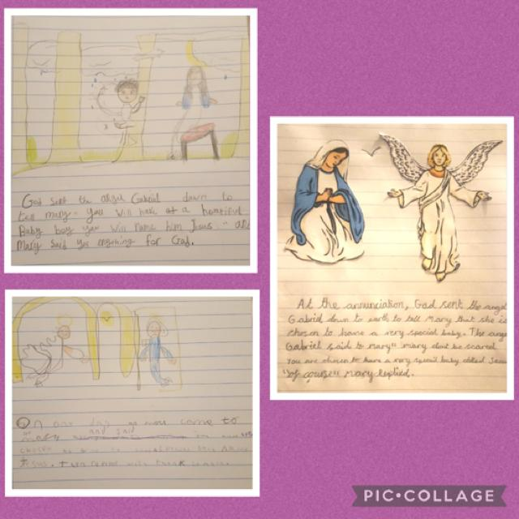

Sapphires acted out and then wrote about the Annunciation.
Pentecost - Birthday of the Church and our school feast day

 | 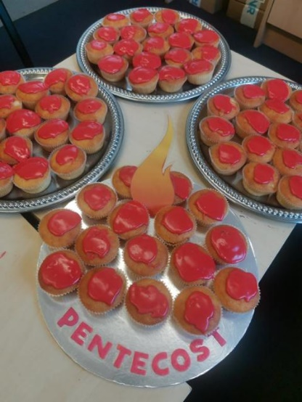
June
The feasts of the Sacred Heart and Body and Blood of Jesus. Children receive first communion around this time.

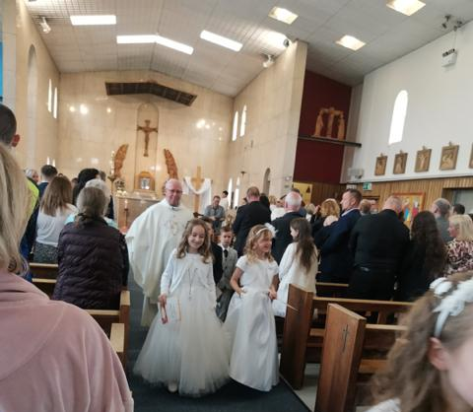 | 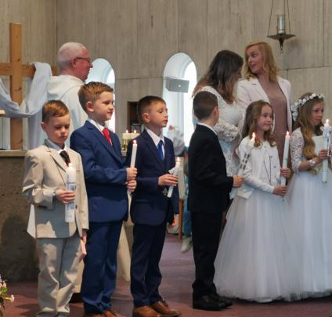
Feast of St. Peter and Paul – 29th June
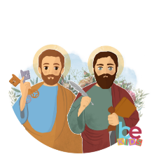

October – The month of Mary and the Rosary
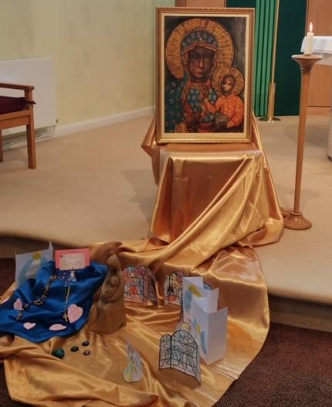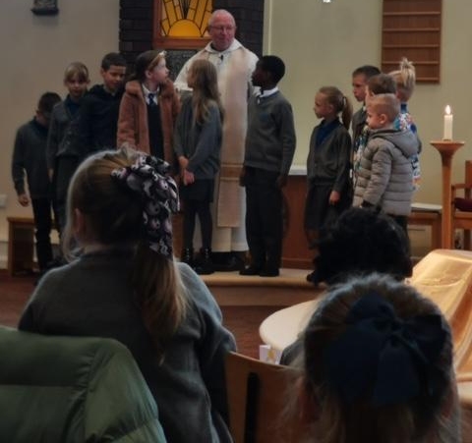
Praying for peace, praying the Rosary with Fr. Peter
November – Remembering all the saints; those of our family and friends who have died and those who have died in war.

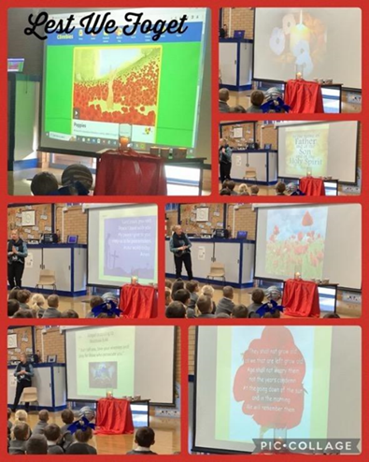 | We have a ‘Memory Book’ where people can fill in the names of those they would like us to remember in our prayers…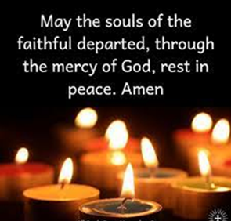
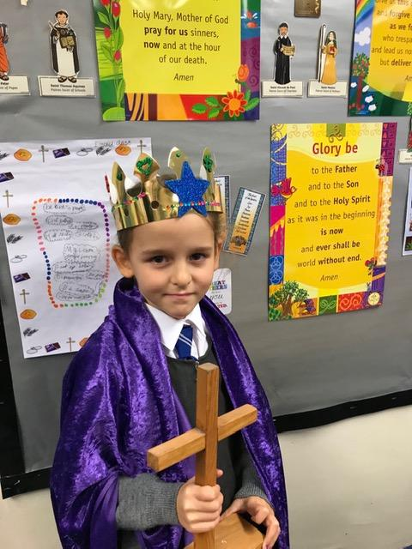 | The Feast of Christ the King brings the Church’s year to a close…  The cycle begins again with Advent!

