School Opening Hours

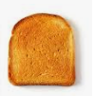
The Holy Spirit Catholic Primary School is a small school with a strong family ethos and serve the community of Halton Brook in Runcorn. We have five classes: Reception & Year 1, Year 1 /2, Year 3 /4, Year 5 and Year 6.

We have a breakfast club that opens at 8 am.
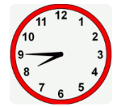
School gates open at 8.40am
Classroom doors open at 8.45am
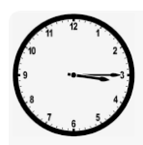
Doors close: 8.55 am
Home time: 3.15pm
School Run Clubs: 3.15pm- 4.15pm
This amounts to a total of 32.5 hours weekly.

