Pupil premium strategy statement

This statement details our school’s use of pupil premium funding to help improve the attainment of our disadvantaged pupils.

It outlines our pupil premium strategy, how we intend to spend the funding in this academic year and upcoming years and the effect that last year’s spending of pupil premium had within our school.

School overview
Detail
School name | Queen’s Park CE/URC Primary School
Number of pupils in school | 274– from Sept 26
Proportion (%) of pupil premium eligible pupils | 46% – from Sept 26
Academic year/years that our current pupil premium strategy plan covers (3 year plans are recommended) | 2026 – 2027  2027 – 2028  2028 - 2029
Date this statement was published | September 2026
Date on which it will be reviewed | Interim review: September 2027/September 2028  Full review: September 2029
Statement authorised by | Justine Bolan
Pupil premium lead | Jennie Kennedy
Governor / Trustee lead | Debbie Dowd

Funding overview
Year 1: 2026 - 2027
Detail | Amount
Pupil premium funding allocation this academic year | £287,880.00
Recovery premium funding allocation this academic year | £0.00
Pupil premium funding carried forward from previous years (enter £0 if not applicable) | £0.00
Total budget for academic year 2026 - 2027 | £287,880.00

Part A: Pupil premium strategy plan

Statement of intent
Our school vision ‘For with God, everything is possible’ and our CROWN curriculum underpins our intent for this pupil premium strategy.
Queen’s Park is a larger-than-average primary school serving a community with levels of socio-economic disadvantage that are above those seen nationally. It is located in St Helens, which is ranked 26th most deprived out of 317 local authorities in England and sits within the top 10% for deprivation nationally. Deprivation across the borough is widespread, with a significant proportion of pupils living in areas of high socio-economic need.
The proportion of pupils eligible for the Pupil Premium is above the national average. We recognise that many disadvantaged pupils face a range of barriers to learning, including weaker starting points in language and communication, limited access to wider experiences, and social and emotional needs that can affect engagement and readiness to learn.
We have a clear understanding of the specific challenges faced by our pupils and have prioritised the achievement of disadvantaged pupils within school improvement planning. We committed to ensuring that all pupils benefit from consistently high-quality teaching, alongside targeted academic support and wider strategies to address non-academic barriers, including attendance and wellbeing.
The Pupil Premium strategy is informed by evidence and is sharply focused on improving outcomes for disadvantaged pupils, particularly in communication and language, reading and writing. Leaders monitor the impact of their actions closely and adapt provision to ensure it remains responsive and effective in diminishing differences between disadvantaged pupils and their peers
In our strive to create a culture to support disadvantage, we consider the challenges faced by disadvantaged and other vulnerable children, such as those who have social workers, are young carers or who have experienced ACES. Our strategy outlines our intention to support all of these children including those who are in receipt of pupil premium.
Our intention is to maximise the potential of all pupil premium children by offering high quality of education through our bespoke Crown Curriculum, which is ambitious, inclusive and evidence informed and designed to give all pupils, particularly disadvantaged pupils, not only the academic strong foundations to thrive but also the cultural capital they need to succeed in life.
Our expectation is for all our children, inclusive of those who are disadvantaged to leave Queen’s Park as confident and resilient learners. It is the intention of Queen’s Park Primary School for the attainment of disadvantaged children to be improved alongside the progress of their disadvantaged peers, through consistent quality first teaching across school, supported by individualised, targeted intervention. Our monitoring ensures that rigorous tracking of the effectiveness of intended outcomes in this strategy is reviewed frequently and that any actions required align with our school development plan.
We acknowledge that the social, emotional and wellbeing needs of our children and families not only impact on the attendance at school but subsequently their academic progress. Relationships with parents and families are therefore at the heart of everything we do at Queen’s Park Primary. We therefore intend to promote the extensive personal development of disadvantaged pupils to give our pupils access to a wide and rich set of experiences. Emotional wellbeing is at the heart of our intent for all children’s personal development and we ensure our provision is targeted to our disadvantaged learners to ensure all children are emotionally ready to access our Crown Curriculum. We have a strong understanding of how the life experiences of our disadvantaged learners can impact on academic progress and emotional wellbeing and place significant importance on a ‘team around a child’ approach through our offer of extensive pastoral support to both the child and the wider family.
We believe that attendance at school is vitally important for all children but particularly for our disadvantaged learners. Our attendance team take a rigorous approach to monitoring the attendance of pupil premium children and offer bespoke, targeted support to families where required.
We provide a wide range of opportunities for our disadvantaged pupils to build their cultural capital in accordance with our vision to enable all our pupils to achieve everything possible.
This strategy has been written to indicate our drive to tackle disadvantage and as such we:
- Aim to identify the needs of pupil premium children in our school and any barriers to their possible progress and target these through appropriate intervention.
- Will target funding to accomplish our intended outcomes for the benefit of all children inclusive of pupil premium.
- Ensure that high quality and adaptive teaching provide appropriate support and challenge for disadvantaged pupils.
- Every action we take will be informed by national research and evidence of best practise for raising outcomes among disadvantaged from the EEF.
- Ensure that we achieve the most efficient use of resources and can respond to new challenges in a timely manner.
- Provide quality professional learning to teaching and support staff.
- Continuously monitor progress against our set objectives – redirecting and re-planning where necessary to achieve the desired outcomes.
- Monitor the progress of each individual pupil and ensure timely intervention where necessary.
- Work to lessen the gap in terms of progress and achievement between disadvantaged and non-disadvantaged pupils.
- Provide the very best opportunities for all pupils centred on a curriculum which is appropriately adapted and strives for ambition for all.

Challenges

This details the key challenges to achievement that we have identified among our disadvantaged pupils.
Challenge number | Detail of challenge
1 | Improving Attendance, Reducing Persistent Absentees and Ensuring School Readiness  Data analysis, knowledge of the pupils and families and pupil voice indicate that many of our disadvantaged pupils face multiple challenges beyond the school gate that can affect their learning, emotional wellbeing and participation in wider school life. Through our analysis, we identify that these pupils are often at greater risk of poor or inconsistent attendance due to socio-economic disadvantage and other contextual barriers.  At the end of the academic year 2024 – 2025, the attendance for our children in receipt of pupil premium was 93.8% which was above national data for pupil premium children which was 89.4%.  At the end of the academic year 2024 – 2025, 21% of our children in receipt of pupil premium were persistently absent. However, through targeted intervention over the academic year, this was still below the national rate of pupil premium children who were persistently absent which ended the year at 33%.  At the end of the academic year 2025 – 2026, the attendance for our children in receipt of pupil premium was 92.94%. National FSM – 88.38%  National gap is 19.59%. Gap at QP is 1.49%. - this is unvalidated data and will need to be checked when data set is released  At the end of the academic year 2025 – 2026, 13.9% of our children in receipt of pupil premium were persistently absent. However, through targeted intervention over the academic year, this was still below the national rate of pupil premium children who were persistently absent which ended the year at 36.06%.
2 | Securing Foundational Knowledge and Skills Across the Curriculum  Analysis of EYFS outcomes over time shows a gap between the attainment of pupil premium children and non-pupil premium children. At the end of the academic year 2024 – 2025, there was a gap of 6.3% between the attainment of pupil premium children and non-pupil premium children. At the end of the academic year 2025 – 2026, there was a gap of 18% between the attainment of pupil premium children and non-pupil premium children.  Analysis of phonics screening data over time shows a gap between the attainment of pupil premium children and non-pupil premium children. At the end of the academic year 2024 – 2025, there was a gap of 8.6% between the attainment of pupil premium children and non-pupil premium children. At the end of the academic year 2025 – 2026, there was a gap of 12% between the attainment of pupil premium children and non-pupil premium children.  Analysis of KS2 data from the end of the academic year 2024 – 2025 shows a continued stubborn gap between children in receipt of pupil premium compared with children not in receipt of pupil premium however our pupil premium children attainment for combined was 56.5% compared with 47% nationally. In 2025- 2026 68% of our children in receipt of pupil premium attained combined ARE. This is above national averages for all children.
3 | Addressing under-developed oral language skills and vocabulary gaps  Assessment, observation and pupil voice consistently highlight underdeveloped oral language skills and limited vocabulary among children entering early years. These challenges are further highlighted for children in receipt of pupil premium and without targeted support these challenges often persist into KS1 and KS2.  On entry in September 2025, 23% of children were assessed as on track during baseline assessment for listening, attention and understanding and 28% were assessed as on track for speaking and listening.  On entry in September 2026 46% of children were assessed as on track during baseline assessment for listening, attention and understanding and 40% were assessed as on track for speaking.
4 | Providing enrichment opportunities and experiences to meet on going needs of the school community  Families in our community frequently manage significant financial pressures, which can restrict access to enrichment opportunities at home. However, this reinforces the crucial role the school can play in unlocking pupil’s talents, skills and interests. By working in partnership with parents, we can ensure every child’s potential is nurtured and fully realised.
5 | Supporting vulnerable families and pupils with socio-economic or social, emotional and mental health difficulties  The support offered to vulnerable families and pupils has increased with rising incidents of social, emotional or mental health difficulties – particularly amongst our most disadvantaged pupils and families.

Intended outcomes
This explains the outcomes we are aiming for by the end of our current strategy plan, and how we will measure whether they have been achieved.
Intended outcome | Success criteria
Improve attendance and punctuality of targeted pupils and ensure school readiness. | To improve the attendance of disadvantaged pupils in order to tackle the gap against non-disadvantaged pupils.  To reduce the percentage of all pupils, including disadvantaged pupils, who are persistently absent.
Improve attainment and progress in reading, writing and mathematics | The attainment gap between disadvantaged and non-disadvantaged pupils reduces in reading, writing and mathematics.  Disadvantaged pupils make at least expected progress from their individual starting points, with accelerated progress for pupils identified as below their flightpath.  The proportion of disadvantaged pupils achieving the expected standard at KS2 increases year on year.  Pupils receiving targeted intervention demonstrate measurable progress against their identified starting point.  Pupil progress meetings identify disadvantaged pupils at risk of falling behind and result in timely adaptations to teaching or intervention
Improve attainment in language and communication at EYFS through positive impact of quality first teaching, targeted intervention, Talk for Writing and NELI programme. | Outcomes indicate that disadvantaged pupils are making sustained progress in narrowing the attainment gap in communication and language at EYFS.  To continue to tackle the attainment gap at GLD in EYFS with a sharp focus on communication and language.
Disadvantaged pupils have equitable access to enrichment and can articulate how experiences have developed their interests, knowledge, confidence and aspirations. | Through pupil voice, disadvantaged pupils can articulate aspirations for the future and know how their learning will support this.  Through monitoring of books and learning walks, the CROWN curriculum will be fully embedded to ensure a high-quality curriculum for all disadvantaged learners.  High uptake of extra-curricular activities in line with peers.
Develop pupil’s social, emotional and mental health so they fully access all aspects of school life. | Improved engagement within lessons of those pupils who have difficulty in regulating emotions.  Reduction in behaviour incidents and referrals related to social and emotional difficulties.  Higher attendance and punctuality rates particularly among disadvantaged pupils.  Evidence of effective use of social and emotional learning interventions through monitoring.  Positive feedback from parents and carers regarding their child’s wellbeing and support received.

Activity in this academic year (Year 1 2026– 2027 )
This details how we intend to spend our pupil premium this academic year to address the challenges listed above.

Teaching
Budgeted cost: £17300.00
Activity | Evidence that supports this approach | Challenge number(s) addressed
To offer an extensive internal and external programme of high quality, evidence-based CPD targeted to individual teacher’s and learning assistant’s needs and whole school priorities with a sharp focus on high quality first teaching, inclusive practice and strong foundations.  To ensure CPD provides understanding and engagement for school improvement priorities to ensure engagement with SIP targets to improve standards.  To ensure full implementation of the ECT statutory framework including specific CPD based on the needs of the individual ECT and whole school priorities. | EEF ‘Menu of Approaches’ Evidence Brief, September 2023: “Evidence indicates that high quality teaching is the most powerful way for schools to improve pupil attainment, particularly for socio-economically disadvantaged students. Schools should focus on building teacher knowledge and pedagogical expertise, curriculum development, and the purposeful use of assessment. This could include the selection of high quality curriculum materials or investment in the use of standardised assessments.”  EEF Guide to Implementation, May 2024:  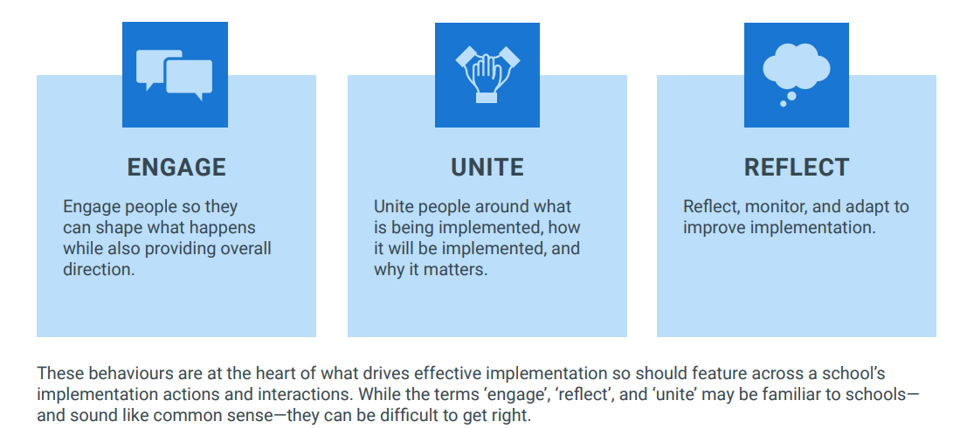  “When people work collaboratively during implementation, they can share knowledge and expertise, bounce ideas off each other, and solve problems together.”  “The factors that influence whether an individual or group can support implementation include the degree to which:  • they have the knowledge, skills, and expertise to help implement the intervention  • they feel empowered to act and can empower others  • they have agency—choice over actions—within their remit.”  “High quality professional development is a key strategy to support people to change their behaviour and practices. Professional development unites staff’s knowledge, skills, and practices, which supports implementation of a new approach.”  “Follow-on support should align with the best available guidance on effective professional development (see page 38 and the EEF’s guide to professional development76) and should include:  • building-in opportunities for teachers to revisit prior learning;  • arranging social supports so teachers can discuss problems, share insights, and provide peer support and assistance;  • modelling the delivery of new skills and strategies, for example, via demonstrations from expert practitioners;  • creating opportunities for teachers to rehearse techniques and prompt context specific repetition;  • providing supportive and formative feedback to improve techniques and set specific goals;  • encouraging teachers to monitor and reflect on their own performance;  • acknowledging teacher’s efforts and reinforcing key messages.”  EEF (2022) School Planning Guide: “Effective professional development is vital to support, develop, and sustain high quality teaching. As schools move forwards into the next academic year, professional development programmes are an important focus for school plans” The Guide discusses the importance of CPD be based on mechanisms in four groups:  building knowledge; • motivating teachers; • developing teacher techniques; and • embedding practice  NIOT’s Mentoring and coaching of teachers research report (July 2023): There is some evidence that mentoring can have small positive impacts on mentee pupil attainment and literacy. Mentoring can also lead to a range of positive outcomes for mentees, including improved teaching practice, confidence and self-belief, enhanced teacher student interactions, and an improved classroom environment.  Writing Framework July 2025: The new Writing Framework emphasizes that spelling should be taught systematically and practiced regularly, rather than relying solely on spelling tests. It highlights the importance of building a strong foundation in spelling, alongside handwriting, from Reception and continuing throughout primary school. The framework also suggests using strategies like dictation, revisiting known words, and exploring morphology and etymology to support spelling development. | 2,3
To embed a highly effective monitoring programme throughout school through a collaborative approach to monitor teaching (including pupil progress) and provide support/individualised CPD where required by SLT to engage, unite and reflect as identified in EEF research to implementation. |  | 2,3
To embed a high-quality coaching model throughout school to offer peer to peer support to improve teaching standards across school with a focus on strong foundations, oracy and targeted interventions for reading and writing for both teachers and teaching assistants.  To embed an ongoing coaching model for new leaders through in school support and through the facilitation of a professional learning curriculum to impact of high quality leadership (e.g. NPQs). |  | 2,3
To deploy 1 UPS x 0.6, 1 UPS x 0.25 and 1 Leadership Spine x0.25 to teach a specialised curriculum to Years 1, 2,3 4, 5 and 6 PPG and flightpath children, including offering a bespoke, modified curriculum to PPG children working on a modified curriculum. | EEF study into reducing class size: “Reducing class size appears to result in around one months' additional progress for pupils, on average.” This study shows that this is effective when class sizes are small, as ours are, and when teachers are able to teach differently which is evident with our approach.  EEF (2022) School Planning Guide on flexible grouping: “Allocate groups temporarily, based on current level of attainment. This could, for example, be a group that comes together to get some additional spelling instruction based on current need before re-joining the main class”  EEF (2022) School Planning Guide on scaffolding: “When pupils are working on a written task, provide a supportive tool or resource such as a writing frame or a partially completed example. Aim to provide less support of this nature throughout the course of the lesson, week, or term.”  EEF Special Educational Needs in Mainstream Classrooms (October 2021):  “The research suggests a group of teaching strategies that teachers should consider emphasising for pupils with SEND. Teachers should develop a repertoire of these strategies they can use flexibly in response to the needs of all pupils. — flexible grouping; — cognitive and metacognitive strategies; — explicit instruction; — using technology to support pupils with SEND; and — scaffolding.”  Every child achieving and thriving (SEND White Paper February 2026)  National SEND reform highlights the importance of mainstream schools developing inclusive provision that delivers early intervention, specialist support and access to an ambitious curriculum. The school's inclusion base reflects these principles by providing targeted academic, therapeutic and pastoral support that enables pupils with SEND and other vulnerabilities to remain successfully included within mainstream education. Through specialist expertise, adaptive practice and strong multi-agency partnerships, the provision removes barriers to learning, improves attendance, wellbeing and achievement.  Inclusion Bases in Mainstream Schools (June 2026)  The development of our school-led inclusion base reflects the national ambition for a more inclusive mainstream education system. Through targeted academic, pastoral and therapeutic support, we are ensuring disadvantaged pupils receive "the right support, in the right place, at the right time" whilst maintaining access to an ambitious mainstream curriculum. Our approach aligns with national expectations that schools become "truly inclusive", providing "high-quality, adaptive, early support" and building the capacity to meet a broader range of needs within mainstream education.  Disadvantaged pupils with SEND will successfully access ambitious mainstream learning through adaptive teaching, targeted intervention and inclusive provision, resulting in improved attendance, engagement and academic outcomes. | 2,3
To improve teaching and learning of phonics in line with early reading strategy through the subscription to the RWI online platform (including resources and training) and the commissioning of an external consultant to evaluate early reading provision and provide CPD.  To improve teaching and learning of spelling through application of phonics through the delivery of RWI spelling.  To improve the teaching of transcription skills through the implementation of the RWI handwriting programme. | EEF study into the teaching of phonics  Phonics has a positive impact overall (+5 months) with very extensive evidence and is an important component in the development of early reading skills, particularly for children from disadvantaged backgrounds.  EEF Improving Literacy in KS1 (October 2021):  “Consider the following when teaching a phonics programme: — Training: ensure all staff have the necessary pedagogical skills and content knowledge”  Writing Framework July 2025: The new Writing Framework emphasizes that spelling should be taught systematically and practiced regularly, rather than relying solely on spelling tests. It highlights the importance of building a strong foundation in spelling, alongside handwriting, from Reception and continuing throughout primary school. The framework also suggests using strategies like dictation, revisiting known words, and exploring morphology and etymology to support spelling development.  EEF Read Write Inc Phonics and Fresh Start – trail (October 2022): The EEF has conducted multiple evaluations of Read Write Inc Phonics and the findings show that it can support foundational reading knowledge, particularly for disadvantaged pupils. | 2
To continue to refine the curriculum and enhance teaching pedagogy to ensure oracy remains at the heart of the curriculum to develop children’s communication skills through the implementation of ‘The Oracy Project’ working in collaboration with network schools. | Moss and Washbrook (2016): found that pupils receiving FSM are 1.6 times more likely to be below language expectations at age 5 compared to their non-FSM peers. This gap grows to be twice as likely to be below language expectations by the age of 11.  Further research from EEF evidences that oral language interventions have a high impact on average (+6 months for primary age and +7 months during early years).  Voice 21 Oracy Across The Curriculum: The average impact of oral language interventions is 6 months additional progress over the course of the year. | 2,3

Targeted academic support
Budgeted cost: £167,605.20
Activity | Evidence that supports this approach | Challenge number(s) addressed
Deployment of a full time learning assistant in all classrooms to ensure effective support in lessons and also to deliver immediate feedback from teacher or LA (where possible) intervention 1:1 to identify misconceptions in line with school intervention strategies with a sharp focus on strong foundations.  LAs to also deliver specific, individualised interventions where required during afternoon sessions based on teacher assessments and use of diagnostic assessments. Intervention strategy to be underpinned by EEF’s: TARGET approach. These interventions include RWI phonics, RWI handwriting and delivery of the EEF spelling research project with School Improvement Liverpool.  Purchasing of specific intervention programmes, including digital programmes, as required (Reading Plus, Nessy, Time Tables Rockstars, led by teaching assistants where adult support is required. | EEF Study into one to one tuition: “Evidence indicates that one to one tuition can be effective, delivering approximately five additional months’ progress on average.”  The use of digital technology to supplement quality first teaching is highlighted by EEF to have a positive impact on learning.  EEF study into feedback:  EEF research shows that feedback and self regulation are high impact strategies – this can be promoted and embedded in classrooms with additional staff and training.  EEF study into teaching assistants:  Research which focuses on teaching assistants who provide one to one or small group support shows a stronger positive benefit of four additional months on average.  EEF (2022) School Planning Guide on diagnostic assessments: Diagnostic assessments provide opportunities to reflect on pupils’ thinking, strengths, and weaknesses. They can give useful insights into learning, adding to the richness of the information teachers hold about their pupils.  EEF (2022) School Planning Guide on TARGET approach:  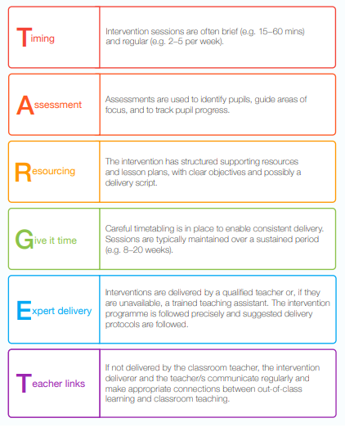  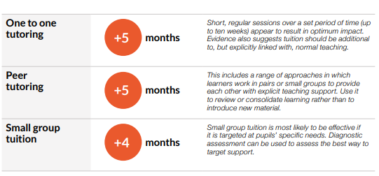  EEF – Trial – Spelling Matters Programme  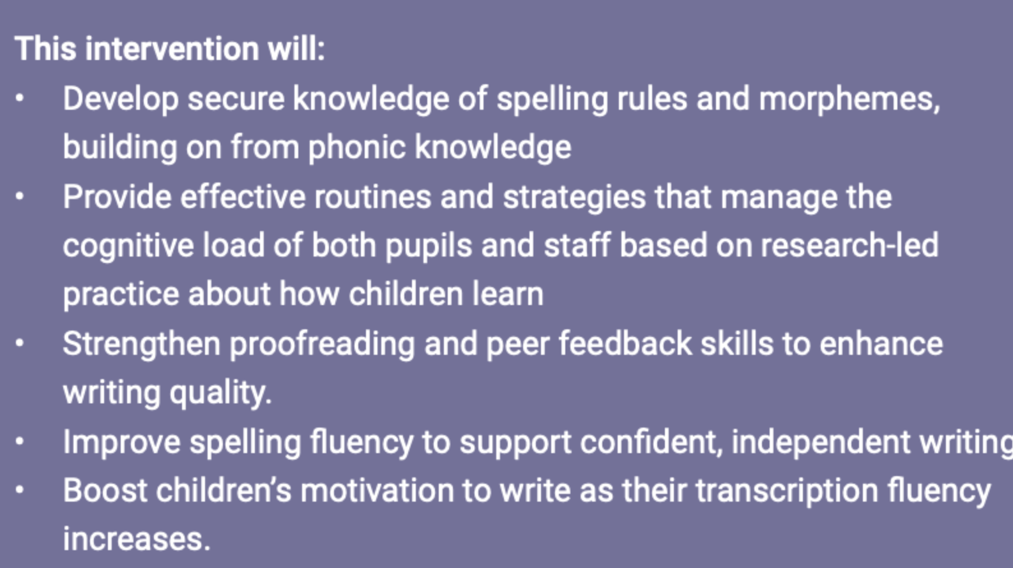 | 2,3
To purchase subscription to NELI to provide targeted intervention in EYFS and KS1 to develop speech and language skills. | EEF research into oral language intervention:  “Overall, studies of oral language interventions consistently show positive impact on learning, including on oral language skills and reading comprehension. On average, pupils who participate in oral language interventions make approximately five months' additional progress over the course of a year.”  “All pupils appear to benefit from oral language interventions, but some studies show slightly larger effects for younger children and pupils from disadvantaged backgrounds (up to six months' additional progress).”  EEF Preparing for Literacy (2022):  The Education Endowment Foundation (EEF) highlights the significant impact of communication and language approaches on early learning, suggesting a potential for seven months' additional progress in young children. The EEF emphasizes the importance of high-quality adult-child interactions, explicit vocabulary teaching, and a range of strategies that include vocabulary development, language skills, talk, and social communication.  Ofsted Strong Foundations in First Years of School (2024)  Ofsted report "Strong foundations in the first years of school", emphasizes that language development is crucial for early learning and should be a priority in the curriculum.  Voice 21 Oracy Across The Curriculum: The average impact of oral language interventions is 6 months additional progress over the course of the year. | 3

Wider strategies
Budgeted cost: £110,233.35
Activity | Evidence that supports this approach | Challenge number(s) addressed
To deploy an attendance team in school led by the Pastoral Manager (ML), including the appointment of an attendance officer to improve attendance and punctuality of PPG children to ensure they are in school and ready to learn.  To work alongside authority’s statutory EWO service to target Pas and those PPG children at risk of being a PA.  To offer breakfast club to identified children to improve attendance. | DFE Link between attendance and attainment: “in general, the higher the overall absence rate across the KS, the lower the likely level of attainment at the end of KS2.”  DFE Improving Attendance at School: “There is a clear link between poor attendance at school and lower academic achievement.”  EEF (2022) School Planning Guide on attendance “There is some evidence of promise for several strategies including parental engagement approaches and responsive interventions to target the individual causes of low attendance.” Attendance Interventions Rapid Evidence Assessment (EEF, 2022)”  DFE Working Together to Improve School Attendance (2024): The DfE guidance has been informed by engagement with schools that have significantly reduced levels of absence and persistent absence.  DFE The Link between attendance and attainment (2025): At KS2, pupils who attended school nearly every day in Year 6 (with an attendance rate of 95-100%) were 1.3 times more likely to achieve the expected standard in reading, writing and maths compared to pupils who only attended 90-95% of the time. This means missing just 10 days of year 6 reduced the likelihood of reaching the expected standard by around 25%. Pupils who attended nearly every day were 1.8 times more likely to achieve the standard than persistently absent pupils who only attend 85-90% of the time (relating to 4 -6 weeks more time in school).  GOV.Uk (April 2025): Free Breakfast Clubs: Guidance for school and trusts: This paper outlines the progress evident in the early adopter schools. | 1, 2, 5
To employ a pastoral assistant to support behaviour and emotional wellbeing across school.  Provision of CPD in relation to understanding behaviours and social, emotional and mental health needs.  To offer nurture groups or 1:1 nurture sessions for identified children using DESTY as a resource or lego therapy or OPAL where applicable.  To subscribe to BOXALL online to track impact of nurture based interventions and identify target areas and next steps to ensure targeted intervention. | EEF study into social and emotional interventions: “On average, SEL interventions have an identifiable and valuable impact on attitudes to learning and social relationships in school. They also have an average overall impact of four months' additional progress on attainment.”  EEF study into behaviour interventions:“ Evidence suggests that, on average, behaviour interventions can produce moderate improvements in academic performance along with a decrease in problematic behaviours. Impacts are larger for targeted interventions matched to specific students with particular needs or behavioural issues than for universal interventions or whole school strategies.” | 2, 5
To commission an in-house counsellor for 1 day per week to provide counselling support for identified vulnerable children. | EEF study into social and emotional interventions: “On average, SEL interventions have an identifiable and valuable impact on attitudes to learning and social relationships in school. They also have an average overall impact of four months' additional progress on attainment.” | 5
To employ full time pastoral lead and full time pastoral assistant to work alongside families and offer early intervention.  To lead on EHATS/FAM and liase with external services in providing a package of support to families. | Many children eligible for PP at Queens Park have barriers to learning involving social and economic issues in the family. These barriers can present in challenging behaviours at times. Addressing these issues through family support has had a proven effect in raising attendance and achievement and can be shown in case studies. | 1,2, 5
To provide extracurricular activities - open to all children with priority given to disadvantaged children.  To subsidise opportunities for experiential learning including school trips and resources.  To offer additional boosters to targeted children through various after school activities.  To provide Easter school for children in Year 6 in preparation for end of key stage assessments.  To offer a summer school to provide enhanced transition to targeted EYFS PP children to ensure a successful transition to primary school. | EEF study into extending school time: “The evidence indicates that, on average, pupils make two additional months' progress per year from extended school time and in particular through the targeted use of before and after school programmes. There is some evidence that disadvantaged pupils benefit more, making closer to three months’ additional progress.”  EEF (2022) School Planning Guide in relation to transition: “A main area for development is support for pupils from disadvantaged backgrounds transitioning between primary and secondary school—anticipating risk points and deliberately building the support needed to set every child up for success”  EEF Teaching and Learning Toolkit:  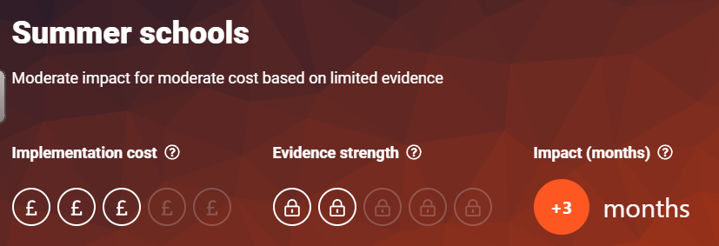 | 2,4,5
To offer extensive support for parent/carers (Stay and plays, Open Events, Parent workshops and parent engagement sessions) to support them in fully engaging with their learning. | EEF Parental Engagement: Levels of parental engagement are consistently associated with improved academic outcomes. Practical approaches, such as supporting share book reading or tailoring positive communications about learning can prove actionable for schools.

Total budgeted cost: £295,138.55

Part B: Review of outcomes in the previous academic year

Outcomes for disadvantaged pupils
This details the impact that our pupil premium activity had on pupils in the 2025 to 2026 academic year.
Impact Report: Pupil Premium Provision 2025 – 2026
Data 2025 -2026
Statutory Assessment Points | Pupil Premium |  | Non- Pupil Premium
GLD -EYFS | 8/13 - 62% |  | 20/25 80%
Year One PSC | 22/27 -81% |  | 25/27 – 93%
MTC | 13/25 – 52% |  | 27/33 – 82%
Year Six Outcomes | RWM - 24/35 – 66% (NA – 49%)  Reading 27/35 – 77% (NA 63%)  Writing 30/35 86% (NA 60%)  Maths 26/35 – 74% (NA 62%)  GPS -25/35 – 71% (NA 61%) |  | RWM - 18/24 – 75% (NA – 70%)  Reading 20/24 – 83% (NA 81%)  Writing 21/24 86% (NA 79%)  Maths 21/24 – 86% (NA 82%)  GPS -22/24 – 92% (NA 80%)
Provision: | Estimated cost: | Outcomes/Impact Evaluation
To offer an extensive internal and external programme of high quality, evidence-based CPD targeted to individual teacher’s and learning assistant’s needs and whole school priorities with a sharp focus on high quality first teaching.  To ensure CPD provides understanding and engagement for school improvement priorities to ensure engagement with SIP targets to improve standards.  To embed a highly effective monitoring programme throughout school through a collaborative approach to monitor teaching (including pupil progress) and provide support/individualised CPD where required by SLT to engage, unite and reflect as identified in EEF research to implementation.  To embed a high-quality coaching model throughout school to offer peer to peer support to improve teaching standards across school with a focus on early reading for both teachers and teaching assistants.  To deploy UPS x 0.4 and x1 MPS 0.5, 1 Leadership Spine x0.6 to teach a specialised curriculum to Years 2, 3, 4 and 6 PPG and flightpath children, including offering a bespoke, modified curriculum to PPG children working on a modified curriculum.  To improve teaching and learning of phonics in line with early reading strategy through the subscription to the RWI online platform (including resources and training) and the commissioning of an external consultant to evaluate early reading provision and provide CPD. | £77160 | - The school has developed an extensive internal and external programme of professional development for teachers and learning assistants. CPD has been closely aligned to individual professional development needs, school improvement priorities and the specific barriers experienced by disadvantaged pupils.  - There has been a strong focus on high-quality first teaching, ensuring that teachers and learning assistants have the knowledge, strategies and confidence to identify gaps early, adapt teaching appropriately and provide effective support without creating unnecessary dependency.  - Professional development has included a combination of whole-school training, targeted support, external expertise, coaching and opportunities for staff to reflect on and apply new learning in practice.  Impact  - Staff knowledge and confidence have been strengthened in areas directly linked to pupil outcomes.  - Professional development is increasingly connected to identified pupil need rather than being viewed as a series of standalone training events.  - Teachers and learning assistants have greater understanding of how high-quality classroom practice can reduce barriers for disadvantaged pupils.  - CPD has strengthened consistency in teaching approaches across year groups.  - Staff development has supported a greater focus on identifying and addressing misconceptions and gaps in learning at the earliest opportunity.  - The approach has contributed to a culture in which professional development is increasingly viewed as an ongoing process of implementation, reflection and refinement.  - 100% of staff that completed the CPD agreed that CPD provided by the school has positively impacted on their practice in the classroom  - 100% of staff further agreed that CPD had a positive impact on pupil learning, engagement and outcomes.  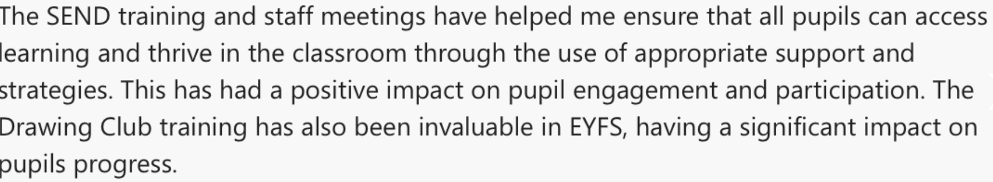  Engagement with School Improvement Plan priorities  Impact  - There is stronger alignment between professional development and school improvement priorities.  - Staff are increasingly able to articulate the rationale behind key school improvement strategies.  - Implementation of agreed approaches is monitored rather than assuming that attendance at training equates to successful implementation.  - Leadership discussions increasingly focus on the impact of professional development on teaching quality and pupil learning.  - The approach has strengthened collective responsibility for improving outcomes for disadvantaged pupils.  3. Collaborative monitoring and responsive support  Impact  - Monitoring provides leaders with a clearer understanding of the quality and consistency of provision.  - Pupil progress information is increasingly used alongside qualitative evidence to identify pupils requiring additional support.  - Staff receive more precise feedback linked to classroom practice and pupil need.  - Identified areas for development can be addressed through targeted CPD and coaching.  - The approach has strengthened professional dialogue and collective accountability.  - Monitoring has enabled the school to identify where additional provision should be adapted, intensified or discontinued.  - This approach supports the EEF principle that implementation should be treated as a process rather than a single event, with leadership creating the conditions for sustained change.  Whole-school coaching model  Impact  - Staff have increased opportunities to observe, discuss and refine effective practice.  - Coaching has strengthened professional collaboration across the school.  - Teachers and learning assistants have developed greater consistency in early reading approaches.  - The focus on early reading has supported the identification and reduction of gaps in pupils' foundational reading knowledge.  - Coaching has provided a mechanism for sustaining CPD beyond the initial training event.  - Staff are increasingly encouraged to reflect on the impact of their practice and make evidence-informed adjustments.  Targeted specialist teaching for pupil premium, children with SEN and flightpath pupils  Impact  - Additional staffing capacity has enabled the school to provide more targeted teaching for pupils identified as requiring additional support.  - Pupils have benefited from smaller-group and more focused teaching opportunities.  - Teaching has been increasingly responsive to individual starting points and identified gaps.  - Pupils working on a modified curriculum have received a more appropriate and coherent learning pathway.  - The provision has supported pupils to develop greater confidence and engagement in learning.  - Flightpath information has enabled leaders and teachers to identify pupils who may require additional intervention to remain on track.  - Targeted teaching has complemented rather than replaced high-quality classroom provision.  6. Strengthening early reading and phonics.  Impact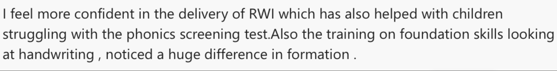  - Phonics teaching is consistent across the school.  - Staff have improved access to high-quality phonics resources and training.  - Staff have strengthened their teaching of phonics and this contributed to 81% of pupil premium pupils meeting the Year 1 Phonics Screening Check and 96% of pupil premium pupils in Year 2 meeting the expected standard, above national outcomes for this group."  - Assessment information is increasingly used to identify pupils requiring additional support.  - Pupils who are at risk of falling behind are identified earlier and provided with targeted support.  - The external review has provided leaders with additional challenge and assurance regarding the quality of early reading provision.  - Strengthened early reading provision provides disadvantaged pupils with improved access to the wider curriculum.  - PSC data for children in year one was above national  - 81% of children in receipt of PPG achieved. 96% in year 2  - This is above national for this pupil group
Deployment of a full time learning assistant in all classrooms to ensure effective support in lessons and also to deliver immediate feedback from teacher or LA (where possible) intervention 1:1 to identify misconceptions in line with school intervention strategies  LAs to also deliver specific, individualised interventions where required during afternoon sessions based on teacher assessments and use of diagnostic assessments. Intervention strategy to be underpinned by EEF’s: TARGET approach.  Purchasing of specific intervention programmes, including digital programmes, as required (Reading Plus, Nessy, Time Tables Rockstars, led by teaching assistants where adult support is required.  To purchase subscription to NELI to provide targeted intervention in EYFS and KS1 to develop speech and language skills. | £119,840 | Impact of Learning Assistant Deployment and Targeted Intervention  The strategic deployment of full-time learning assistants across classrooms has strengthened the school's capacity to provide timely, responsive and purposeful support for disadvantaged pupils. Learning assistants work alongside teachers to ensure pupils can access learning effectively, while maintaining a clear focus on developing independence and avoiding unnecessary adult dependency.  Learning assistants provide immediate feedback and clarification during lessons, enabling misconceptions to be identified and addressed at the point of learning. This has increased opportunities for pupils to revisit, practise and secure key knowledge before misconceptions become embedded. The approach has also enabled teachers to receive more immediate information about pupils' understanding and use this to inform subsequent teaching.  The use of learning assistants to deliver individualised interventions has strengthened the school's ability to respond to identified gaps in learning. Interventions are informed by teacher assessment and diagnostic assessment, ensuring that support is increasingly precise and focused on the specific knowledge or skills pupils need to develop.  The school's intervention approach is underpinned by evidence-informed principles, including the EEF's TARGET approach, with an emphasis on identifying need, providing appropriately targeted support, monitoring progress and adapting provision where required. This has strengthened the consistency and purpose of intervention across the school.  The purchase of targeted intervention programmes, including Reading Plus, Nessy and Times Tables Rock Stars, has increased opportunities for disadvantaged pupils to practise and consolidate key skills. Learning assistants provide additional adult support where required, ensuring that pupils can engage effectively with these programmes and that digital intervention complements, rather than replaces, high-quality teacher-led instruction.  52% of children in receipt of PPG scored full marks on the MTC . This is above national for all pupils  81% of children in receipt of PPG passed their PSC – this in line with all children nationally.  66% of children in receipt of PPG met ARE for combined reading, writing and maths. This is above all pupils nationally and significantly above PPG group nationally  The impact of targeted reading provision has been particularly important in strengthening pupils' fluency, comprehension and reading independence, while targeted mathematics programmes have provided additional opportunities to develop automaticity and confidence with multiplication facts. Programme information is considered alongside teacher assessment and classroom performance to ensure that progress demonstrated through intervention translates into wider learning.
To deploy an attendance team in school led by the Pastoral Manager (ML), including the appointment of an attendance officer to improve attendance and punctuality of PPG children to ensure they are in school and ready to learn.  To work alongside authority’s statutory EWO service to target Pas and those PPG children at risk of being a PA.  To offer breakfast club to identified children to improve attendance.  To employ a pastoral assistant to lead on behaviour across school. To track behaviour through CPOMs, offer early intervention, work alongside parents and external professionals where necessary.  Provision of CPD in relation to understanding behaviours.  To offer nurture groups or 1:1 nurture sessions for identified children using DESTY as a resource or lego therapy or OPAL where applicable.  To subscribe to BOXALL online to track impact of nurture based interventions and identify target areas and next steps to ensure targeted intervention.  To commission an in-house counsellor for 1 day per week to provide counselling support for identified vulnerable children.  To employ full time pastoral lead and full time pastoral assistant to work alongside families and offer early intervention.  To lead on EHATS/FAM and liase with external services in providing a package of support to families.  To provide extracurricular activities - open to all chil-dren with priority given to disadvantaged children.  To subsidise opportunities for experiential learning including school trips and resources.  To offer additional boost-ers to targeted children through various after school activities.  To provide Easter school for children in Year 6 in preparation for end of key stage assessments.  To offer a summer school to provide enhanced tran-sition to targeted EYFS PP children to ensure a suc-cessful transition to prima-ry school. | £83500 | Impact of Attendance, Behaviour, Pastoral and Wider Opportunities Provision  The strategic deployment of an attendance team led by the Pastoral Manager, including a dedicated Attendance Officer, has strengthened the school's capacity to identify and respond to attendance and punctuality concerns for disadvantaged pupils. Attendance is monitored closely, enabling emerging concerns to be identified at an earlier stage and followed up promptly with families. This has increased the school's ability to remove practical and pastoral barriers to attendance and ensure that pupils are in school, on time and ready to learn.  Overall attendance for the whole school was in line with NA at 94.2%  Close collaboration with the local authority's statutory Education Welfare Officer service has strengthened the school's response to persistent absence and pupils at risk of becoming persistently absent. This partnership has enabled the school to escalate concerns appropriately, secure additional support for families and maintain a clear focus on improving attendance as a key contributor to educational outcomes.  The provision of a breakfast club for identified pupils has provided a practical response to barriers affecting punctuality and morning attendance. It has supported pupils to arrive at school in a calm and positive way, ready to begin learning, while providing an additional opportunity for pastoral staff to build positive relationships with pupils and families.  The appointment of a Pastoral Assistant has strengthened the school's capacity to identify and address pastoral concerns at an early stage. Concerns are systematically tracked through CPOMS, enabling patterns and emerging concerns to be identified and appropriate support to be put in place. Early intervention, close work with parents and collaboration with external professionals have enabled the school to respond more effectively to individual needs and reduce the risk of behavioural difficulties becoming barriers to learning.  CPD focused on understanding behaviour has strengthened staff knowledge and confidence in identifying the underlying factors contributing to behaviour. This has supported a more consistent, relational and preventative approach across school, with staff increasingly able to consider behaviour as a form of communication and respond appropriately to individual need.  Targeted nurture provision, including 1:1 and small-group sessions using resources and approaches such as DESTY, Lego Therapy and OPAL, has provided identified pupils with opportunities to develop emotional regulation, communication, social skills, confidence and positive relationships. Provision is matched to individual need and has enabled pupils who experience barriers to engagement to develop the skills required to participate more successfully in classroom learning and wider school life.  The use of BOXALL Online has strengthened the school's ability to assess and monitor pupils' social and emotional development. This provides a more systematic approach to identifying areas of need, measuring progress and determining appropriate next steps. As a result, nurture provision is increasingly based on identified need and evidence of pupil response rather than being a generic intervention.  The commissioning of an in-house counsellor for one day each week has increased access to specialist emotional support for identified vulnerable pupils. This has provided pupils with a consistent and confidential opportunity to explore emotional difficulties, develop coping strategies and strengthen their readiness to engage with learning. The provision also increases the school's capacity to respond at an earlier stage before difficulties escalate.  The school's extracurricular and enrichment programme has provided disadvantaged pupils with increased access to experiences beyond the classroom. Activities are available to all pupils, with priority given to disadvantaged children where appropriate. This has supported pupils' confidence, interests, relationships and sense of belonging while ensuring that financial circumstances do not prevent participation in the wider life of the school.  Subsidised school trips and experiential learning opportunities have reduced financial barriers to participation and enabled disadvantaged pupils to benefit from experiences that broaden their knowledge, vocabulary, cultural understanding and aspirations. These opportunities contribute to the school's wider curriculum and support pupils to make meaningful connections between classroom learning and the wider world.  Targeted after-school boosters and additional learning opportunities have provided pupils with further opportunities to consolidate learning, address gaps and build confidence. These have been particularly valuable for pupils requiring additional practice or support to secure key knowledge and prepare for future learning.  The Year 6 Easter School has provided targeted pupils with additional preparation for end-of-key-stage assessments. The additional time has enabled pupils to revisit key knowledge, address misconceptions and develop confidence with assessment approaches in a supportive environment. This complements, rather than replaces, the high-quality teaching pupils receive during the school day.  The EYFS Summer School has strengthened transition for targeted disadvantaged pupils entering Reception. Providing additional opportunities to become familiar with the school environment, routines, adults and peers has supported pupils to develop confidence and familiarity before starting school. This has helped to reduce potential transition barriers and establish positive foundations for engagement and learning from the beginning of Reception.  Overall impact  The combined attendance, behaviour, pastoral and enrichment provision has strengthened the school's ability to address the wider barriers that can prevent disadvantaged pupils from being ready to learn and fully engaged in school life.

Externally provided programmes

Programme | Provider
Phonics, Spelling and Handwriting | Read Write Inc
Multiplication Facts Intervention  Number Bots | Times Tables Rockstars
Reading Intervention | Reading on your head
Phonics | Nessy  RWI Portal

