Queen’s Park CE/URC Primary school is incredibly proud of its duel denominational heritage.
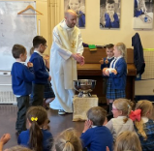
We have three churches that we work alongside: St Luke’s COE, Newtown URC and Ormskirk Street URC. All of our churches work in a meaningful, reciprocal and vision-driven partnership with each other and offer fantastic support. Each of our three churches has worships with our whole school community regularly:
St Lukes CE Eccleston - Members of the Ministry Team visits school monthly to lead worship. We have one foundation governor from St Lukes, Kate, she is committed to our school.
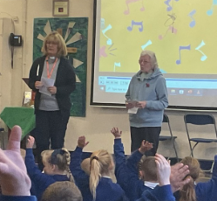
Ormskirk Street URC - Our 'Worship Warriors' come from Ormskirk Street to lead worship every month along with Rev Cath. We have three governors that are from Ormskirk Street: Rev. Cath, Ann and Margret.
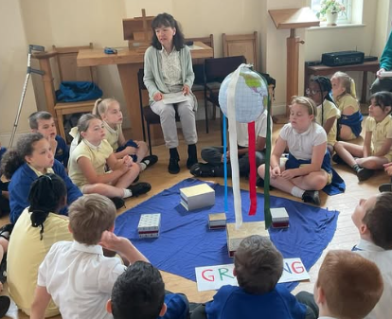
Newtown URC - Rev Diane comes to deliver worship at our school half termly - the children really enjoy listening to her stories.

Our churches also offer a range of services and experience events throughout the year to our children. This partnership ensures that our pupils have a wider and richer range of opportunities and that all that elements of SMSC are enhanced. Each year our three churches join with the headteacher and Religious Education/Collective Worship lead, to plan events and visits for the next year which are outlined below.
Name of event | Date | Location | Year groups involved
Education Sunday  #EverythingIsPossible  Matt 19:26  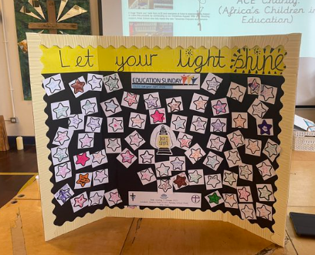 | October 2026  10am | Queen’s Park Primary School Hall | All year groups and all three churches involved.
Welcome Service  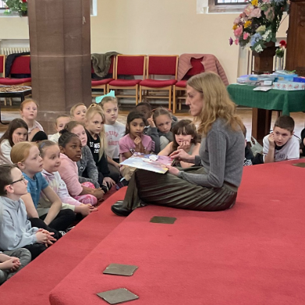 | October 2026  All parents welcome | St. Lukes | EYFS
Experience Harvest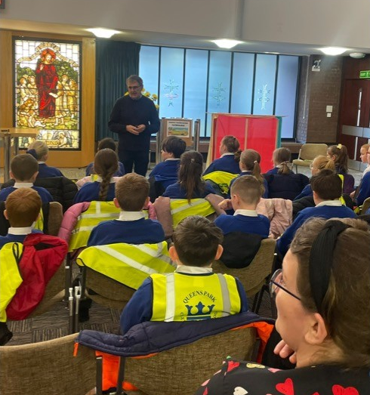 | September 2026 | Ormskirk Street URC | Year 5
Christmas Tree Festival  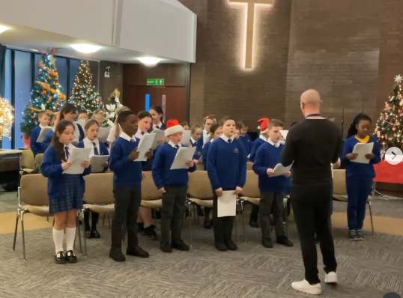 | December 2026 | Ormskirk Street URC | School Ethos Council and  Pop Shop (choir)
Christmas Celebration  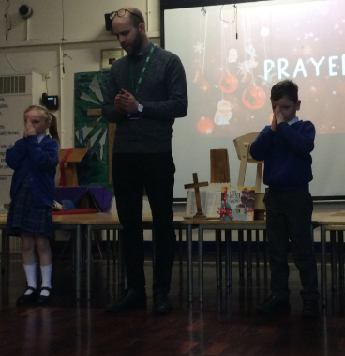 | December 2026 | St. Lukes CE | Year 1
Newtown URC Carol Service  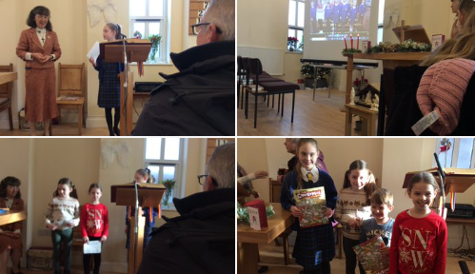 | December 2026 | Newtown URC | School Ethos Council and whole school community.
St Lukes CE Carol Service  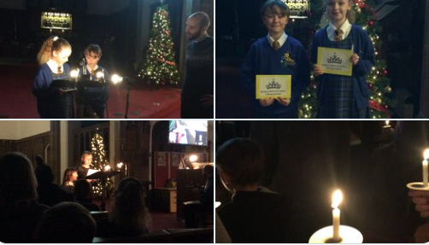 | December 2026 | St Lukes CE | Head Boy, Head Girl and whole school community.
Carols by Candlelight  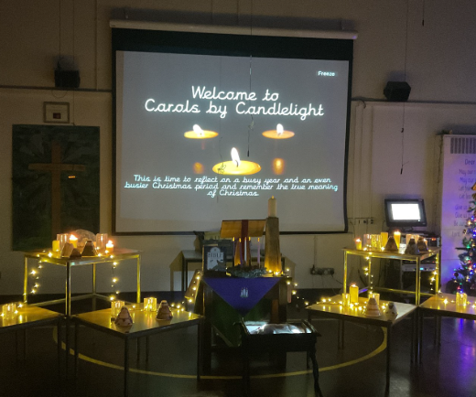 | December 2026 | Queen’s Park CE/URC | Whole school community.
Pancake Party  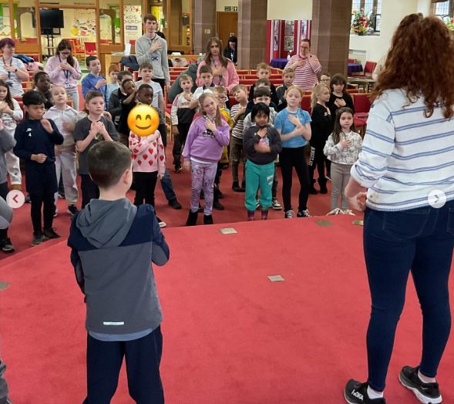 | February 2027  All parents welcome | St. Lukes CE | Year 3
Experience Easter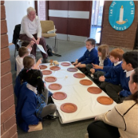 | March 2027 | Ormskirk Street URC | Year 2
Experience Pentecost  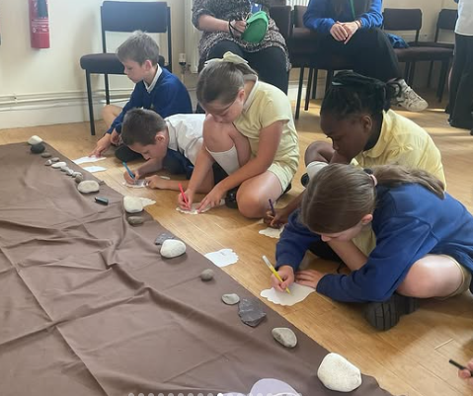 | Tuesday May 2027 | Newtown URC | Year 4
Your Move  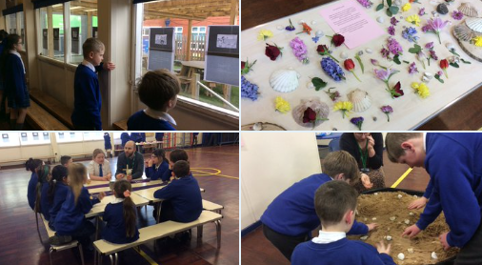 | Transition Week | St. Luke’s CE | Year 6  (All children in the same session)
Education Sunday 2026 | October 2027  10am | Queen’s Park CE/URC Primary School Hall | All year groups and all three churches involved.

