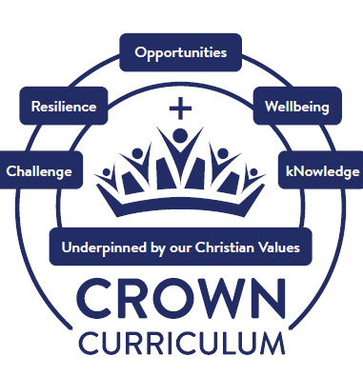





“For with God, everything is possible”
(Matthew 19:26)
Through our continued service to our community and rooted in our Christian Values, the opportunities we provide inspire our children and adults at our school to learn, to grow and to flourish. We are committed to developing our children into confident individuals who make a positive difference through developing a respect for themselves, and the world around them. For with God, everything is possible. (Matthew 19:26)

Through our vision, we serve our community by providing an inclusive, happy, secure and caring Christian environment where all are valued and respected. We believe that God loves all his children unconditionally and values the uniqueness of the individual and recognise the diversity and range of contributions that each child can make. In our computing curriculum, we ensure that children fully understand the role and benefits that technology can have on our daily lives. We ensure our school vision drives our computing curriculum as we understand that this subject is pivotal for our children’s futures. When they master computing skills, ‘everything is possible’, as we are equipping them for careers in the future that haven’t been invented yet!


The spiritual development of our children is a priority across all areas of the curriculum. At Queen’s Park CE/URC Primary School, we define spirituality as connecting with ourselves, others, the world and God, through whom, everything is possible (Matthew 19:26).
We explore spirituality through our Spiritual Capacities (our Spiritual C’s) which are curiosity, creativity, compassion, captivation, consciousness, being courageous contributors and having opportunities to contemplate.

We understand the importance of both planned and spontaneous opportunities in all aspects of our CROWN Curriculum. This is evidenced in our class reflections book, through ‘spirituality in the spotlight’ and through speaking to our children.



Challenge Resilience Opportunities Wellbeing kNowledge
Our five Crown Principles drive our computing curriculum.


Challenge

Through the ‘challenge’ curriculum driver we want our children to relish challenges that being a computer scientist can bring: asking perceptive questions, thinking critically, weighing evidence, sifting arguments, and developing perspective and judgement. Our computing curriculum is to prepare our children for a rapidly changing world through the use of technology. Our high-quality computing curriculum is designed to enable them to use computational thinking and creativity to further understand the world.

Resilience

Through the ‘resilience’ curriculum driver, we promote optimism and determination in computing. Not only do we want our pupils to be digitally literate and competent end-users of technology, we also want them to develop creativity, resilience and problem-solving as well as critical thinking skills. A selection of carefully chosen challenges are embedded within our computing curriculum to promote resilience. Children are encouraged to be resilient and good at problem solving using key computational thinking skills such as abstraction, decomposition, generalisation and pattern spotting.
Opportunities

Through ‘opportunities’, we raise aspirations to broaden our children’s horizons – opening their eyes to the myriad careers they might pursue. We have carefully planned and incorporated visits from guest speakers within the local area who have careers in computer technology. Our children aspire to work towards careers in the field of computing. These tangible role models have the effect of raising the aspirations of our pupils to inspire them to work even harder to be the best that they can be. We want our pupils to have a clear understanding of the link between achieving well and having goals for the future.
Wellbeing

At Queen’s Park, we understand that happiness is linked to personal growth, health and development. We ensure our children are happy, healthy individuals. In computing, children can discuss and reflect upon the impact that computing has on their learning, development and their wellbeing. Pupils are able to find a balance between their online and offline life and understand why this balance is essential. Our computing curriculum inspires confident users of technology who are competent digital citizens of the future. With ‘wellbeing’ as a curriculum driver, we give children the confidence to thrive in a diverse, global society and be respectful citizens with British and Christian Values at the core.
kNowledge

Through the ‘kNowledge’ curriculum driver, we encourage our children to be resourceful learners. It is uniquely challenging and coherent to our children. The knowledge imparted in computing is crafted by our curriculum leader and computing subject leader to ensure that all pupils understand and apply the fundamental principles and concepts of computer science, including abstraction, logic, algorithms and data representation can analyse problems in computational terms, and have repeated practical experience of writing computer programs in order to solve such problems. All our teachers teach with the aim to ensure pupils have sufficient knowledge to progress through primary school and beyond.


Being a computer scientist means that children will have developed the knowledge, skills and understanding to help them access and use a range of technology in a safe and creative way. Our approach to digital wellbeing cross references Teaching Online Safety in Schools (DFE 2019) and Education for a Connected World (UK Council for Internet Safety 2020). It is delivered via our PSHE and SMSC curriculum, alongside stand-alone digital wellbeing lessons which are taught 6 times a year. After reading Children and Parents: Media Use and Attitudes Report, we knew this needed to be high priority in our Computing curriculum. 'Importantly, there is a positive correlation when we look at the proportion of children who are having regular lessons about online safety and how useful they are finding these lessons – highlighting the importance of having more frequent lessons in this area.' Ofcom 2024
Children will have developed skills that equip them to use computational thinking and creativity to understand and change the world. Our computing curriculum is enhanced by the use of carefully selected quality fiction and non-fiction texts which have been embedded in our guided reading lessons.



Computing Long Term Plan

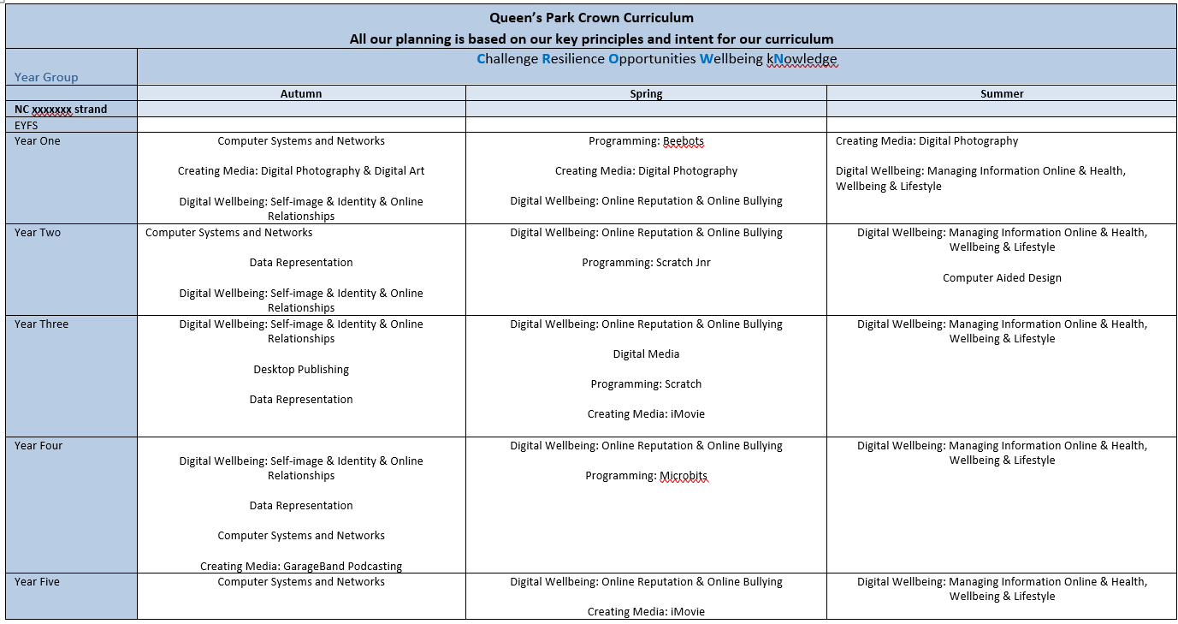

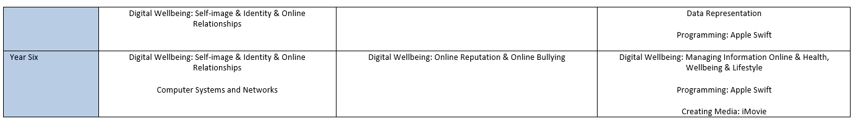
Computing is taught explicitly for some units of work. However, at Queen’s Park we believe that ‘computing is like glitter – it gets everywhere!’ therefore, we ensure that computing enhances a range of different subjects and it is used effectively cross-curricularly.


Our progression documents have been created by the Curriculum Leader and Computing Subject Leader to ensure clear progress in the five strands of computing we focus on at Queen’s Park: Computer Science, Information Technology / Digital Artefacts, Data representation and Digital Literacy. Our Digital Wellbeing curriculum is also progressive and is taught discretely.

The progression documents show key knowledge, key vocabulary, key skills and assessment outcomes from EYFS – Year 6 in these strands.

Progression document example

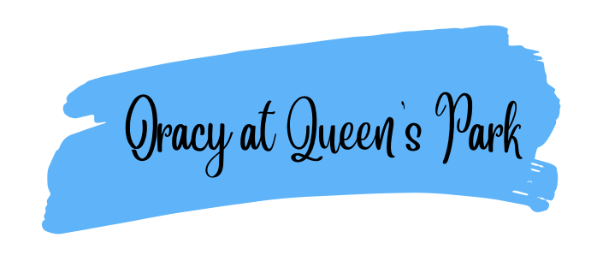

Oracy is a fundamental pillar of our curriculum and underpins all learning. We recognise that strong communication and language skills are essential foundations for pupils’ success across the curriculum and in later life. From the earliest years, children are taught to listen attentively, speak clearly, and express their ideas with confidence, using a rich and ambitious vocabulary.
Our curriculum places a strong emphasis on developing oracy through structured talk, discussion, and purposeful opportunities to articulate thinking. By embedding high-quality talk across all subjects, we enable pupils to deepen understanding, build knowledge, and make connections in their learning. Strong foundations in oracy support pupils’ reading and writing development, enhance engagement, and ensure all children, including those who may experience language barriers, can access the full curriculum

Vocabulary is V.I.T.A.L in Computing
Valued
We value vocabulary in computing and in everything we do.

Identified
Computing vocabulary is identified by the computing subject leader and is explicitly planned for.

Taught
Vocabulary is explicitly taught in every lesson. Our Crown Planners are used as a teaching tool for key computing vocabulary and the computing medium term plans include additional vocabulary to be taught.

Applied
Once vocabulary is taught, it is applied. Children apply their vocabulary in their speaking and listening, writing and assessment outcomes in computing.

Learned
Vocabulary is revisited and relearned. Vocabulary sticks in the children’s long-term memory. Lesson by lesson, year by year, children revisit and relearn key computing vocabulary.

Through an ‘explosion of experiences’, our youngest computer scientists are exposed to the foundations of their computing learning. Computing knowledge, skills and experiences are provided for through play-based, unplugged (no computer) activities that focus on building children’s listening skills, curiosity and creativity and problem solving. High quality, carefully selected books, stories and rhymes are the beating heart of our computing curriculum in EYFS. Computing vocabulary is planned for. Staff are role models in demonstrating computing vocabulary and this is further enhanced in our excellent provision. Children take part in a variety of tasks with digital devices, such as Bee Bots, tablets, laptop and the interactive whiteboard. This develops their understanding of a technologically diverse world and gains familiarity with the foundations of computing learning in EYFS which are linked to Year 1 and beyond.
Year 1 to Year 6
Year on year, children will build upon their computing knowledge, skills and vocabulary. The curriculum leader and computing subject leader have created a meaningful, sequential learning journey through computing. Careful curriculum thinking and planning ensures that our children have the subject knowledge and components embedded in their long-term memories.



Pedagogy

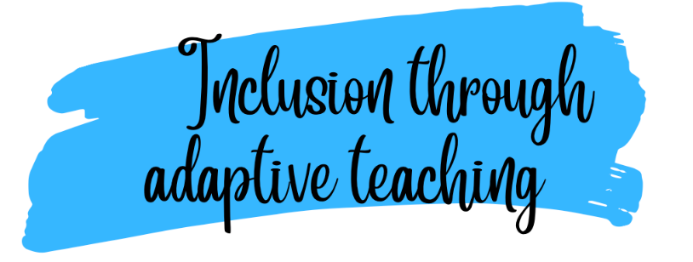

Both our staff and children are enthusiastic about computing. Through ongoing CPD, we strive to ensure our teachers have expert knowledge of the computing they teach. Our pedagogy is firmly based upon our curriculum intent of embedding concepts into long-term memory so that they are able to be recalled, to ensure substantive and disciplinary knowledge and skills can be applied fluently.
Our ‘Queen’s Park Quality First Teaching’ model ensures that lessons are effectively sequenced so that new knowledge and skills build on what has been taught before and towards defined end points.

At Queen’s Park, we implement an adaptive teaching approach to ensure that all learners engage in meaningful, challenging, and achievable learning experiences. Our strategy is informed by the Education Endowment Foundation (EEF) research on adaptive teaching, emphasising high expectations, scaffolded support, and responsive adjustments to meet the needs of all pupils. We ensure effective, early identification of any additional barriers to learning, inclusive of but not restricted to Special Educational Needs, Pupil Premium and EAL. Adaptive teaching is essential to our quality first teaching offer as part of our graduated response.

Our Approach: 80% Proactive, 20% Reactive
We recognise that effective adaptive teaching is most successful when it is intentionally planned in advance (proactive) while also allowing for real-time adjustments (reactive) based on pupil responses and progress. Our model ensures:
80% Proactive Adaptive Teaching: Teachers anticipate and plan for diverse learning needs by designing lessons that provide challenge while being accessible to all. This includes the following:
  - Carefully structured tasks that encourage all learners to think hard but remain achievable with time, effort, and support.
  - Scaffolded instruction, including modelling, worked examples, and guided practice.
  - Strategic use of questioning to check understanding and deepen learning.
  - Use of visuals and concrete resources to support learning.
  - Scaffolded tasks that enable all children to access the curriculum without lowering expectations.
  - Planned opportunities for retrieval throughout the curriculum and where appropriate planned opportunities for pre-teach of new learning.
  - Use of accessibility features on iPads to support learning tasks or use of ICT to provide further scaffolding.
  - Where necessary, a modified curriculum to ensure full curriculum entitlement for children who are working below the age-related expectations as identified on the SEND register.
20% Reactive Adaptive Teaching: Teachers remain responsive during lessons, adapting in the moment to ensure all learners stay engaged and make progress. This includes:
  - Making in-the-moment adjustments, such as providing additional explanations, breaking down tasks further, or offering immediate feedback.
  - Using formative assessment strategies to identify and address misconceptions as they arise.
  - Adjusting levels of support, such as peer collaboration, teacher intervention, or additional scaffolding, based on pupil responses.
Our pedagogy around adaptive teaching is based on our Crown Curriculum principles:
Challenge
We ensure that all learners engage in thinking hard about their learning while accessing tasks that are achievable with time, effort, and support. We do not lower expectations or simplify content unnecessarily; instead, we provide the right scaffolds and strategies to enable all pupils to meet ambitious learning goals.

Resilience
We ensure that all learners develop the ability to embrace mistakes as part of learning and take ownership of their progress. We recognize that resilience is not just a personal trait but a skill that can be developed through carefully structured learning experiences.
Opportunities
Our adaptive teaching strategy is designed to provide every learner with opportunities to succeed and raise their aspirations. We believe that every child, regardless of their starting point, should have access to a rich, challenging, and supportive curriculum that enables them to achieve success now and in their futures.
Wellbeing
Our adaptive teaching strategy is designed not only to support academic success but also to prioritize pupil wellbeing. We recognize that effective learning happens when children feel safe, valued, and supported and our approach ensures that every pupil can engage with challenge and make progress without feeling overwhelmed. By embedding wellbeing into our teaching practices, we create a learning environment where all children thrive and feel personal success.
kNowledge
Our adaptive teaching strategy prioritises learning through knowledge acquisition. By tailoring instruction to meet diverse learners' needs, we facilitate deeper engagement with the curriculum.

Both our staff and children are enthusiastic about art. Through ongoing CPD, we strive to ensure our teachers have expert knowledge of the art they teach. Our pedagogy is firmly based upon our curriculum intent of embedding concepts into long-term memory so that they are able to be recalled, to ensure substantive and disciplinary knowledge and skills can be applied fluently.
Our ‘Queen’s Park Quality First Teaching’ model ensures that lessons are effectively sequenced so that new knowledge and skills build on what has been taught before and towards defined end points.
We firmly believe that all children should have full access, including those with additional needs, to our art curriculum therefore lessons are scaffolded where appropriate in order to meet the needs of all our children.
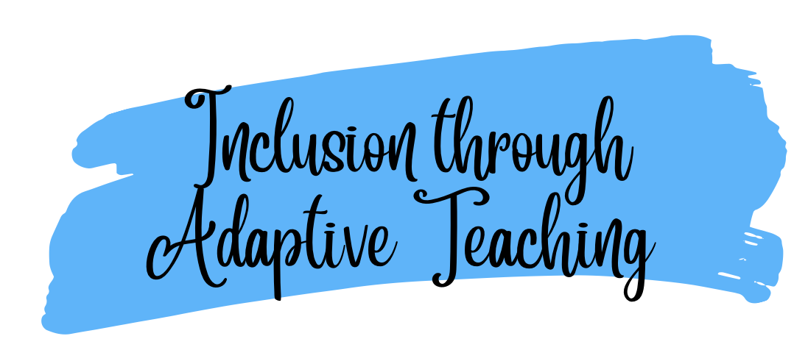
Both our staff and children are enthusiastic about Art and Design Through ongoing CPD, we strive to ensure our teachers have expert knowledge of the Art and Design curriculumthey teach. Our pedagogy is firmly based upon our curriculum intent of embedding concepts into long-termmemory so that they are able to be recalled, to ensure substantive and disciplinary knowledge and skills can be applied fluently.
Our ‘Queen’s Park Quality First Teaching’ model ensures that lessons are effectively sequenced so that new knowledge and skills build on what has been taught before and towards defined end points.
At Queen’s Park, we implement an adaptive teaching approach to ensure that all learnersengage in meaningful, challenging, and achievable learning experiences. Our strategy is informed by the Education Endowment Foundation (EEF) research on adaptive teaching, emphasising high expectations, scaffolded support, and responsive adjustments to meet the needs of all pupils. We ensure effective, early identification of any additional barriers to learning, inclusive of but not restricted to Special Educational Needs, Pupil Premium and EAL. Adaptive teaching is essential to our quality first teaching offer as part of our graduated response.
Our Approach: 80% Proactive, 20% Reactive
We recognise that effective adaptive teaching is most successful when it is intentionally planned in advance (proactive) while also allowing for real-time adjustments (reactive) based on pupil responses and progress. Our model ensures:
80% Proactive Adaptive Teaching: Teachers anticipate and plan for diverse learning needs by designing lessons that provide challenge while being accessible to all. This includes the following:
- Carefully structured tasks that encourage all learners to think hard but remain achievable with time, effort, and support.
- Scaffolded instruction, including modelling, worked examples, and guided practice.
- Strategic use of questioning to check understanding and deepen learning.
- Use of visuals and concrete resources to support learning.
- Scaffolded tasks that enable all children to access the curriculum without lowering expectations.
- Planned opportunities for retrieval throughout the curriculum and where appropriate planned opportunities for pre-teach of new learning.
- Use of accessibility features on iPads to support learning tasks or use of ICT to provide further scaffolding.
- Where necessary, a modified curriculum to ensure full curriculum entitlement for children who are working below the age-related expectations as identified on the SEND register.
20% Reactive Adaptive Teaching: Teachers remain responsive during lessons, adapting in the moment to ensure all learners stay engaged and make progress. This includes:
- Making in-the-moment adjustments, such as providing additional explanations, breaking down tasks further, or offering immediate feedback.
- Using formative assessment strategies to identify and address misconceptions as they arise.
- Adjusting levels of support, such as peer collaboration.

At our school, we believe that with God, everything is possible. We create a caring and exciting learning environment where children are encouraged to be curious, confident, and to believe in themselves.
We use digital technology to help children learn, explore, and prepare for the world around them. By using technology in positive and meaningful ways, we help our children become confident learners who are ready for life in an increasingly digital world. We teach our children how to use technology safely, responsibly, and kindly. This helps them grow into respectful digital citizens who understand how to make good choices online and treat others with care.
Our aim is to give every child the skills they need for the future. Technology supports our teaching, helping us to personalise learning and provide extra support where needed. It is always used to enhance learning and never replaces high-quality teaching or the important relationships between teachers and children.
We also use technology to make learning accessible for all children, supporting different learning needs and helping every child to find their voice. By building confidence, communication skills, and independence, we prepare our children to become lifelong learners who are ready to face future challenges.


The sequence of lessons across computing follows the same structure:

Each lesson, within the sequence, follows the structure so prior knowledge is constantly revisited and transferred to long term memory.


Our Crown Planners support our children with vocabulary and key knowledge for each unit of work. They enhance children’s understanding of key concepts, present information clearly and promote appropriate discussion. Crown Planners are uploaded onto Seesaw to support the children with their learning and are used as a teaching tool during the lesson input.
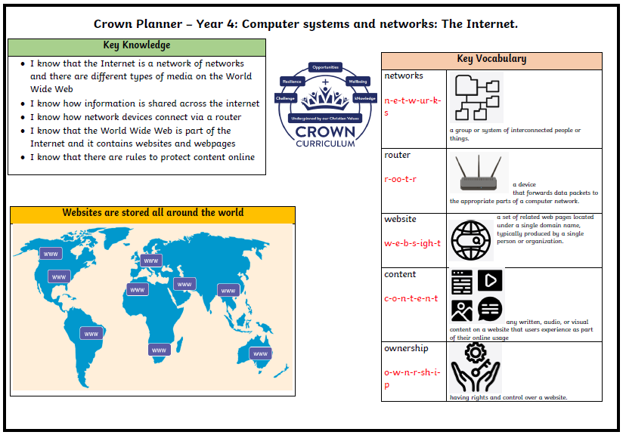

We understand that we may not see the true impact of our computing curriculum on our children as our computing curriculum is just the beginning of a lifetime of learning.
Our well-constructed and well-taught computing curriculum leads to great outcomes. Our results are a reflection of what our children have learnt. At Queen’s Park, our philosophy is that broad and balanced leads to great outcomes and meeting end points at the end of each key stage. National assessments are useful indicators of the outcomes our children achieve.
We ensure all groups of children are given the knowledge and cultural capital they need to succeed in life. We strive to ensure that our children are equipped with the skills (through a growth mindset approach) to fluently be able to retrieve key facts from their semantic memory.
The quality of our children’s work, at every stage, is of a high standard. All learning is built towards an end point and at each stage of their education, we prepare our children for the next stage.
We ensure all our children read to a stage appropriate level and fluency. Reading is the beating heart of our computing curriculum. Through disciplinary literacy in computing lessons, the impact of reading on the children’s computational learning is paramount.
The impact of Queen’s Park computing curriculum is measured through the following:
- Assessment at the end of each unit of work
- Vocabulary and knowledge are assessed at the end of each lesson and at the end of each sequence
- Pupil voice
- Progress evident on Seesaw and record of experiences
- Seeking views of parents where appropriate

