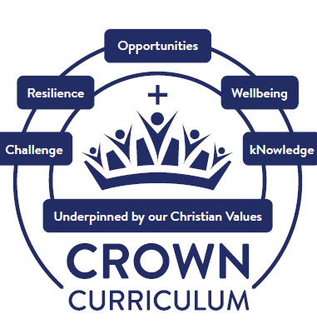




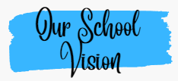
Through our continued service to our community and rooted in our Christian Values, the opportunities we provide inspire our children and adults at our school to learn, to grow and to flourish. We are committed to developing our children into confident individuals who make a positive difference through developing a respect for themselves, each other and the world around them. For with God, everything is possible. (Matthew 19:26)

Through our vision, we serve our community by providing an inclusive, happy, secure and caring Christian environment where all are valued and respected. We believe that God loves all his children unconditionally and values the uniqueness of the individual and recognise the diversity and range of contributions that each child can make. In our art curriculum, we ensure that children recognise and celebrate diversity within art and value the uniqueness of each piece of art. We ensure that all children contribute to their own art learning journey through inspire - explore – create – evaluate..
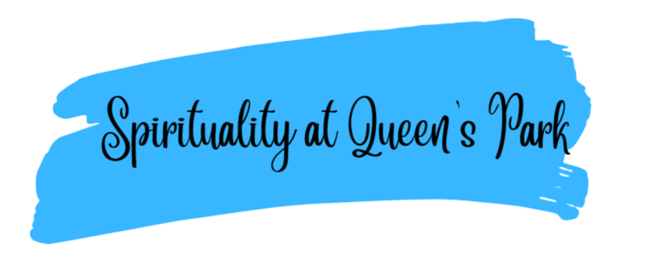

The spiritual development of our children is a priority across all areas of the curriculum. At Queen’s Park CE/URC Primary School, we define spirituality as connecting with ourselves, others, the world and God, through whom, everything is possible (Matthew 19:26).
We explore spirituality through our Spiritual Capacities (our Spiritual C’s) which are curiosity, creativity, compassion, captivation, consciousness, being courageous contributors and having opportunities to contemplate.

We understand the importance of both planned and spontaneous opportunities in all aspects of our CROWN Curriculum. This is evidenced in our class reflections book, through ‘spirituality in the spotlight’ and through speaking to our children.

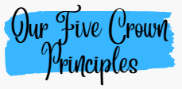
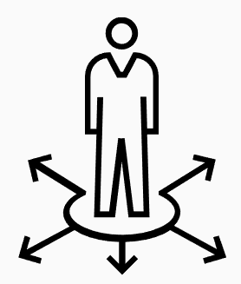
Challenge Resilience Opportunities Wellbeing kNowledge
Our five Crown Principles drive our art curriculum.

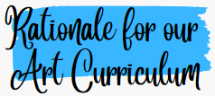
Challenge

Through the ‘challenge’ curriculum driver we want our children relish challenges that being an artist can bring. Our art curriculum challenges and inspires pupils to create their own work of art.
We challenge our children to think critically, observe and develop a secure understanding of art and design through our structure Inspire, Explore, Create (skill), Evaluate.

Resilience

Through the ‘resilience’ curriculum driver, we promote optimism and determination in art. We encourage the children to refine their skills through work in sketch books.
Opportunities

Through ‘opportunities’, we raise aspirations to broaden our children’s horizons – opening their eyes to the myriad careers they might pursue. In our art curriculum, our children learn about the work of a great artists, craft makers, architects and designers. There are regular opportunities to celebrate and display their artwork through exhibitions, displays and competitions. We want our pupils to have a clear understanding of the link between achieving well and having goals for the future.
Wellbeing

At Queen’s Park, we understand that happiness is linked to personal growth, health and development. We ensure our children are happy, healthy individuals. Our children know how art and design both reflect and shape our art, and contribute to the culture, creativity and wealth of our nation.
Art lessons create a sense of calm and mindfulness when creating art work. With ‘wellbeing’ as a curriculum driver, we give children the confidence to thrive in a diverse, global society and be respectful citizens with British and Christian Values at the core.
kNowledge

Through the ‘kNowledge’ curriculum driver, we encourage our children to be resourceful learners. It is uniquely challenging and coherent to our children. The knowledge imparted in art is crafted by our curriculum leader and art subject leader to ensure that all pupils achieve secure subjective and disciplinary knowledge in art. All our teachers teach with the aim to ensure pupils have sufficient knowledge to progress through primary school and beyond.

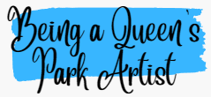
Being an artist means that disciplinary and substantive knowledge complement each other harmoniously. Art disciplines such as sketching, painting, sculpture, craft are high profile within our art curriculum.




Art Long Term Plan
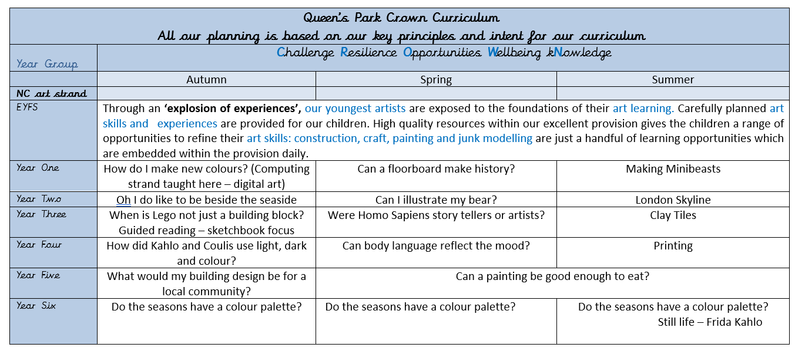

Art is taught three times throughout the year (with the exception of Years 5 and 6).

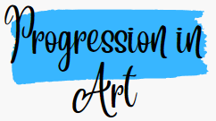
Our progression documents have been created by the Curriculum Leader and Art Subject Leader to ensure clear progress in the art disciplines: drawing, painting, sculpture, printing craft and collage.

The progression documents show key knowledge (substantive knowledge), key vocabulary and key skills (disciplinary knowledge) and assessment outcomes from EYFS – Year 6.
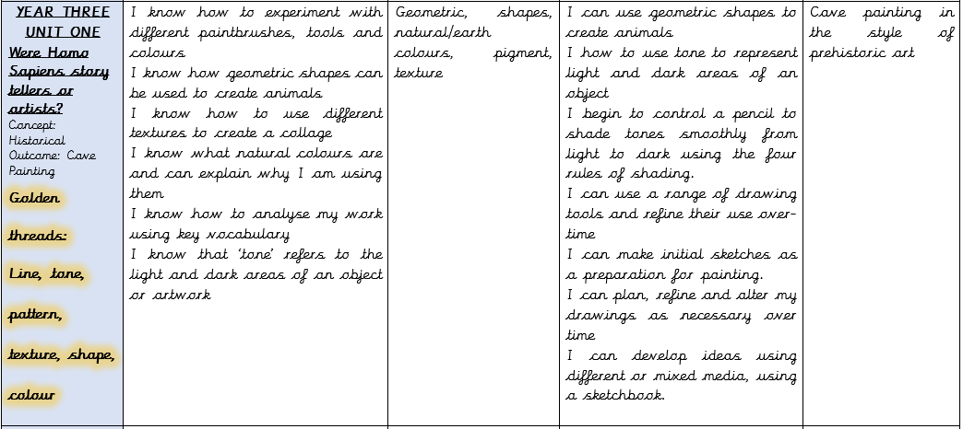
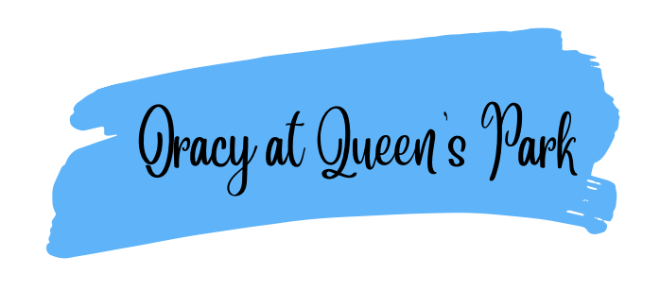

Oracy is a fundamental pillar of our curriculum and underpins all learning. We recognise that strong communication and language skills are essential foundations for pupils’ success across the curriculum and in later life. From the earliest years, children are taught to listen attentively, speak clearly, and express their ideas with confidence, using a rich and ambitious vocabulary.
Our curriculum places a strong emphasis on developing oracy through structured talk, discussion, and purposeful opportunities to articulate thinking. By embedding high-quality talk across all subjects, we enable pupils to deepen understanding, build knowledge, and make connections in their learning. Strong foundations in oracy support pupils’ reading and writing development, enhance engagement, and ensure all children, including those who may experience language barriers, can access the full curriculum.
As a result, pupils become confident communicators who can explain their thinking, collaborate effectively with others, and engage thoughtfully with the world around them.

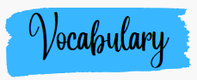

Vocabulary is V.I.T.A.L in Art
Valued
We value vocabulary in art and in everything we do.

Identified
Art vocabulary is identified by the art subject leader and is explicitly planned for.

Taught
Vocabulary is explicitly taught in every lesson. Our Crown Planners are used as a teaching tool for key art focused vocabulary and the art medium term plans include additional vocabulary to be taught.

Applied
Once vocabulary is taught, it is applied. Children apply their vocabulary in their speaking and listening, writing and assessment outcomes in art.

Learned
Vocabulary is revisited and relearned. Vocabulary sticks in the children’s long-term memory. Lesson by lesson, year by year, children revisit and relearn key art vocabulary.

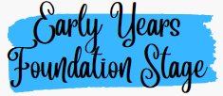

Through an ‘explosion of experiences’, our youngest artists are exposed to the foundations of their art learning. Carefully planned art skills and experiences are provided for our children. High quality resources within our excellent provision gives the children a range of opportunities to refine their art skills: construction, craft, painting and junk modelling are just a handful of learning opportunities which are embedded within the provision daily. Art vocabulary is planned for. Staff are role models in demonstrating art vocabulary. The foundations of art learning in EYFS is linked to Year 1 and beyond.

Year 1 to Year 6
Year on year, children will build upon their art knowledge, skills and vocabulary. The curriculum leader and art subject leader have created a meaningful, sequential learning journey through art. Careful curriculum thinking and planning ensures that our children have the subject knowledge and components embedded in their long-term memories.



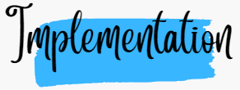
Pedagogy


Both our staff and children are enthusiastic about art. Through ongoing CPD, we strive to ensure our teachers have expert knowledge of the art they teach. Our pedagogy is firmly based upon our curriculum intent of embedding concepts into long-term memory so that they are able to be recalled, to ensure substantive and disciplinary knowledge and skills can be applied fluently.
Our ‘Queen’s Park Quality First Teaching’ model ensures that lessons are effectively sequenced so that new knowledge and skills build on what has been taught before and towards defined end points.
We firmly believe that all children should have full access, including those with additional needs, to our art curriculum therefore lessons are scaffolded where appropriate in order to meet the needs of all our children.
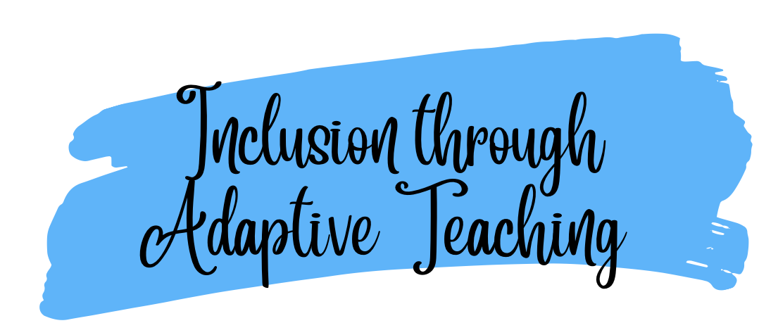
Both our staff and children are enthusiastic about Art and Design Through ongoing CPD, we strive to ensure our teachers have expert knowledge of the Art and Design curriculumthey teach. Our pedagogy is firmly based upon our curriculum intent of embedding concepts into long-termmemory so that they are able to be recalled, to ensure substantive and disciplinary knowledge and skills can be applied fluently.
Our ‘Queen’s Park Quality First Teaching’ model ensures that lessons are effectively sequenced so that new knowledge and skills build on what has been taught before and towards defined end points.
At Queen’s Park, we implement an adaptive teaching approach to ensure that all learnersengage in meaningful, challenging, and achievable learning experiences. Our strategy is informed by the Education Endowment Foundation (EEF) research on adaptive teaching, emphasising high expectations, scaffolded support, and responsive adjustments to meet the needs of all pupils. We ensure effective, early identification of any additional barriers to learning, inclusive of but not restricted to Special Educational Needs, Pupil Premium and EAL. Adaptive teaching is essential to our quality first teaching offer as part of our graduated response.
Our Approach: 80% Proactive, 20% Reactive
We recognise that effective adaptive teaching is most successful when it is intentionally planned in advance (proactive) while also allowing for real-time adjustments (reactive) based on pupil responses and progress. Our model ensures:
80% Proactive Adaptive Teaching: Teachers anticipate and plan for diverse learning needs by designing lessons that provide challenge while being accessible to all. This includes the following:
- Carefully structured tasks that encourage all learners to think hard but remain achievable with time, effort, and support.
- Scaffolded instruction, including modelling, worked examples, and guided practice.
- Strategic use of questioning to check understanding and deepen learning.
- Use of visuals and concrete resources to support learning.
- Scaffolded tasks that enable all children to access the curriculum without lowering expectations.
- Planned opportunities for retrieval throughout the curriculum and where appropriate planned opportunities for pre-teach of new learning.
- Use of accessibility features on iPads to support learning tasks or use of ICT to provide further scaffolding.
- Where necessary, a modified curriculum to ensure full curriculum entitlement for children who are working below the age-related expectations as identified on the SEND register.
20% Reactive Adaptive Teaching: Teachers remain responsive during lessons, adapting in the moment to ensure all learners stay engaged and make progress. This includes:
- Making in-the-moment adjustments, such as providing additional explanations, breaking down tasks further, or offering immediate feedback.
- Using formative assessment strategies to identify and address misconceptions as they arise.
- Adjusting levels of support, such as peer collaboration.
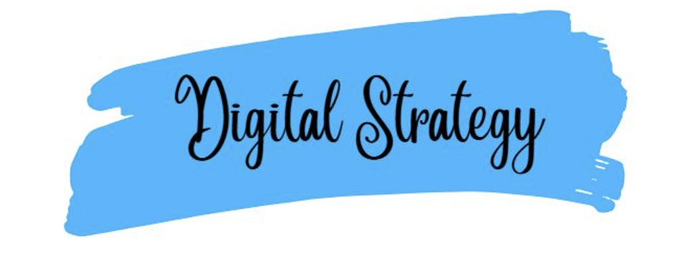
At our school, we believe that with God, everything is possible. We create a caring and exciting learning environment where children are encouraged to be curious, confident, and to believe in themselves.
We use digital technology to help children learn, explore, and prepare for the world around them. By using technology in positive and meaningful ways, we help our children become confident learners who are ready for life in an increasingly digital world. We teach our children how to use technology safely, responsibly, and kindly. This helps them grow into respectful digital citizens who understand how to make good choices online and treat others with care.
Our aim is to give every child the skills they need for the future. Technology supports our teaching, helping us to personalise learning and provide extra support where needed. It is always used to enhance learning and never replaces high-quality teaching or the important relationships between teachers and children.
We also use technology to make learning accessible for all children, supporting different learning needs and helping every child to find their voice. By building confidence, communication skills, and independence, we prepare our children to become lifelong learners who are ready to face future challenges.

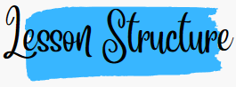
The sequence of lessons across art follows the same structure:

Each lesson, within the sequence, follows the structure so prior knowledge is constantly revisited and transferred to long term memory.

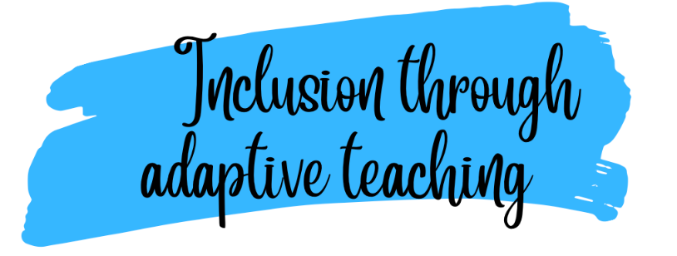

Both our staff and children are enthusiastic about art. Through ongoing CPD, we strive to ensure our teachers have expert knowledge of the art they teach. Our pedagogy is firmly based upon our curriculum intent of embedding concepts into long-term memory so that they are able to be recalled, to ensure substantive and disciplinary knowledge and skills can be applied fluently.
Our ‘Queen’s Park Quality First Teaching’ model ensures that lessons are effectively sequenced so that new knowledge and skills build on what has been taught before and towards defined end points.
We firmly believe that all children should have full access, including those with additional needs, to our Art curriculum therefore lessons are scaffolded where appropriate in order to meet the needs of all our children.
At Queen’s Park, we implement an adaptive teaching approach to ensure that all learners engage in meaningful, challenging, and achievable learning experiences. Our strategy is informed by the Education Endowment Foundation (EEF) research on adaptive teaching, emphasising high expectations, scaffolded support, and responsive adjustments to meet the needs of all pupils. We ensure effective, early identification of any additional barriers to learning, inclusive of but not restricted to Special Educational Needs, Pupil Premium and EAL. Adaptive teaching is essential to our quality first teaching offer as part of our graduated response.

Our Approach: 80% Proactive, 20% Reactive
We recognise that effective adaptive teaching is most successful when it is intentionally planned in advance (proactive) while also allowing for real-time adjustments (reactive) based on pupil responses and progress. Our model ensures:
80% Proactive Adaptive Teaching: Teachers anticipate and plan for diverse learning needs by designing lessons that provide challenge while being accessible to all. This includes the following:
  - Carefully structured tasks that encourage all learners to think hard but remain achievable with time, effort, and support.
  - Scaffolded instruction, including modelling, worked examples, and guided practice.
  - Strategic use of questioning to check understanding and deepen learning.
  - Use of visuals and concrete resources to support learning.
  - Scaffolded tasks that enable all children to access the curriculum without lowering expectations.
  - Planned opportunities for retrieval throughout the curriculum and where appropriate planned opportunities for pre-teach of new learning.
  - Use of accessibility features on iPads to support learning tasks or use of ICT to provide further scaffolding.
  - Where necessary, a modified curriculum to ensure full curriculum entitlement for children who are working below the age-related expectations as identified on the SEND register.
20% Reactive Adaptive Teaching: Teachers remain responsive during lessons, adapting in the moment to ensure all learners stay engaged and make progress. This includes:

- Making in-the-moment adjustments, such as providing additional explanations, breaking down tasks further, or offering immediate feedback.
- Using formative assessment strategies to identify and address misconceptions as they arise.
- Adjusting levels of support, such as peer collaboration, teacher intervention, or additional scaffolding, based on pupil responses.
Our pedagogy around adaptive teaching is based on our Crown Curriculum principle

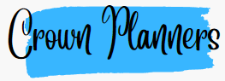
Our Crown Planners support our children with vocabulary and key knowledge for each unit of work. They enhance children’s understanding of key concepts, present information clearly and promote appropriate discussion.
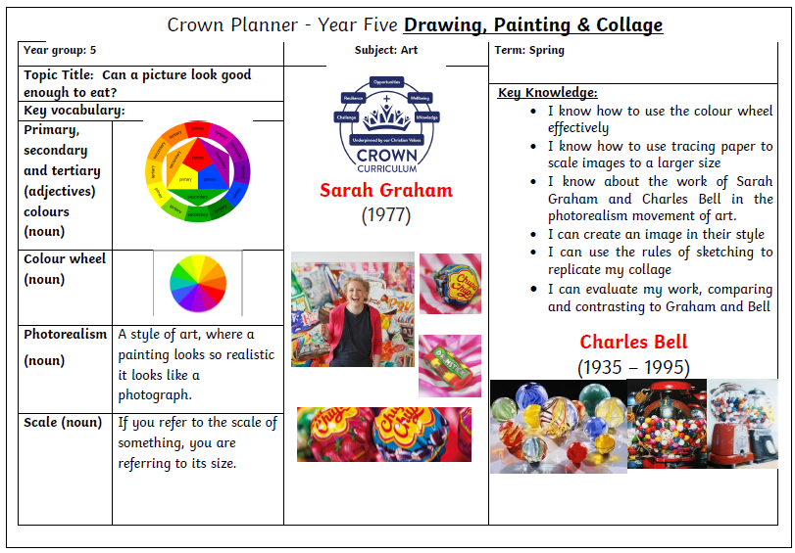
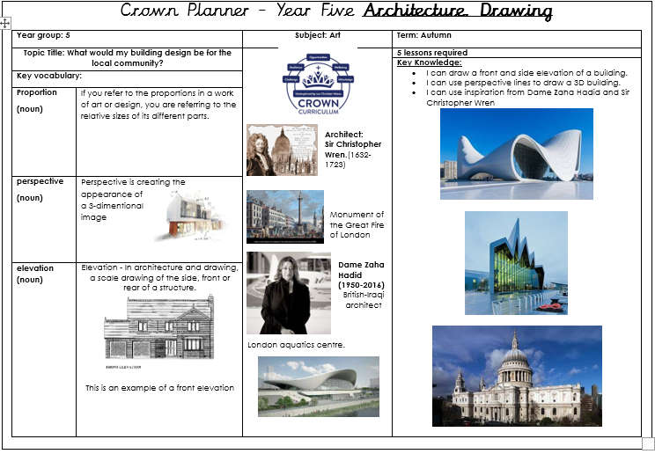
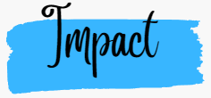
We understand that we may not see the true impact of our art curriculum on our children as our art curriculum is just the beginning of a lifetime of learning.
Our well-constructed and well-taught art curriculum leads to great outcomes. Our results are a reflection of what our children have learnt. At Queen’s Park, our philosophy is that broad and balanced leads to great outcomes and meeting end points at the end of each key stage. National assessments are useful indicators of the outcomes our children achieve.
We ensure all groups of children are given the knowledge and cultural capital they need to succeed in life. We strive to ensure that our children are equipped with the skills (through a growth mindset approach) to fluently be able to retrieve key facts from their semantic memory.
The quality of our children’s work, at every stage, is of a high standard. All learning is built towards an end point and at each stage of their education, we prepare our children for the next stage.
The impact of Queen’s Park art curriculum is measured through the following:
- Assessment at the end of each unit of work (a completed piece of artwork)
- Art exhibitions
- Work is assessed at the end of each lesson and at the end of each sequence
- Journey through sketchbooks to ensure children are refining technique
- Pupil voice
- Progress evident in children’s books and record of experiences
- Seeking views of parents where appropriate

