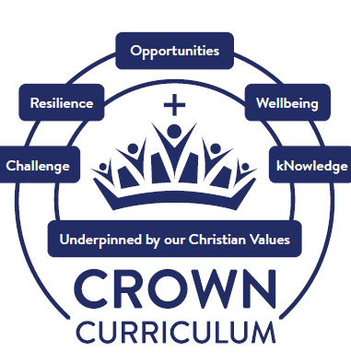

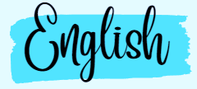



“For with God, everything is possible” (Matthew 19:26)
​
Through our continued service to our community and rooted in our Christian Values, the opportunities we provide, inspire our children and adults at our school to learn, to grow and to flourish. We are committed to developing our children into confident individuals who make a positive difference through developing a respect for themselves, each other and the world around them. For with God, everything is possible. (Matthew 19:26)

We believe that every child is unique, gifted with talents and abilities that, when nurtured, allow them to be the best they can be. Our curriculum is designed to reflect this vision, ensuring that every learner is supported and challenged to succeed in all aspects of their education—academically, spiritually, socially, and emotionally.

Through our vision, we provide a high-quality education within a creative, stimulating, encouraging and mutually supportive environment where children are enabled to develop the skills they require to become confident, articulate and successful in English, achieving everything possible. English, as the foundation of communication and understanding, is central to the curriculum. Through reading, writing, speaking and listening, pupils develop the ability to express ideas, engage with the world around them and think critically. Attainment in English is key to opening new doors to further study, employments and lifelong learning.

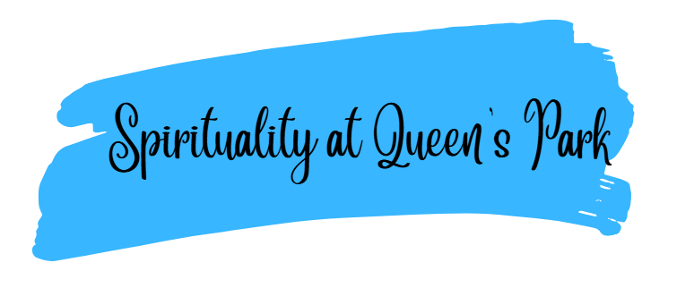
The spiritual development of our children is a priority across all areas of the curriculum. At Queen’s Park CE/URC Primary School, we define spirituality as connecting with ourselves, others, the world and God, through whom, everything is possible (Matthew 19:26).
We explore spirituality through our Spiritual Capacities (our Spiritual C’s) which are curiosity, creativity, compassion, captivation, consciousness, being courageous contributors and having opportunities to contemplate.

We understand the importance of both planned and spontaneous opportunities in all aspects of our CROWN Curriculum. This is evidenced in our class reflections book, through ‘spirituality in the spotlight’ and through speaking to our children.


The purpose of our English curriculum is to ensure that every child builds strong and secure foundations in communication, language and literacy, enabling success in both life and learning, regardless of their starting points or any barriers they may face. These foundations are rooted in high-quality early language and literacy experiences and are carefully developed throughout the primary years, ensuring children acquire the essential knowledge, skills and learning behaviours needed to flourish.
Strong foundations in reading, writing, speaking and listening sit at the heart of our curriculum, as we recognise that these are fundamental to accessing all areas of learning and to expressing ideas, thoughts and emotions with confidence and clarity. Our English curriculum is built on ensuring our children develop an excellent moral compass. Texts are carefully selected to raise the profile of diversity, inclusivity and respect, helping children to understand the world around them and their place within it.
Alongside academic success, we place equal importance on developing children’s character, resilience, self-motivation and curiosity. Through rich discussion, purposeful writing and meaningful engagement with high-quality literature, children are inspired to read widely, write creatively, and speak and listen with confidence. They understand that their voices matter and that they can make a difference through the skills and knowledge they gain in English.
Just as the Crown symbolises reward from a Christian perspective, our curriculum teaches children that effort, perseverance and ambition lead to future rewards in the form of opportunity and aspiration. We set high expectations for every pupil and are relentless in overcoming barriers to learning. Where required, learning is carefully scaffolded so that all children can access a broad and balanced English curriculum and build strong foundations to become confident, capable and independent communicators. Everything is possible!
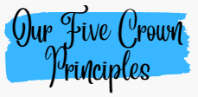

Challenge Resilience Opportunities Wellbeing kNowledge
Our five Crown Principles drive our English curriculum and are underpinned by our Christian Values which promote our Christian distinctiveness.
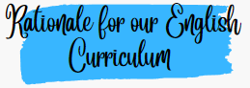
Challenge

Through the ‘challenge’ curriculum driver we want our children relish challenges that English can bring such as writing a range of genres, considering audience and purpose. Despite the challenges of barriers or background, we ensure that every child at Queen’s Park is a reader.
Resilience

Through the ‘resilience’ curriculum driver, we promote optimism and determination in English. We have the highest of expectations in all areas of English: reading, writing, spelling, handwriting, speaking and listening. Our high expectations and aspirational English curriculum encourage children to be resilient learners. Through next step marking and purposeful feedback in English, children have opportunities each day to edit and improve their work thus promoting resilience.
Opportunities

Through ‘opportunities’, we raise aspirations to broaden our children’s horizons – opening their eyes to the myriad careers they might pursue. Through careful curriculum planning ensure we have a range of enhancements throughout the year such as: author, poet and illustrator visits, themed days and trips. We provide ample opportunities within the curriculum for children to become articulate speakers, readers and writers. We believe that ‘reading opens doors’ – our English book spine offers a range of opportunities through the power of reading.
Wellbeing

At Queen’s Park, we understand that happiness is linked to personal growth, health and development. We ensure our children are happy, healthy individuals.
Our English curriculum content encompasses quality texts pertaining wellbeing. We work hard to build a great parent partnership, encouraging 1:1 reading at home through training videos. We create a love of reading including daily story time from EYFS – Y6. SMSC, British and Christian Values woven throughout each quality text. With ‘wellbeing’ as a curriculum driver, we give children the confidence to thrive in a diverse, global society and be respectful citizens with British and Christian Values at the core.
kNowledge

Through the ‘kNowledge’ curriculum driver, we encourage our children to be resourceful learners. It is uniquely challenging and coherent to our children. The knowledge imparted in English is crafted by our English lead to ensure that all pupils achieve secure substantive and disciplinary knowledge in all areas of English. All our teachers teach with the aim to ensure pupils have sufficient knowledge to progress through primary school and beyond.

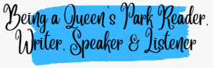
Being a confident reader, writer, speaker and listener requires both substantive knowledge (the content, vocabulary and texts children learn) and disciplinary knowledge (how pupils read, write, speak and listen as experts) to work together harmoniously. At Queen’s Park, all aspects of English are high profile within our curriculum, reflecting our belief that literacy underpins success across every subject.
Our English curriculum is coherently planned and carefully sequenced to ensure pupils build knowledge cumulatively over time. We ensure there are purposeful and meaningful opportunities to apply and strengthen English skills across all areas of the curriculum. Each core text is chosen carefully for its purpose, cultural richness and deliberate links to wider curriculum enabling pupils to deepen their understanding of the world while making connections across subjects. Every text is chosen with clear intent and serves a specific purpose, whether to develop vocabulary, comprehension, writing craft, or to promote diversity, inclusivity and respect.
Reading, writing, spelling and phonics are taught daily through structured, high-quality lessons that prioritise consistency, practice and progression. In the early stages, systematic synthetic phonics provides the foundations for confident decoding and early reading success. As pupils progress, explicit instruction in vocabulary, grammar, comprehension strategies and writing techniques ensures knowledge is embedded and can be applied independently.
In line with the national Writing Framework, we develop transcription skills early, including handwriting and spelling, so that pupils achieve automaticity in these foundational elements and are able to devote their working memory to the compositional aspects of writing. Children are supported to compose orally before writing, enabling them to compose complete sentences and structured paragraphs to articulate their ideas with clarity and confidence. Sentence-level competence is prioritised before extended writing is introduced, ensuring that grammar and vocabulary are taught meaningfully and in context rather than in isolation. Pupils are then supported to write with a clear purpose and audience in mind, using high-quality model texts and engaging, authentic writing tasks that promote creativity, expression and effective communication across the wider curriculum.
Through regular opportunities for talk, discussion and performance, pupils develop strong oracy skills, enabling them to articulate ideas, reason effectively and engage critically with texts. Teachers use precise questioning, modelling and feedback to ensure misconceptions are identified and addressed promptly, supporting all pupils to achieve highly.
By ensuring English is embedded across the curriculum, supported by high-quality texts and daily practice, our pupils leave Queen’s Park as confident, fluent and motivated communicators who are well prepared for the next stage of their education and for life beyond school.


Our English curriculum offer ensures a well-planned, sequential curriculum is delivered throughout school, underpinned by the National Curriculum and its core aims that: all pupils be fluent in the fundamentals of reading, writing, speaking and listening.
Our English long-term plans are to ensure pupils develop the knowledge and skills to write effectively for a wide range of purposes, audiences and levels of formality. Writing is carefully sequenced so that children progressively learn how to adapt language, structure and tone, enabling them to communicate clearly and confidently in different contexts. Through exposure to high-quality model texts and meaningful writing opportunities across the curriculum, pupils learn to make deliberate choices as writers and understand how writing changes according to its purpose and audience.

English Long-Term Plans (Example)
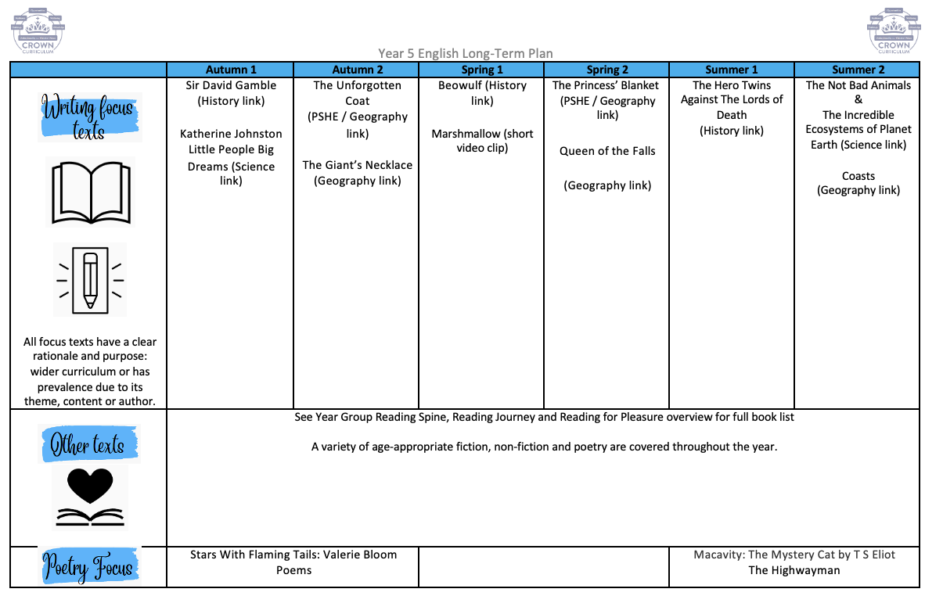
English Medium-Term Plans (Example)
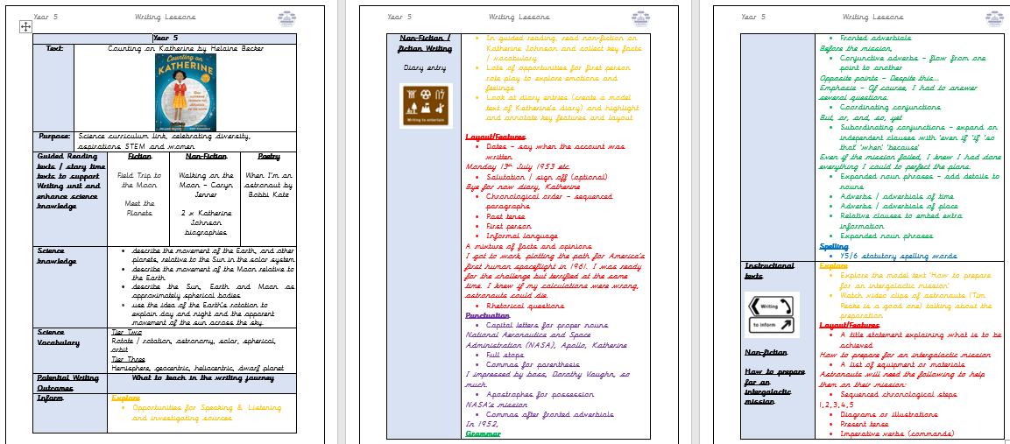
Sample: English medium-term plans show the reading and writing journey the children will take throughout each unit of work.
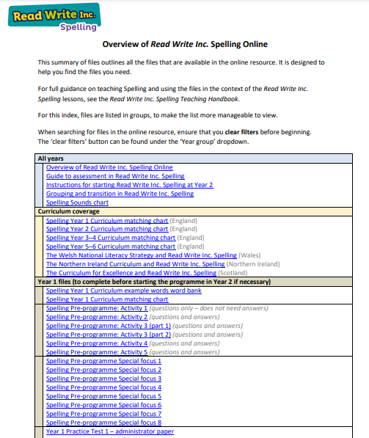

Sample: Spelling long term plans are followed by children who are off the RWI phonics program.

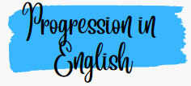
Progression documents
Our progression documents have been created by the English lead to ensure clear progress in all areas of English.
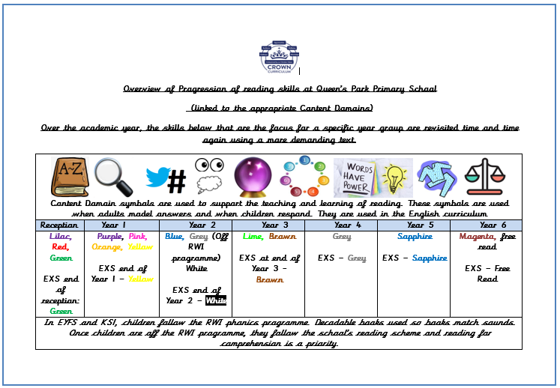
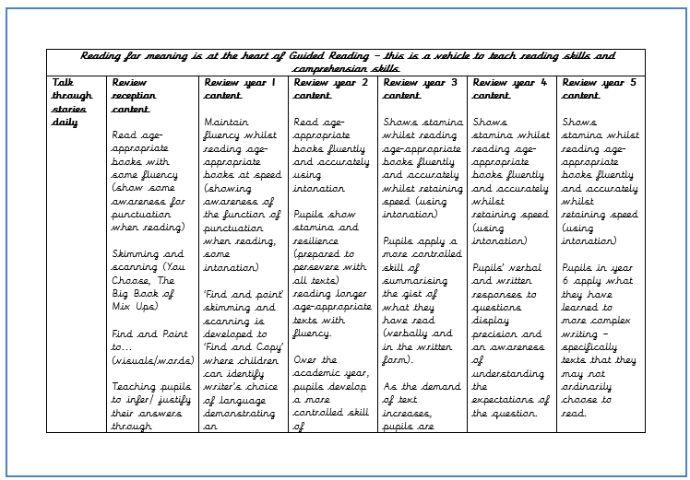
Sample: Progression in reading skills.

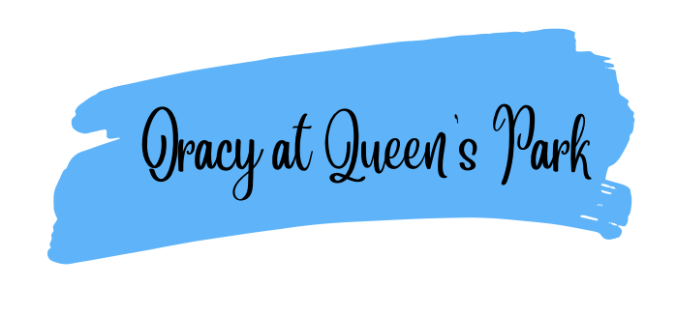
Oracy is a fundamental pillar of our curriculum and underpins all learning. We recognise that strong communication and language skills are essential foundations for pupils’ success across the curriculum and in later life. From the earliest years, children are taught to listen attentively, speak clearly, and express their ideas with confidence, using a rich and ambitious vocabulary.
Our curriculum places a strong emphasis on developing oracy through structured talk, discussion, and purposeful opportunities to articulate thinking. By embedding high-quality talk across all subjects, we enable pupils to deepen understanding, build knowledge, and make connections in their learning. Strong foundations in oracy support pupils’ reading and writing development, enhance engagement, and ensure all children, including those who may experience language barriers, can access the full curriculum.
As a result, pupils become confident communicators who can explain their thinking, collaborate effectively with others, and engage thoughtfully with the world around them.


Vocabulary is V.I.T.A.L in English
Valued
We value vocabulary in English and in everything we do.

Identified
Vocabulary is identified by an adult in reading sessions and are explicitly planned for.

Taught
Vocabulary is explicitly taught in every lesson or reading session. The texts are chosen using Alex Quigley’s ‘arduous eight’ to ensure texts are appropriate in challenge – including vocabulary. Tier 2 and 3 vocabulary is explicitly taught so the word is ‘mastered’.
Applied
Once vocabulary is taught, it is applied. Children apply their vocabulary in their speaking and listening, writing and assessment outcomes in English.
Learned
Vocabulary is revisited and relearned. Vocabulary sticks in the children’s long-term memory.

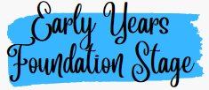
Through an ‘explosion of experiences’, our youngest readers, writers, speakers and listeners are exposed to the strong foundations of their English learning. We believe that that a strong foundation in in EYFS is key to every child’s future success. Using Talk for Writing, our English curriculum comes to life enabling our children to become great storytellers and early writers. Carefully planned opportunities and experiences are provided for our children to enhance their English learning. Early reading is the highest priority in EYFS and their phonics learning commences on entry. High quality books (including non-fiction), stories and rhymes are the beating heart of our curriculum in EYFS and are the bedrock of all learning across the curriculum. Vocabulary is planned for and is explicitly planned through Talk Through Stories. Staff are role models in demonstrating vocabulary in the lesson inputs and this is further enhanced in our excellent provision. The foundations of reading, writing speaking and listening in EYFS is linked to Year 1 and beyond.
Year 1 to Year 6
Year on year, children will build upon their English learning. The English lead has created a meaningful, sequential learning journey through all areas of English. Careful curriculum thinking and planning ensures that our children have the subject knowledge and components embedded in their long-term memories.

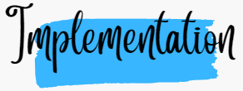
Pedagogy

Both our staff and children are enthusiastic about English. Through ongoing CPD, we strive to ensure our teachers have expert knowledge of the English they teach. Our pedagogy is firmly based upon our curriculum intent of embedding concepts into long-term memory so that they are able to be recalled, to ensure substantive and disciplinary knowledge and skills can be applied fluently.
Our ‘Queen’s Park Quality First Teaching’ model ensures that lessons are effectively sequenced so that new knowledge and skills build on what has been taught before and towards defined end points.
Every area of English has a Queen’s Park structure to ensure there is consistency across school. All pedagogical structures are based on research and what our children need.
Phonics and Early Reading = Read Write Inc Phonics
Spelling = Read Write Inc Spelling
Writing = Explore, Practise, Compose
Handwriting = Letter Join / expectations for lead in lines
Guided Reading = Queen’s Park structure
EYFS = Talk for Writing and Talk Through Stories
English lessons are carefully linked with other curriculum subjects to enhance learning in all subjects and to avoid cognitive overload. Our lessons are scaffolded to ensure all learners have access a full English curriculum. If appropriate, these lessons are modified to meet the needs of the individual.
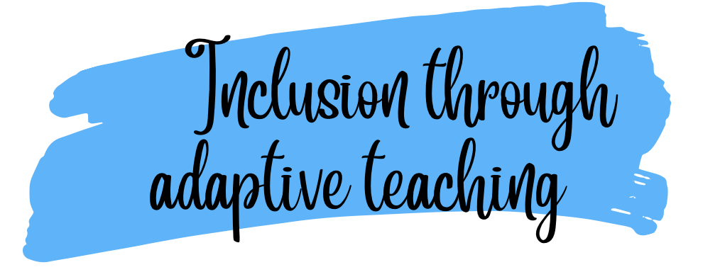
Both our staff and children are enthusiastic about English. Through ongoing CPD, we strive to ensure our teachers have expert knowledge of the English curriculum they teach. Our pedagogy is firmly based upon our curriculum intent of embedding concepts into long-term memory so that they are able to be recalled, to ensure substantive and disciplinary knowledge and skills can be applied fluently.
Our ‘Queen’s Park Quality First Teaching’ model ensures that lessons are effectively sequenced so that new knowledge and skills build on what has been taught before and towards defined end points.
At Queen’s Park, we implement an adaptive teaching approach to ensure that all learners engage in meaningful, challenging, and achievable learning experiences. Our strategy is informed by the Education Endowment Foundation (EEF) research on adaptive teaching, emphasising high expectations, scaffolded support, and responsive adjustments to meet the needs of all pupils. We ensure effective, early identification of any additional barriers to learning, inclusive of but not restricted to Special Educational Needs, Pupil Premium and EAL. Adaptive teaching is essential to our quality first teaching offer as part of our graduated response.

Our Approach: 80% Proactive, 20% Reactive
We recognise that effective adaptive teaching is most successful when it is intentionally planned in advance (proactive) while also allowing for real-time adjustments (reactive) based on pupil responses and progress. Our model ensures:
80% Proactive Adaptive Teaching: Teachers anticipate and plan for diverse learning needs by designing lessons that provide challenge while being accessible to all. This includes the following:
  - Carefully structured tasks that encourage all learners to think hard but remain achievable with time, effort, and support.
  - Scaffolded instruction, including modelling, worked examples, and guided practice.
  - Strategic use of questioning to check understanding and deepen learning.
  - Use of visuals and concrete resources to support learning.
  - Scaffolded tasks that enable all children to access the curriculum without lowering expectations.
  - Planned opportunities for retrieval throughout the curriculum and where appropriate planned opportunities for pre-teach of new learning.
  - Use of accessibility features on iPads to support learning tasks or use of ICT to provide further scaffolding.
  - Where necessary, a modified curriculum to ensure full curriculum entitlement for children who are working below the age-related expectations as identified on the SEND register.
20% Reactive Adaptive Teaching: Teachers remain responsive during lessons, adapting in the moment to ensure all learners stay engaged and make progress. This includes:
  - Making in-the-moment adjustments, such as providing additional explanations, breaking down tasks further, or offering immediate feedback.
  - Using formative assessment strategies to identify and address misconceptions as they arise.
  - Adjusting levels of support, such as peer collaboration, teacher intervention, or additional scaffolding, based on pupil responses.

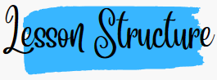
Guided Reading Lesson Structure:

Writing lesson structure
Writing sits at the heart of every subject and helps our children to access the curriculum
Our lesson structure is based on research released in July 2025. The writing framework brings together the latest research and practical approaches to:
- Build a curriculum that develops writing skills step by step
- Establish effective writing routines in every subject.
- Identify pupils who need extra support so no one gets left behind
- Foster o genuine love of writing and help pupils feel proud of their work.
The children follow three board areas on the writing journey: Explore, Practise, Compose.
Please see our writing journey below for more details.

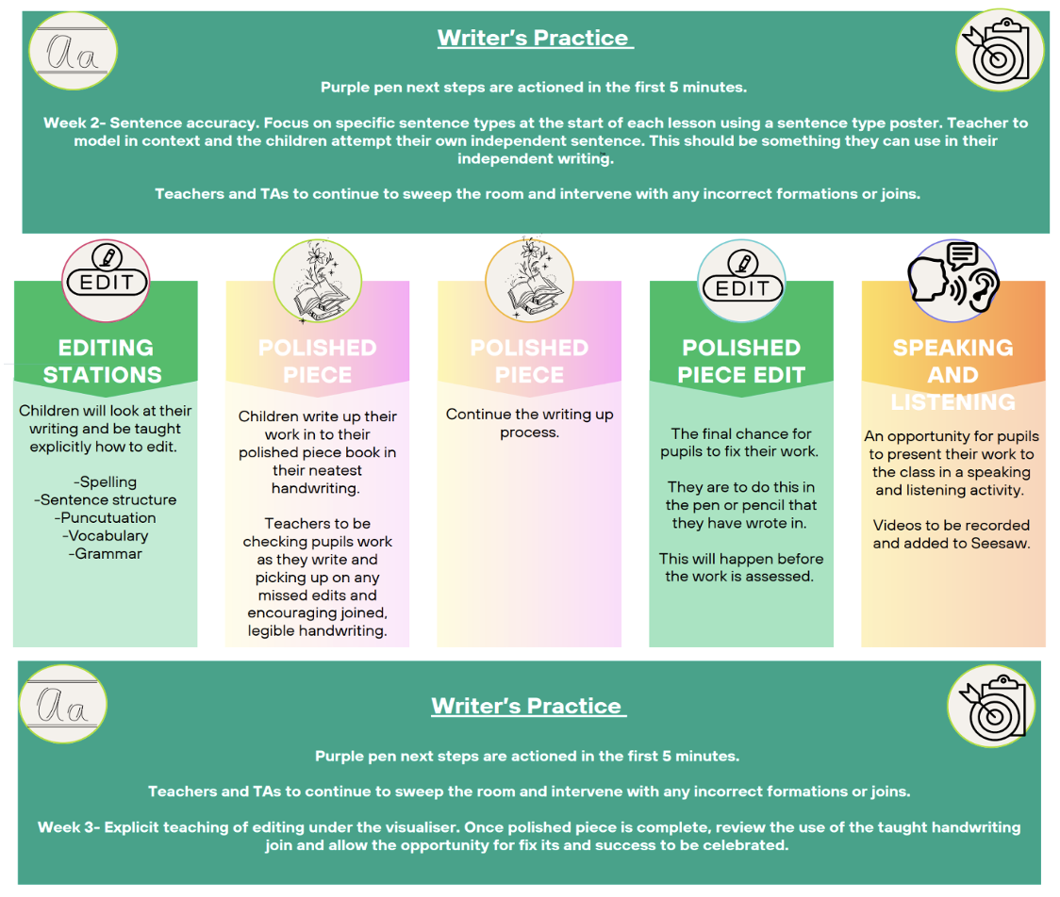
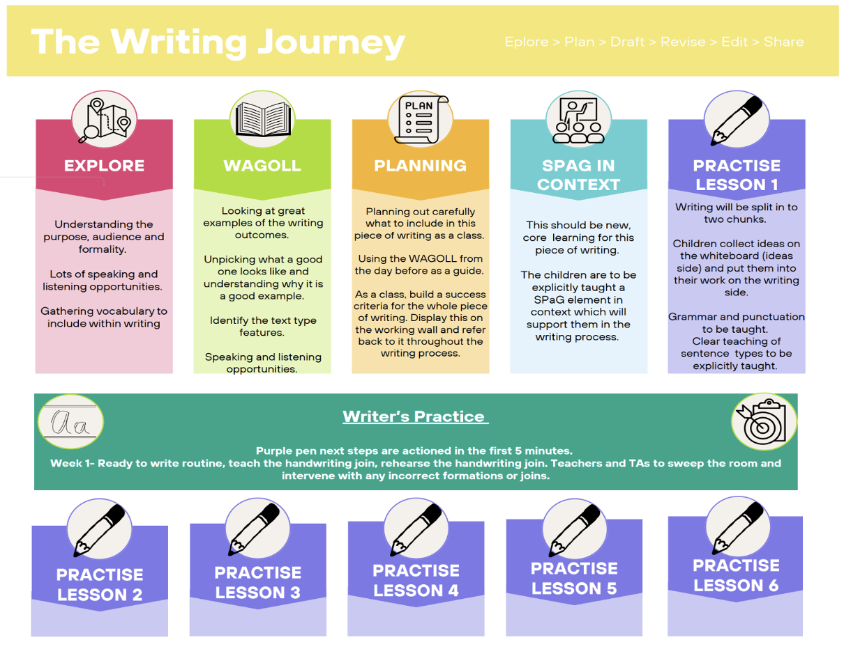
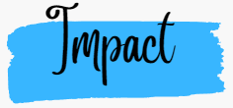
We understand that we may not see the true impact of our English curriculum on our children as our English curriculum is just the beginning of a lifetime of learning.
Our well-constructed and well-taught English curriculum leads to great outcomes. Our results are a reflection of what our children have learnt. At Queen’s Park, our philosophy is that broad and balanced leads to great outcomes and meeting end points at the end of each key stage. National assessments are useful indicators of the outcomes our children achieve.
We ensure all groups of children are given the knowledge and cultural capital they need to succeed in life. We strive to ensure that our children are equipped with the skills (through a growth mindset approach) to fluently be able to retrieve key facts from their semantic memory.
The quality of our children’s work, at every stage, is of a high standard. All learning is built towards an end point and at each stage of their education, we prepare our children for the next stage.
We ensure all our children read to a stage appropriate level and fluency. Reading is the beating heart of our English curriculum.
The impact of Queen’s Park English curriculum is measured through the following:
- Assessment
- National test data
- Pupil voice
- Progress evident in children’s books
- Seeking views of parents where appropriate

