 | Autumn 1 | Autumn 2 | Spring 1 | Spring 2 | Summer 1 | Summer 2
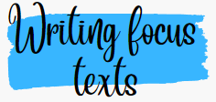      All focus texts have a clear rationale and purpose: wider curriculum or has prevalence due to its theme, content or author. | George Stephenson  (History link)  Jolly Postman, Meerkat Mail, Paddington’s Post  (Geography link)  Colours – non-fiction (art)  Creation Story (RE) | Animal Music by Julia Donaldson (Music)  Instructional text on materials/recycling (Science)  The Rainbow Fish  (DT link) | Lost in the Toy Museum  (History link)  Jim and The Beanstalk  (Science link) | Oliver’s Fruit Salad (Science, PSHE, Food tech link)  The Queen’s Handbag  (Geography link)  Mr Bunny’s Chocolate Factory | Big Book of Bugs by Yuval Zommer (Science link)  Poles apart (Geography/Science)  Plants Fact file (Science) | The Wright Brothers- Non-fiction (History)  On The Way Home  (Science link)
   | See Year Group Reading Spine, Reading Journey and Reading for Pleasure overview for full book list  A variety of age-appropriate fiction, non-fiction and poetry are covered throughout the year.
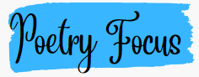   | I See Leaves  Autumn is Here |  | The Owl and the Pussycat by Edward Lear |  | Poems to Perform by Julia Donaldson
  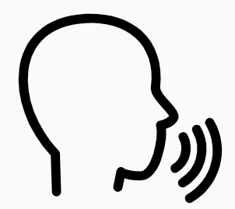 | See Queen’s Park whole school expectations for Speaking & Listening and year group objectives
  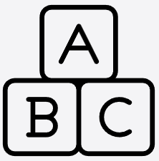 |   - apply phonic knowledge and skills as the route to decode words  - respond speedily with the correct sound to graphemes (letters or groups of letters) for all 40+ phonemes, including, where applicable, alternative sounds for graphemes  - read accurately by blending sounds in unfamiliar words containing GPCs that have been taught  - read common exception words, noting unusual correspondences between spelling and sound and where these occur in the word  - read words containing taught GPCs and –s, –es, –ing, –ed, –er and –est endings  - read other words of more than one syllable that contain taught GPCs  - read words with contractions [for example, I’m, I’ll, we’ll], and understand that the apostrophe represents the omitted letter(s)  - read aloud accurately books that are consistent with their developing phonic knowledge and that do not require them to use other strategies to work out words  - re-read these books to build up their fluency and confidence in word reading.
 | develop pleasure in reading, motivation to read, vocabulary and understanding by:  - listening to and discussing a wide range of poems, stories and non-fiction at a level beyond that at which they can read independently  - being encouraged to link what they read or hear read to their own experiences  - becoming very familiar with key stories, fairy stories and traditional tales, retelling them and considering their particular characteristics  - recognising and joining in with predictable phrases  - learning to appreciate rhymes and poems, and to recite some by heart  - discussing word meanings, linking new meanings to those already known  - understand both the books they can already read accurately and fluently and those they listen to by:  - drawing on what they already know or on background information and vocabulary provided by the teacher  - checking that the text makes sense to them as they read and correcting inaccurate reading  - discussing the significance of the title and events  - making inferences on the basis of what is being said and done  - predicting what might happen on the basis of what has been read so far  - participate in discussion about what is read to them, taking turns and listening to what others say  - explain clearly their understanding of what is read to them.  Priority content domains for Year 1  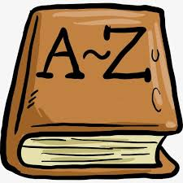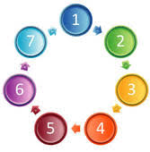  Vocabulary Retrieval Inference Prediction Sequencing
 | write sentences by:  - saying out loud what they are going to write about  - composing a sentence orally before writing it  - sequencing sentences to form short narratives  - re-reading what they have written to check that it makes sense  - discuss what they have written with the teacher or other pupils  - read aloud their writing clearly enough to be heard by their peers and the teacher.
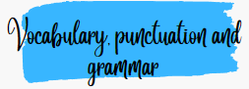   | develop their understanding of the concepts set out in English Appendix 2 by:  - leaving spaces between words  - joining words and joining clauses using and  - beginning to punctuate sentences using a capital letter and a full stop, question mark or exclamation mark  - using a capital letter for names of people, places, the days of the week, and the personal pronoun ‘I’  - learning the grammar for year 1 in English Appendix 2  - use the grammatical terminology in English Appendix 2 in discussing their writing.
   | - words containing each of the 40+ phonemes already taught  - common exception words  - the days of the week name the letters of the alphabet:  - naming the letters of the alphabet in order  - using letter names to distinguish between alternative spellings of the same sound  - add prefixes and suffixes:  - using the spelling rule for adding –s or –es as the plural marker for nouns and the third person singular marker for verbs  - using the prefix un–  - using –ing, –ed, –er and –est where no change is needed in the spelling of root words [for example, helping, helped, helper, eating, quicker, quickest]  - apply simple spelling rules and guidance, as listed in English Appendix 1  - write from memory simple sentences dictated by the teacher that include words using the GPCs and common exception words taught so far.
 | - sit correctly at a table, holding a pencil comfortably and correctly  - begin to form lower-case letters in the correct direction, starting and finishing in the right place  - form capital letters  - form digits 0-9  - understand which letters belong to which handwriting ‘families’ (i.e. letters that are formed in similar ways) and to practise these.

