 | Autumn 1 | Autumn 2 | Spring 1 | Spring 2 | Summer 1 | Summer 2
      All focus texts have a clear rationale and purpose: wider curriculum or has prevalence due to its theme, content or author. | Thomas Beecham and Beecham’s Factory  (History link)  Chester Travel Guide (Geography link) | Edison: The Mystery of the Missing Mouse Treasure (Science link)  Oscar and the Bird  (Science and DT link) | Escape from Pompeii  (History and Geography link)  Rome Travel Guide (Geography link) | The Lorax (Science and PSHE link) | Greek Myths  (History link)  Varmints  (PSHE link / Science link) | The Quest to Digest and  Kay’s Anatomy  (Science link)  The Pebble in my Pocket and Earth Shattering Events (Geography link)
   | See Year Group Reading Spine, Reading Journey and Reading for Pleasure overview for full book list  A variety of age-appropriate fiction, non-fiction and poetry are covered throughout the year.
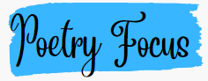   | Allan Allberg – Heard it on the Playground / Please Mrs Butler |  | Jabberwocky by Lewis Carroll and other nonsense poems
  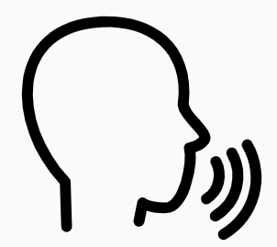 | See Queen’s Park whole school expectations for Speaking & Listening and year group objectives
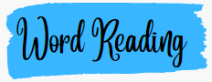  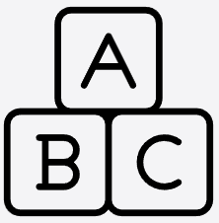 | - apply their growing knowledge of root words, prefixes and suffixes (etymology and morphology) as listed in English Appendix 1, both to read aloud and to understand the meaning of new words they meet  - read further exception words, noting the unusual correspondences between spelling and sound, and where these occur in the word.
 | develop positive attitudes to reading and understanding of what they read by:  - listening to and discussing a wide range of fiction, poetry, plays, non-fiction and reference books or textbooks  - reading books that are structured in different ways and reading for a range of purposes  - using dictionaries to check the meaning of words that they have read  - increasing their familiarity with a wide range of books, including fairy stories, myths and legends, and retelling some of these orally  - identifying themes and conventions in a wide range of books  - preparing poems and play scripts to read aloud and to perform, showing understanding through intonation, tone, volume and action  - discussing words and phrases that capture the reader’s interest and imagination  - recognising some different forms of poetry [for example, free verse, narrative poetry]  - understand what they read, in books they can read independently, by:  - checking that the text makes sense to them, discussing their understanding and explaining the meaning of words in context  - asking questions to improve their understanding of a text  - drawing inferences such as inferring characters’ feelings, thoughts and motives from their actions, and justifying inferences with evidence  - predicting what might happen from details stated and implied  - identifying main ideas drawn from more than one paragraph and summarising these  - identifying how language, structure, and presentation contribute to meaning retrieve and record information from non-fiction  - participate in discussion about both books that are read to them and those they can read for themselves, taking turns and listening to what others say.  Priority content domains for Year 3  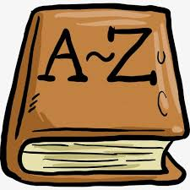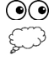
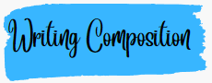 | Pupils should be taught to:  - plan their writing by:  - discussing writing similar to that which they are planning to write in order to understand and learn from its structure, vocabulary and grammar  - discussing and recording ideas  draft and write by:  - composing and rehearsing sentences orally (including dialogue), progressively building a varied and rich vocabulary and an increasing range of sentence structures (English Appendix 2)  - organising paragraphs around a theme  - in narratives, creating settings, characters and plot  - in non-narrative material, using simple organisational devices [for example, headings and sub-headings]  evaluate and edit by:  - assessing the effectiveness of their own and others’ writing and suggesting improvements  - proposing changes to grammar and vocabulary to improve consistency, including the accurate use of pronouns in sentences ♣ proof-read for spelling and punctuation errors  - read aloud their own writing, to a group or the whole class, using appropriate intonation and controlling the tone and volume so that the meaning is clear.
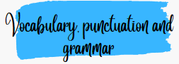   | Pupils should be taught to:  develop their understanding of the concepts set out in English Appendix 2 by:  - extending the range of sentences with more than one clause by using a wider range of conjunctions, including when, if, because, although  - using the present perfect form of verbs in contrast to the past tense  - choosing nouns or pronouns appropriately for clarity and cohesion and to avoid repetition  - using conjunctions, adverbs and prepositions to express time and cause  - using fronted adverbials  - learning the grammar for years 3 and 4 in English Appendix 2  indicate grammatical and other features by:  - using commas after fronted adverbials  - indicating possession by using the possessive apostrophe with plural nouns  - using and punctuating direct speech  - use and understand the grammatical terminology in English Appendix 2 accurately and appropriately when discussing their writing and reading.
   |   Spelling (see English Appendix 1) Pupils should be taught to:  - use further prefixes and suffixes and understand how to add them (English Appendix 1)  - spell further homophones  - spell words that are often misspelt (English Appendix 1)  - place the possessive apostrophe accurately in words with regular plurals [for example, girls’, boys’] and in words with irregular plurals [for example, children’s]  - use the first two or three letters of a word to check its spelling in a dictionary  - write from memory simple sentences, dictated by the teacher, that include words and punctuation taught so far.
 | Pupils should be taught to:  - use the diagonal and horizontal strokes that are needed to join letters and understand which letters, when adjacent to one another, are best left unjoined  - increase the legibility, consistency and quality of their handwriting [for example, by ensuring that the downstrokes of letters are parallel and equidistant; that lines of writing are spaced sufficiently so that the ascenders and descenders of letters do not touch].

