 | Autumn 1 | Autumn 2 | Spring 1 | Spring 2 | Summer 1 | Summer 2
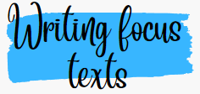      All focus texts have a clear rationale and purpose: wider curriculum or has prevalence due to its theme, content or author. | WW1 St Helens Pals  + Real letters from the trenches (History link)  Macbeth by William Shakespeare | The Arrival (PSHE link)  Top Ten Fairground Rides / Awesome Engineering (DT / Computing link) | Letters from the Lighthouse (History link)  The Heart – non-fiction (science link) | Greta’s Story  We are all Greta  (PSHE / Geography link) | La Luna (short video clip)  Hotel advertisements + reviews | The Explorer (Geography link)  What Mr Darwin Saw (Science link)
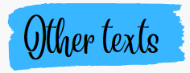   | See Year Group Reading Matrix, Reading Journey and Reading for Pleasure overview for full book list  A variety of age-appropriate fiction, non-fiction and poetry are covered throughout the year.
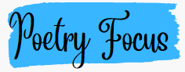   | Poems from the First World War |  | Life Doesn’t Frighten Me by Maya Angelou  If by Rudyard Kipling |  | Moth an Evolution Story
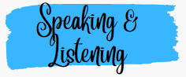  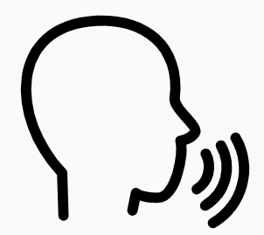 | See Queen’s Park whole school expectations for Speaking & Listening and year group objectives
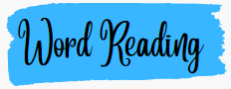  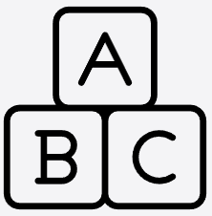 | apply their growing knowledge of root words, prefixes and suffixes (morphology and etymology), as listed in English Appendix 1, both to read aloud and to understand the meaning of new words that they meet.
 | maintain positive attitudes to reading and understanding of what they read by:  - continuing to read and discuss an increasingly wide range of fiction, poetry, plays, non-fiction and reference books or textbooks  - reading books that are structured in different ways and reading for a range of purposes  - increasing their familiarity with a wide range of books, including myths, legends and traditional stories, modern fiction, fiction from our literary heritage, and books from other cultures and traditions  - recommending books that they have read to their peers, giving reasons for their choices  - identifying and discussing themes and conventions in and across a wide range of writing  - making comparisons within and across books  - learning a wider range of poetry by heart  - preparing poems and plays to read aloud and to perform, showing understanding through intonation, tone and volume so that the meaning is clear to an audience  - understand what they read by:  - checking that the book makes sense to them, discussing their understanding and exploring the meaning of words in context  - asking questions to improve their understanding  - drawing inferences such as inferring characters’ feelings, thoughts and motives from their actions, and justifying inferences with evidence  - predicting what might happen from details stated and implied  - summarising the main ideas drawn from more than one paragraph, identifying key details that support the main ideas  - identifying how language, structure and presentation contribute to meaning  - discuss and evaluate how authors use language, including figurative language, considering the impact on the reader  - distinguish between statements of fact and opinion  - retrieve, record and present information from non-fiction  - participate in discussions about books that are read to them and those they can read for themselves, building on their own and others’ ideas and challenging views courteously  - explain and discuss their understanding of what they have read, including through formal presentations and debates, maintaining a focus on the topic and using notes where necessary  - provide reasoned justifications for their views.
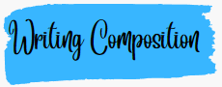 | Pupils should be taught to:  plan their writing by:  - identifying the audience for and purpose of the writing, selecting the appropriate form and using other similar writing as models for their own  - noting and developing initial ideas, drawing on reading and research where necessary  - in writing narratives, considering how authors have developed characters and settings in what pupils have read, listened to or seen performed  - draft and write by:  - selecting appropriate grammar and vocabulary, understanding how such choices can change and enhance meaning  - in narratives, describing settings, characters and atmosphere and integrating dialogue to convey character and advance the action  - précising longer passages  - using a wide range of devices to build cohesion within and across paragraphs using further organisational and presentational devices to structure text and to guide the reader [for example, headings, bullet points, underlining]  evaluate and edit by:  - assessing the effectiveness of their own and others’ writing  - proposing changes to vocabulary, grammar and punctuation to enhance effects and clarify meaning  - ensuring the consistent and correct use of tense throughout a piece of writing  - ensuring correct subject and verb agreement when using singular and plural, distinguishing between the language of speech and writing and choosing the appropriate register  - proof-read for spelling and punctuation errors perform their own compositions, using appropriate intonation, volume, and movement so that meaning is clear.
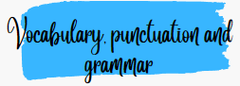   | Pupils should be taught to:  - develop their understanding of the concepts set out in English Appendix 2 by:  - recognising vocabulary and structures that are appropriate for formal speech and writing, including subjunctive forms  - using passive verbs to affect the presentation of information in a sentence  - using the perfect form of verbs to mark relationships of time and cause  - using expanded noun phrases to convey complicated information concisely  - using modal verbs or adverbs to indicate degrees of possibility  - using relative clauses beginning with who, which, where, when, whose, that or with an implied (i.e. omitted) relative pronoun  - learning the grammar for years 5 and 6 in English Appendix 2  - indicate grammatical and other features by:  - using commas to clarify meaning or avoid ambiguity in writing  - using hyphens to avoid ambiguity  - using brackets, dashes or commas to indicate parenthesis  - using semi-colons, colons or dashes to mark boundaries between independent clauses  - using a colon to introduce a list  - punctuating bullet points consistently  - use and understand the grammatical terminology in English Appendix 2 accurately and appropriately in discussing their writing and reading.
   |   Spelling (see English Appendix 1) Pupils should be taught to:  - use further prefixes and suffixes and understand the guidance for adding them  - spell some words with ‘silent’ letters [for example, knight, psalm, solemn]  - continue to distinguish between homophones and other words which are often confused  - use knowledge of morphology and etymology in spelling and understand that the spelling of some words needs to be learnt specifically, as listed in English Appendix 1  - use dictionaries to check the spelling and meaning of words  - use the first three or four letters of a word to check spelling, meaning or both of these in a dictionary  - use a thesaurus
 | Handwriting and presentation Pupils should be taught to:  - write legibly, fluently and with increasing speed by:  - choosing which shape of a letter to use when given choices and deciding whether or not to join specific letters  - choosing the writing implement that is best suited for a task.

