On 23rd June Hindus will celebrate the festival Rath Yatra.
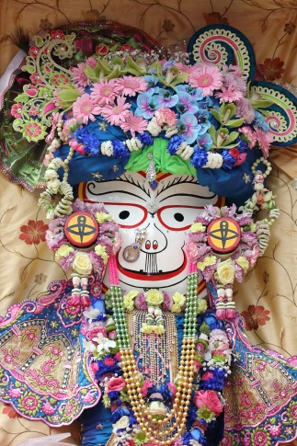
Look at the pictures below. What do you think the festival is about?
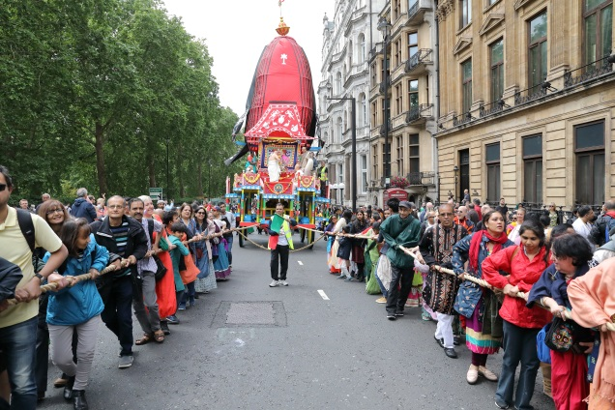
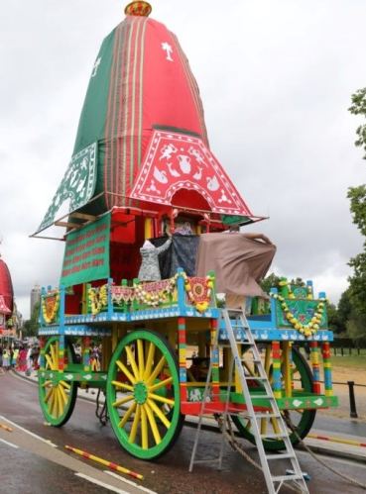
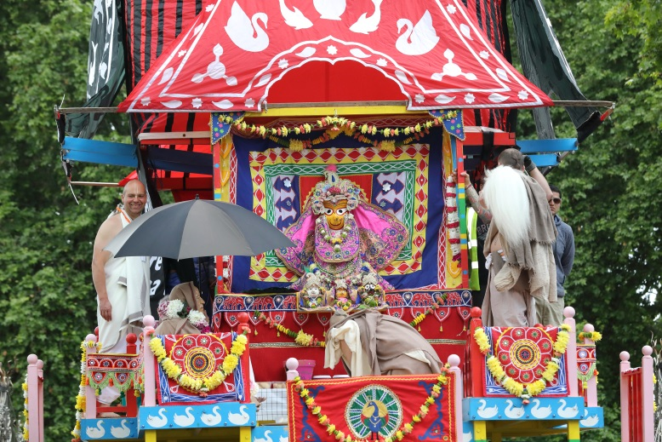

Work through the PowerPoint to learn more about the Rath Yatra festival.

