
ECCLESTON LANE ENDS
SCHOOL CLOSURE WORK

YEAR: 2
DATE: Wednesday 17th June 2020

PE: 9-9.30am
Log in to YouTube at 9am to access a 30-minute PE lesson with Joe Wicks, the body coach. https://www.youtube.com/user/thebodycoach1 Also, take a look at the keeping active and mindful website Fitter Future, for some different activities to stay active during this time.

Reading
Carry on reading Charlie and the campervan. In chapter three, they all start to clean the van and dad shows the children how the roof pops up to make a bed. They find an old photograph of the van with the name Betty painted on it. Please complete the activities once you’ve this chapter.

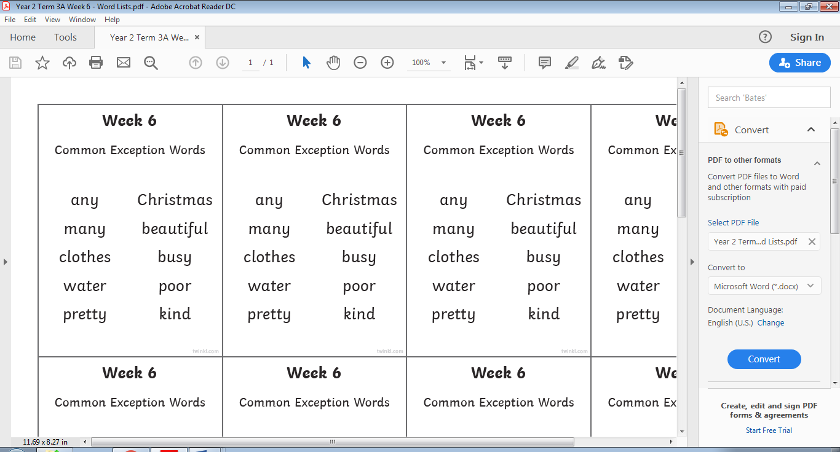
Spellings
This week’s spellings are:

Handwriting practise sheets for this week’s spellings are available to download on spelling section at the top of our class page.

English
Today’s task is to write two paragraphs about the early life of Grace to the stage that she moved to the lighthouse in Longstone aged 10. Tomorrow you will be writing the next part of Grace’s life.
Remember to use a title at the top of your fact file, when you are writing it has to be true correct information. You are not writing a made up story, they are facts. Remember when writing and using proper nouns use a capital letter. After each sentence stop, check and edit each sentence. Do not draw any pictures of Grace yet. Take a piece of paper out of your home learning journal to write this on or if you have lined paper use this. This will go behind your front cover that you designed yesterday. Write about Grace using your notes from last week. Who was she? When was she born? Where was she born? Who was her father? What was her father’s job? What did it entail? Where did she move to? How old was she when this happened?

New paragraph, capital letter at the start of a sentence and name.
Title
Grace Darling

Grace Darling was born in 1815 in Northumberland.

Place
Date

Surname

Use my example sentence BUT improve and edit it, add in Grace’s middle name, use her exact date of birth, where about in Northumberland was she born?

Maths
Following on from yesterday’s learning, today your task is to use your knowledge of 2D shapes, their properties and drawing them to complete the following challenges.

There are three different levels starting at level 1 on page 1.
Page 1 includes questions to support drawing regular 2D shapes, visual support or scaffolding provided.
Page 2 includes questions to support drawing regular and some irregular 2D shapes.
Page 3 includes questions to support drawing regular and irregular 2D shapes, some shapes presented with different orientations.

Geography
Lets make a St. Ives holiday leaflet
To do this you can use your ‘Word Web Frame’ from last week with information all about the seaside resort of St.Ives. On this you might have notes, pictures and your observations about the town.
Using the leaflet template (found in downloads), add the heading
‘Come and visit St.Ives’
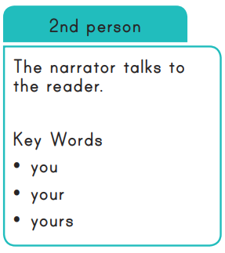
Then underneath can you add these headings and write 3-4 sentences about each one?
Where is St.Ives?
What can you do there?
Where can you stay?
What places are there to eat and drink?
Remember to write in the 2nd person because you are the writer talking to the reader.

