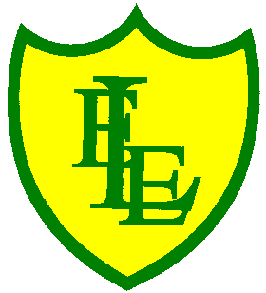
ECCLESTON LANE ENDS
SCHOOL CLOSURE WORK

YEAR: 2
DATE: Thursday 18th June 2020

PE: 9-9.30am
Log in to YouTube at 9am to access a 30-minute PE lesson with Joe Wicks, the body coach. https://www.youtube.com/user/thebodycoach1 Also, take a look at the keeping active and mindful website Fitter Future, for some different activities to stay active during this time.

Reading
Today in chapter four, Charlie’s birthday arrives and all the children help to paint the van. Mum gets Betty started and they head off to Scotland on holiday. After you have read chapter four, please complete the activities based on this chapter.

Spellings
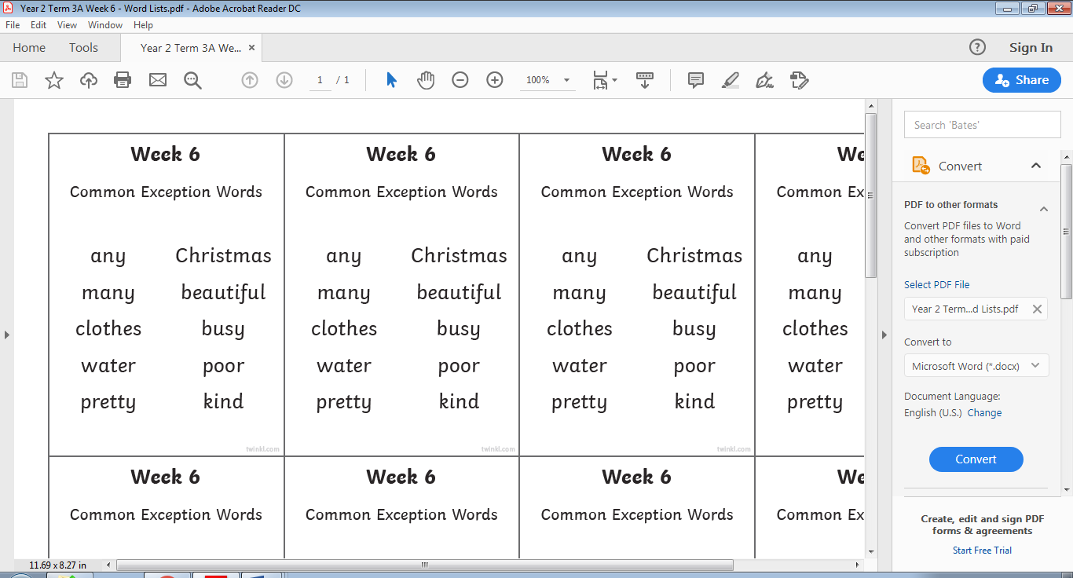
This week’s spellings are:

Please find an attached spelling activity for this week’s spellings in
home learning week 10.

English
Today’s English lesson will be continuing to write your fact file on Grace Darling. Today’s task will be to write more information from her life of the events of the night she rescued the people trapped at sea. This is crucial information why she is a national treasure. I would like you to try to use adverbs in your writing today. An adverb is a word that describes a verb (an action or a doing word). Quickly, slowly, carefully, dramatically. Think about your lesson on Monday using end words.
You will need to include the rescue, what happened? Who was she with? How did it all unfold? Remember to write in paragraphs and also check, check and double check you work. (Mrs Clarke always would say this in her silly voice to you all).

Maths
Today’s maths objective is to able to describe rotation, using vocabulary, such as 'quarter turn', 'half turn' and 'three-quarter turn'
Also to be able to describe direction using vocabulary, such as 'clockwise' and
'anti-clockwise'.

Example task question
Start

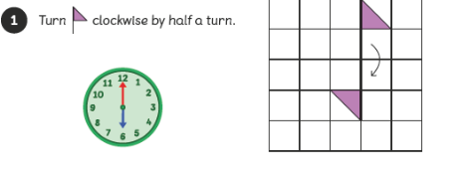
If possible, cut-out the shape needed for the particular question. This way the children can practise rotating the flag according to the instructions. The second part of the task involves turning a shape. If using a cut-out shape the children can rotate it on the grid or screen and then describe the rotations using the correct vocabulary, such as 'clockwise' and
'anti-clockwise'.

**This work does not need to be printed. Your child could draw and cut out the shape in question and rotate or move according using the screen visual.

Spanish
This week we are going to continue thinking about the phrase ‘ Me llamo…’ (My name is…).
Click on the link below to watch listen and join in with one of our favourite songs in class. https://www.youtube.com/watch?v=ij5R1YTG48Q
Now I would like you to draw a picture of you or your face. You can use any colouring pencils, felt tips or paints you own. You might even want to collage your picture. It is up to you (and your family!) how you would like to complete this activity.
Next I would like you to write somewhere on your picture the phrase
Me llamo …..
and complete it with your name. You could have a go at writing this all by yourself or maybe you would like someone from your family to write the phrase first and you can copy it underneath.

