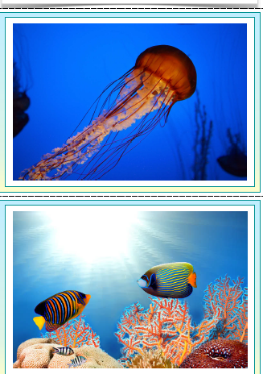
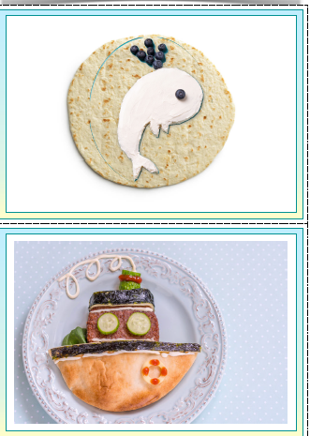

Base design on a sea creature.
Wraps

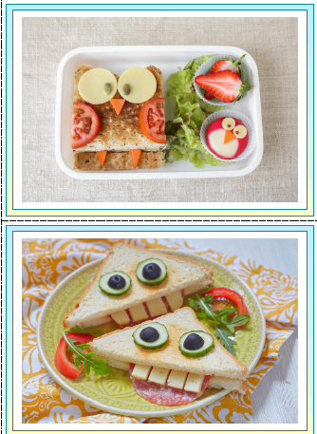
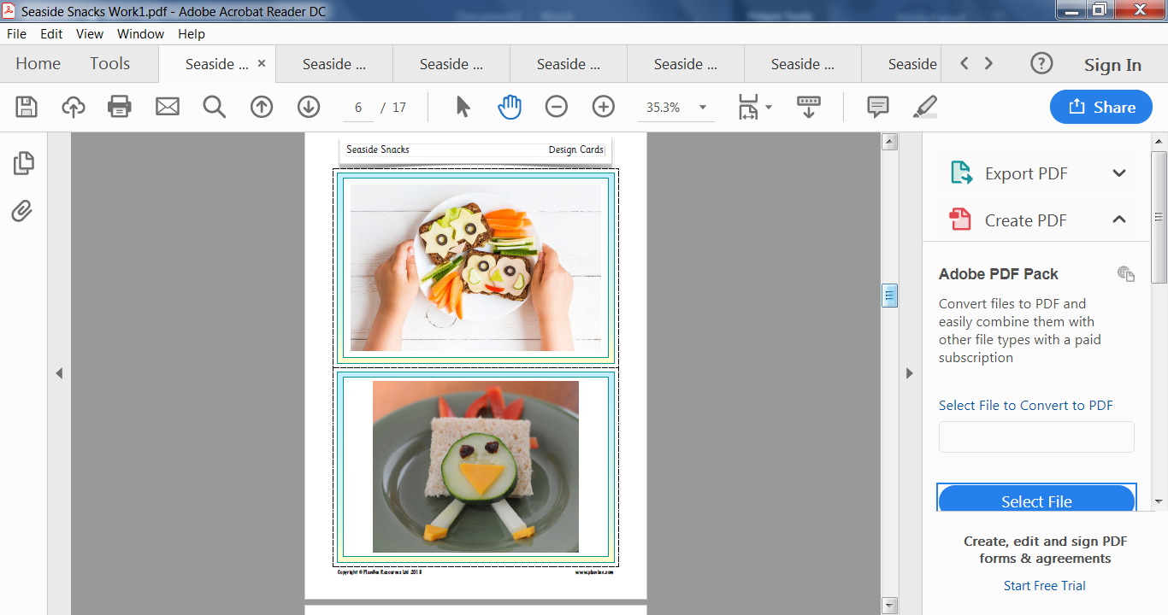

Crackers

Sandwiches

Please note your seaside snack doesn’t have to be a pinwheel.
Your brief is 1. Savoury 2. Based on a sea creature.
Get creative – Send your photos to Mrs Farrell
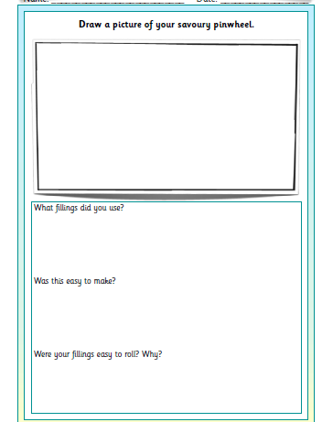
I cant wait to see them!!!
Draw a picture of your savoury seaside snack

What filling will you use?

What equipment will you need?

How will you make it?

Instructions below are for bread pinwheel only.
