
ECCLESTON LANE ENDS
SCHOOL CLOSURE WORK

YEAR: 2
DATE: Wednesday 20th May 2020

PE: 9-9.30am
Log in to YouTube at 9am to access a 30-minute PE lesson with Joe Wicks, the body coach. https://www.youtube.com/user/thebodycoach1 Also, take a look at the keeping active and mindful website Fitter Future, for some different activities to stay active during this time.

Reading
Remember in Year 2 we should be reading at home as much as possible but preferably for 15-20 minutes every day.
Please continue to read the story ‘Wolf’s New Friends’. Today in chapter 3, Wolf gets a big surprise when he tries to play with the other children in the park.
https://www.purplemash.com/

Spellings
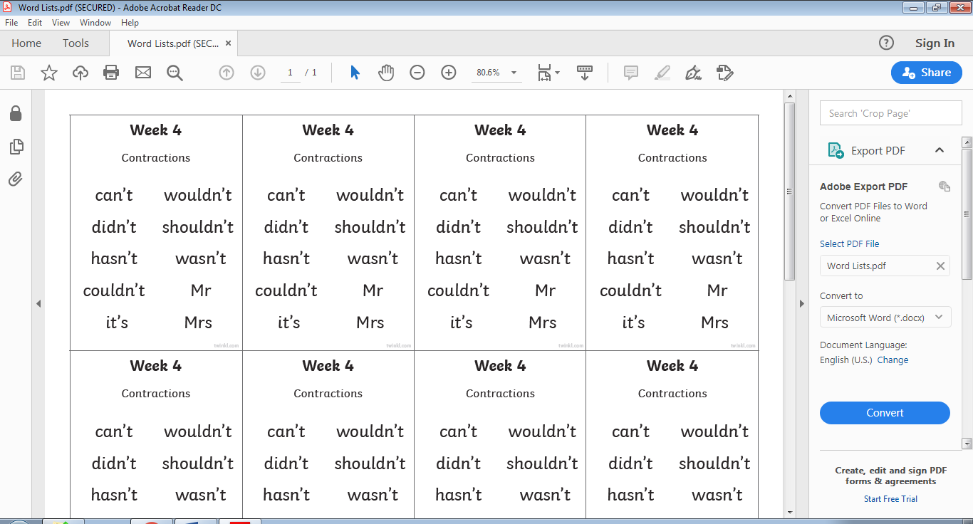
This week’s spellings are:

Handwriting practise sheets for this week’s spellings are available to download on spelling section at the top of our class page.

English
Today’s English lesson will be identifying and using homophones. You will be learning to understand that some words sound the same but have different meaning and put these into practice. This lesson includes: A video to help refresh your knowledge of homophones and three activities to do at home. You should work in your home learning journal for this task.
https://www.bbc.co.uk/bitesize/articles/z7g8jhv

Maths
Following on from yesterday’s learning, measuring in litres (l), today your task is to be able to measure volume in millilitres. We write 'l' for litre. Can you find a container that contain liquid measured in millilitres (10ml, 20ml, 30ml etc) ? 'millilitres' are another standard unit of measurement for volume used to measure smaller amounts of liquid.
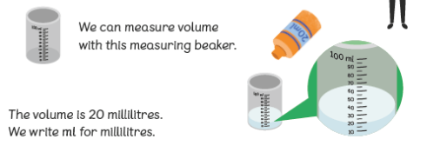
There is 1000ml in 1 litre. So 10 bottles with a volume of 100ml makes 1 litre.
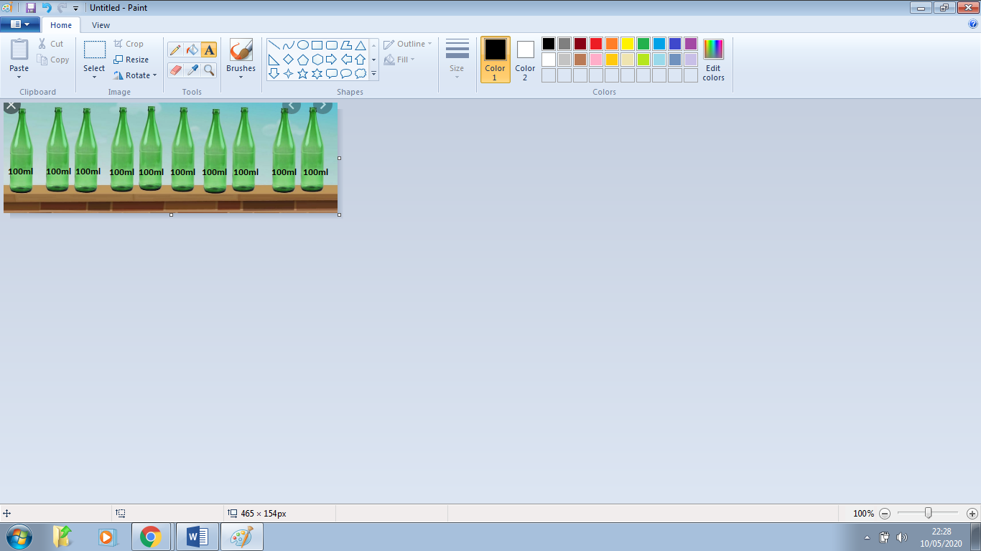

Computing
For your computing activity today, you will be finding out what an algorithm is.
You use code to tell a computer what to do. Before you write code, you need an algorithm.
An algorithm is a list of rules to follow in order to solve a problem. Algorithms need to have their steps in the right order.
Think about an algorithm for getting dressed in the morning. What if you put on your coat before your jumper? Your jumper would be on top of your coat and that would be silly! When you write an algorithm the order of the instructions is very important.

Follow the link to watch the video and find out more about algorithms and how we use them in our everyday lives.
https://www.bbc.co.uk/bitesize/topics/z3tbwmn/articles/z3whpv4

R.E
On Saturday 23rd May and Sunday 24th May, Muslims will be celebrating the end of Ramadan with the festival of Eid. Watch the video clips and think about how Eid compares to a festival you celebrate.
https://www.bbc.co.uk/cbeebies/puzzles/lets-celebrate-eid

