Can you make two lists of places:
Places by the sea
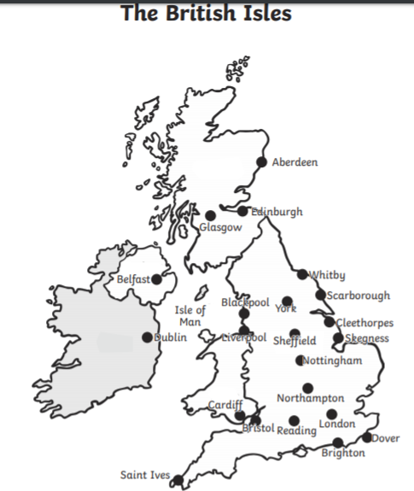
Places NOT by the sea

