Sacramental Preparation Programme 2025-2026
Now that your child is in Year 3, we invite parents of baptised Catholic children to consider whether you would like them to participate in the Sacramental Preparation Programme which leads to the celebrations of First Forgiveness and First Holy Communion. These wonderful steps along the faith journey of life are joyful for us in Catholic education and we dedicate ourselves in faithfulness to supporting our Catholic families walk through these precious steps with their child. This year, our programme will be as follows:
Parents’ Enrolment Meeting
- This meeting will be held in school on Thursday 14th January at 3.20pm in the Y3 classroom. For parents unable to attend at this time, I will repeat the meeting later on at 5.30pm if requested to.
- At this meeting, I will explain the journey of Sacramental Preparation and you will be able to enroll your child on the programme. I will also explain which elements of the programme will be covered in school, which elements need to be completed at home and which elements will be parish based.
Friday 22nd January – classes begin
- For only those children enrolled on the programme, preparation classes will start on this day. Classes will be held every Friday, in school time and will be led by Mrs Kane. Children will be presented with their own special “I belong” book, and these will be used as the focus for the classes for the following 10 weeks.
Mass Attendance
- There is an expectation that as part of the sacramental journey, all children & families will attend Sunday Mass.
- Sunday Mass times are 9am at St Mary of the Angels Church, 11am at Christ the King Church.
- Parents are expected to commit to Mass attendance as part of the programme
Tuesday 21st April 2026 at 6pm: This is the date set for the celebration of First Forgiveness (Reconciliation)
Saturday 9th May 2026 at 10am: This is the date set for the celebration of First Holy Communion.
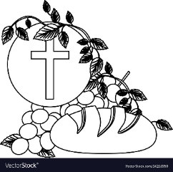
I hope that this letter sets out for you an overview of how our programme will work this year. If you have any questions regarding sacramental preparation, there will be opportunities for discussion at the Parents’ Enrolment Meeting, or alternatively, you are welcome to come and speak with me at school.
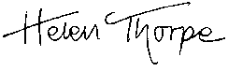
With kind regards,

Mrs Thorpe
Headteacher

