St Mary of the Angels Catholic Primary School
Long Term Connected Planning Overview - 2025-2026 Year 1
Y1 | Autumn 1 | Autumn 2 | Spring 1 | Spring 2 | Summer 1 | Summer 2
English  Driver | 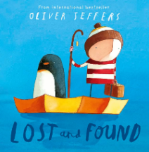 | 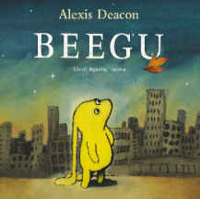 | 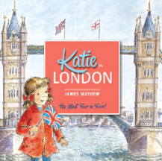 | 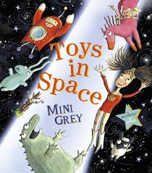 | 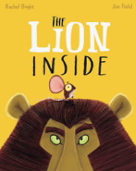 | 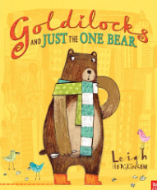
English  Units | Labels  Character description  Narrative | Letter writing  Address writing  Narrative | Postcards  Non-chronological report | Fantasy Story  Change part of a story | Character description  Fact files  Changing part of a story | Character description  Setting description  Biography
Class Reads | Author: Julia Donaldson | Look Up! – Nathan Byron and Dapo Adeola | The bear and the Piano – David Litchfield | Man on the Moon – Simon Bartram | Poems: Smile Out Loud 25 Happy Poems | Theme: Traditional Tales
MATHS
Maths  Topics | Place Value  Addition and Subtraction (within 10) | Addition and Subtraction (within 10)  Shape | Place Value (within 20)  Addition and Subtraction (within 20) | Place Value (within 50)  Length and Height  Mass and Volume | Multiplication and Division  Fractions  Position and Direction | Place Value (within 100)  Money  Time
RELIGIOUS EDUCATION
RE | Creation & Covenant | Prophecy & Promise | Galilee to Jerusalem | From Desert to Garden | To the Ends of the Earth | Dialogue & Encounter
SCIENCE
Science | Seasonal Changes | Animals including humans: All about me | Materials: Exploring Materials | Science Skills | Animals including humans: All about animals | Plants
 | WS: Asking questions and carrying out fair and comparative tests  Observing and measuring changes | WS: Identifying, classifying, recording and presenting data | WS: Identifying, classifying, recording and presenting data | WS: Ask simple questions and identify that they can be answered in different ways | WS: Identifying, classifying, recording and presenting data | WS: Drawing conclusions, noticing patterns and presenting findings
COMPUTING
Computing | 1 - Online Safety  3 - Pictograms | 4 – Early Coding - BeeBots | 5 – Maze Explorers  2 - Grouping and Sorting | 7 - Coding | 6 – Animated Stories | 8 - Spreadsheets  9 – Tech Outside
HISTORY / GEOGRAPHY
Topic | Geography – Wonderful Weather  Geography – All about Little Sutton |  | History – Great Fire of London  History – Toys Through Time |  | Geography – The United Kingdom  History - Victorians
DESIGN TECHNOLOGY
Topic | Design, Make and Evaluate: A Weather Station  Rainbow Kebabs |  | Design, Make and Evaluate: A Sock Puppet  Bake Bread |  | Design, Make and Evaluate: Victorian Clay Tiles  Bake Scones
ART
Topic | Andy Goldsworthy – Land Art  Emotions through art  Colour Theory |  | Piet Mondrian – Vertical and Horizontal  Joining Materials in Different Ways |  | William Morris – Patterns
MUSIC
Topic | Old School Hip Hop, Reggae and Hip Hop |  | Blues, Latin, and Big Band Jazz. |  | Western Classical and Pop
PSHE / SRE
PSHE / SRE | My Happy Mind – Meet Your Brain  My World Your World | My Happy Mind – Celebrate  Journey in Love  Elmer | My Happy Mind – Appreciate  Journey in Love  10 Little Pirates | My Happy Mind – Relate  Journey in Love | My Happy Mind – Engage  Journey in Love  My Grandpa is Amazing | Journey in Love  Max the Champion
PHYSICAL EDUCATION
PE | Gymnastics – Body Parts  Team Building | Dance – Heroes  Gymnastics – Wide and Curled | Athletics  Circuits | Ball Games – Hands  Dance | Athletics  Ball Skills - Hands | Tennis  Ball Games - Feet

