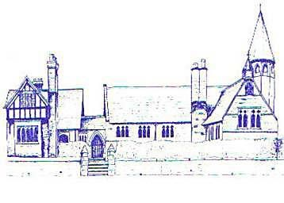

E
c
c
l
e
s
t
o
n

C
.
E
.

P
r
i
m
a
r
y

S
c
h
o
o
l

L
e
t

o
u
r

l
i
g
h
t

s
h
i
n
e

Eccleston C.E. Primary School
Let Our Light Shine

Calculations Policy

Curriculum Committee

Reviewed: Spring 2022

Approved by the Curriculum Committee: Spring 2022

Approved by the Full Governing Board: Spring 2022
Signed by Chair of Governors:

Review Date: Spring 2025

Intent

This document is a statement of the aims, principles and strategies for teaching and learning of calculation strategies in Mathematics at Eccleston CE Primary School. This calculation policy has been devised to meet requirements of the National Curriculum 2014 for the teaching and learning of mathematics, and is also designed to give pupils a consistent and smooth progression of learning in calculation strategies, using efficient methods, across the school. The policy is designed to build progressively, using a mastery approach to learning, using concrete, pictorial and abstract methods of calculation, from the content and methods established in the Early Years Foundation Stage through to Year 6. At whatever stage in their learning, and whatever method is being used, children’s methods of calculating will be underpinned by a secure and appropriate knowledge of number facts, along with the mental skills that are needed to carry out the process and judge if it was successful.
Implementation

Oral and mental mathematics is essential, particularly so in calculation. Early practical, oral and mental work lays the foundations by providing children with a good understanding of how the four operations build on efficient counting strategies and a secure knowledge of place value and number facts. Later learning and skill development must ensure that children recognise how the operations relate to one another and how the rules and laws of arithmetic are to be used and applied, using the most efficient method. Ongoing oral and mental mathematics learning provides practice and consolidation of these ideas. It must give children the opportunity to apply what they have learned to particular cases, exemplifying how the rules and laws work, and to general cases where children make decisions and choices for themselves. The calculation policy is organised according to year groups, as set out in the National Curriculum 2014. It is important that as many pupils as possible are taught according to the year group that they are currently working in, with the use of mastery level questioning, investigating and reasoning to extend learning to greater depth, as required. Staff at Eccleston endeavour to do this by:
- Introducing children to the processes of calculation through practical, oral and mental activities, using concrete, pictorial and abstract resources.
- Supporting children in developing ways of recording to support their thinking and calculation methods.
- Enabling children to learn to interpret and use the signs and symbols.
- Facilitating children’s use of models and images, such as empty number lines, cubes and counters to support their mental and informal written methods of calculation.
- Enabling children to strengthen and refine their mental methods in order to develop informal written methods.
- Supporting children in becoming more efficient and succinct in their recordings which will ultimately lead to efficient written methods that can be used more generally.
- Providing a context for calculation:
It is important that any type of calculation is given a real life context or problem solving approach to help build children’s understanding of the purpose of calculation, and to help them recognise when to use certain operations and methods when faced with problems. The children need to be taught and encouraged to use the following processes in deciding what approach they will take to a calculation, to ensure they select the most appropriate and efficient method for the numbers involved to work out a tricky calculation:
- Can I do it in my head using a mental strategy?
- Could I use some jottings to help me?
- Should I use a written method to work it out?
Impact
By the summer term of Year 4, children should be equipped with knowledge, skills and speed to complete the on-line Times Tables test. By the end of Key Stage 2 children should be equipped with mental, written and calculator methods that they understand and can use correctly, ready for the transition to High School. By the end of Key Stage 2, when faced with a calculation, children will be able to decide which method is most appropriate and efficient and have strategies to check its accuracy. Through the intent and implementation of this calculation policy children should leave Eccleston with a secure understanding of mental math’s facts to apply to written mathematics; a knowledge of number facts and an excellent understanding of the four operations, including using each to reason and problem solve; an efficient, reliable, compact written method of calculation for each operation that children can apply with confidence when undertaking calculations that they cannot carry out mentally; be able to use this knowledge and understanding to solve problems.

Addition
Maths for young children should be meaningful. Where possible, concepts should be taught in the context of real life.

Early Learning Goals - Reception
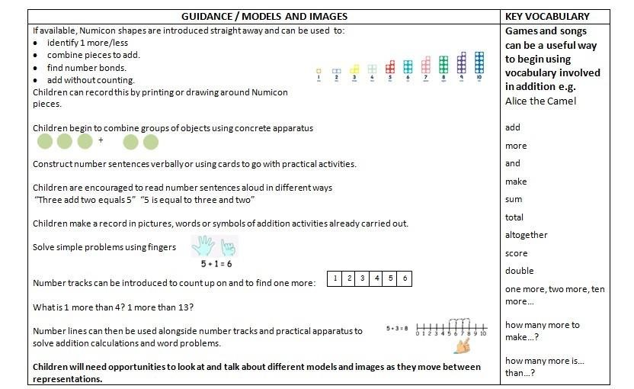

Year 1 | Year 2 | Year 3
igns and missing numbers  Children need to understand the concept of equality before using the ‘=’ sign. Calculations should be written either side of the equality sign so that the sign is not just interpreted as ‘the answer’.  - = 1+ 1 2 + 3 = 4 + 1  Missing numbers need to be placed in all possible places.    - + 4 = = 3 + 4 3 + = 7 7 = + 4  Counting and Combining sets of Objects  Combining two sets of objects which will progress onto adding on to a set  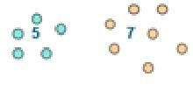  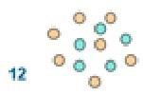  Understanding of counting on with a numbertrack.  Understanding of counting on with a numberline (supported by models and images).  7+ 4  0 1 2 3 4 5 6 7 8 9 10 11 12 | Missing number problems e.g 14 + 5 = 10 + 32 + + = 100 35 = 1 + + 5  Continue to use numberlines to develop understanding of: Counting on in tens and ones  23 + 12 = 23 + 10 + 2 +10 +2  = 33 + 2  = 35  23 33 35  Partitioning and bridging through 10.  The steps in addition often bridge through a multiple of 10  e.g. Children should be able to partition the 7 to relate adding the 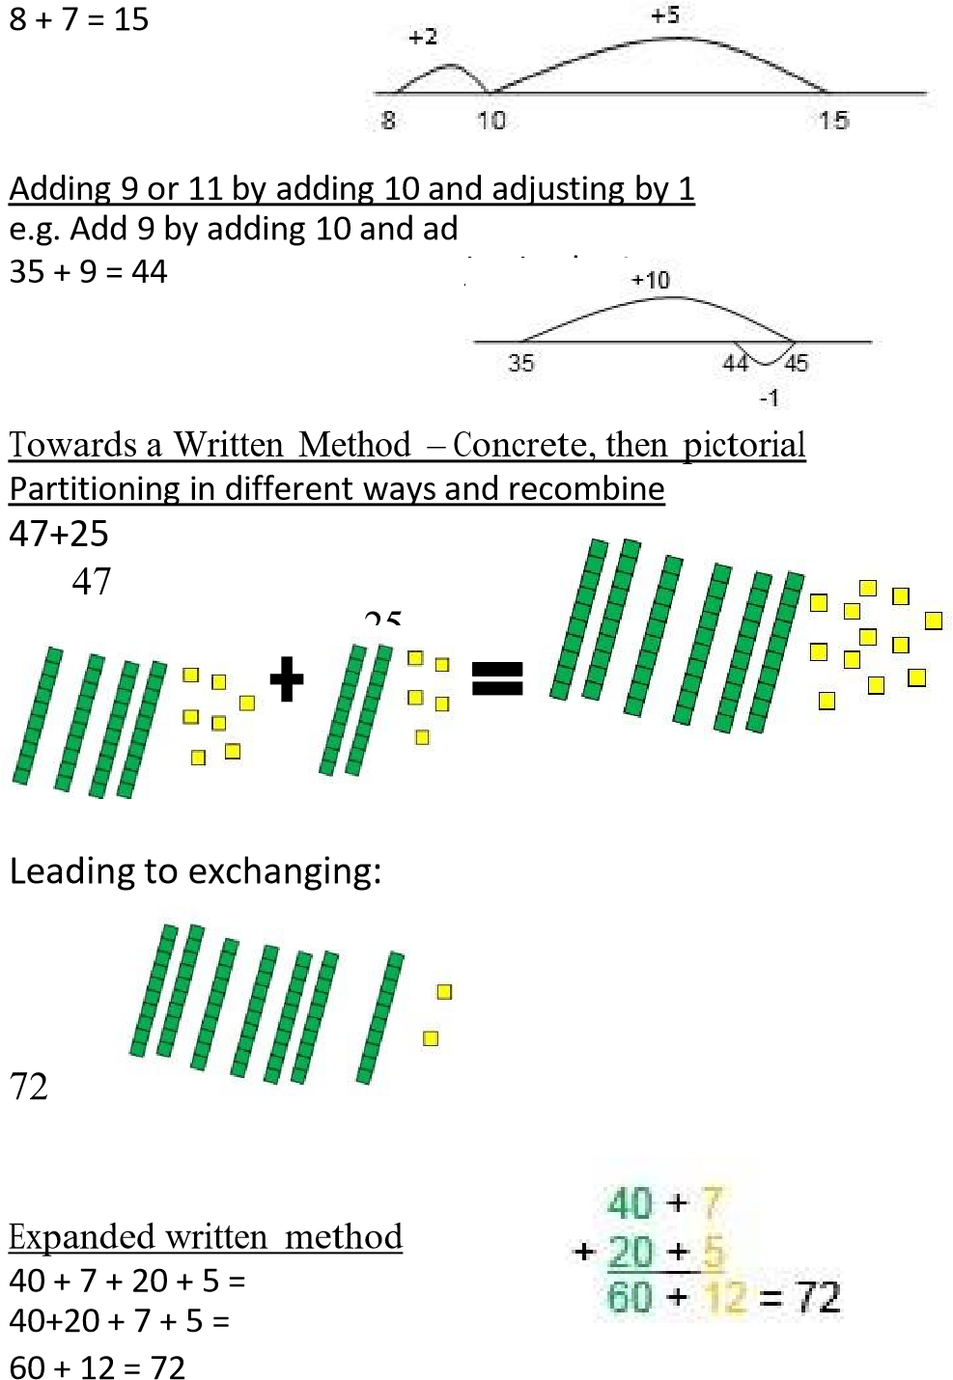2 and then the 5. | Partition into tens and ones  Partition both numbers and recombine.  Count on by partitioning the second number only e.g.  247 + 125 = 247 + 100 + 20+ 5  = 347 + 20 + 5  = 367 + 5 = 372  Towards a Written Method  Introduce expanded column addition modelled with place value counters  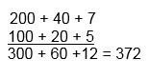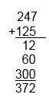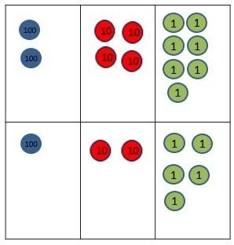  L  e  a  d  i  n  g  t  o  c  h  i  l  d  r  e  n  unde  rs  t  a  nd  i  n  g  t  h  e  ex  c  h  a  n  g  e  be  tw  ee  n  t  en  s  a  n  d  o  ne  s.  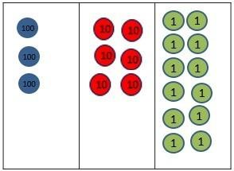  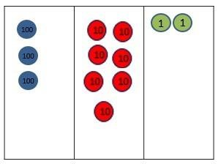  Some children may begin initially introduced alongside the expanded method. The formal method should be seen as a more streamlined version of the expanded method, not a new method.  t  o  u  s  e  a  fo  rmal  m  e  t  h  o  d  ,  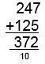

Year 4 | Year 5 | Year 6
Mental methods should continue to develop, supported by a range of models and images, including the number line.  Compact written method  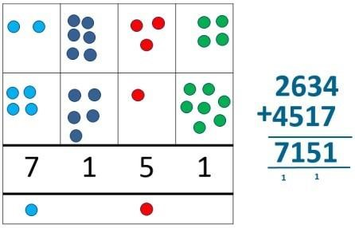  Extend to up to two places of decimals (same number of decimals places) and adding several numbers (with different numbers of digits).  72.8  + 54.6  127.4  1 1 | Mental methods  Children should practise with increasingly large numbers to aid fluency  e.g. 12462 + 2300 = 14762  Written methods (progressing to more than 4-digits)  172.83  + 54.68  227.51  1 1 1 | Mental methods should continue to develop.  Written methods  Progression to larger numbers, aiming for both conceptual understanding and procedural fluency with columnar method to be secured. Continue calculating with decimals, including those with different numbers of decimal places  Problem Solving – throughout Rec, KS1 and KS2 Teachers should ensure that pupils have the opportunity to apply their knowledge in a variety of contexts and problems (exploring cross curricular links) to deepen their understanding.  .

Subtraction

Early Learning Goals - Reception
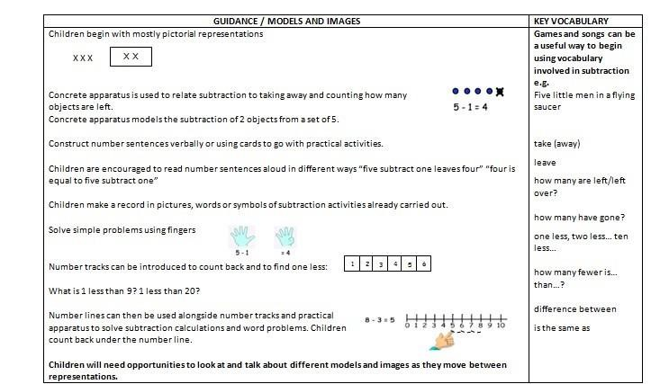

Year 1 | Year 2 | Year 3
Missing number problems e.g. 7 = □ - 9; 20 - □ = 9;  15 – 9 = □; □ - □ = 11; 16 – 0 = □ Use concrete objects and pictorial representations.  Understand subtraction as take-away:  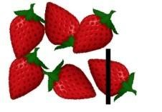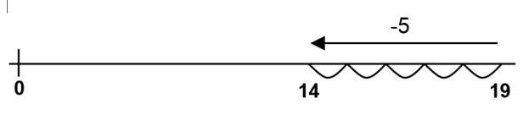  Understand subtraction as finding the difference:  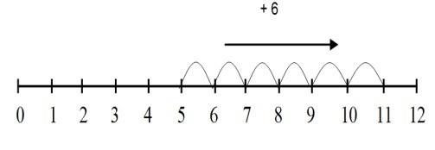  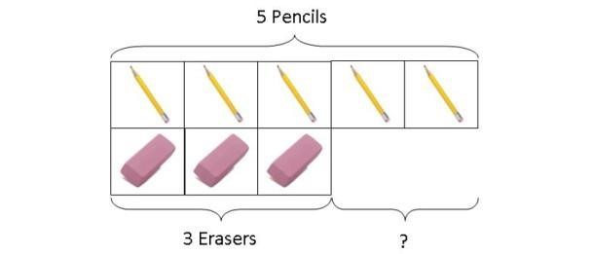  The use of other images is also valuable for modelling subtraction e.g. Numicon, bundles of straws, Diennes apparatus, multi-link cubes, bead strings | Missing number problems e.g. 52 – 8 = □; □ – 20 = 25; 22 = □ –  21; 6 + □ + 3 = 11  Continue to use number lines to model take-away and difference.  E.g.  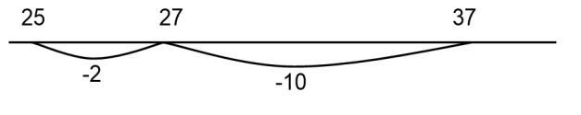  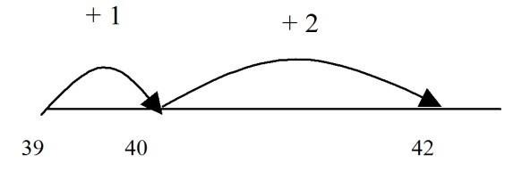  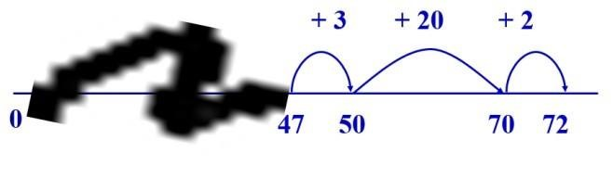  The link between the two may be supported by an image like this, with 47 being taken away from 72, leaving the difference, which is 25.  Towards written methods  Recording addition and subtraction in expanded columns can support understanding of the quantity aspect of place value and prepare for efficient written methods with larger numbers. The numbers may be represented with Dienes apparatus. E.g. 75 – 42  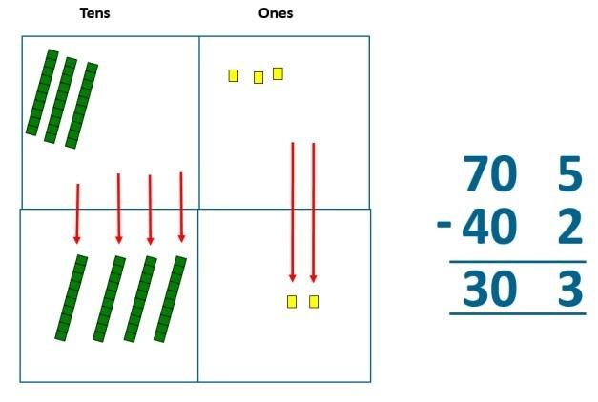 | Missing number problems e.g. □ = 43 – 27; 145 – □ =  138; 274 – 30 = □; 245 – □ = 195; 532 – 200 = □; 364 – 153 = □  Mental methods should continue to develop, supported by a range of models and images, including the number line. Children should make choices about whether to use complementary addition or counting back, depending on the numbers involved.  Written methods (progressing to 3-digits)  Introduce expanded column subtraction with no decomposition, modelled with place value counters (Diennes could be used for those who need a less abstract representation)  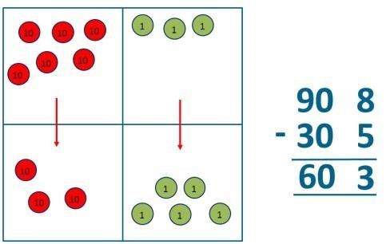  modelled  s  o  me  c  h  i  l  d  r  e  n  th  is  w  ill  l  e  ad  t  o  e  x  c  h  a  n  g  i  n  g,  F  o  r  u  s  i  n  g  p  lace  v  a  l  u  e  c  o  unte  rs  (  o  r  D  i  e  nes  )  .  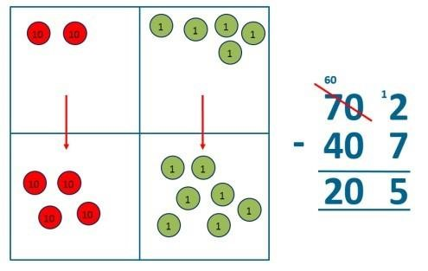  A n ay be  comupmarbeed r nexlinet atnod e eaxcph aondtheedr. column method m

Year 4 | Year 5 | Year 6
Missing number/digit problems: 456 + □ = 710;  1□7 + 6□ = 200; 60 + 99 + □ = 340; 200 – 90 – 80 =  □; 225 - □ = 150; □ – 25 = 67; 3450 – 1000 = □; □ - 2000 = 900  Mental methods should continue to develop, supported by a range of models and images, including the number line.  Written methods using larger numbers  Expanded column subtraction with decomposition, modelled with place value counters, progressing to calculations with 4-digit numbers.  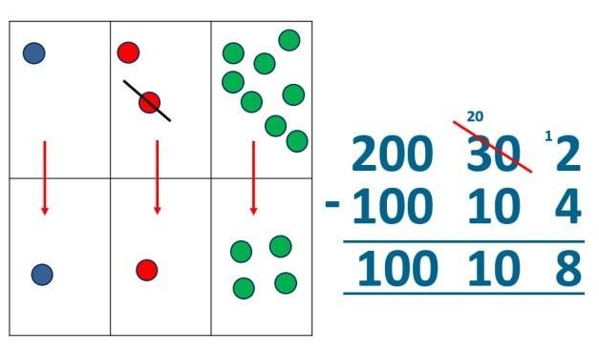  If understanding of the expanded method is secure, children will move on to the formal method of decomposition.  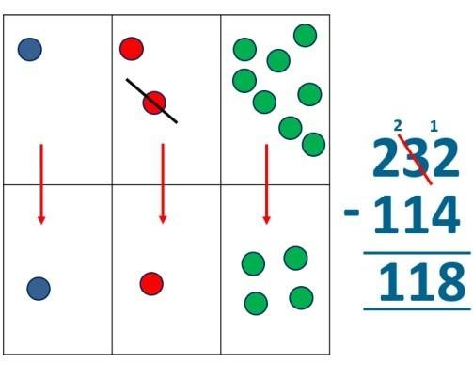 | Missing number/digit problems: 6.45 = 6 + 0.4 + □; 119 - □  = 86; 1 000 000 - □ = 999 000; 600 000 + □ + 1000 = 671  000; 12 462 – 2 300 = □  Mental methods should continue to develop, supported by a range of models and images, including the number line.  Written methods using larger numbers  When understanding of the expanded method is secure, children will move on to the formal method of decomposition, which can be initially modelled with place value counters.  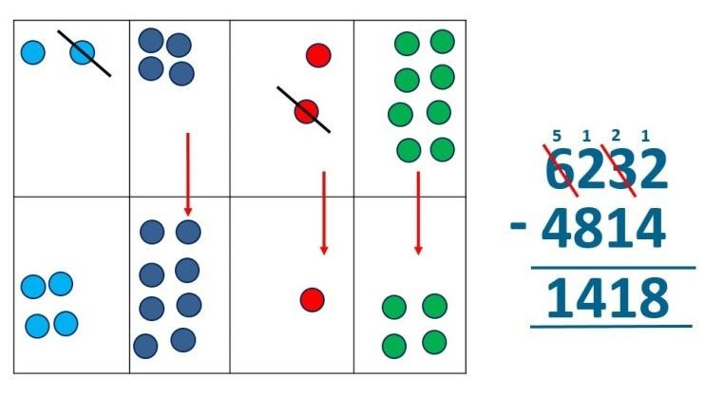  Progress to calculating with decimals, including those with different numbers of decimal places. | Missing number/digit problems: □ and # each stand for a different number. # = 34. # + # = □ + □ + #. What is the value of □? What if # = 28? What if # = 21  10 000 000 = 9 000 100 + □  7 – 2 x 3 = □; (7 – 2) x 3 = □; (□ - 2) x 3 = 15  Mental methods should continue to develop, supported by a range of models and images, including the number line.  Written methods  Progressing to larger numbers, aiming for both conceptual understanding and procedural fluency with decomposition to be secured.  Teachers may also choose to introduce children to other efficient written layouts which help develop conceptual understanding. For example:  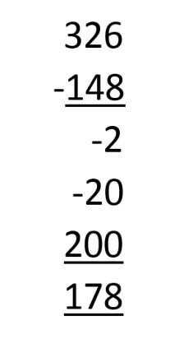  Continue calculating with decimals, including those with different numbers of decimal places.

Multiplication

Early Learning Goals - Reception
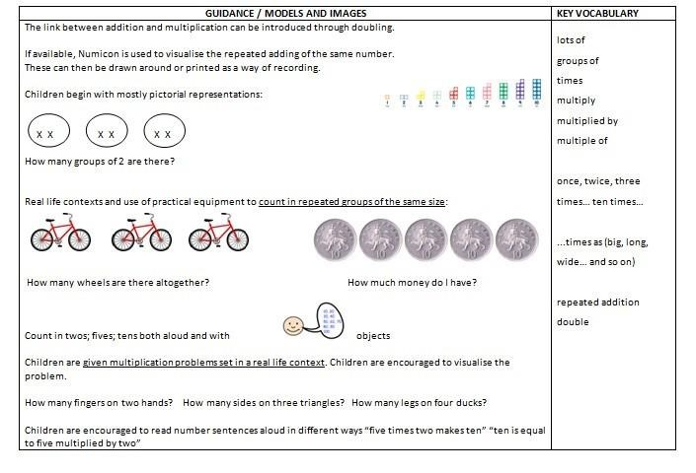

Year 1 | Year 2 | Year 3
Understand multiplication is related to doubling and combing groups of the same size (repeated addition)  Washing line, and other practical resources for counting. Concrete objects. Numicon; bundles of straws, bead strings  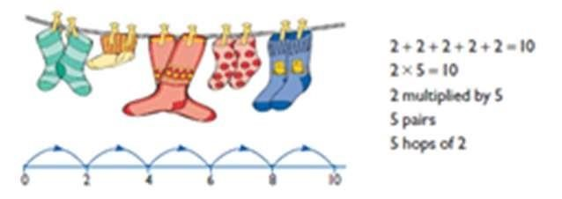  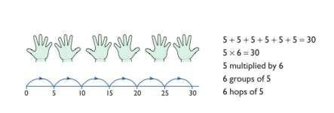  Problem solving with concrete objects (including money and measures  Use arrays to understand multiplication can be done in any order (commutative)  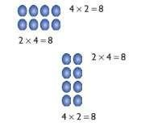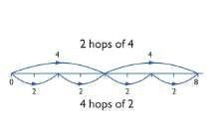 | Expressing multiplication as a number sentence using x Using understanding of the inverse and practical resources to solve missing number problems.  7 x 2 = = 2 x 7    7 x = 14 14 = x 7 x 2 = 14 14 = 2 x x ⃝ = 14 14 = x ⃝  Continue to develop understanding of multiplication using array and number lines. Include multiplications not in the 2, 5 or 10 times tables. Begin to investigate x4, 8, 50, 100  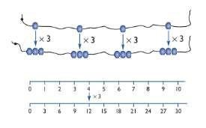    Doubling numbers up to 10 + 10  Link with understanding scaling Using known doubles to work out double 2d numbers  (double 15 = double 10 + double 5)  Towards written methods  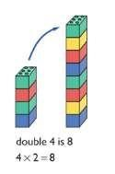  Use jottings to develop an understanding of doubling two digit numbers.  16  10 6  x2 x2  20 12 | Mental methods  Doubling 2 digit numbers using partitioning  Use times tables – 2,4,5,8,10 and count in increments of  50 and 100  Demonstrating multiplication on a number line – jumping in larger groups of amounts  13 x 4 = 10 groups 4 = 3 groups of 4  Written methods (progressing to 2d x 1d)  Developing written methods using understanding of concrete apparatus, such as diennes or counters and then visual images  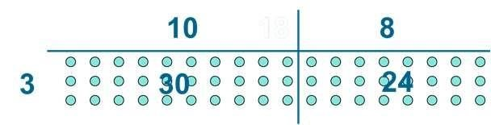  Develop onto the grid method  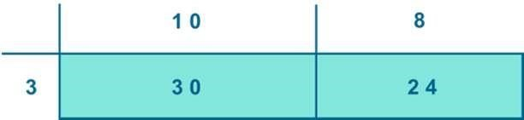

Year 4 | Year 5 | Year 6
Include equations with missing digits:    2 x 5 = 160  Mental methods  Counting in multiples of 6, 7, 9, 25 and 1000, and steps of 1/100.  Learn common factors and multiples.  Increase confidence and speed in calculating multiples and solving times tables questions, ready for the Times Tables test in the summer term.  Written methods (progressing to 3d x 2d) Children to embed and deepen their understanding of the grid method to multiply up 2d x 2d. Ensure this is still linked back to their understanding of arrays and place value counters.  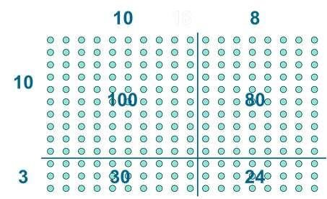  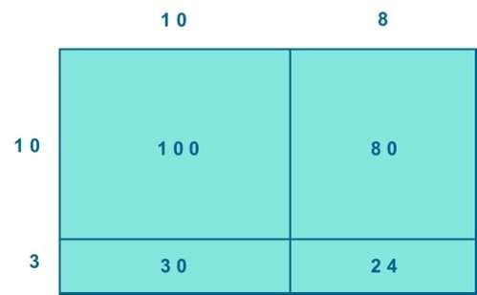 | Equations with missing digits.  Mental methods X by 10, 100, 1000  Use practical resources and jottings to explore equivalent statements (e.g. 4 x 35 = 2 x 2 x 35)  Recall of prime numbers up 19 and identify prime numbers up to 100 (with reasoning)  Written methods (progressing to 4d x 2d)  Children to explore how the grid method supports an understanding of long multiplication (for 2d x 2d)  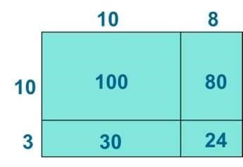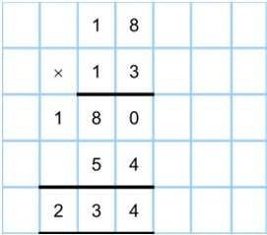 | Written methods  Continue to refine and deepen understanding of written methods including fluency for using long multiplication  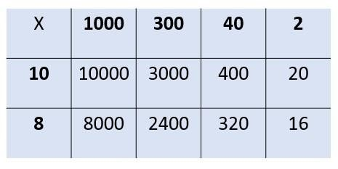  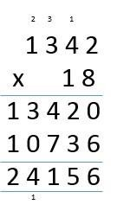

Division and fractions

Early Learning Goals - Reception
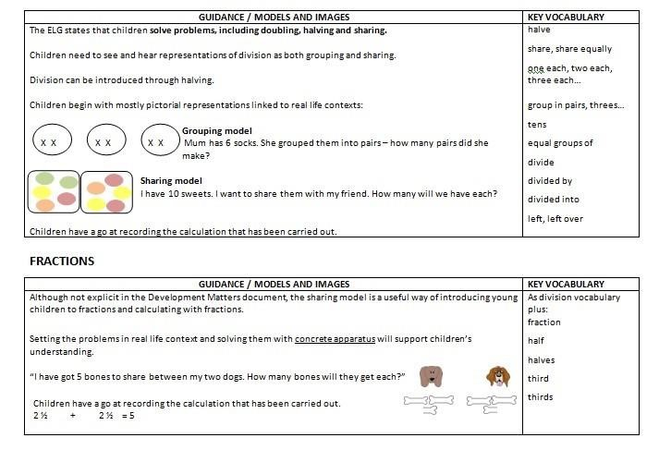

Year 1 | Year 2 | Year 3
Children must have secure counting skills- being able to confidently count in 2s, 5s and 10s.  Group AND share small quantities- understanding the difference between the two concepts. Sharing Develops importance of one-to-one correspondence.  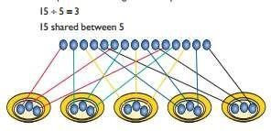  C apparatus. Grouping  h  il  dr  e  n  s  h  o  u  ld  b  e  t  a  u  g  h  t  t  o  s  h  are  u  si  n  g  c  o  n  cr  e  t  e  Children should apply their counting skills to develop some understanding of grouping.  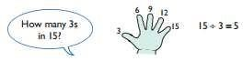  ₁Use of arrays as a pictorial representation for division.  155 ÷÷ 53 == 35 TThheerree aarree 35 grgrooupupss ooff 53..      Children should be able to find ½ ple and ¼ and sim fractions of objects, numbers and quantities. | ÷ = signs and missing numbers  6 ÷ 2 = = 6 ÷ 2      6 ÷ = 3 3 = 6 ÷ ÷ 2 = 3 3 = ÷ 2 ÷ = 3 3 = ÷  Know and understand sharing and grouping- using the ÷ symbol/operation.  Children should continue to use grouping and sharing for division using practical apparatus, arrays and pictorial representations.  Grouping using a numberline  Group from zero in jumps of the divisor to find our ‘how many groups of 3 are there in 15?’.  15 ÷ 3 = 5  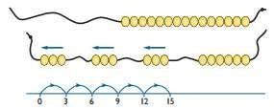  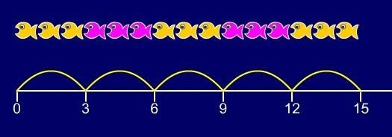  Continue work on arrays. Support children to understand how multiplication and division are inverse. Look at an array – what do you see? | Grouping  How many 6’s are in 30?  30 ÷ 6 can be modelled as:  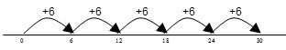  Becoming more efficient using a numberline  Children need to be able to partition the dividend in different ways. 48 ÷ 4 = 12  +40 + 8 10 groups 2 groups  Remainders  49 ÷ 4 = 12 r1  +40 + 8 + 1  10 groups 2 groups  Sharing – 49 shared between 4. How many left over? Grouping – How many 4s make 49. How many are left over?  Chunking:  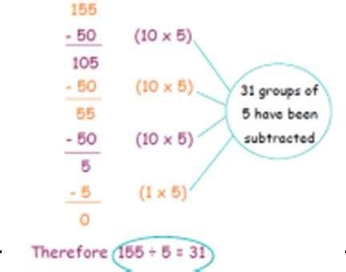

Year 4 | Year 5 | Year 6
Sharing, Grouping and using a number line  Children will continue to explore division as sharing and gr have a secure understanding. Children should progress in  •Using tables facts with which they are fluent  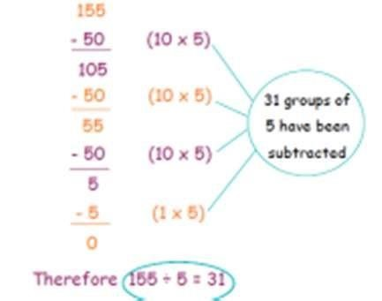  0 | ouping, and to represent calculations on a number line until they their use of written division calculations:  Jottings  e.g. 840 ÷ 7 = 120 7 x 100 = 700  7 x 10 = 70  7 x 20 = 140  100 groups 20 groups  700 840 | Formal Written Methods – long and short division  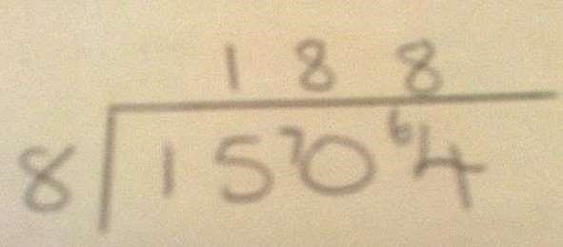  E  .  g  .  1  5  0  4  ÷  8  E  .  g  .  2  3  6  4  ÷  1  5  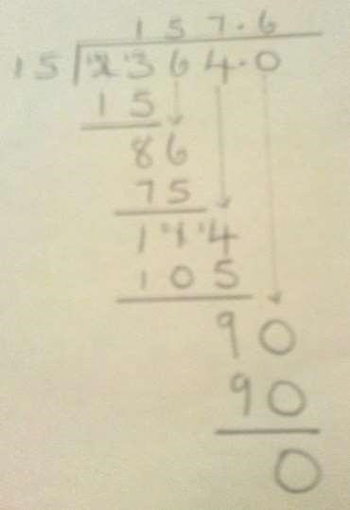
Formal Written Methods  Chunking up  Short division to be modelled for understanding using place value counters as shown below. Calculations with 2 and 3-digit dividends. E.g. fig 1  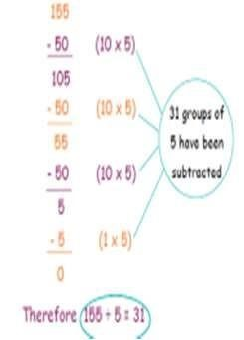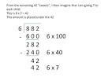 | Formal Written Methods  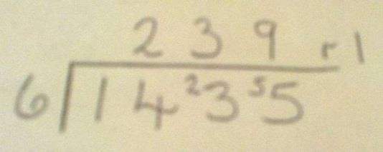  Children begin to practically develop their understanding of how express the remainder as a decimal or a fraction.

