

Eccleston C.E. Aided Primary School
"Let your light shine" - Matthew 5:16

Admissions Policy 2027-2028

Thank you for considering Eccleston C of E (Aided) Primary School for your child, we are proud to have educated pupils in the Parish of Eccleston since 1875. We recently achieved a Judgement 1 from SIAMs (2024) and our Year 6 pupils consistently achieve strong SATs results.
Eccleston C of E (Aided) Primary School is rooted in the Christian faith, and this forms the basis of much of how we behave and how we teach, our ethos is based on that of the Church of England. At Eccleston, we are a partnership of school, church, home and community. We create a stimulating and caring environment, grounded in Christian belief and practice, so that all members of our school community feel happy, safe and secure. Time is taken to value and nurture each child educationally, holistically and spiritually.

Our Vision Statement
At Eccleston C of E Primary School, we believe that every child is known and loved by God and is made in the image of God. We are united in our vision of every child fulfilling their God-given potential as they are nurtured to reflect the example Jesus set in all they do.
We aim to achieve this through instilling a life-long love of learning and development that is rooted in Christian Values. We strive for excellence in all we do enabling all members of our school to flourish.
"Let your light shine" - Matthew 5:16

Making an Application
Applications for admission to the school should be made via the Local Authority. Details of which can be found via the website https://www.cheshirewestandchester.gov.uk/residents/education-and-learning/school-admissions/reception-admissions/making-an-application in line with the dates stipulated by the Local Authority coordinated scheme (the national closing date for primary school applications as stipulated by the School Admissions Code 2021 IS currently 15th January).
For applications considering criteria 2 or 5 (listed below), the Supplementary Form For School Admissions that is specific to Eccleston C of E (Aided) School should be used and returned to us directly. This can be found on the school website https://www.ecclestonprimary.cheshire.sch.uk/page/admissions/19688, and returnable (supplementary form only) to the school via email admin@ecclestonprimary.cheshire.sch.uk
It is not normally possible to change the order of your preferences for schools after the closing date. Whether application is made on paper or electronically, both forms must be completed by those applying under criteria 2 or 5.
Letters informing parents of whether or not their child has been allocated a place will be sent out by the Local Authority – the current dates in line with the LA coordinated scheme are the 16th April. Parents of children not admitted will be informed of the reason and offered an alternative place by the Authority. Applicants will have the right to appeal.
The number of places available for admission to the Reception class will be a maximum of 15. This arrangement follows consultation between the Governing Board, the Diocesan Board of Education, Local Authorities and other admissions authorities in the area. The Governing Board will not place any restrictions on admissions to the Reception class unless the number of children for whom admission is sought exceeds this number. By law, no infant class may contain more than thirty children. The School Admissions Code 2021 states “Additional children may be admitted under limited exceptional circumstances. These children will remain an ‘excepted pupil’ for the time they are in an infant class or until the class numbers fall back to the current infant class size limit.”

Application Criteria
The Governing Board operates a system of equal preferences under which they consider all preferences equally and the Local Authority allocates places according to its policy. In the event that there are more applicants than places, the Governing Board will allocate places using the following criteria, which are listed in order of priority:
1. Looked after children and previously looked after children including those who have been in state care outside of England and ceased to be in state care as a result of being adopted.
A 'looked after child' or a child who was previously looked after but immediately after being looked after became subject to an adoption, child arrangements, or special guardianship order including those who appear to the admission authority to have been in state care outside of England and ceased to be in state care as a result of being adopted. A looked after child is a child who is (a) in the care of a local authority, or (b) being provided with accommodation by a local authority in the exercise of their social services functions (see the definition in Section 22(1) of the Children Act 1989). A child is regarded as having been in state care outside of England if they were in the care of or were accommodated by a public authority, a religious organisation or any other provider of care whose sole main purpose is to benefit society
2. Children with special medical or social circumstances affecting the child where these needs can only be met at this school.
Professional supporting evidence from eg a doctor, psychologist, social worker, is essential if admission is to be made under the criterion for special medical or social circumstances, and such evidence must set out the particular reasons why the school in question is the most suitable school and the difficulties which would be caused if the child had to attend another school.
3. Children who have a brother or sister (sibling) who attends Eccleston C of E (Aided) Primary School on the date of applications closing for entry to reception.
Siblings include step, half, foster, adopted brothers and sisters living at the same address and full brother and sister living apart.
4. Children resident in the ecclesiastical parishes of Eccleston and Pulford. Please see Boundary Map below or visit https://www.achurchnearyou.com/search/?acny_search_place=Eccleston%2C+Chester%2C+UK&lat=53.1566189&lon=-2.8814159&place=Eccleston%2C+Chester+CH4%2C+UK&postcode=CH4&text=
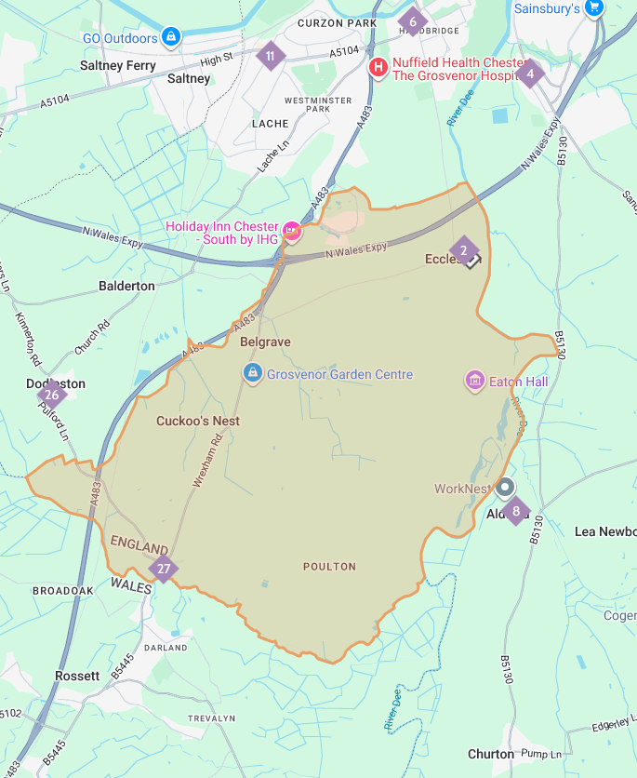
5. Children whose parent/s are faithful and regular worshipers in a Christian church.
By “faithful and regular” we mean attendance at a minimum of one service per month for at least 1 year prior to the closing date for applications. Completion and signature of the Supplementary Information Form should be used as proof and emailed to admin@ecclestonprimary.cheshire.sch.uk.
Christian church means any church, which is designated under the Ecumenical Relations Measure nationally by the Archbishops of Canterbury and York or locally by the Diocesan Bishop, or is a member of Churches Together in England, or the Evangelical Alliance, or a partner church of Affinity.
In the event that during the period specified for attendance at worship the church has been closed for public worship and has not provided alternative premises for that worship, the requirements of these [admissions] arrangements in relation to attendance will only apply to the period when the church or alternative premises have been available for public worship.
Where admission arrangements refer to ‘parent’s attendance at church’ it is sufficient for just one parent to attend.
6. Children who are in receipt of the Early Years Pupil Premium or Service Premium.
7. Children who live nearest to the school as per the definition of the Local Authority - this information is supplied to the school directly from the Local Authority – queries should be directed to the Local Authority.
Pupils living nearest to the school measured in a straight line from the centrally plotted Basic Land and Property Unit point of the child’s home address to the centrally plotted basic land and property unit point of the school as defined by local land and property gazetteer.

Admissions information
The school can be oversubscribed, therefore listing Eccleston C of E (Aided) as first choice on the application form is important if it is your first choice.
Random allocation will be used as a tie-break in the final category above to decide who has highest priority for admission if the distance between two children’s homes and the school is the same. This process will be independently verified. If a tie-break is required in earlier categories to decide who has priority for admission between two children, distance from the school will be used to decide as measured above.

Late applications for admission
Where an application is received after the closing date due to extenuating circumstances, and this is before the admission authority has determined the list of pupils to be admitted, the application will be treated as on-time and considered alongside all other applications in accordance with the published admission arrangements.

Waiting list
Where we have more applications than places, the admissions criteria will be used. Children who are not admitted will have their name placed on a waiting list. The names on this waiting list will be in the order resulting from the application of the admissions criteria. Since the date of application cannot be a criterion for the order of names on the waiting list, late applicants for the school will be slotted into the order according to the extent to which they meet the criteria. Thus, it is possible that a child who moves into the area later to have a higher priority than one who has been on the waiting list for some time. If a place becomes available within the admission number, the child whose name is at the top of the list will be offered a place. This waiting list will operate until the end of the Autumn term, 31st December.
Placing a child’s name on a waiting list does not affect the statutory right of appeal.
Children who are subject of a direction by a local authority to admit, are part of a managed transfer from a closing school or who are allocated to a school in accordance with the Council’s Fair Access protocol will take precedence over those on a school’s waiting list.

Address of pupil
The address used on the school’s admission form must be the current one at the time of application. If the address changes subsequently, the parents should notify the school and Council immediately. Where the parents live at different addresses, the current-at-the-time-of-application, normal address of the child will be the one used. This will normally be the one where the child wakes up for the majority of Monday to Friday mornings. Parents may be asked to show evidence of the claim that is being made for the address, e.g. utility bills of various sorts showing the child’s address as the one claimed. Where there is a dispute about the correct address to use, the governors reserve the right to make enquiries of any relevant third parties, e.g. the child’s GP. For children of UK Service personnel and other Crown Servants returning to the area proof of the posting is all that is required.

In Year Admissions
It sometimes happens that a child needs to change school other than at the “normal” time; such admissions are known as non-routine admissions. Information about in-year admissions can be found on the Cheshire West and Chester website https://www.cheshirewestandchester.gov.uk/residents/education-and-learning/school-admissions/in-year-school-transfers with the relevant procedure and application forms or detail the process that the school follows.

Appeals
Where the governors are unable to offer a place because the school is oversubscribed, parents have the right to appeal to an independent admission appeal panel, set up under the School Standards and Framework Act, 1998, as amended by the Education Act, 2002. Parents should notify the clerk to the governors at the school within 14 days of receiving the letter refusing a place. Parents will have the opportunity to submit their case to the panel in writing and also to attend in order to present their case. You will normally receive 14 day notice of the place and time of the hearing. If your child is refused a place in Reception or Key Stage 1 because of Government limits on Infant Class Sizes, the grounds on which your appeal could be successful are limited. You would have to show that the decision was one which in the circumstances no reasonable Governing Board would have made, or that your child would have been offered a place if the governors’ admissions arrangements had been properly implemented. Please note that this right of appeal against the governors’ decision does not prevent you from making an appeal in respect of any other school.

Fraudulent applications
Where the Governing Board discovers that a child has been awarded a place as the result of an intentionally misleading application from a parent (for example a false claim to residence in the catchment area or of involvement in a place of worship) which effectively denies a place to a child with a stronger claim, then the Governing Board is required to withdraw the offer of the place. The application will be considered afresh and a right of appeal offered if a place is refused.

Deferred admission
Children are eligible for a Reception place from the beginning of the school year in which they become 5 years old. However, they do not become of compulsory school age until the start of the term after their fifth birthday. After a place has been allocated and accepted parents may defer the school place until later in the school year and, if they do this, the place will be held for the child. They cannot however defer entry beyond the beginning of the term after the child’s fifth birthday, nor beyond the summer term. Parents may also choose that their child attends on a part time basis until the child reaches compulsory school age.

Children Educated Outside of Their Normal Age Group
Parents who wish to delay entry until the following year due to specific circumstances, such as ill health, specific circumstances which mean they are not ready to start school or summer born children (those between 1st April and 31st August), must contact the school and Local Authority as soon as possible as this would involve either an in-year application for Year 1 or a new application for Reception in the following year. Parents should submit the request for admittance outside of the chronological year group to the Headteacher and LA as soon as possible in addition to submitting the normal application. The decision as to which year group the child will enter will be made taking into account information from the parents and headteacher and should be in the best interests of the child. Information that parents could include in their request may include details of medical conditions or reports from professionals to support their request.
Parents of summer born children should be aware that agreement by the school to allow a child to enter Reception in the following year does not guarantee a place in the class. Parents must apply to the school in the normal co-ordinated round and the application will be considered in the normal manner following the oversubscription criteria. Parents may also choose to apply in-year for admittance to Year 1 and the child’s normal age group.
Parents whose children have been educated outside of their normal age group because of being a summer born child are not required to submit a Secondary application in Year. They can apply when the child is in Year 6. However, they should be aware that it is the admission authority of the secondary school’s decision as to whether they will admit a child outside of their chronological age group.
These requests will be considered based on the best interests of the child and will take into account the fact the child has been educated in a different year group up until this point.
For many children, it will be right for them to remain with their adopted year group but it is possible that others may be better off joining their normal year group. All decisions will be made taking the circumstances of the case into account and considering all of the child’s needs, including their social and emotional needs.
Unless there are sound educational reasons to do otherwise, the assumption would be that children remain outside their normal year group (that is, in the year which they have been educated so far).
Similarly, if the parents of a gifted and talented child wish to apply for a place outside of their child’s normal age group, they should make a request to the school and the Local Authority. Any application will be considered to ensure any decision is in the best interests of the child and parents informed of the outcome.

Twins
Where there are children of multiple births wishing to be admitted and the sibling is the 15th child, the governors may admit over the infant class requirement if it is possible to do so.

Special Educational Needs
Where a child has an education, health and care plan (EHCP) which names the School, then that child will be admitted to the School and the number of available places in the PAN will reduce correspondingly. Admission of children with an EHCP is dealt with by the home Local Authority (LA) (which is where you reside).

Eccleston C.E. Aided Primary School

"Let your light shine" - Matthew 5:16

Supplementary Form for School Admissions
Surname of Child
Christian name (s)
Date of Birth
Name of parent/guardian
Address
Postcode
Name, address and phone number of the place of worship one of parents / guardians regularly attends
Name of vicar / priest / minister / faith leader / church officer (please include role)
I confirm that the above named parent(s) have attended public worship at least once a month for the last 12 months. | Yes/No
Signature of vicar / priest / minister / faith leader / church officer

Worship attendance:
In the event that during the period specified for attendance at worship the church has been closed for public worship and has not provided alternative premises for that worship. The requirements of these [admissions] arrangements in relation to attendance will only apply to the period when the church or alternative premises have been available for public worship.
The definition of a Christian church is
Any church which is designated under the Ecumenical Relations Measure nationally by the Archbishops of Canterbury and York or locally by the Diocesan Bishop, or is a member of Churches Together in England, or the Evangelical Alliance, or a partner church of Affinity.
I have attended worship at least once a month for the past 12 months

Signed: …………………………………………………………..………..….……… Date: ……………………………………………………..….………

Special medical or social circumstances
Tick here if you are applying under this criterion.
Give details of professional evidence submitted:

