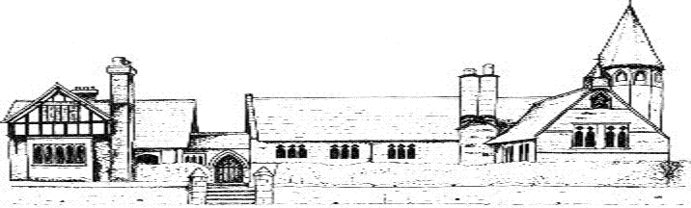

ECCLESTON C.E. PRIMARY SCHOOL CURRICULUM
“Let your light shine”
-Matthew 5:16

Eccleston C E Primary School
Reception and Year 1– Overview of two-year rolling programme
Year A
Year B
Topics are always linked to children’s interests so curriculum objectives may be taught in a different order to fit with topics and interests.
Subject | Autumn | Spring | Summer
Literacy | Mr Gumpy’s Outing – John Burningham  (Narrative and invitations)  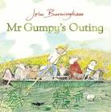  Little Red – Beth Woolvin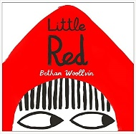  (Labels, captions, invitations, menus, speech, narrative, recount  Traditional tale – narrative writing, instruction writing)  Daily phonics  The Something – Rebecca Cobb  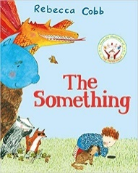  (A losing story and information text)  Star in a Jar – Sam Hay and Sarah Massini  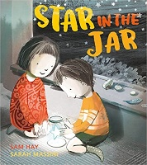  (Messages, information writing, sequencing, poster, recount, information)  Daily phonics | Hermelin – Mini Grey  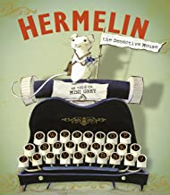  (Detective narrative and letters)  Where the Wild Things Are – Maurice Sendak  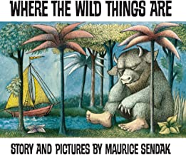  (Letter writing, recount, information writing)  Daily phonics  Rapunzel – Beth Woolvin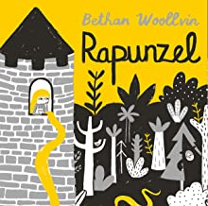  (Traditional tale and instructions)  Juniper Jupiter – Lizzy Stewart  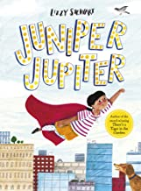  (Traditional tale – narrative writing, instruction writing, letter)  Daily phonics | The Storm Whale – Benji Davies  The Last Wolf – Mini Grey  (Postcards, recount, recipes, instructions)  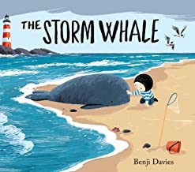  The Last Wolf by Mini Gray  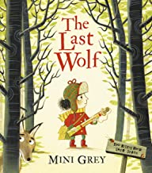  (Hunting narrative and recipes)  Daily phonics  The Secret of Black Rock – Todd Stanton  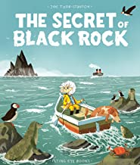  (Descriptive narrative and postcards)  The Extraordinary Gardener – Sam Boughton  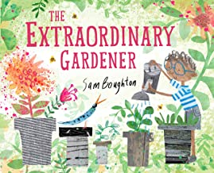  (Narrative, postcards, recount, description, speech, recipes, instructions, information)  Daily phonics
Maths – programme of Mastery for Year 1   | Place value, (within 10)  Addition and subtraction, (within 10)  Place value, (within 20)  Geometry – shape  Place value, (within 10)  Addition and subtraction, (within 10)  Place value, (within 20)  Geometry – shape | Number and addition, (within 20)  Place value, (within 50)  Measurement - length/height/weight, volume  Number and addition, (within 20)  Place value, (within 50)  Measurement - length/height/weight, volume | Multiplication and division  Fractions  Geometry – position and direction  Place value, (within 100)  Measurement – money and time  Multiplication and division  Fractions  Geometry – position and direction  Place value, (within 100)  Measurement – money and time
Science | Everyday materials  Everyday materials | Plants  Animals, including humans | Animals, including humans  Plants
Geography | The UK natural and man-made features  Comparing  Weather  The UK natural and man-made  features  Study of the local environment, including the Eaton Estate  Weather | Around school – maps, local area, comparing Eccleston to Chester  Weather  Around school – Maps, local area, compare Eccleston to Chester  Weather | Farming  Weather  Farming  Weather
History | Changes within living memory – looking at how children’s lives have changed and that of their immediate family  Changes within living memory | How buildings and schools have changed over time, using clues from the past  How transport has changed over time | Comparing old and new farming methods and equipment  Significant people who have shaped British history  Duke of Westminster  Comparing old and new farming methods and equipment  Significant people who have shaped British history  Duke of Westminster
RE | Harvest  Why do people of faith say thank you to God at Harvest time?  I am Special  Why are we all different and special?  Islam  Harvest  How can we help those who do not have a good harvest?  How do people of Jewish faith celebrate the harvest?  Judaism?  Creation  What are your favourite things that God created? What do people of Muslim and Hindu faith believe about how God made the world?  Hinduism  Islam  Christmas  How do Christians celebrate Jesus’ birthday?  Why do Hindus light candles at Diwali?  Hinduism | Jesus  What made Jesus special?  Easter  Why do Christians believe that Easter is all about love?  Prayer  What is prayer?  Buddhism  Islam  Judaism  Easter  What do you think is the most important part of the Easter story? | Baptism  Why is Baptism special?  Hinduism  Islam  Sikhism  Humanism  Special Times  How do you celebrate special times?  Hinduism  Islam  Judaism  Sikhism  Special Places  What makes a place holy?  Hinduism  Islam  My World and Jesus’ World  How is the place where Jesus lived different from how we live now?  Judaism
Art | Portraits and puppets  Colour, mood and texture  Portraits  Colour, mood and texture | Painting – history and movement  Landscapes and cityscapes  Painting, history and landscape  Pop art | Under the sea – mixed media  Nature sculptures  Movement and landscape  Natural sculptures
DT | Puppets  Make and decorate mini Christmas cakes  Moving pictures  Design and make tree decoration | Grouping foods and cooking  Moving pictures  Puppets  Puppets  Design and make a superhero mask | Design and make a sea creature  Weaving  Boat models  Sort and group foods  Cooking
Music | Hey You! Charanga Unit  Traditional songs and rhymes  Singing skills  Christmas performance  Me! Charanga Unit  Traditional songs and rhymes  Singing skills  Christmas performance  The Nutcracker - Tchaikovsky | Everyone! Charanga Unit  Wild Man by Kate Bush    Our World Charanga Unit  Traditional songs and rhymes  Rhythm in the Way We Walk Charanga Unit  Banana Rap Charanga Unit  Runway Blues – Ma Rainey  Round and Round Charanga Unit  Peter and the Wolf study  Traditional rhymes and songs | Big Bear Funk Charanga Unit  The Princess and the Pea performance  In the Groove Charanga Unit  Traditional rhymes and songs  The Enormous Turnip performance  Mars from The Planets-Holst  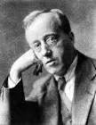
PE | Dance | Gymnastics  Swimming | Games
PHSE | Being Me In My World  Celebrating Difference | Dreams and Goals  Healthy Me | Relationships  Changing Me

Eccleston C E Primary School
Years 2 and 3– Overview of two year rolling programme
Year A
Year B
Subject | Autumn  Rivers  Mighty Metals | Spring  What a Wonderful World!  ‘Whatever the Weather’ | Summer  London  If you go down to the woods…
Literacy | A River – Marc Martin  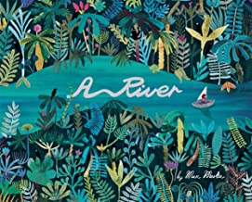  (Circular story and letters)  The Night Gardener by Eric Fan  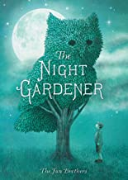  (Narrative, postcard, letter, setting description, poetry, instructions, diary)  Year 2/3 Spelling, Punctuation and Grammar curriculum  Iron Man by Ted Hughes  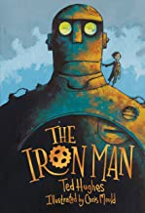  (Approaching threat narrative and explanation)  Fox by Margaret Wild  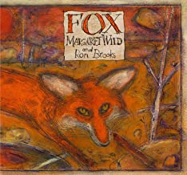  (Fable narrative and persuasion)  Year 2/3 Spelling, Punctuation and Grammar curriculum/ Daily phonics | The Bog Baby - Jeannie Willis  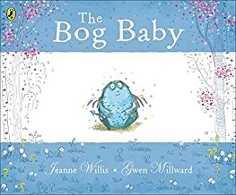  (Finding narrative and instructions)  Grandad’s Island – Benji Davies  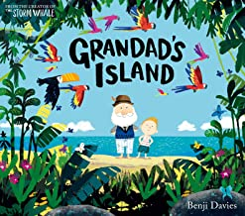  (Return narrative and non-chronological report)  Year 2/3 Spelling, Punctuation and Grammar curriculum  The Rhythm of the Rain – Graham Baker Smith  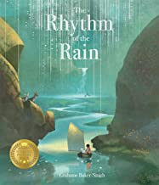  (Setting narrative and information leaflet)  Jemmy Button – Jennifer Uman  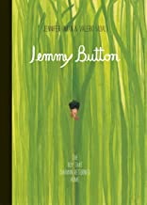  (Return story and letters)  Year 2/3 Spelling, Punctuation and Grammar curriculum/Daily phonics | The King Who Banned the Dark – Emily Haworth Booth  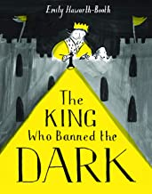  (Persuasive letter and banning narrative)  Rosie Revere Engineer – Andrea Beaty  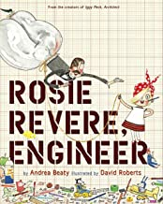  ( Invention narrative and explanation)  Year 2/3 Spelling, Punctuation and Grammar curriculum  Egyptology  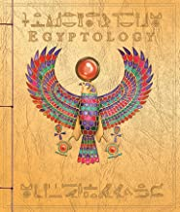  (Egyptian myth narrative and secret diary)  Into the Forest – Anthony Browne  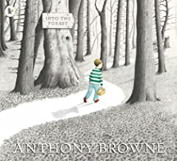  (Lost narrative and newspaper report)  Year 2/3 Spelling, Punctuation and Grammar curriculum/Daily phonics
Maths – programme of Mastery for both Year 2&3 | Place value, shape, statistics  Place value, shape, statistics | Addition and subtraction, money, statistics  Addition and subtraction, money, statistics | Time, mass, length and volume, temperature, multiplication and division  Time, mass, length and volume, temperature, multiplication and division
Science | Environmental science  Forces and magnets | Habitats  Plants  Animals, including humans | Light  Materials  Rocks, soils and fossils
Geography | Study of the River Dee  Magical mapping | Beside the seaside  Comparing Chester to a similar town in a non-European country  Weather and climate  Contienents and Oceans | London and capital cities of the UK  Fieldwork and observational skills
History | Travel and Transport  Famous inventors and inventions  Alexander Bell  Leonardo da Vinci | Intrepid Explorers  Amelia Earhart  Neil Armstrong  Local history – History of Roman Chester | Great Fire of London  Jurassic Forest – Mary Anning
RE | Harvest  How do people of faith say thank you to God for the harvest?  Christmas  How does the presence of Jesus impact on people’s lives?  The Bible  Why is the Bible such an important book?  Do people of all world faiths have holy books?  Islam  Judaism  Sikhism  Christmas  Why was the birth of Jesus such good news? | Jesus  Why did Jesus welcome everyone?  Easter  How do symbols help us to understand the Easter story?  Jesus  How did/does Jesus change lives?  Easter  Is the cross a symbol of sadness of joy? | Rules for Living  Which rules should we follow?  Does everyone follow the same rules? Why? Why not?  Buddhism  Islam  Sikhism  Humanism  New Testament  Which part of the story do you like best?  Which do you think is the most important part of the story?  Hinduism  Islam  Sikhism  The Church  Why is the church a special place for Christians?  Why are holy buildings important to people of faith?  Hinduism  Islam  Judaism  Ascension and Pentecost  What happened at the Ascension and Pentecost?
Art/D&T | Aboriginal and Creation art  Vehicles  Modelling  Magnetic Games | Weaving  Moving pictures  Watercolouring techniques  Easter art  Healthy drink/snack | Portraits  Sir Christopher Wren  Models  Puppets  Art in nature/ Famous artist study  Photo frames
Music | Hands, Feet, Heart Charanga Unit  A Little Help From My Friends – Lennon & McCartney  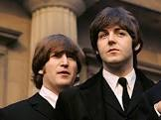  Recorder playing  Reading music  Singing skills  Jai Ho by AR Rahman  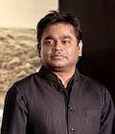  Christmas performance  Let Your Spirit Fly Charanga Unit  Theme from Dr Who by Grainger and Derbyshire    Recorder playing  Reading music  Singing skills  Christmas performance | Recorders and reading music  Stop! Charanga Unit  Bolero – Ravel  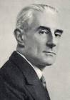  The Dragon Song Charanga Unit  Hound Dog – Elvis Presley    Recorder and reading music  A Night on the Bare Mountain – Mussorgsky  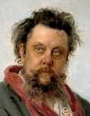  Three Little Birds Charanga Unit  Fanferra – Sergio Mendes   | I Wanna Play in a Band Charanga Unit  Ride of the Valkyries – Wagner  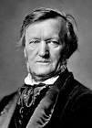  Recorder and reading music  Night Ferry – Anna Clyne    Recorders and reading music  Beethoven’s 5th Symphony  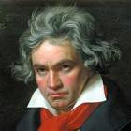  Reflect, Rewind and Replay Charanga Unit  Wonderwall – Oasis  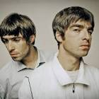
MFL | Numbers 0 -10  Greetings, asking and saying how you are  Christmas – nativity and Christmas vocabulary, letter to Father Christmas  Seasons  Christmas  Nativity play – Characters in the nativity play and simple dialogue | Classroom instructions  Ask for and give name  Revision of numbers 0 – 10  Ask for and state age  Colours  Making a pancake  Easter  Work based on ‘La chenille qui fait des trous’ (The Hungry Caterpillar)  Revision of:  Names of foods  Days of the week  Months of the year | Names of fruit  Names of other foods  Days of the week  Months of the Year  General recap  Work based on ‘Arc-en-ciel le plus beau poisson des océans’ (The Rainbow Fish)  Animals  Revision of colours
Computing | Coding | Short films | Making posters
P.E. | Games  Gymnastics | Games  Swimming | Dance  Gymnastics
PHSE | Being Me In My World  Celebrating Difference | Dreams and Goals  Healthy Me | Relationships  Changing Me

Eccleston C E Primary School
Years 4 and 5– Overview of two year rolling programme
Year A
Year B

Subject | Autumn | Spring | Summer
Literacy | FArTHER – Grahame Baker-Smith  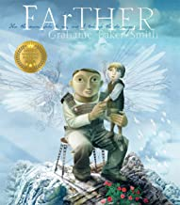  (Setting description and letters)  The Whale – Vita Murrow  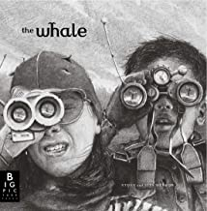  (Setting narrative, newspaper report)  Year 4/5 Spelling, Punctuation, Grammar curriculum  Where we Once Stood – Christopher Riley and Martin Impey  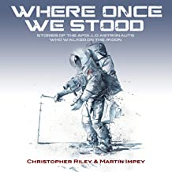  (  The Lost Happy Endings – Carol Ann Duffy  (Twisted narrative and newspaper report)  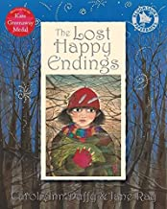  (Explorative narrative, formal report, twisted narrative, persuasive letter)  Year 4/5 Spelling, Punctuation, Grammar curriculum | Manfish – Jennifer Berne  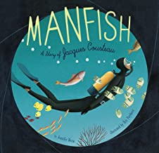  (Invention narrative, biography)  King Kong – Anthony Browne  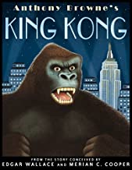  (Dilemma narrative, balanced argument)  Year 4/5 Spelling, Punctuation, Grammar curriculum  The Lost Book of Adventure – Teddy Keen  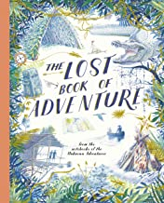  The Journey – Francesca Senna  (Survival narrative, explanation)  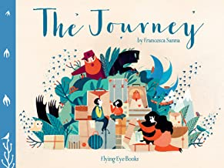  (Refugee narrative, diary recount)  Year 4/5 Spelling, Punctuation, Grammar curriculum | Arthur and the Golden Rope – Joe Todd-Stanton  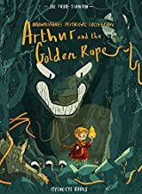  (Myth narrative, information text)  The Promise – Nicola Davies  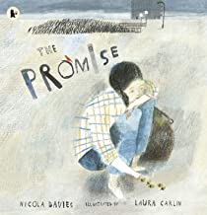  (Character narrative, news report)  Year 4/5 Spelling, Punctuation, Grammar curriculum  Leaf – Sandra Dieckmann  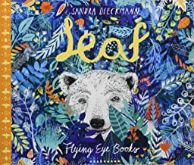  The Hound of the Baskervilles – Arthur Conan Doyle  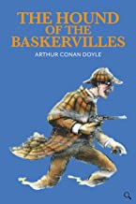  (Outsider narrative, information text, cliff-hangar narrative, formal event report)  Year 4/5 Spelling, Punctuation, Grammar curriculum
Maths – programme of Mastery for Year 4&5 | Place value, addition and subtraction, multiplication and division, area and perimeter  Place value, addition and subtraction, multiplication and division, area and perimeter | Fractions, time, decimals, money, percentages  Fractions, time, decimals, money, percentages | Perimeter and length, angles, shape and symmetry, position and direction, statistics  Perimeter and length, angles, shape and symmetry, position and direction, statistics
Science | States of matter  Properties and changes of materials  Earth and Space | Sound  Forces  Electricity | Animals, including humans  Living things and their habitats
Geography  (objectives are related to the termly topics) | Locational knowledge  World countries  Locational knowledge  World countries | Human and physical geography – Earthquakes and volcanoes and their effects  Human and physical geography | Geographical skills and fieldwork  Geographical skills and fieldwork
History | Ancient Greece  Changes in Britain from the Stone Age to the Iron Age | Study of earthquakes and volcanoes, focusing on Pompeii  Study of an aspect or theme in British history  (famous mountain expeditions) | The Viking and Anglo-Saxon struggle for the Kingdom of England, including Britain’s settlements by Anglo-Saxons and Scots  Ancient Egypt
RE | David and the Psalms  What values do you consider important?  Christian Art  How do Christians express their faith through art?  Hinduism  Islam  Judaism  Christmas  How do our celebrations reflect the true meaning of Christmas?  The Bible  How and why do Christians read the Bible?  Why are sacred texts so important to people of faith?  Hinduism  Islam  Judaism  Sikhism  Christmas  Why is Jesus described as the light of the world?  Why is light an important symbol in world faiths?  Judaism | Jesus  Why do Christians believe Jesus was a great teacher?  Easter  A story of betrayal or trust?  What do world faiths say about forgiveness?  Hinduism  Islam  Judaism  Sikhism  Jesus  Why do Christians believe Jesus is the son of God?  Why do Jewish people believe that the Sabbath/Shabbat is so important?  Judaism  Easter  Why do Christians believe that East is a celebration of victory? | The Church  Are all churches the same?  Are all places of worship the same? Do all people worship God in the same way?  Hinduism  Islam  Judaism  Sikhism  Christian Worship  Why do Christians sing in worship?  Loss, Death and Christian Hopes  Is death an ending or a beginning?  How do people of world faiths mark the end of life?  Buddhism  Hinduism  Islam  Humanism  Old Testament Women  Did she make the right choice?  Judaism
Art/D&T | Designing and making Ancient Greek vases/Greek theatre masks  Looking a healthy recipes in which ingredients change state  Stone Age cave art and Celtic designs  Stone age weapons and tools | Designing and making model volcanoes  Sewing  Islamic patterns  Landscape painting  Alarms | Celtic patterns  Illuminated letters  Bake French bread/pastry  Ancient Egyptian hieroglyphs  Famous artist study  Making a sarcophagus
MFL (French) | Revision of colours  Parts of the body  Adjectives  Asking for French translation (Comment dit-on… en français?)  Zoo animals  Verb – être (to be)  Christmas – phrases and vocabulary for work on snowman theme  Buildings on the high street  Directions  Revision of adjectives  Revision of connectives  Asking where places are  Revision of days of the week  Times of day  Christmas vocabulary | Song ‘Meunier tu dors’  Members of the family  Possessive adjectives  Ask and answer questions about family members  Story ‘Le Radis Géant’ (The Enormous Turnip)  Pets  Verb – avoir (to have)  Easter vocabulary  Revision of days of the week  Revision of sports/hobbies  Simple future tense (Je vais…)  Numbers 0 – 50  Comparisons (plus que – more than)  Revision of fruit/food vocab | Dictionary skills  Playground song and activity  Hobbies  Opinions  Numbers 12 -31  Weather expressions  Items of clothing – packing a suitcase  Breakfast  Ingredients for a French dessert (instructions)  Revision of days of week/months of year  Weather  Seasons  Saying where you live
Computing | Coding | Short films | Paint package
Music | Mama Mia Charanga Unit  Enigma Variations – Elgar  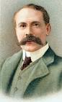  Recorder lessons and reading music  Singing skills  Le Freak – Chic    Christmas performance  Make You Feel My Love Charanga Unit  Recorders and reading music  Recorder lessons  Singing skills | Recorder lessons  Amasing preparation  I Got You – James Brown    Amasing performance at the Storyhouse  Recorders and reading music  Compositions on recorders  Rivers in classical music (Smetna, Strauss, Shostakovich) and composition  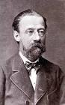  Classroom Jazz 2 Charanga Unit | Classroom Jaz 1 Charanga Unit  Tropical Bird by the Trinidad Steel Band  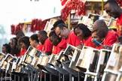  Livin’ On A Prayer Charanga Unit  Inkanyezi Nezazi – Ladysmith Black Mambozo  Fresh Prince of Belair Charanga Unit  Connect It – Anna Meredith  Dancing in the Streets Charanga Unit
P.E. | Tennis  Volleyball | Dance  Gymnastics  Swimming | Games
PHSE | Being In My World  Celebrating Difference | Dreams and Goals  Healthy Me | Relationships  Changing Me

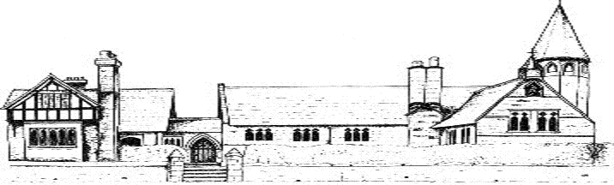

Eccleston C E Primary School
Year 6– Curriculum overview
Subject | Autumn | Spring | Summer
Literacy | Shackleton’s Journey - William Grill  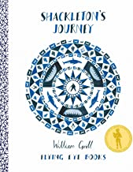  On the Origin of the Species – Sabina Radeva  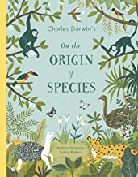  (Character description, letters, poetry, historical narrative, persuasive writing)  The Explorer –Katherine Rundell  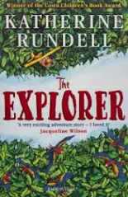  Year 6 Spelling, Punctuation and Grammar curriculum | Letters from the Lighthouse – Emma Carroll  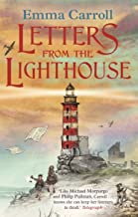  Rose Blanche – Christophe Gallaz and Roberto Innocenti  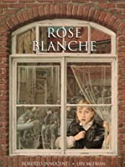  Poems from the Second World War – Gaby Morgan  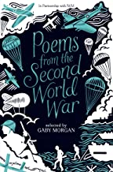  (News report, diary entry, extending part of a story, balanced argument)  Year 6 Spelling, Punctuation and Grammar curriculum | Story like the Wind – Gill Lewis  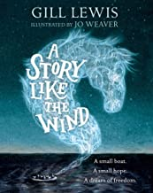  Dreams of Freedom – Amnesty International  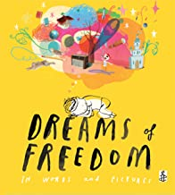  The Way of the Wolf – Smriti Prasadam-Halls  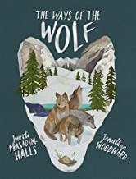  (Flashback, poetry, narrative, information)  Year 6 Spelling, Punctuation and Grammar curriculum
Maths – programme of Mastery for Year 6 | Place value, four operations, fractions | Decimals, percentages, measures, algebra, ratio, geometry, statistics | Shape, position and direction, four operations
Science – working scientifically is relevant to all areas of the science curriculum | Evolution and inheritance  Living Things in their Habitats  Animals, including humans | Light | Electricity
Geography | Locational knowledge – Antarctica physical and human | Mapping World War 2  Investigating countries involved in World War 2 | Mexico  Fieldwork
History | Ernest Shackleton | How World War 2 changed aspects of life in Great Britain | Mayans
RE | Life as a journey  Is every person’s journey the same?  Why do people of faith make pilgrimages?  Hinduism  Islam  Judaism  Sikhism  Advent  How do Christians prepare for Christmas? | The Exodus  Why is the Exodus such a significant event in Jewish and Christian history?  Judaism  The Eucharist  Who was Jesus? Who is Jesus?  Hinduism  Islam  Judaism  Sikhism | God  What is the nature and character of God?  Have you discovered any beliefs about God in common across different faiths?  Hinduism  Islam  People of Faith  How does having faith affect people’s lives?
Art/D&T | Weekly challenges from Mrs Rox, based on famous artists and art works including; line work, building pattern, perspective, water colouring  Boats/ships | Weekly challenges from Mrs Rox, based on famous artists and art works including; flowers, model making  Making an Anderson shelter | Weekly challenges from Mrs Rox, based on famous artists and art works including; sketching, tone, dark and light, adding texture using different mediums  Nutritious meals
MFL | Classroom routines (answering the register, saying the date, describing the weather, asking for classroom objects, following instructions)  Recap of simple negative  As-tu...?  Recap of clothes vocabulary Recap of expressing opinions Justifying opinions  C’est + adjective  Recap of family members  Recap of verb être  Occupations vocabulary  Christmas | Phrases to use when playing games in French  Rooms of the house  Recap of adjectives from Y4/5  Une fenêtre, une piscine  Recap of prepositions from Y5  Furniture vocabulary  Recap of ‘stalling’ strategies from Y5  Recap of days of the week and months of the year from Y3, Y4 and Y5  Recap of verb aller from Y5: on va  Easter vocabulary | Planning a trip:  On va rester dans... (un hôtel, un appartement, un gîte, un camping)  On va aller, prendre  Recap of means of transport (en bateau, en avion, en voiture, en train)  On va visiter… regarder… D’abord, plus tard  Names of places to visit
Music | Happy Charanga Unit  Recorders and reading music  Singing skills  Christmas performance | A New Year Carol Charanga Unit  World War 2 songs    Recorders and reading music  Schindler’s List soundtrack  Say My Name – Destiny’s Child   | You’ve Got a Friend in Me Charanga Unit  Mazurkas Opus 24 – Chopin  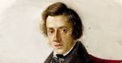  Year 6 musical  Crown – Stormzy  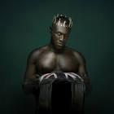
Computing | Coding | Making a short film | Designing a poster
P.E. | Tennis  Volleyball | Dance  Swimming | Games
PHSE | Being Me In My World  Celebrating Difference | Dreams and Goals  Healthy Me | Relationships  Changing Me  Transition to High School

