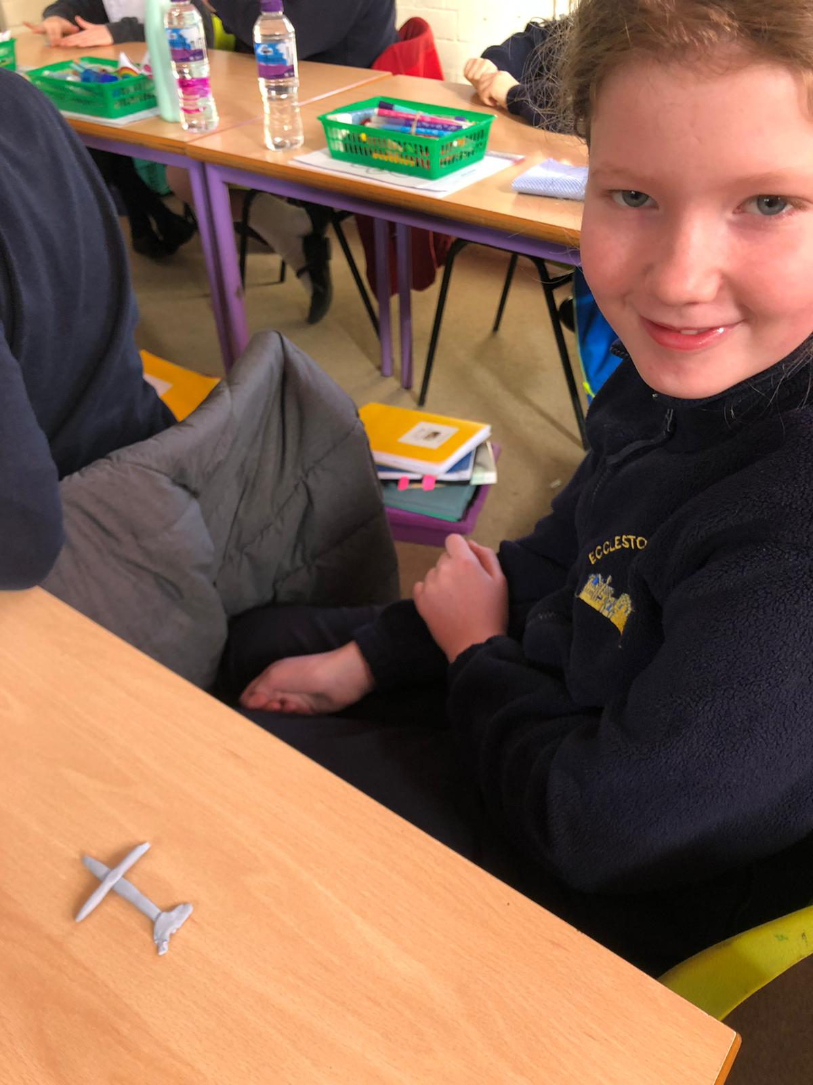

Making crosses and hearts out of playdough during our Easter worship. As we made our crosses, we reflected on the events of Good Friday.

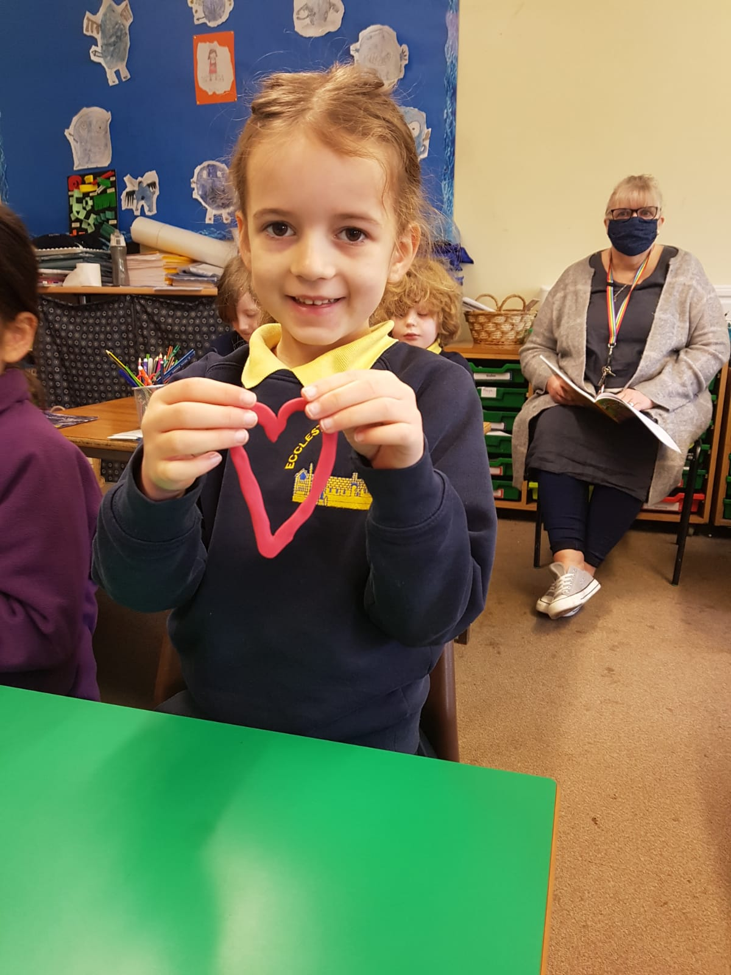

As we made our hearts, we reflected on the love that Jesus showed to us at Easter and how joyous we are that he rose again on Easter Sunday.
