Multiplication word problems
Use formal written method to solve these multiplication word problems

- Elsa takes a train to London. Each train carriage can carry 86 passengers. The train has 14 carriages. What is the total number of passengers that the train can carry?

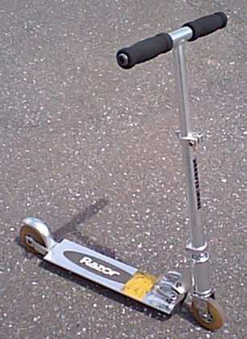
- If Sadia eats 5 pieces of fruit a day, how many pieces of fruit does she eat over 234 days?
- A shop sells scooters for £154. If the nursery school buys 23 scooters how much do they cost them in total?
- Zak is saving money to travel to Australia. He saves £245 a month for 6 months. How much has he saved?

- Oaktree school has won a national spelling competition and one of the prizes is 25 colouring pens per pupil. There are 468 children in the school, how many pens will the school receive?
- Shayla earns £2475 per month. How much does she earn in 14 months?
- A ketchup company purchased 75 shipments of tomatoes. There were 2810 tomatoes in each shipment. How many tomatoes did the company purchase in total?

You will have to read the question extra carefully and think really hard about what you are going to do for these two step problems.
Two step problems

- It takes Jonathon 54 minutes to travel to school. He makes this journey twice a day for the 25 school days this term. How much time does he spend travelling during this term?

- In January, a toy shop company purchased 62 boxes of colouring books. There were 746 colouring books in each box. How many colouring books did the company purchase in total?
They continued buy the same amount of colouring books every month for the rest of the year. How many books did they buy in 12 months?
- Cara buys sweets for everybody in her class to celebrate the start of the holidays. She buys 17 packets containing 45 sweets. She also buys 16 packets containing 145 sweets. How many sweets does she have altogether?
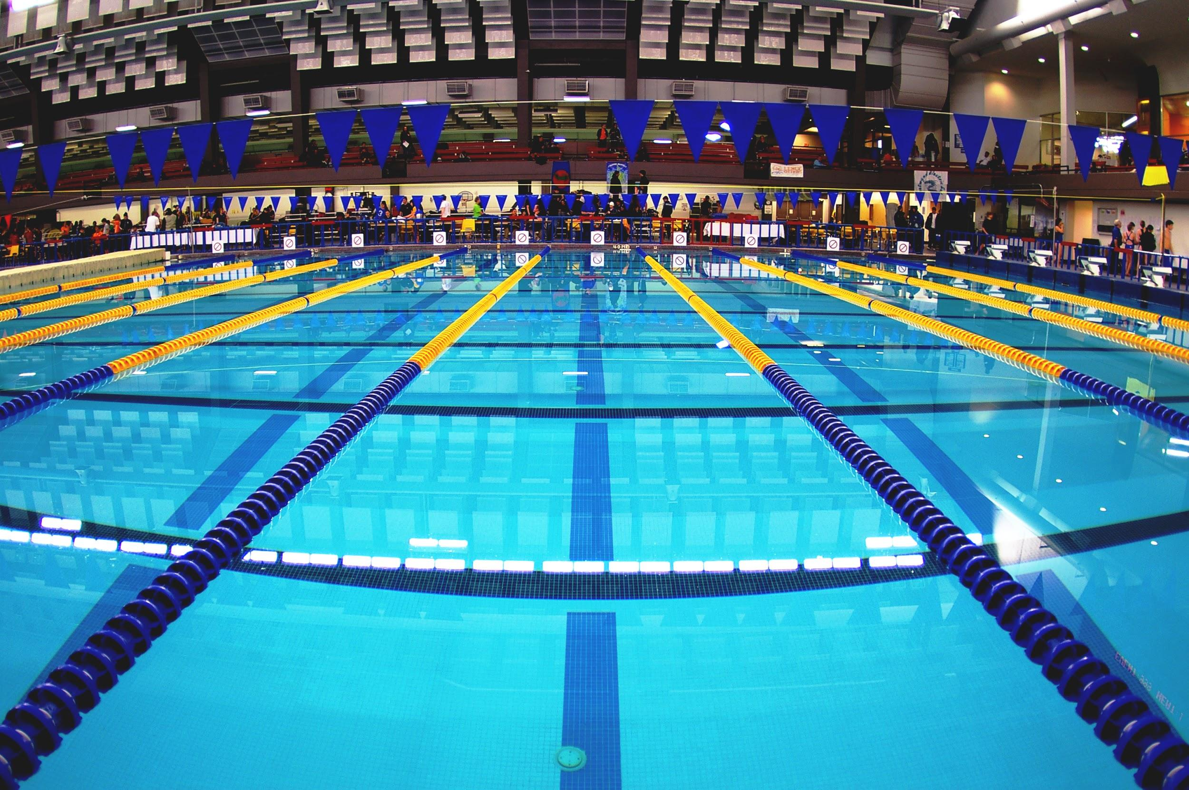
- Amy works at the Swimming Pool and is collecting lesson payments from each school. She collects £349 from every primary school and she collects £1225 from every secondary school. There are 16 primary schools and 8 secondary schools. How much money does she collect in total?

