Count the base 10 and circle the ones to make another 10:
137 + 226 =
133 + 220 + 10 = 363
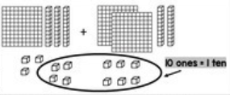

1. 315 + 236 = 4. 327 + 149 =
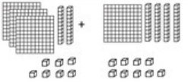
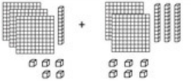
________ + ________ + _________ = ___________ + __________ + _____ =

2. 156 + 528 =
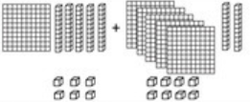
___________ + _________ + _______ =

3. 253 + 228 =

     

