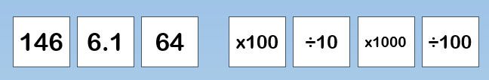
True or false – Using one number
and one operation I can make:
Number | True | False | Explain
610

640

61

1.46

0.064

0.61

14.7

0.16

6400

